The Patio Camper at Four Seasons Resort Whistler is the Most Stylish Locale for Summer Drinks

Retro camper inspires comfort, relaxation and conversations
July 11, 2018, Whistler, Canada

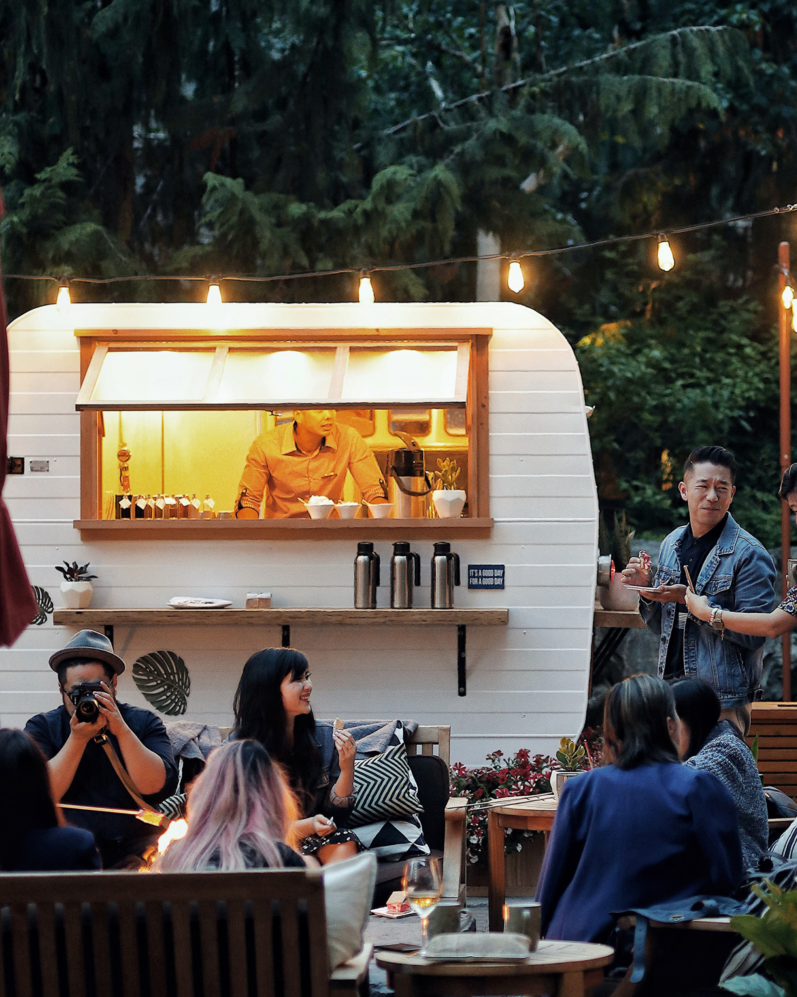
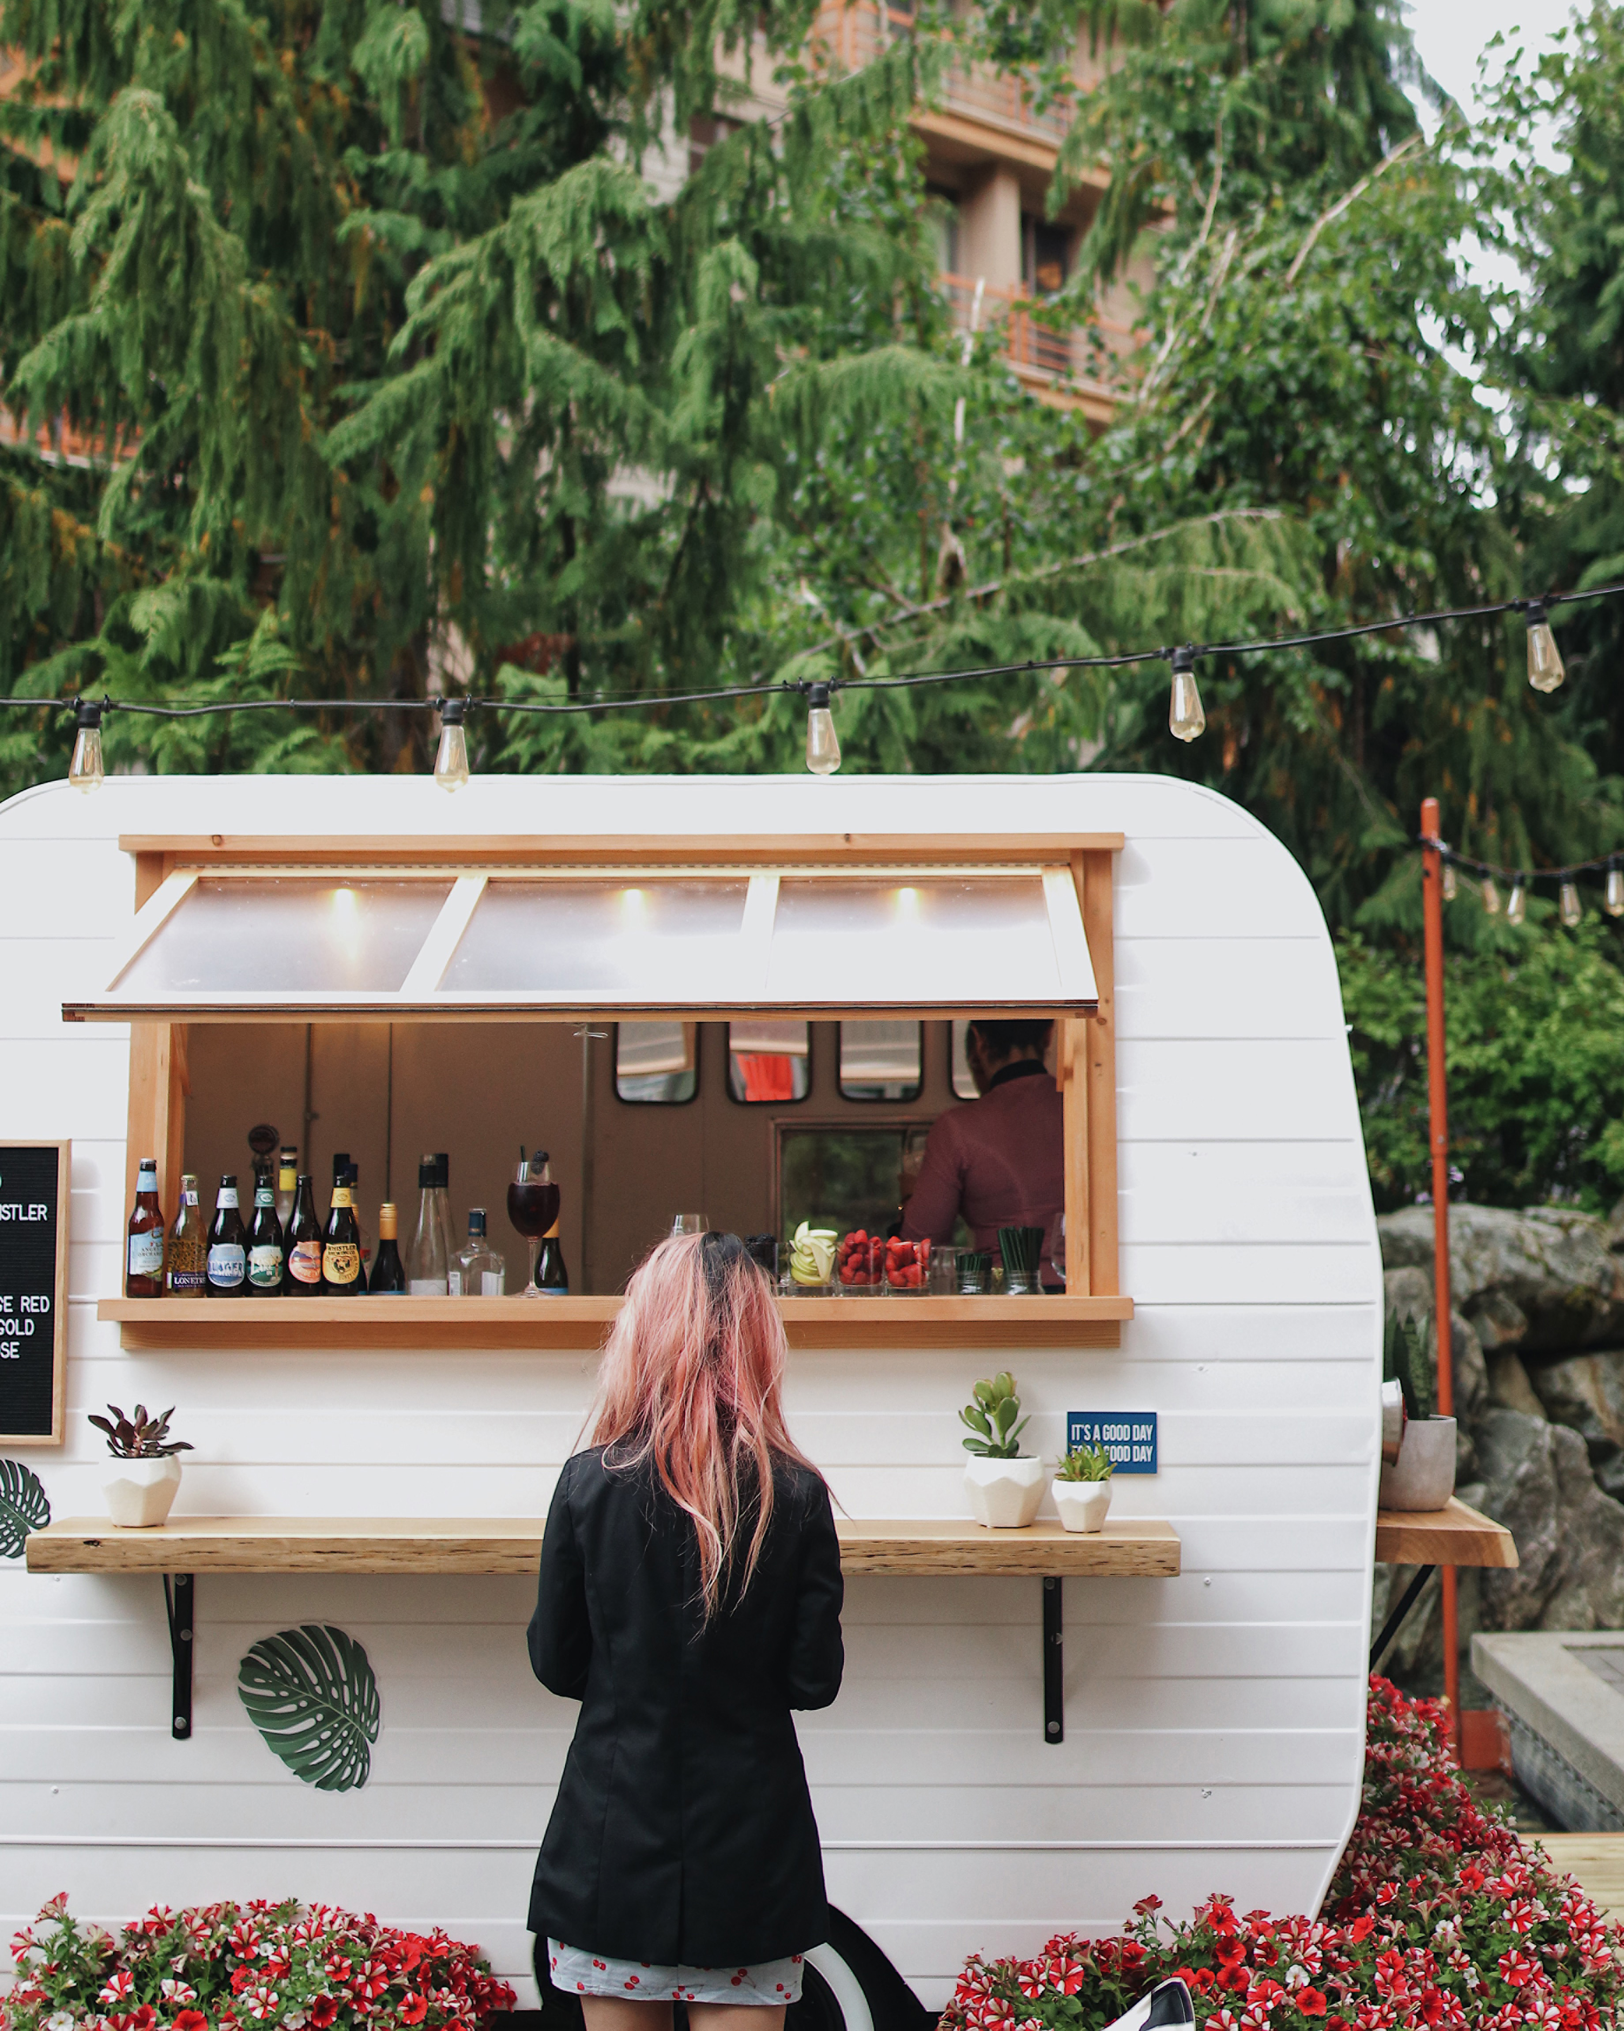 | 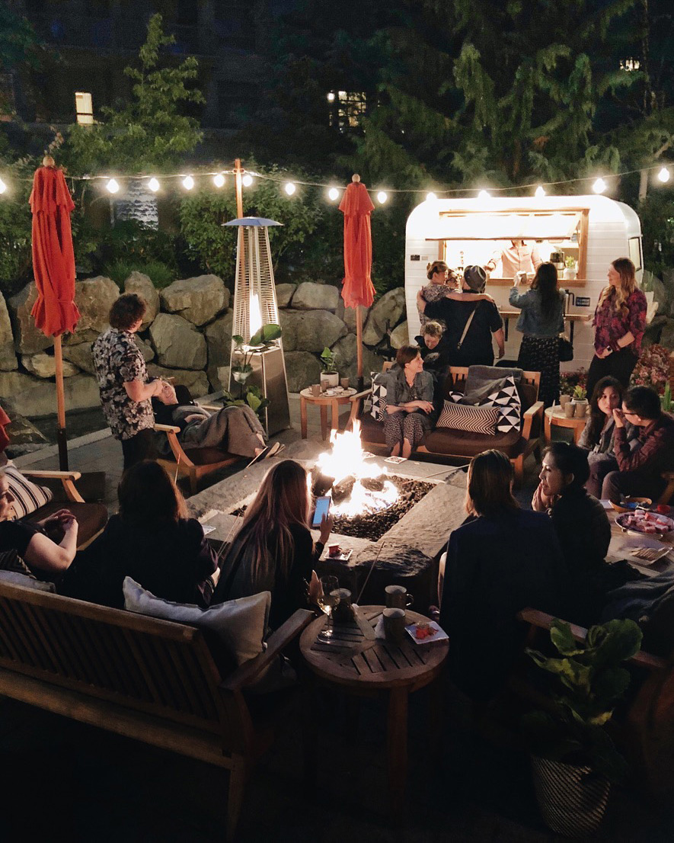
Four Seasons Resort Whistler has launched a picture perfect Patio Camper for the summer season. Distinctly local, the Patio Camper will be serving up craft beers, sangria and local ciders all summer long in the Resort’s gorgeous outdoor courtyard.
Handcrafted in Vancouver suburb Port Moody in 1965, the cute-as-button retro camper takes guests on a local road trip with its welcoming vibe and flavours of British Columbia. From Vancouver to the Okanagan Valley, the Patio Camper offers a local taste of summer thanks to Red Truck Beer’s blackberry bourbon ale, West Coast Cider’s Sunset and Sunrise ciders and sophisticated sangria in hues of red, white and pink made with wines from Penticton’s Pentage Winery.
The vintage camper has enjoyed a facelift from Whistler’s own visionary Ola Smazynski of Flock Events and simply looks stunning. The Patio Camper is the perfect place to set up shop for an afternoon or evening of cosy drinks with friends and fellow travellers. It's parked adjacent to Four Seasons courtyard fireplace, inviting couches and chairs, warmed with blankets, throw pillows, greenery, flowers, music and warm string lights.
Charming in both daytime, dusk and after dark, the Patio Camper is as open daily from 1:00 to 7:00 pm, sure to be the most Instagrammed patio in Whistler.
Team up the bevvies with seriously good bites from SIDECUT. Whatever the mood or craving – from classic juicy burgers, to ahi tuna poke, brie & balsamic pizza, freshly shucked oysters, quinoa and kale salad, and BC spot prawn tacos – SIDECUT delivers.
Social and corporate groups planning weddings, parties or meetings are also invited to enjoy the Patio Camper with customised food and beverage offerings

RELATED

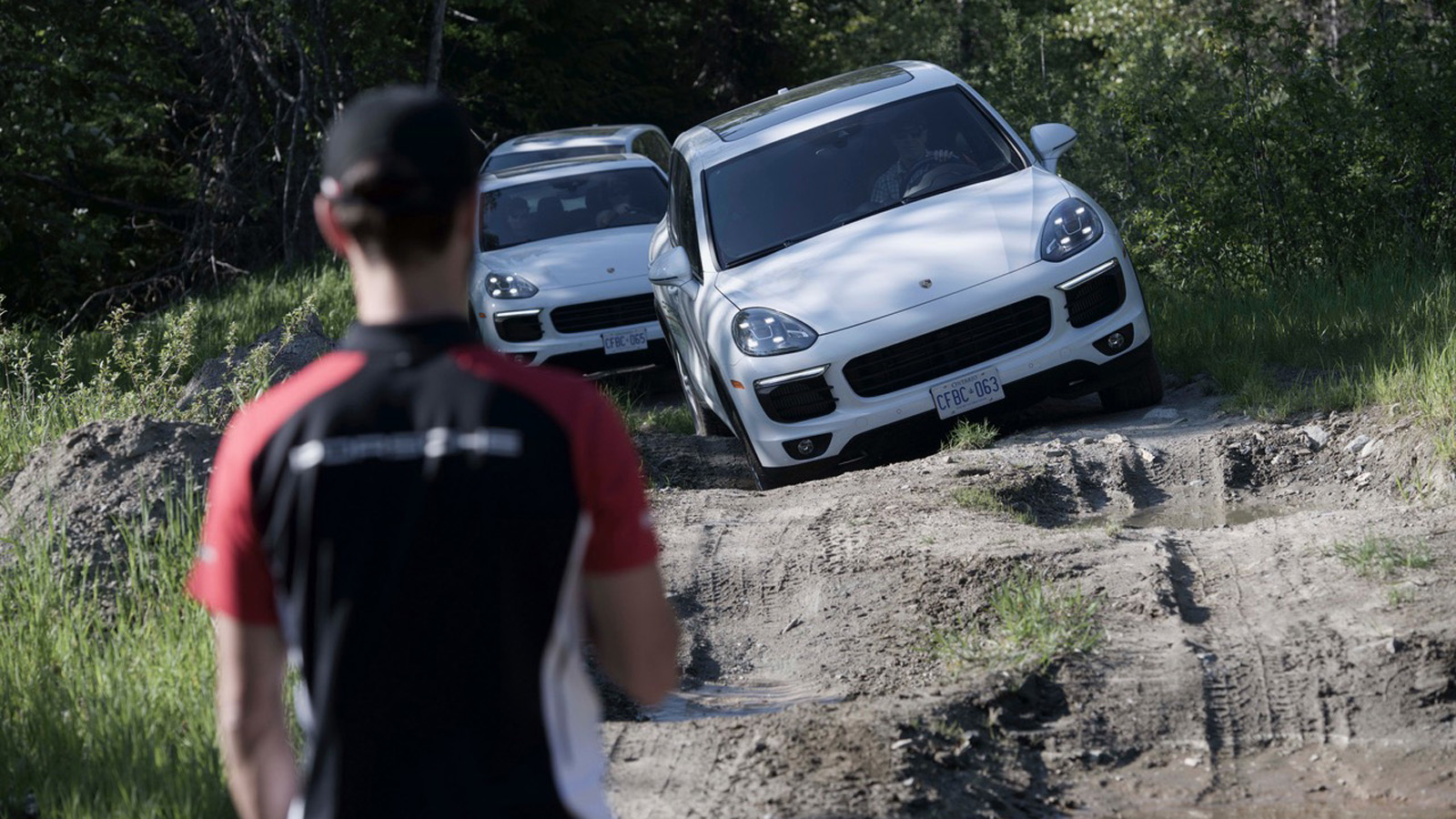 | July 4, 2018, Whistler, Canada  Four Seasons Resort Whistler Welcomes the Porsche Experience Presented by Canadian Wilderness Adventures  https://publish.url/whistler/hotel-news/2018/porsche-experience.html
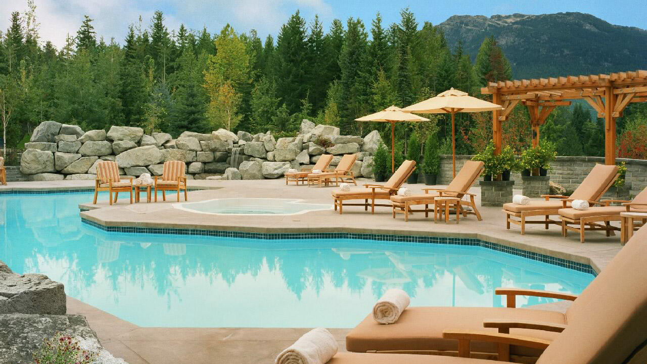 | May 25, 2018, Whistler, Canada  Think Chill Courtyard Campers, Champagne Pool Cabanas, a Legendary Thursday BEER-B-Q and the Ultimate Weekly Vacation Rental in the Glam and Spacious Residences of Four Seasons Resort Whistler  https://publish.url/whistler/hotel-news/2018/summer-season.html

PRESS CONTACTS

Christine Kim
Public Relations and Communications Manager
4591 Blackcomb Way
Whistler
Canada
christine.kim@fourseasons.com

+1 (604) 966-2666

Kate Colley
Director of Public Relations and Communications
4591 Blackcomb Way
Whistler
Canada
kate.colley@fourseasons.com

+1 (604) 844-6769

