An Alexandrian Ramadan by the Sea at Four Seasons Hotel Alexandria in Egypt

Gather with friends and family to reconnect and create memories in this spiritual Mediterranean city
April 24, 2018, Alexandria, Egypt

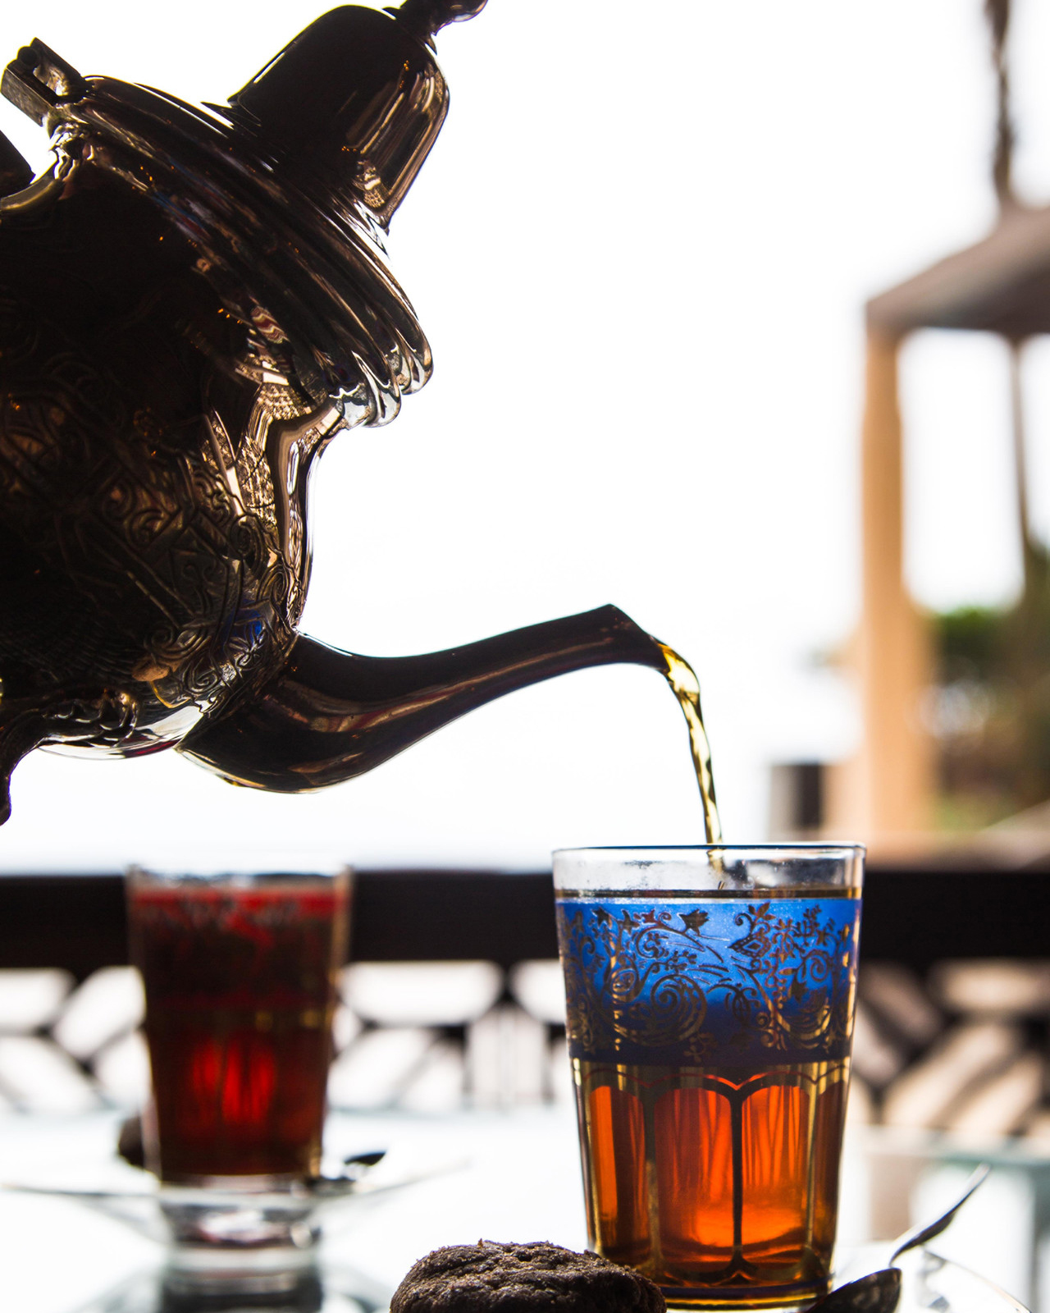
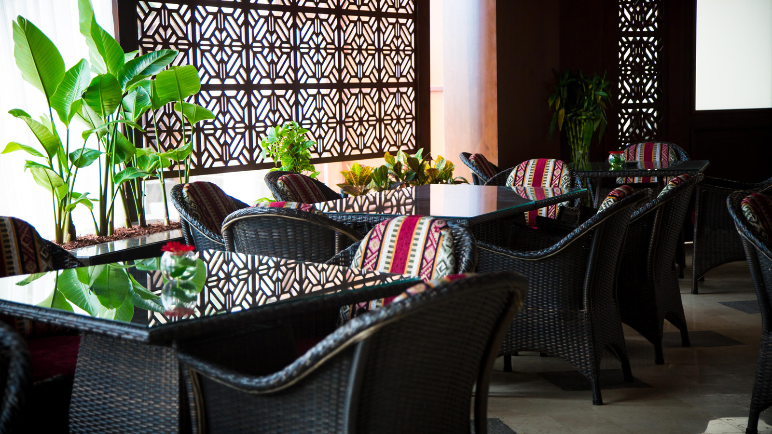
Four Seasons
Hotel Alexandria welcomes the Holy Month with a fresh and optimistic attitude, inviting guests to connect together in the genuine atmosphere that Alexandria creates by the Mediterranean Sea. This includes a number of experiences around the Hotel starting with an exclusive room package, and traditional Iftar and Sohour at Shisha Lounge. In addition, the Hotel offers an interesting Spa program to restore health and mind clearance.
Four Seasons
@Home is a new outside catering service that creates another level of Ramadan experience with a customised menu whether for Iftar or Sohour at the comfort of one's home in a
Four Seasons
style. For large groups, the Hotel's San Stefano Ballroom is the choice for a bonding corporate event during this month.
Ramadan by the Sea
Four Seasons
offers a peaceful stay with friends and family in luxurious accommodations overlooking the Mediterranean to relax and unwind in a natural ambiance by the beach or around the infinity pool.
Package includes:
- Delicious Sohour at Shisha Lounge for two
- Spending credit of EGP 300 to use in any of the restaurants
- 30 percent savings on all spa treatments
- Complimentary basic internet
- Complimentary parking up to one per stay
Oriental Night at Shisha Lounge
An authentic Ramadan Ifar and Sohour at Shisha Lounge will feature a variety of Middle Eastern dishes including the famous mezzeh, Egyptian dishes and a delicious Oriental sweets. Weekends will have an extra ambiance with an oriental live musical band on Thursdays and Fridays.
- Iftar buffet – EGP 485++ per person
- Sohour – EGP 345++ per person (10:00 pm - 2:00 am)
- Children under 5 years old dine free
- 6–12 year olds receive 50 percent savings
- Shisha is available on request
Healthy Spa Experience
Relax body, mind and soul with exclusive experiences at the Spa.
- Book a massage and receive 50 percent savings off on the next one
- Book two sessions of personal training for the price of one at EGP 350
- Purchase a package of 10 personal training sessions and get 15 at the price of EGP 3,200
Prices are inclusive of service charge and applicable taxes.
More Ways to Celebrate
The Hotel’s private beach restaurant has a lounge area with a big screen and a kids playground sets the mood for the whole family to enjoy while the sunset sets the scene with its magic. Or for a Lebanese twist, Byblos restaurant delivers a delicious menu to bring everyone into the Ramadan spirit.
Click here to find out more about
Four Seasons
Hotel Alexandria experiences.

RELATED

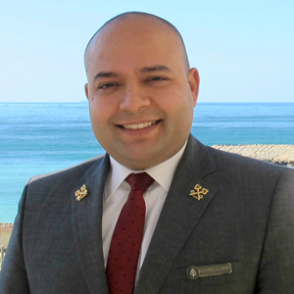 | February 22, 2018, Alexandria, Egypt  Mohamed El Sayed, Concierge at Four Seasons Hotel Alexandria, Earns Prestigious Les Clefs d'Or  https://publish.url/alexandria/hotel-news/2018/les-clef-dor-concierge.html
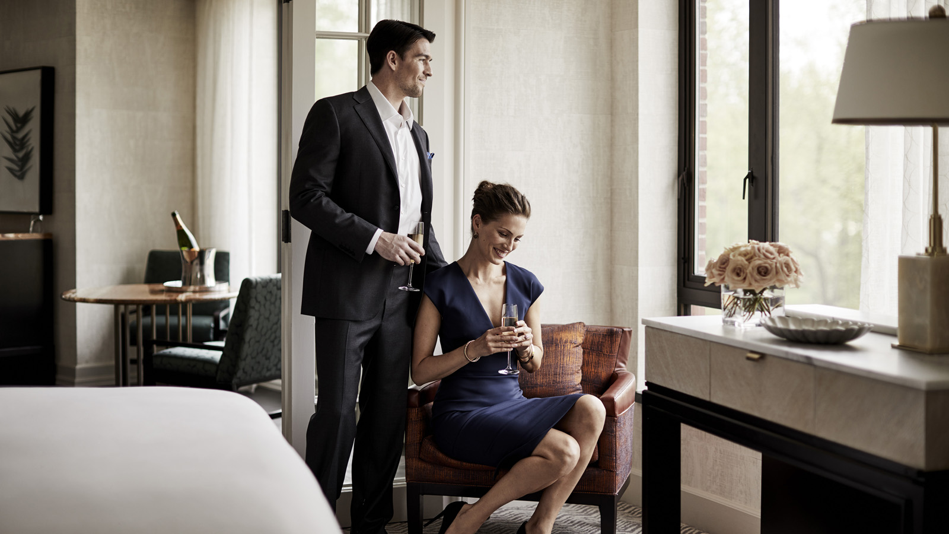 | February 1, 2018, Alexandria, Egypt  Fabu-licious Valentine's Day at Four Seasons Hotel Alexandria  https://publish.url/alexandria/hotel-news/2018/valentines-day.html

PRESS CONTACTS

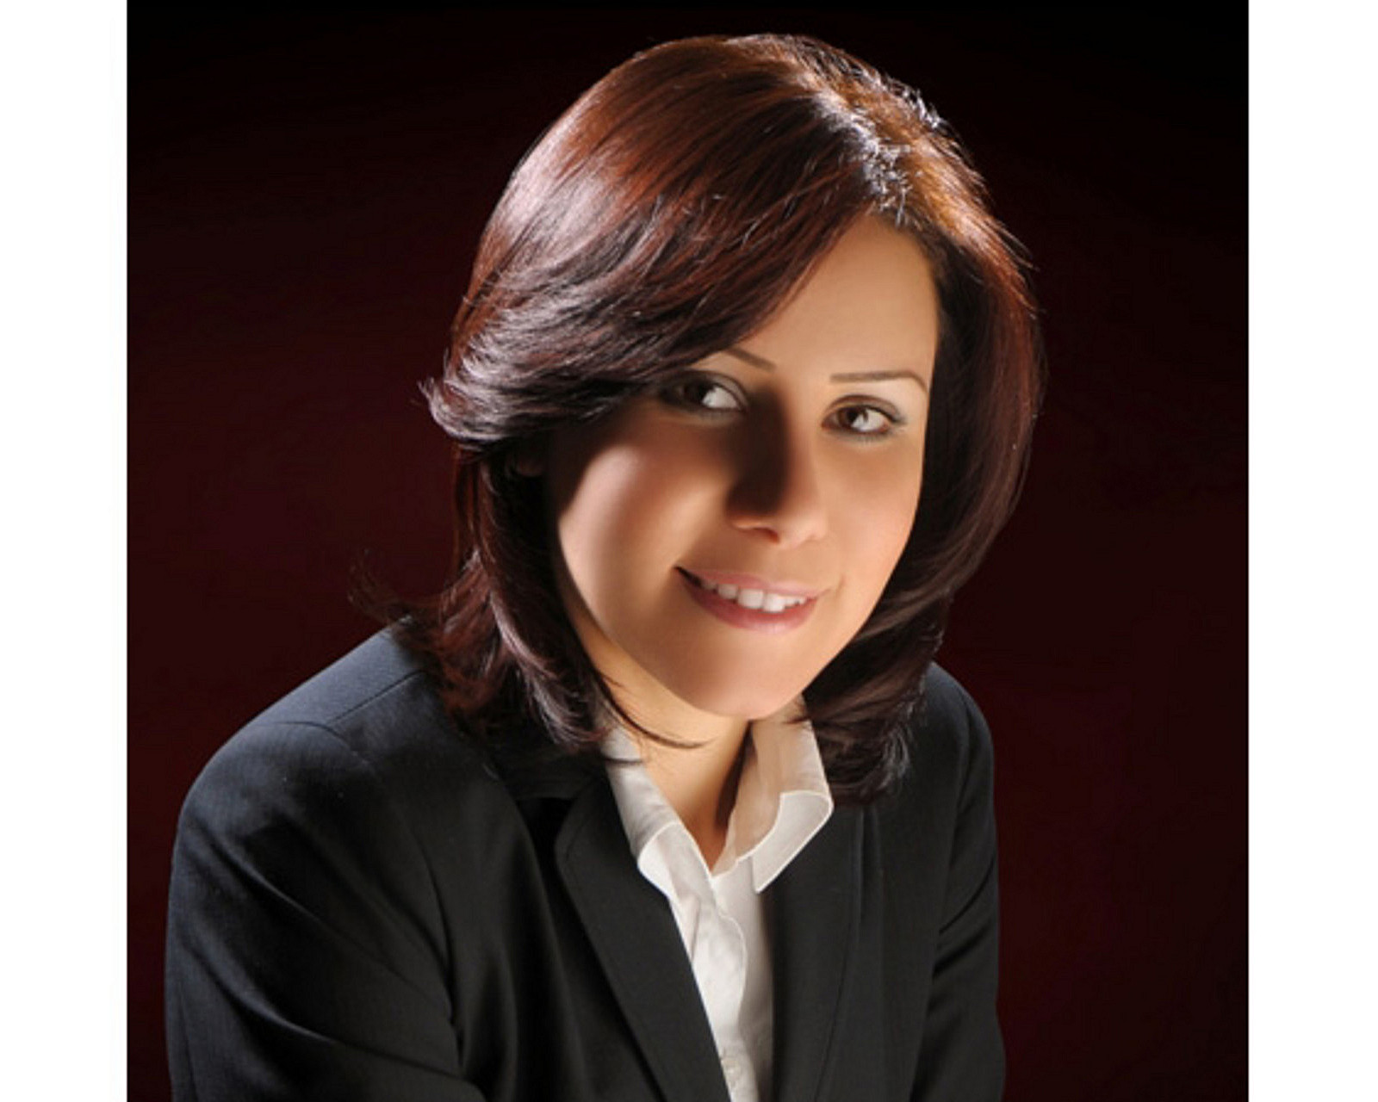 | Sarah Nabil  Director of Public Relations  399 El Geish Road  Alexandria  Egypt  sarah.nabil@fourseasons.com  20 3 581 8000

