Four Seasons Hotel Seattle and Pediatric Brain Tumor Research Fund Aim to Raise USD One Million at 11th Annual Run of Hope Seattle

October 1, 2019, Seattle, U.S.A.

Run of Hope Seattle, an annual 5K run and 3K walk to benefit the Pediatric Brain Tumor Research Fund (PBTRF), will hold its 11th annual Run of Hope on Sunday, October 6, 2019 at Seward Park.
A partnership built on hope, the collaboration between Four Seasons Hotel Seattle and the PBTRF is more than the annual run/walk. It is a story of patients, families and friends, volunteers, local businesses and community members who work tirelessly throughout the year to host mini-fundraising events, support groups and more.
More than USD 5 million has been raised in the first 10 years and more than 81 teams, and almost 2,000 people, are expected to be at the run/walk this year.
“Community fundraising efforts such as the Run of Hope are critical to filling the funding gap for pediatric cancer research. Less than 4 percent of all funds spent on cancer research are given to pediatrics,” said Erin Cordry, Run of Hope co-chair and president of the Pediatric Brain Tumor Research Fund. Teams and individuals can register and make donations for the timed run/walk online.
PBTRF and Four Seasons Hotel Seattle created the Run of Hope Seattle in 2009, adding to the many global efforts made by Four Seasons to eradicate cancer worldwide. All of the proceeds from the Run of Hope are used to fund groundbreaking research for children with brain tumours and brain cancer at Seattle Children’s Hospital.
“This extreme lack of funding makes it incredible difficult to discover new drug therapies and cures. Events like the Run of Hope allow us the funds to discover new paths and treatment options for these kids and save more lives,” said Cordry.
“Through funding from last year’s Run of Hope we were able to open multiple new clinical trials for children with devastating brain tumors,” continued Cordry.
Funds raised have already contributed to important research such as tumour paint, clinical trials, discovery of new cancer markers and other groundbreaking research by doctors and researchers from Seattle Children’s Hospital.
Follow the Run of Hope on Facebook for more information.
Pediatric Brain Tumor Research Fund
The Pediatric Brain Tumor Research Fund is a Seattle Children's Hospital guild dedicated to funding research for curing kids with brain tumors. 100 percent of donations go directly to groundbreaking research being done at the Seattle Children's Hospital in Seattle, one of the prominent research facilities of its kind in the world.

RELATED

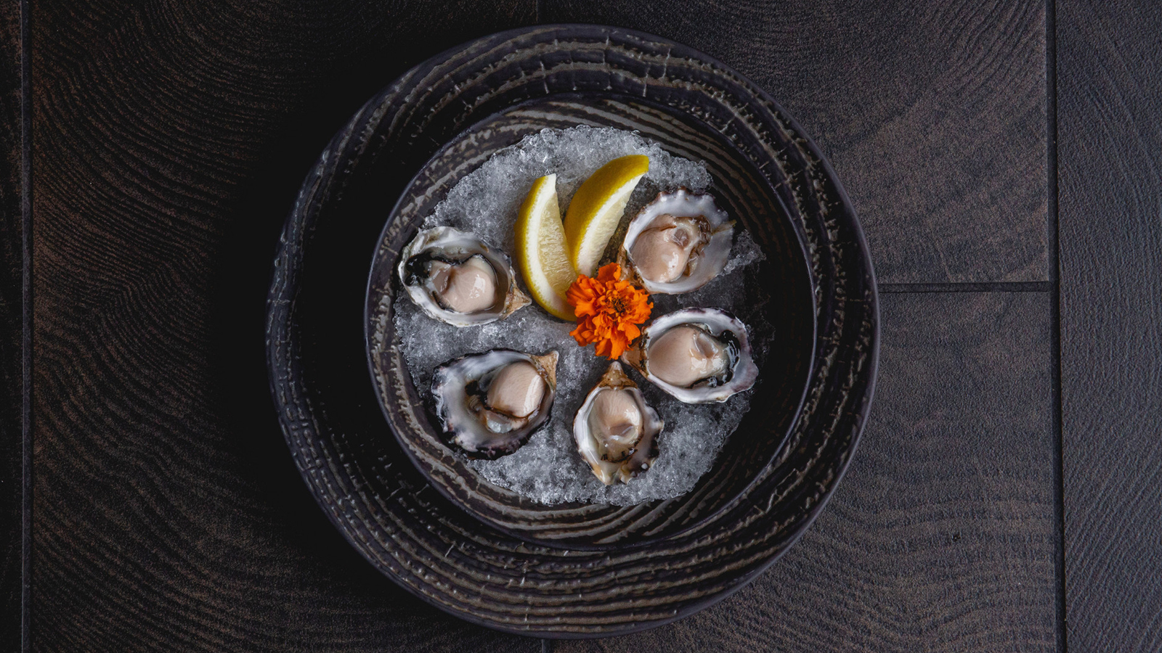 | September 24, 2019, Seattle, U.S.A.  “By the Glass, By the Shell” Culinary Experience at Four Seasons Hotel Seattle  https://publish.url/seattle/hotel-news/2019/champagne-and-oysters.html
June 12, 2019, Seattle, U.S.A.
Rediscover the Best of Seattle with the Guest Room Redesign at Four Seasons Hotel Seattle
https://publish.url/seattle/hotel-news/2019/guest-room-renovations-complete.html

PRESS CONTACTS

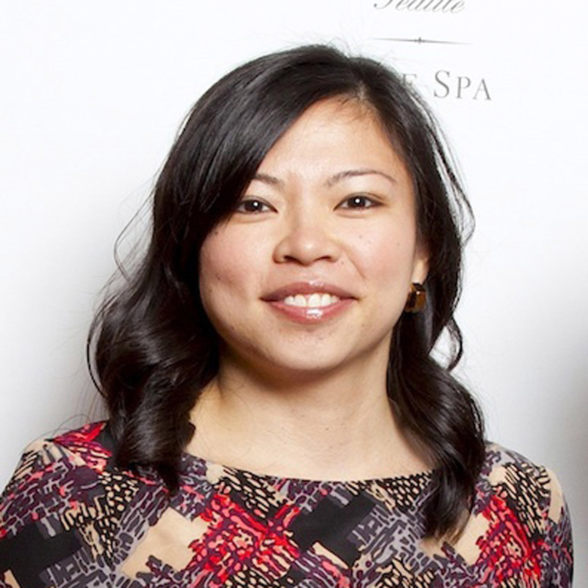 | Meg Paynor  PR Consultant  99 Union Street  Seattle  U.S.A.  meg@paynorpr.com  1 (206) 913-3848
Crystal Southcote
Digital Media Manager
99 Union Street
Seattle
U.S.A.
crystal.southcote@fourseasons.com

+1 (206) 749-3909

