Celebrate Dad at Four Seasons Hotel St. Louis with Whiskey and Bourbon Flights and a Decadent Special Dinner Menu

May 25, 2023, St. Louis, U.S.A.

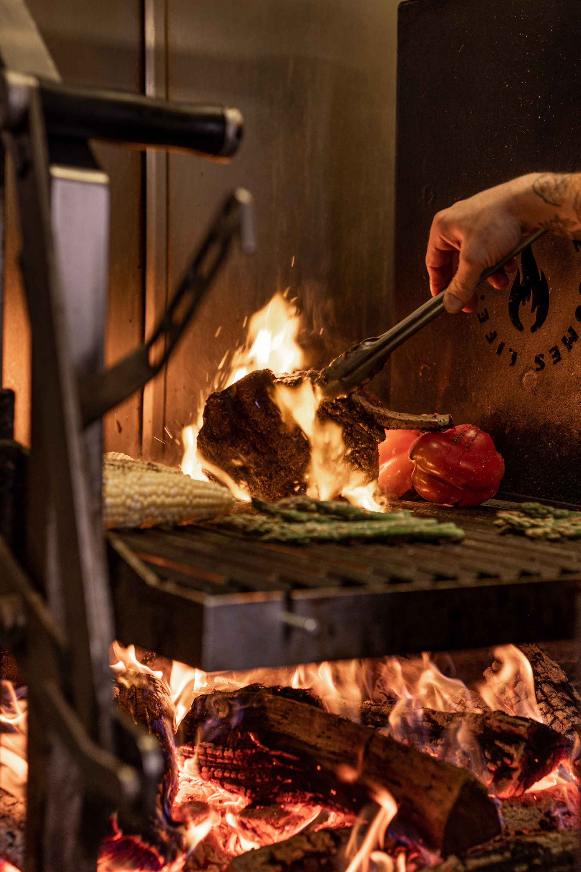
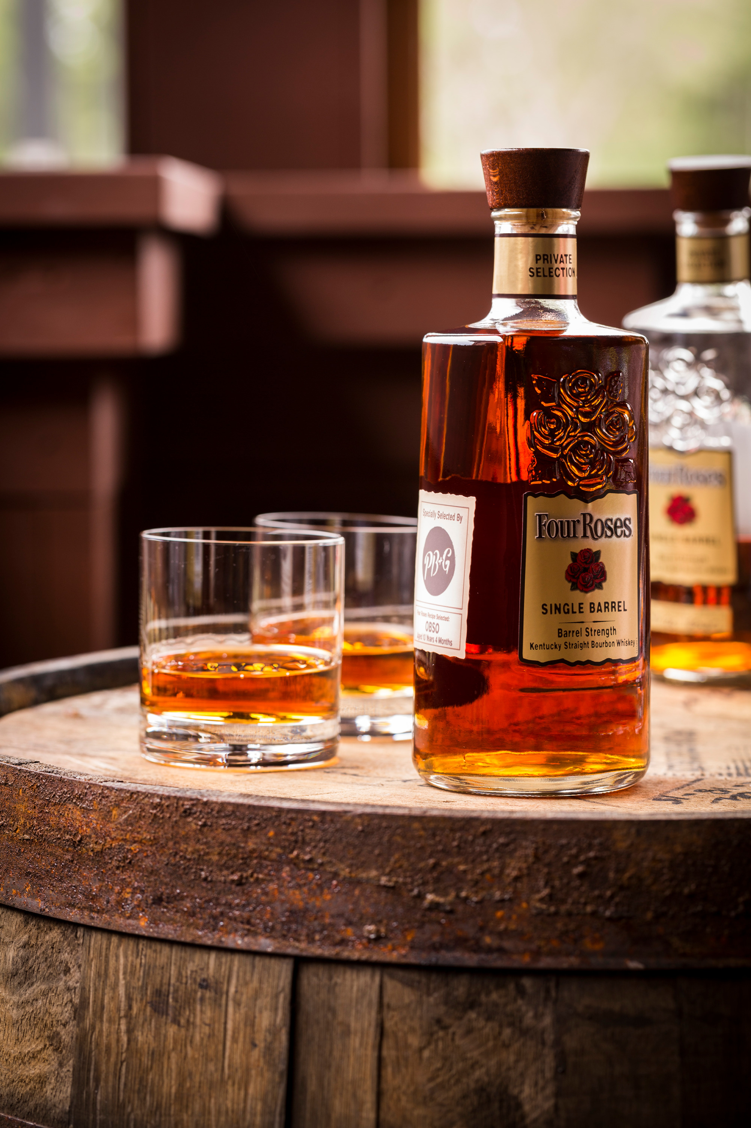
This Father’s Day, Cinder House at Four Seasons Hotel St. Louis pairs its spectacular views of the Gateway Arch and downtown skyline with bourbon, whiskey, and a hardy menu of dinner specials for a truly unforgettable and outsized celebration. Dads will feel appreciated with choices such as Tomahawk Steaks carved tableside paired with a bourbon flight and international whiskey tastings accompanying Bison Rib Eye or Short Rib.
Special Dinner Menu
In addition to the restaurant’s a la carte menu, Cinder House is offering an indulgent choice of special dishes that include:
- Seafood Ravioli - Squid Ink Infused Pasta; Creamy Saffron Sauce; Sweet Peas; Crispy Onion
- Bison Rib Eye - Coffee Rub upon request; Brown Butter Parsnip Silk; Seasonal Vegetables
- Tomahawk Steak - Cut tableside by a chef upon request; Roasted Garlic Puree; Seasonal Vegetables
- Duck Ragout – Tallarines Verdes; Wild Mushrooms; Peruvian pesto (can be prepared as vegetarian option upon request)
- Tamarind Braised Short Rib - Sweet Potato Manioc Polenta; Brazilian Nut Gremolata; Seasonal Vegetables
Bourbon and Whiskey Tastings
Toast the man of the day with a choice of three tasting flights that offer the chance to sniff, swirl, and sip through a variety of spirits.
- Bourbon Tasting - Maker’s Mark, Buffalo Trace, and Four Roses Single Barrel - USD 29
- Around The World Tasting - Red Breast 12 Year Irish Whiskey, Blade and Bow Kentucky Straight Bourbon, and Suntory Hibiki Harmony Japanese Whisky – USD 45
- Peat (Scotch) Tasting - The Macallan 18 Year Sherry Oak Single Malt; Johnny Walker Blue Label Blended Scotch; Lagavulin 16 Year Old Single Malt - USD 85
Cinder House will also offer Sunday Brunch on Father’s Day, June 18, 2023, from 7:00 am to 2:00 pm, where guests can also enjoy the spirit flights. The special dinner menu as well as tastings will be served from 6:00 to 9:00 pm. Reservations are required and can be made on Open Table.

RELATED

May 25, 2023, St. Louis, U.S.A.
Four Seasons Hotel St. Louis Spa Elevates Signature Pedicure with Zero Gravity Loungers
https://publish.url/stlouis/hotel-news/2023/signature-pedicure-at-the-spa.html

May 10, 2023, St. Louis, U.S.A.
Dive into Summer at Four Seasons Hotel St. Louis, an Urban Resort Oasis
https://publish.url/stlouis/hotel-news/2023/summer-programming.html

PRESS CONTACTS

Teresa Delaney
Director of Public Relations
999 North 2nd Street
St Louis
USA
teresa.delaney@fourseasons.com

+1 314 881 2025

