For the Fourth Year Running, Four Seasons Hotel George V, Paris Has Been Awarded with Five Stars in the Michelin Guide

The luxury hotel’s three restaurants have retained their rankings in the 2021 edition of the famous Michelin Guide, with three Michelin-starred Chef Christian Le Squer and Michelin-starred Chefs Simone Zanoni and Alan Taudon at the helm
January 18, 2021, Paris, France

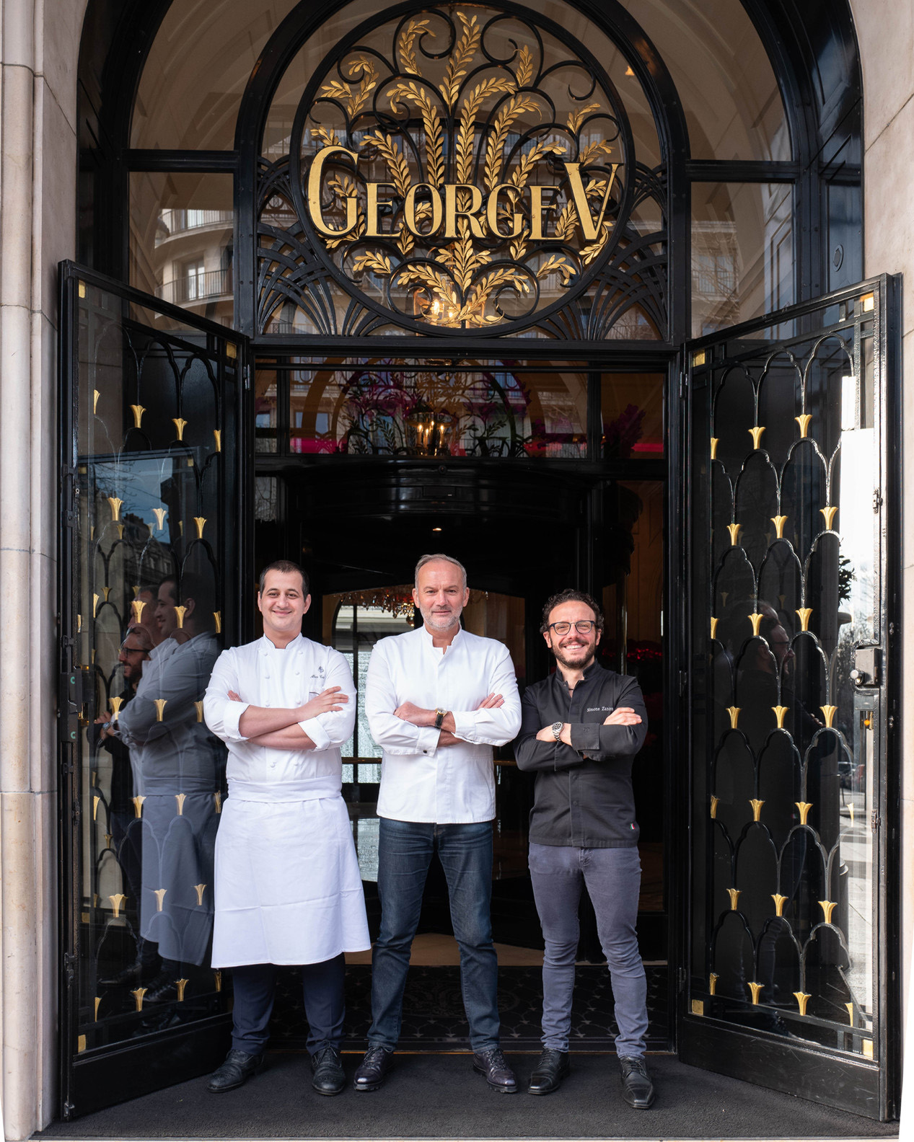
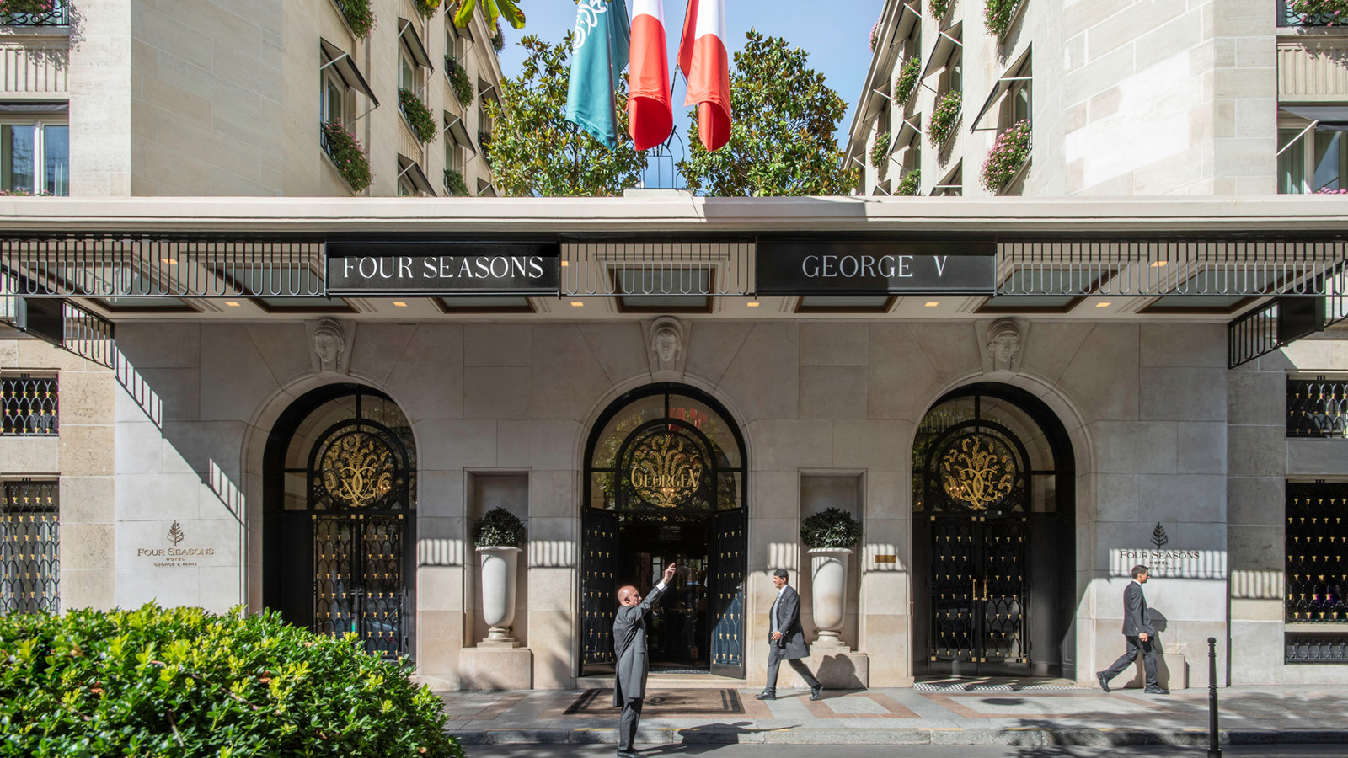 | 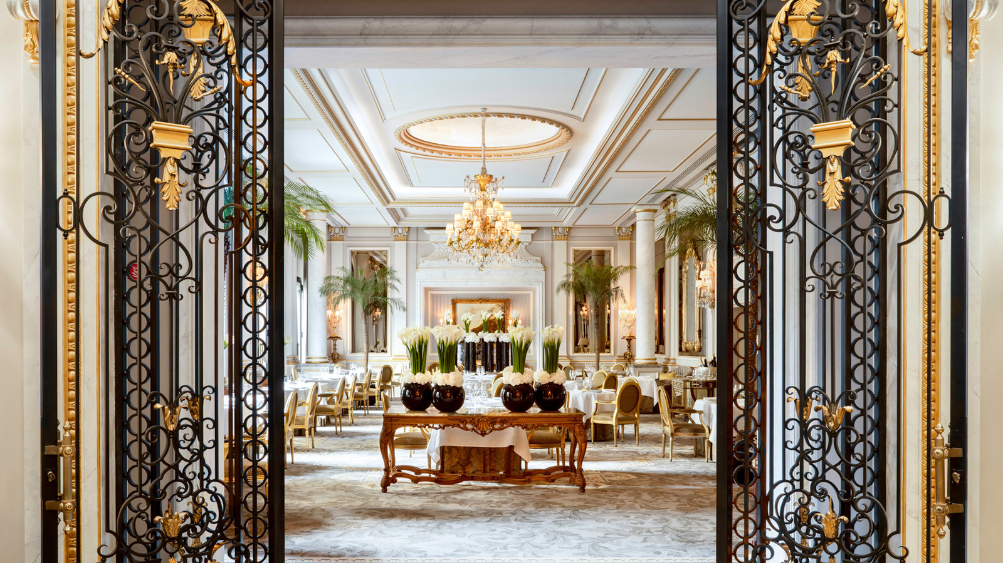 | 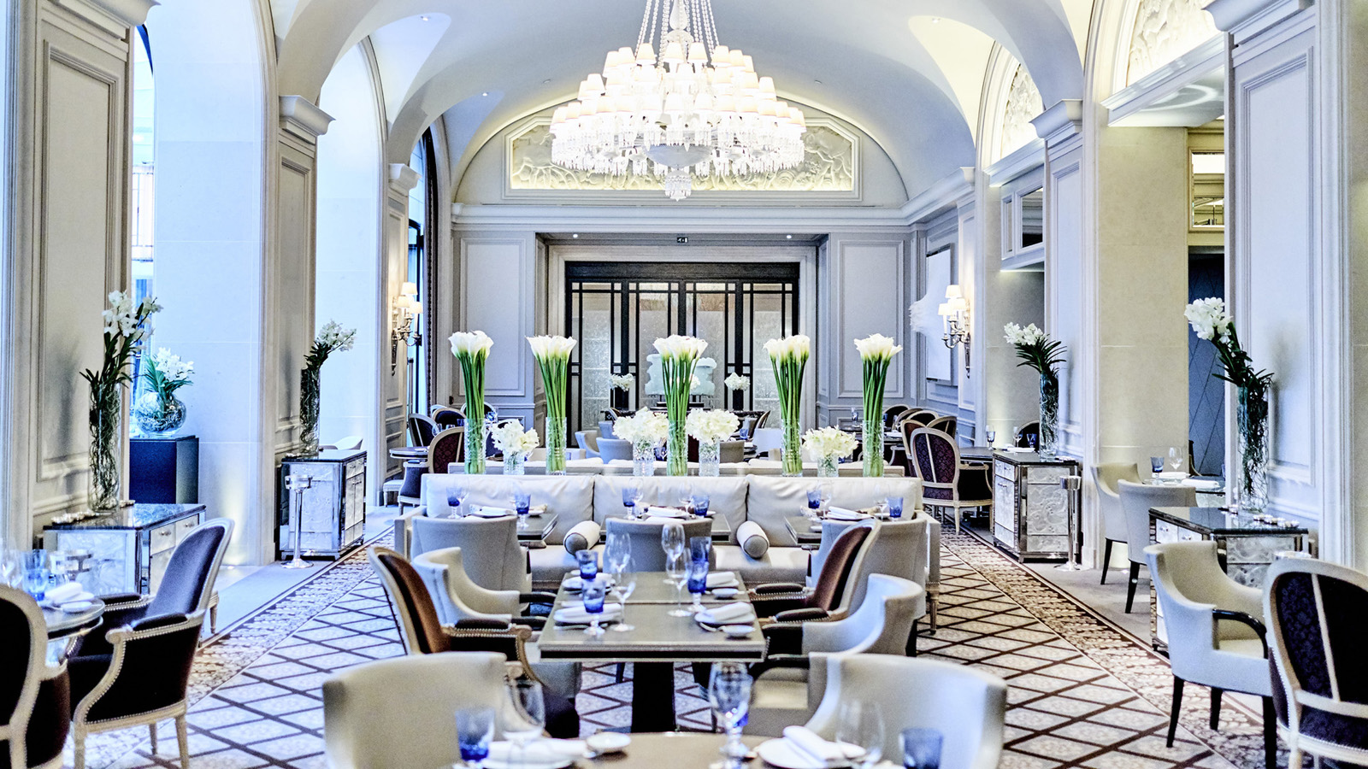
Le Cinq, Le George and L’Orangerie restaurants at Four Seasons Hotel George V, Paris have retained their rankings in the latest edition of the Michelin Guide. In spite of the unprecedented global situation, the Hotel has once again re-established itself as a world leader in culinary excellence.
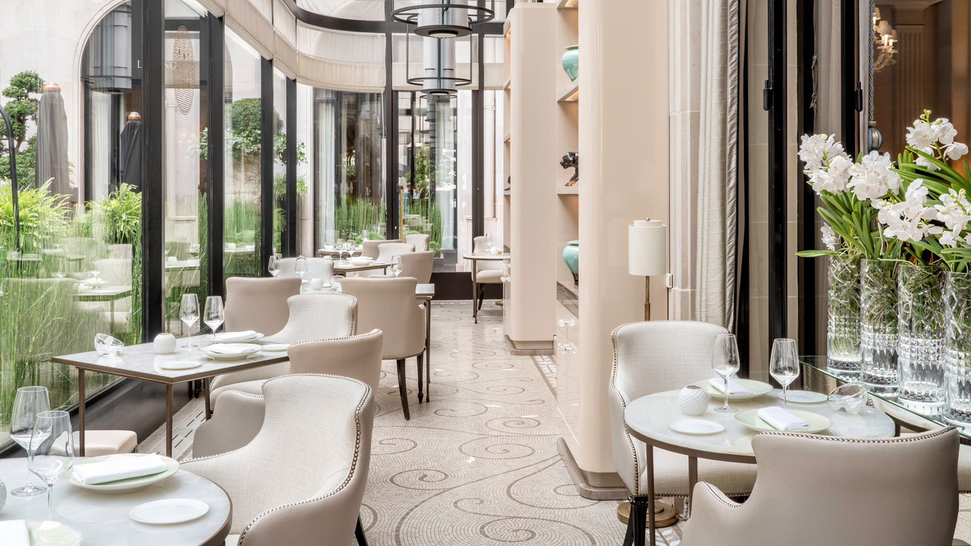
Regional Vice President and General Manager Jean-Claude Wietzel comments, “We are thrilled and honoured to learn the Michelin Guide inspectors have maintained our distinctions. From the very beginning of the crisis, and given the extremely challenging situation facing restaurateurs, farmers, producers and all culinary players today, our chefs and their teams have not ceased to be inventive, passionate and creative, sharing with clients and gourmets their culinary know-how and love for food. The chefs are thoroughly looking forward to welcoming guests again soon in complete safety, offering the chance to enjoy a unique gastronomic experience in our Michelin-starred restaurants.”
For several years now, the chefs of Four Seasons Hotel George V, Paris, internationally recognised as “The Palace of Gastronomy,” have been wholeheartedly committed to the future of gastronomy. Despite the temporary closure of the restaurants, the chefs remain committed to promoting a sustainable approach to cooking. As soon as the restaurants are given the green light to re-open their doors, they will be able to fully embrace their green credentials, championing food sustainability and social responsibility.
Offering elegant and sophisticated cuisine, three Michelin-starred Chef Christian Le Squer is driven by the unconditional desire to constantly research and refine his modern creations. Influenced both by his Breton roots and his beloved adoptive Paris, Le Squer is focused on seasonality, working closely with producers and market gardeners to select French, locally produced ingredients.
At Le George, Chef Simone Zanoni creates Michelin-starred Mediterranean dishes that reflect his bold ethical stance and interest in sustainable foods. Zanoni has taken a number of environmentally friendly initiatives, including growing oyster mushrooms using waste coffee grounds; opening a kitchen garden that takes a local, social and environmental approach; and reducing the carbon output in the kitchen.
Chef Alan Taudon took the bold decision to create a new culinary expression with a no-meat approach at his restaurant L’Orangerie. Vegetables, fruits and seafood form the basis of his cuisine, offering a plant-based, light and healthy gastronomic experience.
With a passion for flavour and a palpable love for products, Pastry Chef Michael Bartocetti gives life to exquisite sweet delights inspired by nature, sourcing ingredients from small producers that employ sustainable farming practices.

RELATED

January 18, 2021, Paris, France
Pour la quatrième année consécutive, le guide MICHELIN confirme les 5 étoiles du Four Seasons Hotel George V, Paris
https://publish.url/fr/paris/hotel-news/2021/five-michelin-stars-2.html

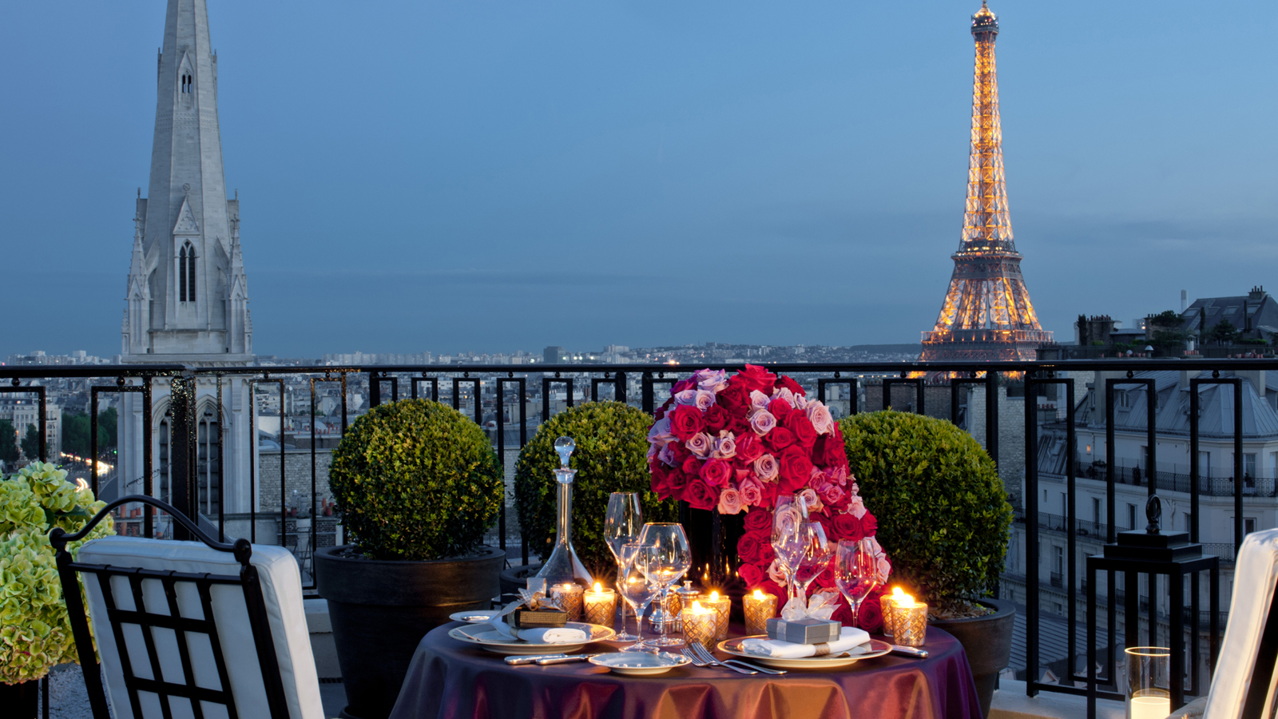 | December 23, 2020, Paris, France  Ring in the New Year and Indulge in a Decadent Festive Feast Crafted by Three Michelin-Starred Chef Christian Le Squer of Four Seasons Hotel George V, Paris  https://publish.url/paris/hotel-news/2020/new-years.html

PRESS CONTACTS

Samuelle Dorol
Public Relations and Communications Manager
31, avenue George V
Paris
France
samuelle.dorol@fourseasons.com

+33 1 49 52 71 69

Nathalie Vimar
Director of Public Relations and Communication
31 avenue George V
Paris
France
nathalie.vimar@fourseasons.com

+33 1 49 52 71 69

