Cielo Spa at Four Seasons Hotel Buenos Aires Presents Special Treatments for the Autumn-Winter Season

May 15, 2018, Buenos Aires, Argentina

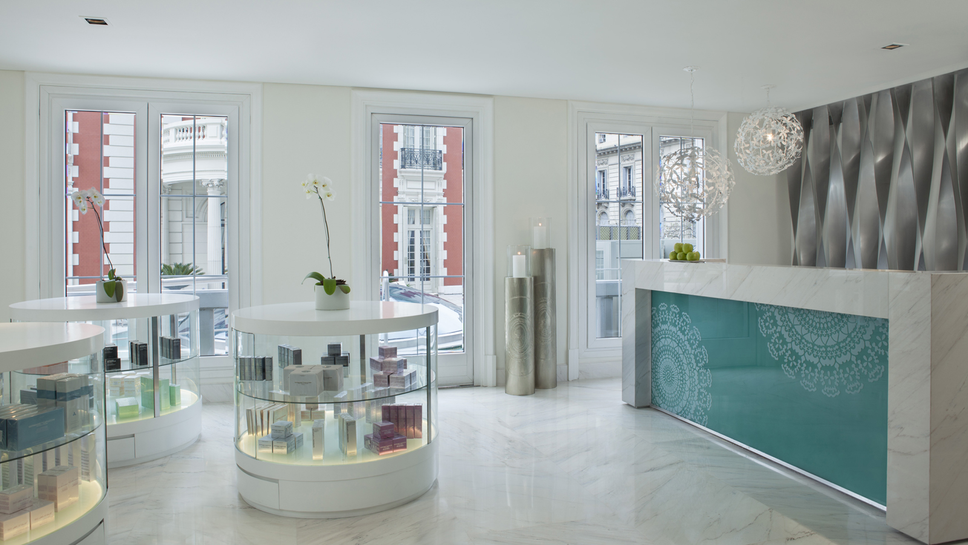
Cielo, the Spa of Four Seasons Hotel Buenos Aires, presents its treatments created especially for the autumn-winter season.
Cielo Spa is an exclusive urban refuge in Recoleta, surrounded by an outdoor garden and located next to the historic Mansion and the only outdoor hotel pool in the area.
The following treatments are now offered:
- Energising with Concentrated Siberian Ginseng - Designed to stimulate the energy of the skin and an effervescent mask that gives vitality.
- Oriental Sensations - A body treatment that includes pre-peeling, exfoliation with gommage clay and application of an amber and date massage oil to nourish the skin.
- Hanakasumi - Consisting of an exfoliation with gommage of cherry blossom and rice powder followed by a massage with shea butter and Asian essences for a revitalising and nourishing ritual.
- Digi-Esthétique - A combination that associates massage, drainage and digit-pressure in a very original way. It restores the good circulation of energy in the organs and achieves a sensation of absolute rest. Thus, the skin is ready and in an optimal state to receive and fully benefit from the effects of the treatments.
These treatments have been created with the brand that is associated with Cielo Spa, Sothys, from Paris, France, known for taking advanced skin care and experience to consumers exclusively through professional spas around the world.
Spa and body products from Sothys can be purchased at the Spa. Among them, preliminary, moisturising, energising, products for eye contour, products for sensitive skin and products specific for men. Body products include moisturising cherry blossom and lotus elixir, cinnamon and ginger elixir and lemon and petit grain elixir.

RELATED

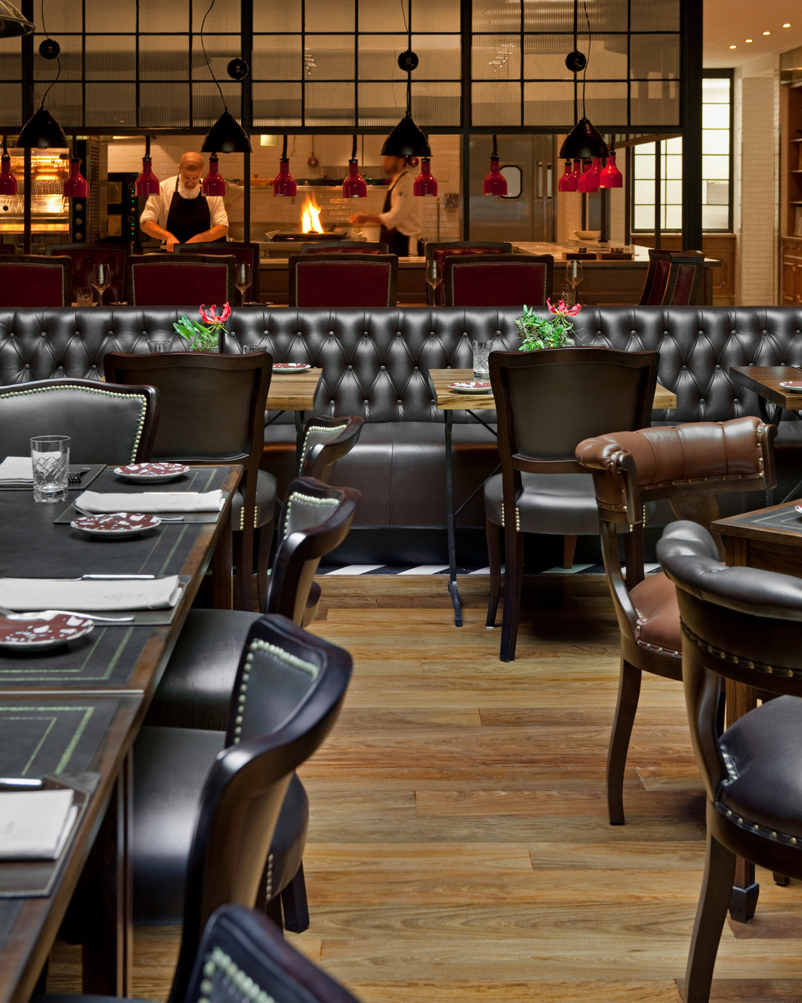 | December 28, 2017, Buenos Aires, Argentina  Four Seasons Hotel Buenos Aires Launches Argentina’s First “Dry Aged Beef Club” at Elena Restaurant  https://publish.url/buenosaires/hotel-news/2017/dry-aged-beef-club.html
December 28, 2017, Buenos Aires, Argentina
Elena lanza el primer Club Dry Aged de Argentina
https://publish.url/es/buenosaires/hotel-news/2017/dry-aged-beef-club-2.html

PRESS CONTACTS

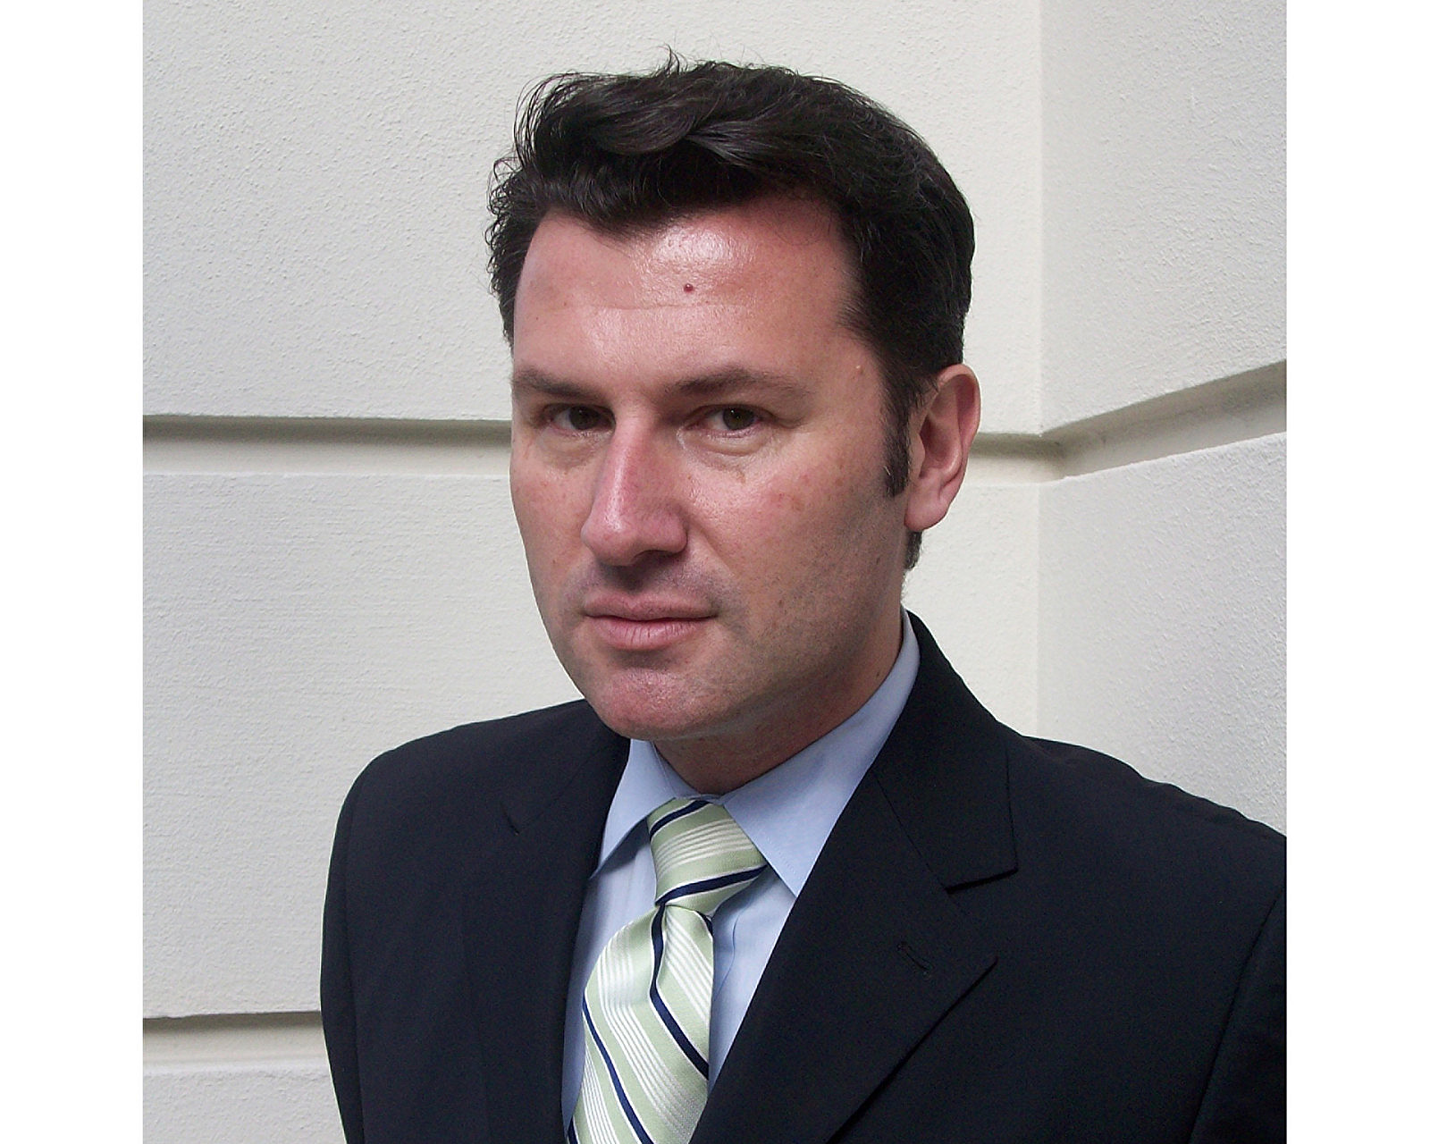 | Gabriel Oliveri  Director of Marketing  Posadas 1086/88  Buenos Aires  Argentina  gabriel.oliveri@fourseasons.com  54 (11) 4321-1634

