Easter Brunch at Quattro at Four Seasons Hotel Silicon Valley

The #1 Hotel in Palo Alto welcomes the time-honoured tradition with an elaborate brunch at Quattro Restaurant and Bar
March 16, 2023, Palo Alto, Silicon Valley, U.S.A.

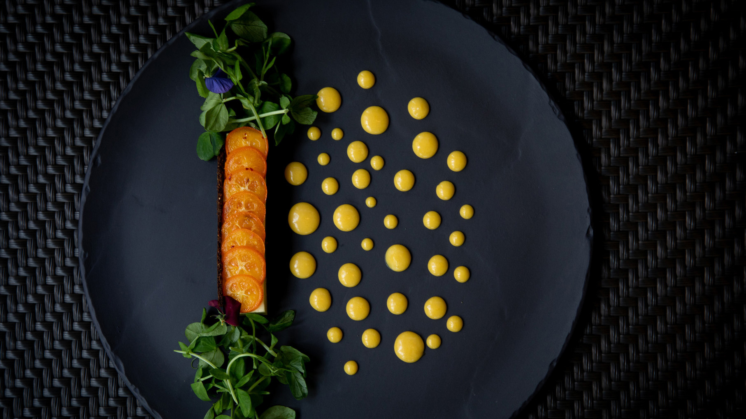
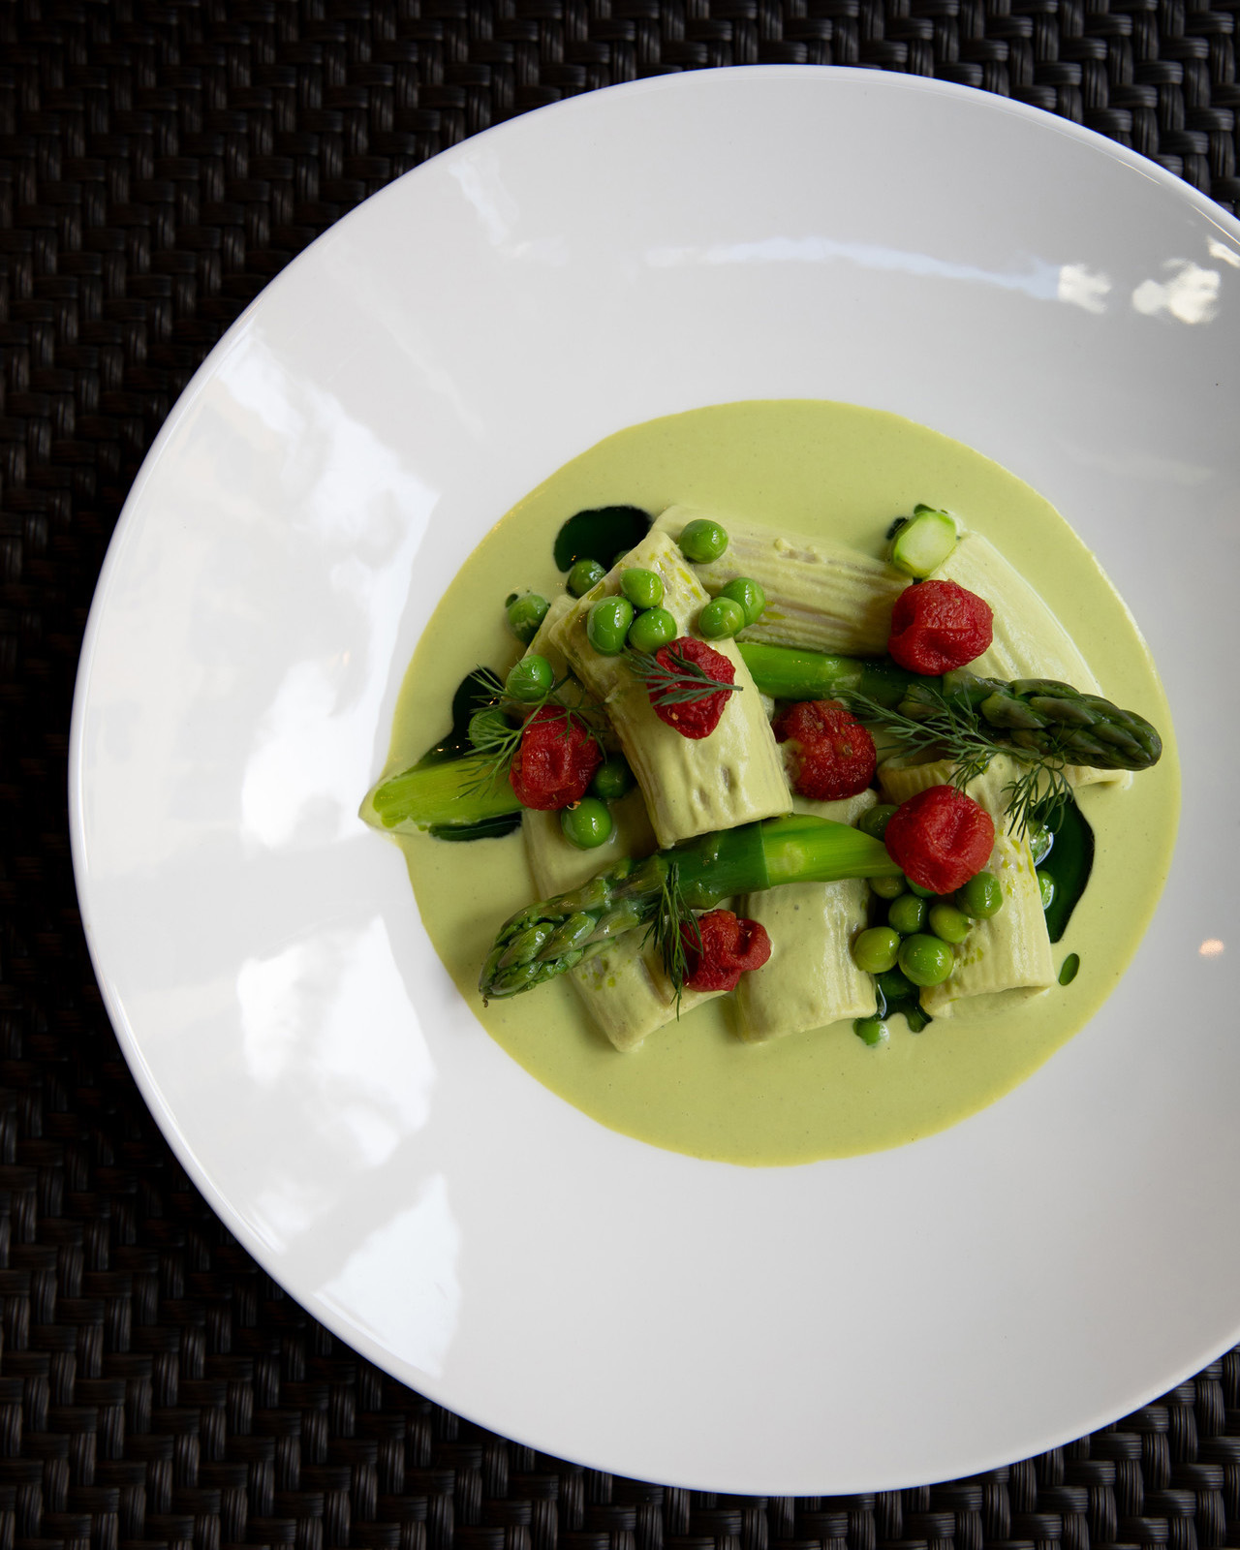 | 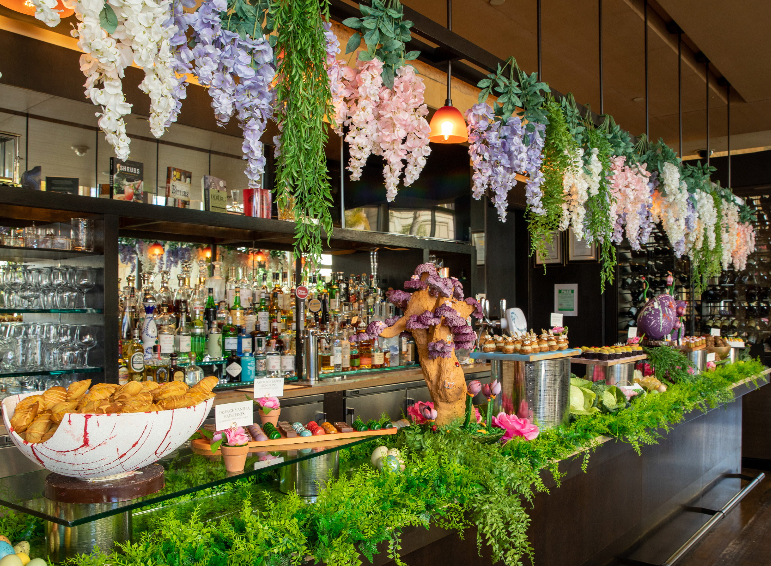 | 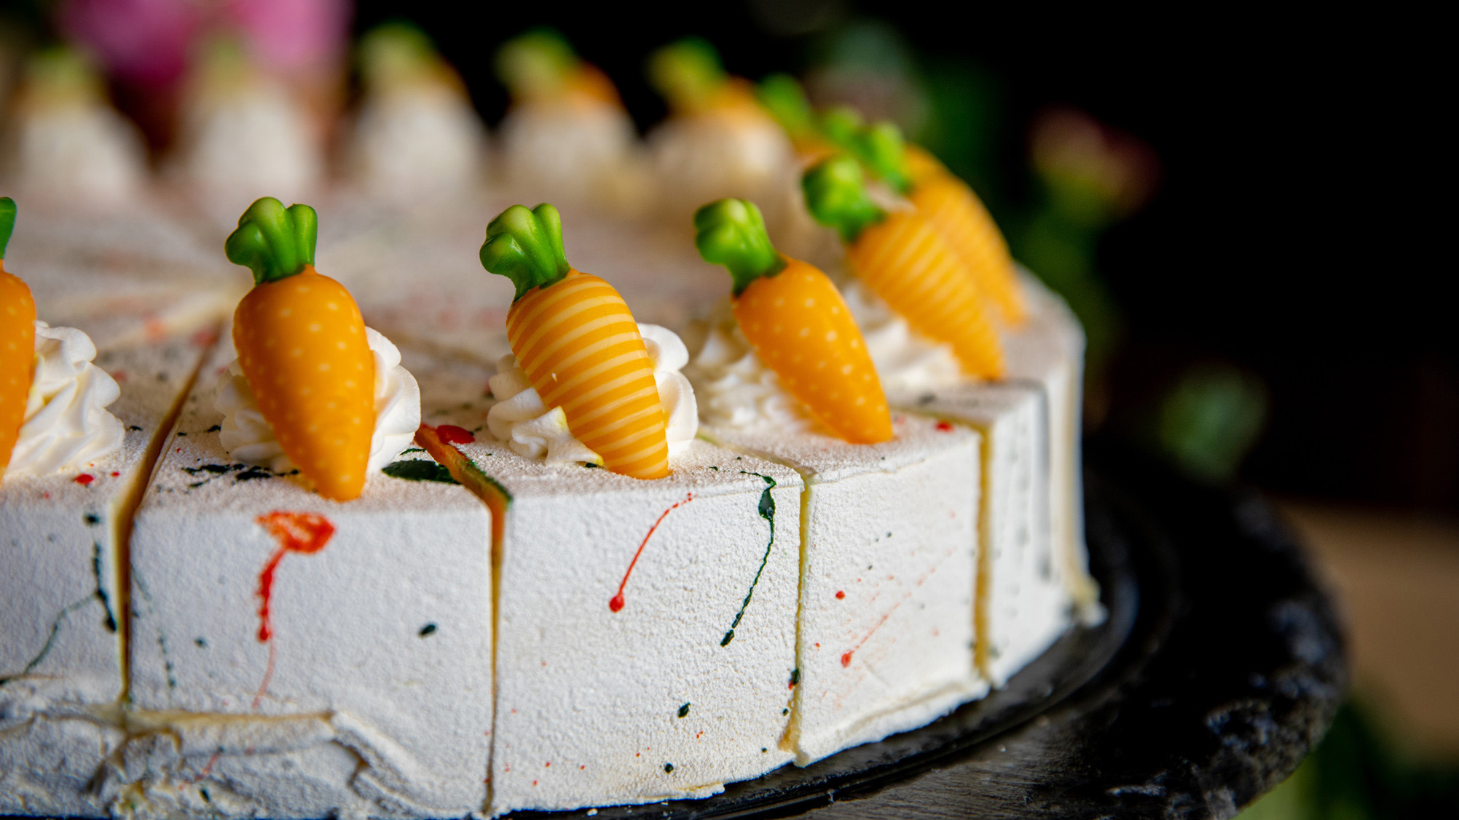
Four Seasons Hotel Silicon Valley welcomes guests and local residents to celebrate Easter with an abundant brunch at Quattro. Enjoy live stations that include a seafood station, a carving station, and a Mimosa and cocktail station along with an ala carte menu comprising of main courses such as Citrus Confit Duck Leg, Classic Beef Wellington and more. An elaborate dessert buffet by Pastry Chef Guillermo Soto Torres features Carrot Cake with Passion Fruit Ganache and Cream Cheese Mousse, Easter Bunny, Assorted Easter Bonbons, Caramelized Honey Cake and Chocolate Earl Grey Tea Crémeux and more. Presented by Executive Chef Daniel Garcia and his culinary team, the extensive and comforting brunch selections are designed to delight the senses and to create a memorable experience with friends and family. In addition, the time-honoured tradition of hunting eggs will bring joy to children.
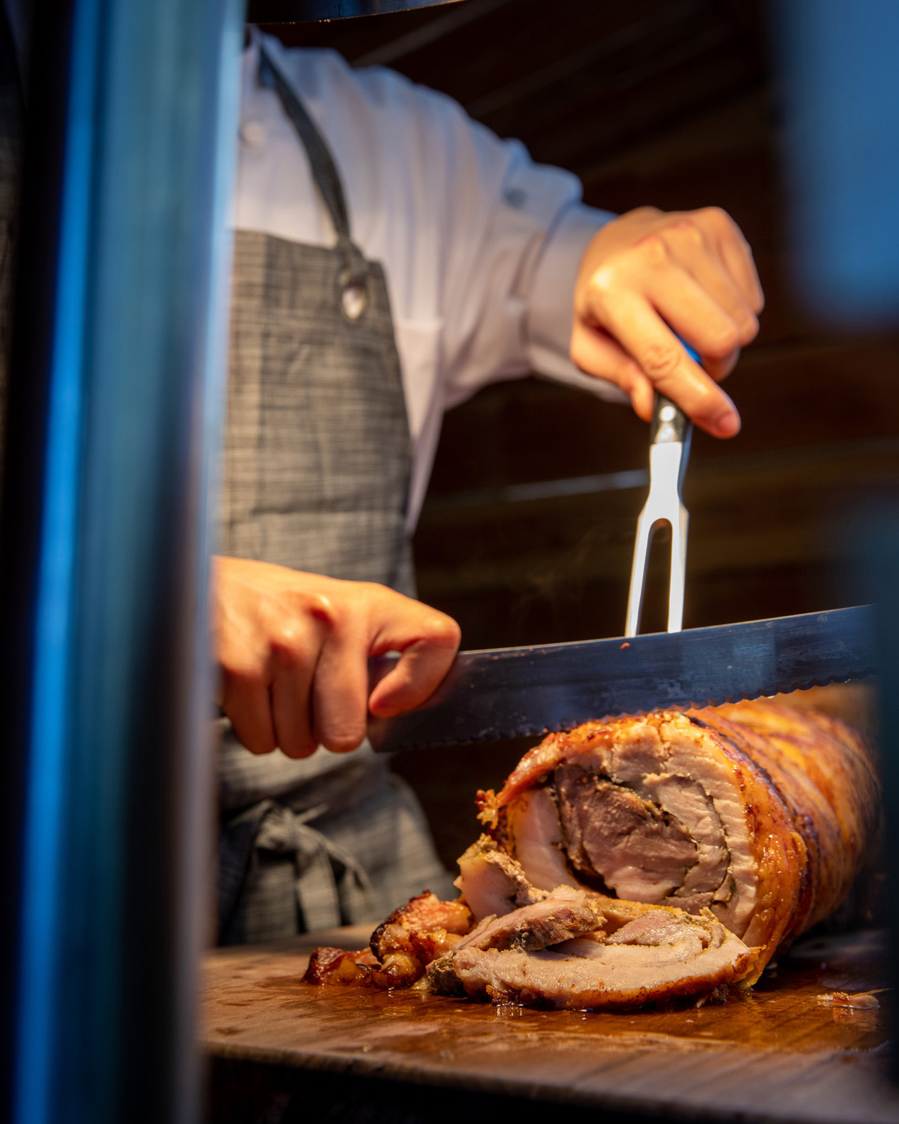 | 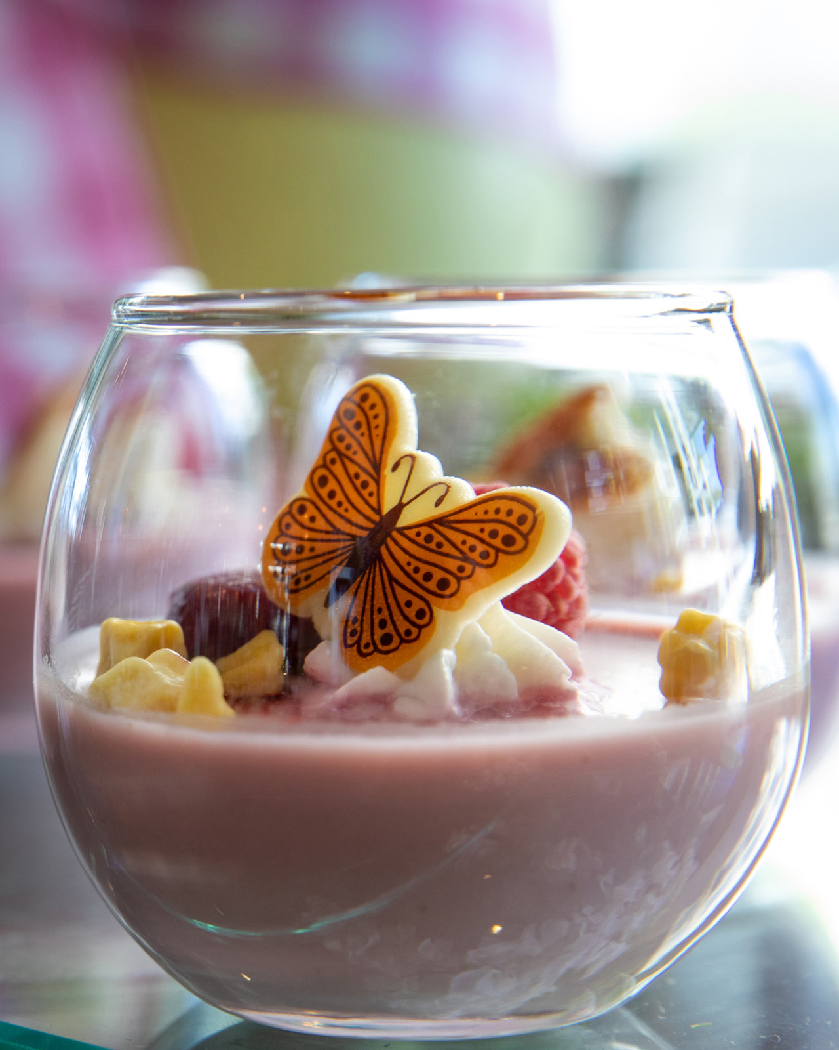 | 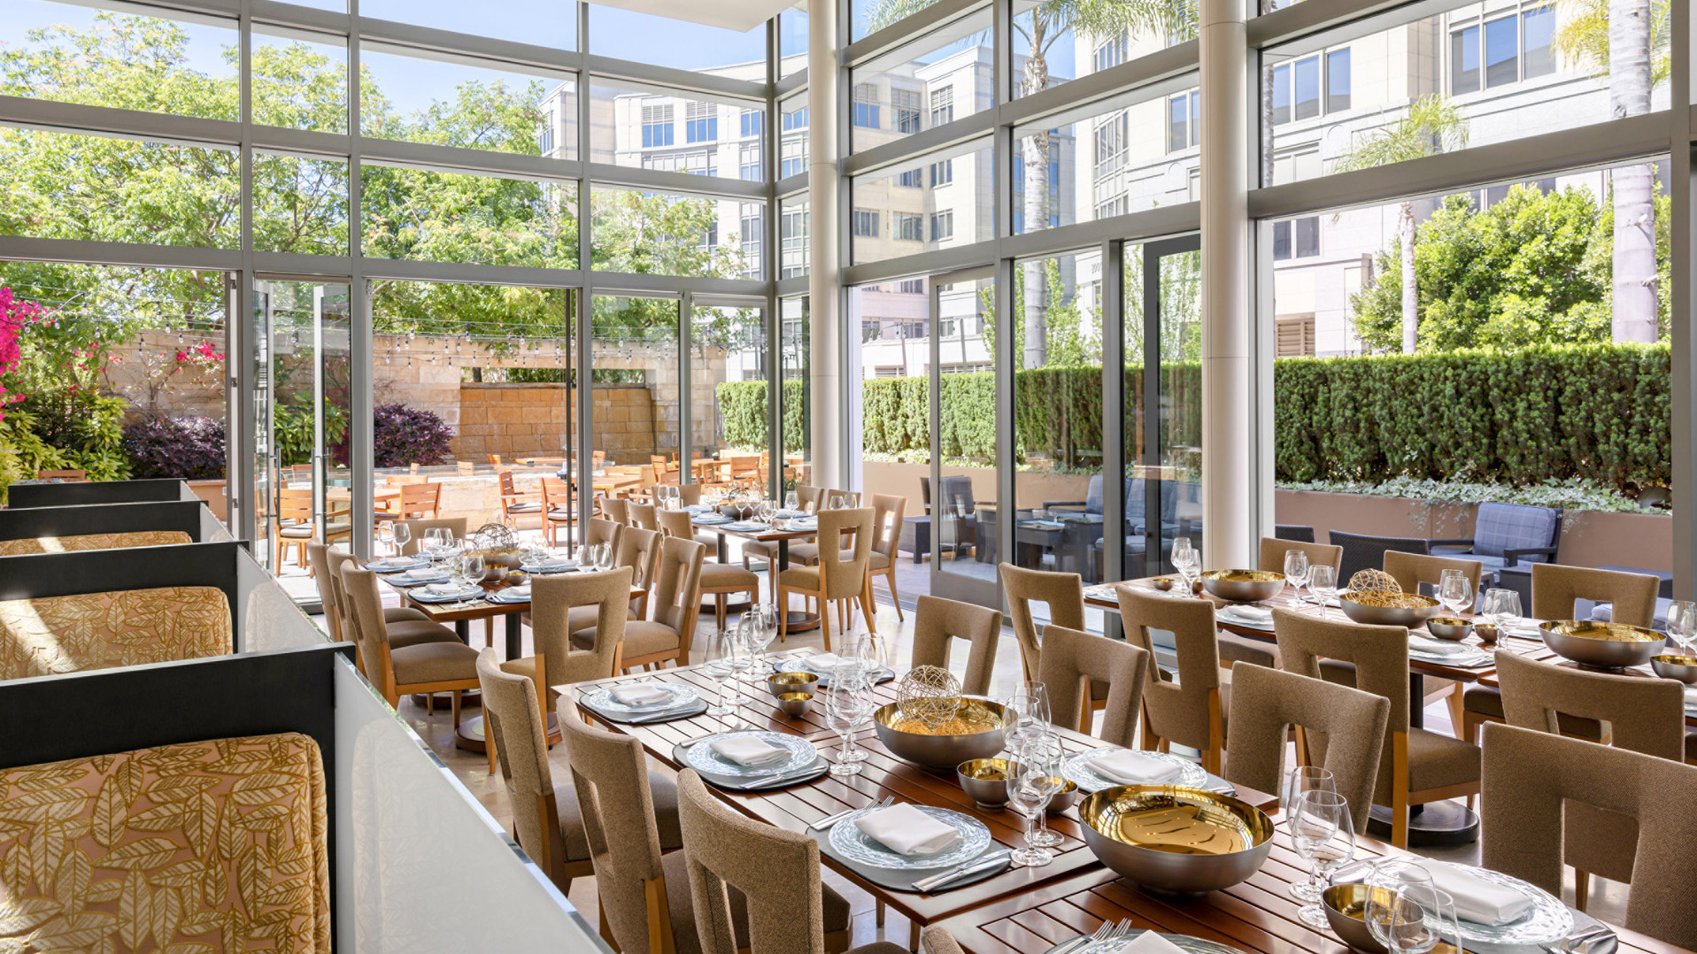
- April 9, 2023, 11:00 am to 7:00 pm
- USD 190 per person; with beverage package, USD 280 includes welcome cocktail and wine pairing; USD 70 per child
- Reservations may be made online

RELATED

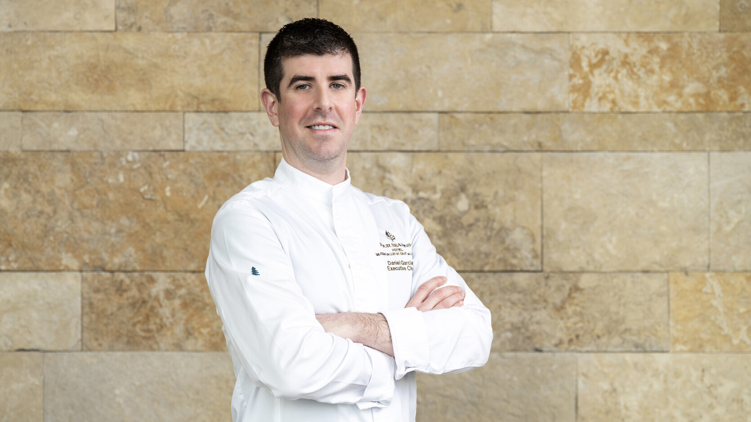 | February 23, 2023, Palo Alto, Silicon Valley, U.S.A.  Four Seasons Hotel Silicon Valley Announces the Appointment of Executive Chef Daniel Garcia  https://publish.url/siliconvalley/hotel-news/2023/new-executive-chef-daniel-garcia.html
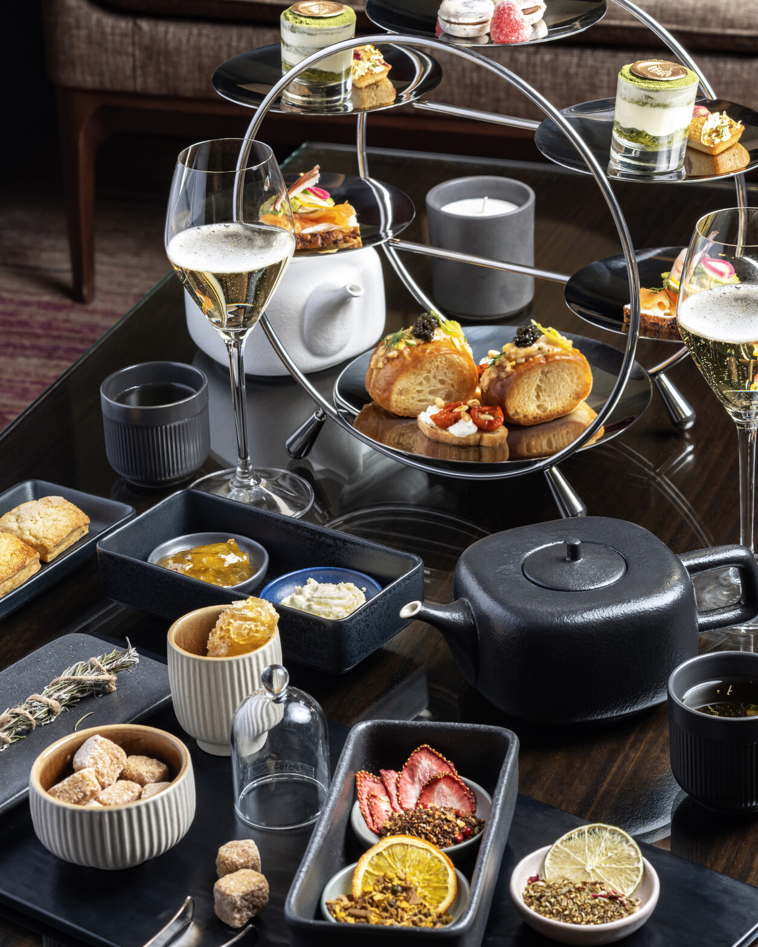 | February 23, 2023, Palo Alto, Silicon Valley, U.S.A.  3 H Afternoon Tea by Four Seasons Silicon Valley Celebrates Women’s History Month  https://publish.url/siliconvalley/hotel-news/2023/3-h-afternoon-tea.html

PRESS CONTACTS

Deepika Sarma
Director of Communications and Digital Marketing
2050 University Avenue
East Palo Alto
USA
deepika.sarma@fourseasons.com

+1 650 391 6611

