Unforgettable Family Moments: Discover the New Mini Maasai Adventure at Four Seasons Safari Lodge Serengeti

From Tinga Tinga paintings to shield-making and sound safaris, Serengeti Safari Lodge reveals new, educational kids’ activity program
February 27, 2019, Serengeti, Tanzania

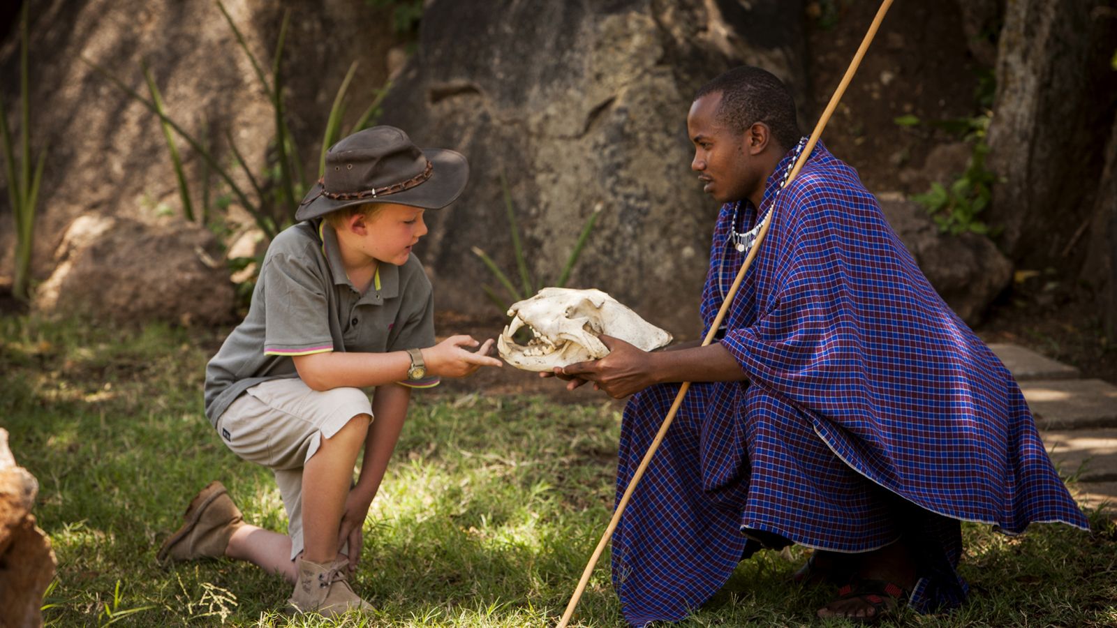
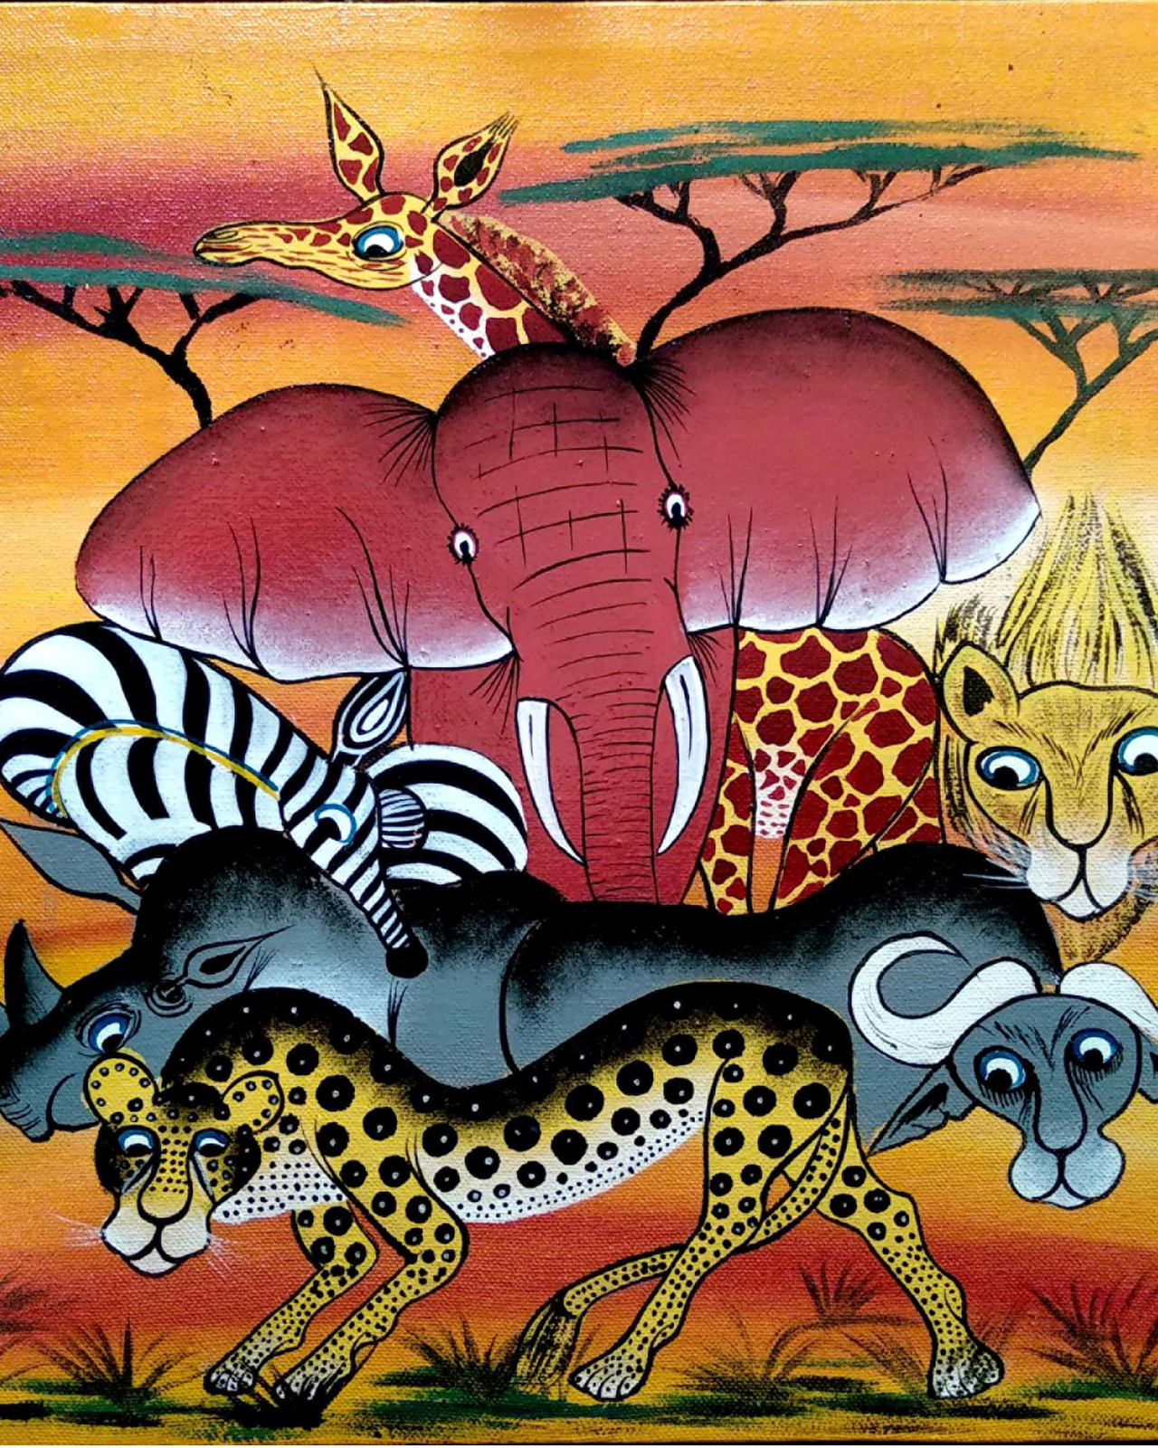 | 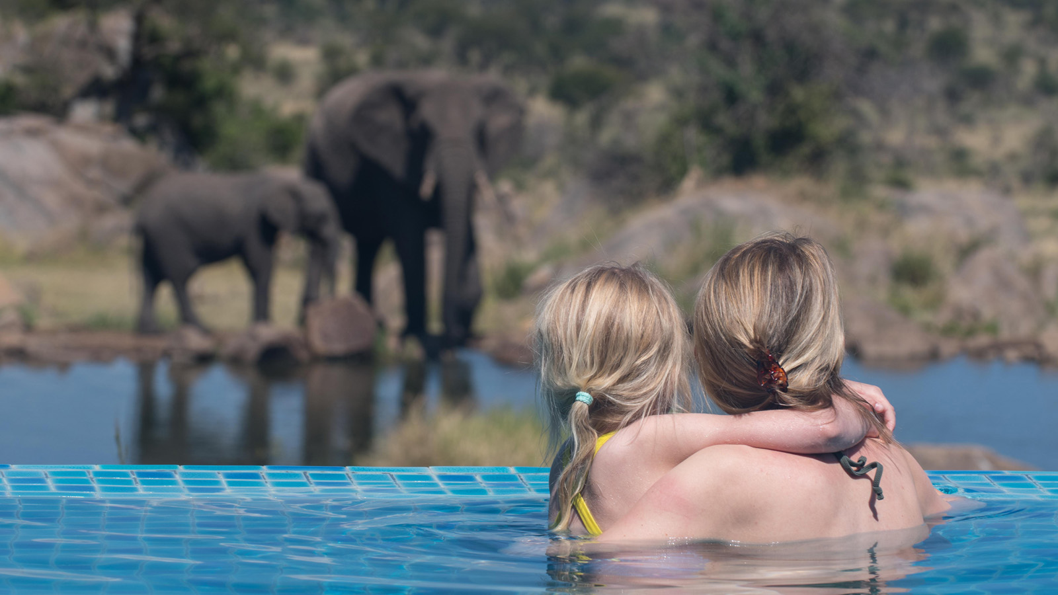 | 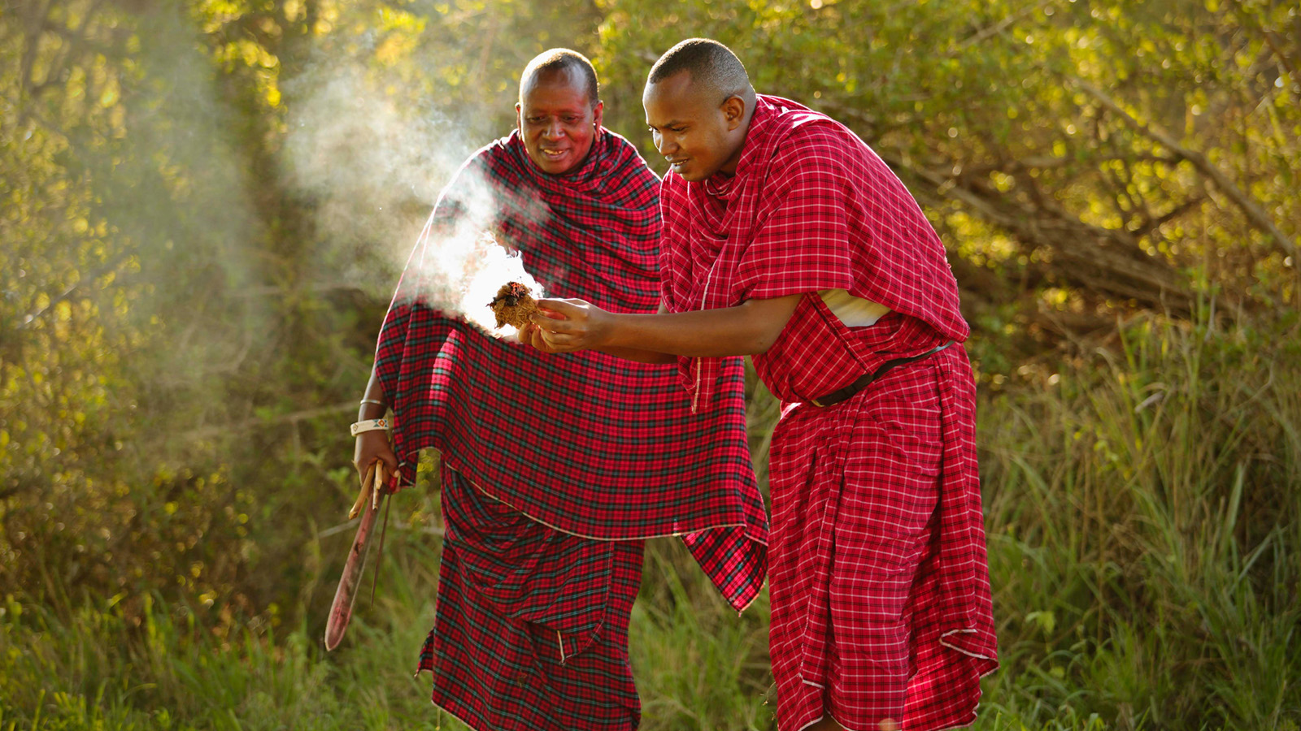
As the home of bucket-list adventure, Serengeti National Park draws travellers from around the world to witness unrivalled, up-close wildlife sightings that captivate every age of safari-goer. And now, to inspire young adventurers even further, Four Seasons Safari Lodge Serengeti is launching a new kids’ activity program, Mini Maasai Adventure.
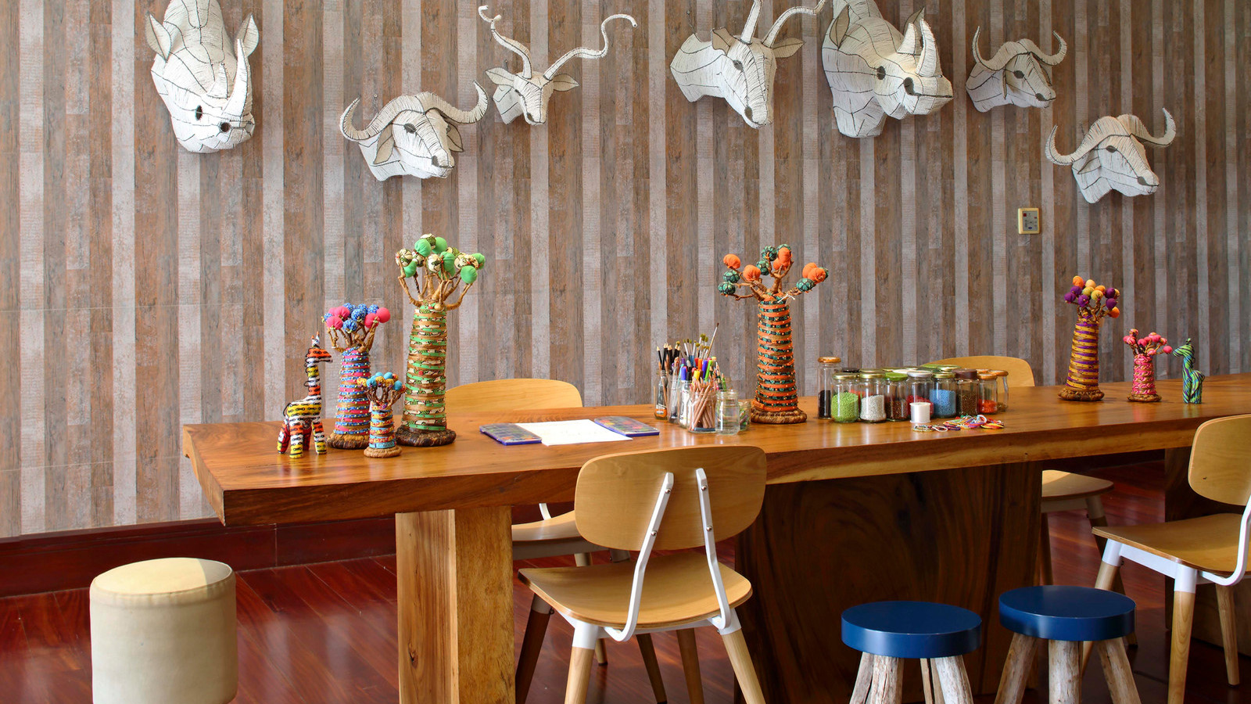
Led by the Lodge’s Kijana Kids’ Club and the Maasai Warriors working at Four Seasons, the new program consists of 10 different themes, ranging from wildlife discoveries to Maasai traditions, local crafts and artwork to keep children entertained at every stage of their safari adventure.
For each theme in the program, a “Did You Know?” fact shares insights and knowledge before a series of puzzles, activities and challenges are set out, with each child able to earn a stamp for every completed activity. Young guests collecting seven or more stamps during their stay will receive a prize. The Mini Maasai Adventure program is designed as a printed booklet to be shared with all children on arrival to the Lodge, with all artwork for the project having been designed by local artist Batromeo Jomeke, who will also be one of the Artists in Residence at the Lodge this year.
“I am very proud of our new Mini Maasai Adventure program,” says General Manager Martin Cody. “Families are a very important market for us and as such, we wanted to create a program that is not only fun for kids, but also allows them to engage with our team and learn about a wide variety of local traditions, as well as animal insights. With the range of content included in the program, there is something to appeal to all age groups, while we also hope the booklet itself will become a treasured keepsake of their time with us in Serengeti.”
Sample activities within Mini Maasai Adventure include:
- Tinga Tinga painting - Named after the original Tanzanian painter Edward Tingatinga, this artwork style captures the beauty of local nature in a distinct, bright and colourful manner and children are challenged to create their own animal drawing in this style.
- Fire-starting with elephant dung – The Maasai reveal how they start fires in the savannah using traditional techniques, before children have a chance to beat the Maasai record of 24 seconds for being able to start a fire in this way.
- Maasai beats – Maasai music does not involve any instruments other than the human voice. Children are able to discover the techniques behind mastering the grunt-like rhythms and hypnotic vibrations ahead of donning a traditional Maasai shuka cloth for a trial performance.
The new Mini Maasai Adventure program is offered through the Kijana Kids’ Club at Four Seasons Safari Lodge Serengeti, which is open daily from 10:00 am to 6:00 pm for children aged 2–17 years. The raised walkways throughout the Lodge offer peace of mind to families on safari, while the range of interconnecting rooms, spacious Suites and free-standing Villas, plus children’s menus and dedicated activities allow for flexibility and comfort for families of all sizes.

RELATED

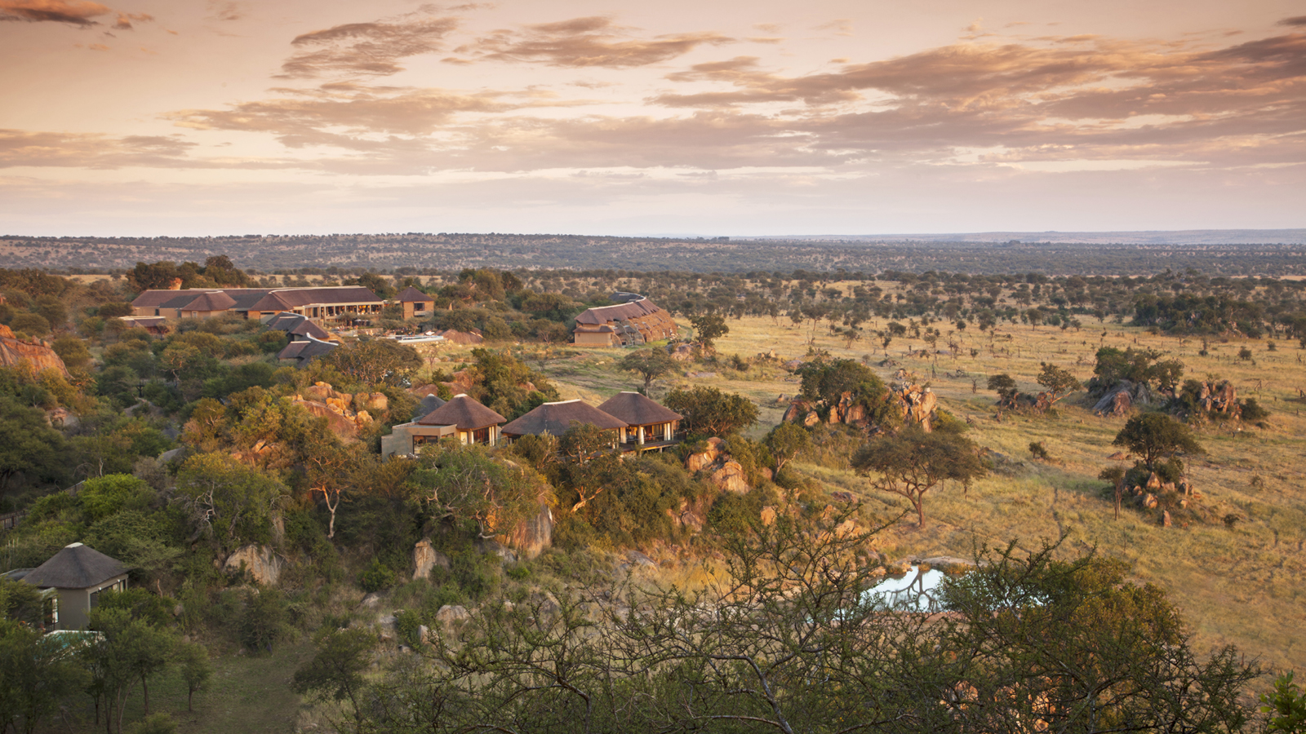 | February 12, 2019, Serengeti, Tanzania  New Artist in Residence Program Revealed by Four Seasons Safari Lodge Serengeti  https://publish.url/serengeti/hotel-news/2019/artist-in-residence-program.html
November 16, 2018, Serengeti, Tanzania
Justin Stevens Named Resort Manager at Four Seasons Safari Lodge Serengeti
https://publish.url/serengeti/hotel-news/2018/new-resort-manager-justin-stevens.html

PRESS CONTACTS

Debbie Duval
Senior Director of Public Relations and Communications

Beau Champ
Mauritius
debbie.duval@fourseasons.com

(230) 402 3100

