A Thriving Culinary Scene

July 12, 2022, Baltimore, U.S.A.

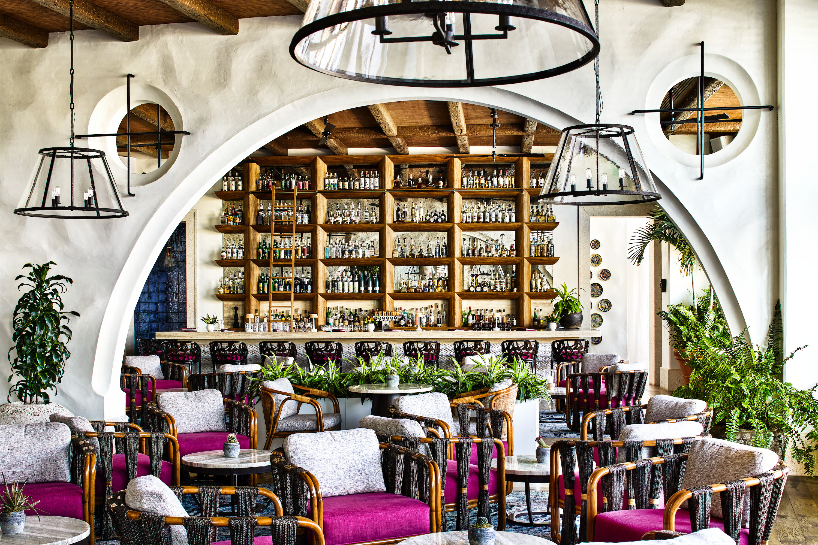
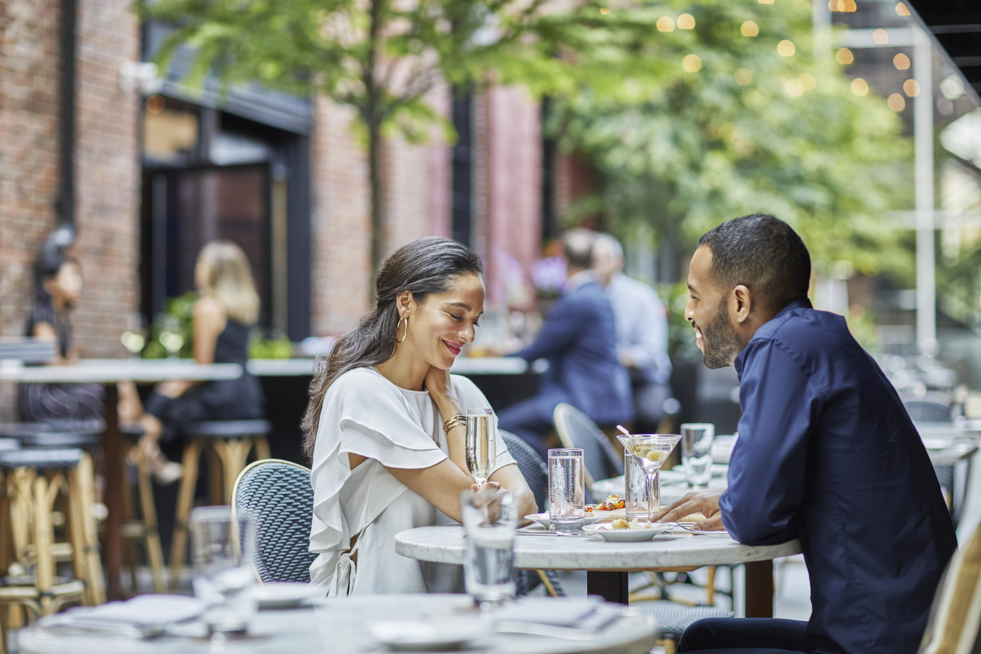 | 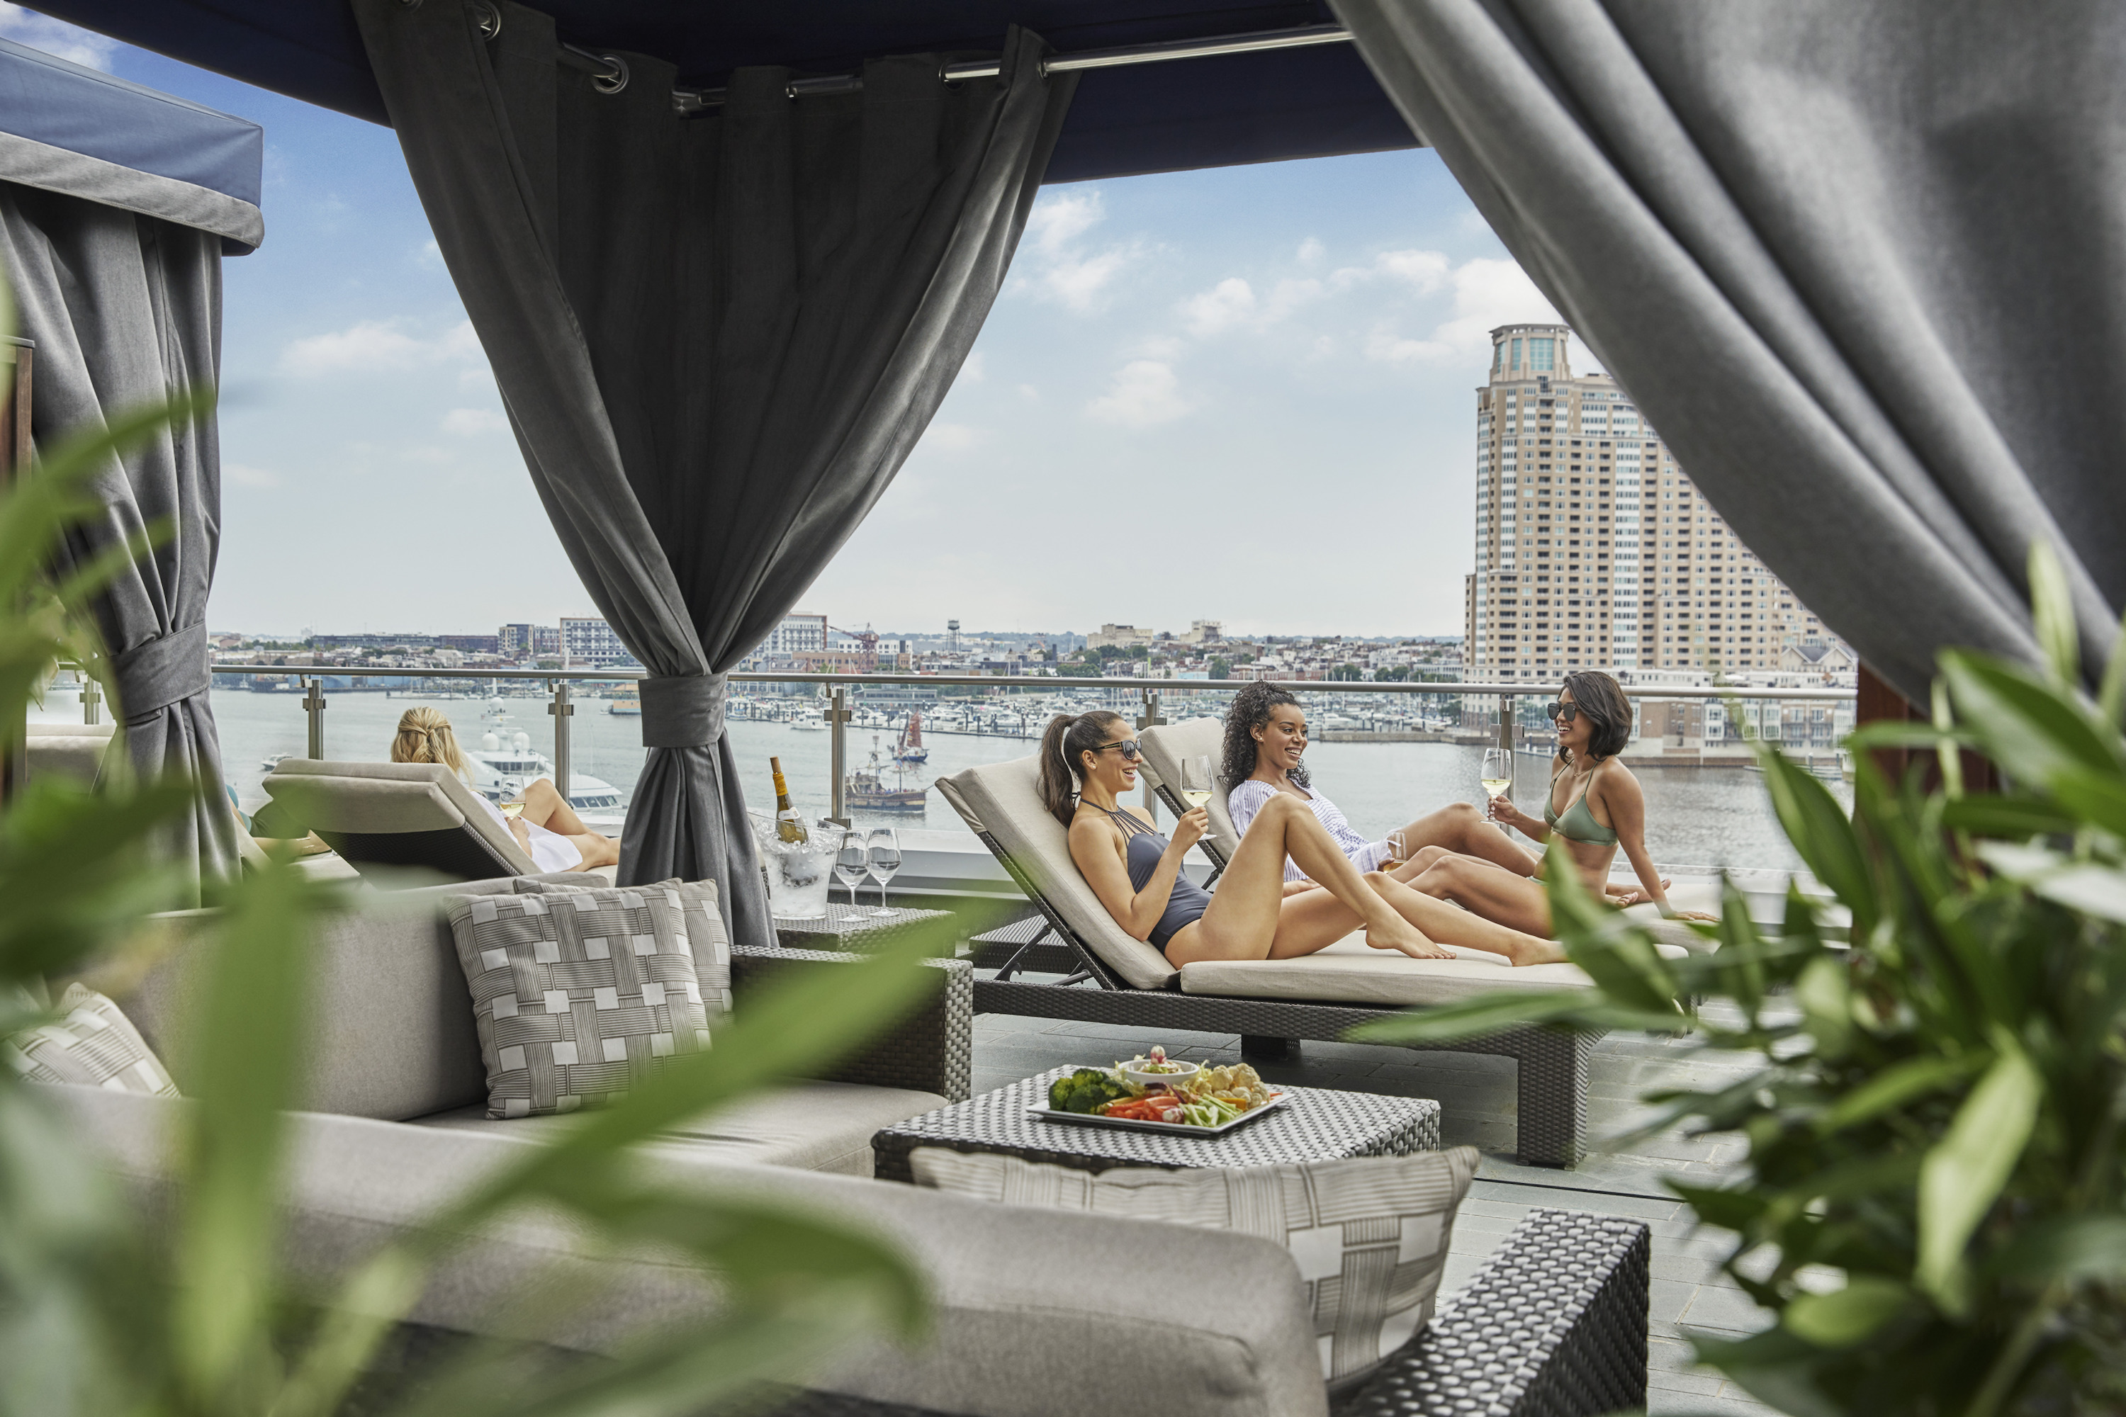 | 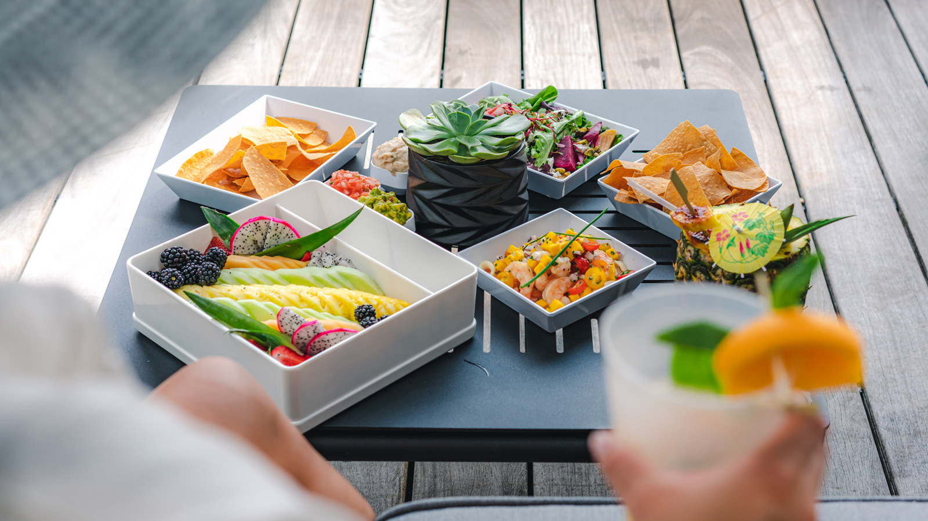
Immerse yourself in Baltimore’s remarkable culinary scene at Four Seasons Hotel Baltimore:
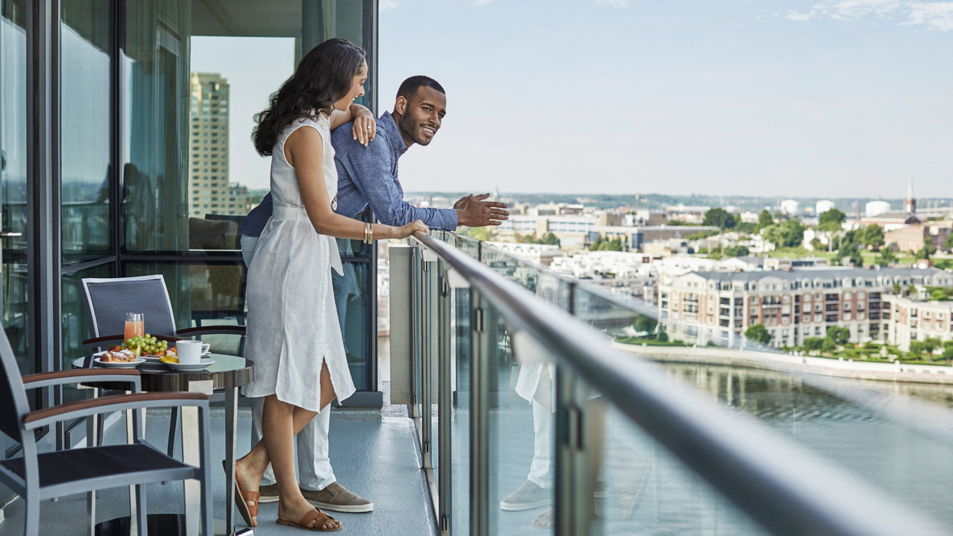
Maximón - Contemporary South American and Mexican‑inspired cuisine complete with stunning harbour views and elevated Spanish‑style courtyard surroundings.
The Bygone - Located atop the Hotel on the 29th floor, The Bygone pays homage to the roaring ’20s with indulgent foods and cocktails accompanied by unrivalled panoramic views of the city and historic Inner Harbor.
Loch Bar- A classic seafood tavern featuring one of the region’s largest raw bars, complemented by one of the most substantial whiskey menus in all of Baltimore. It also offers a wide selection of local craft beers and handcrafted cocktails.
Azumi - An authentic Japanese menu with a focus on sushi flown in fresh daily from Tokyo’s Tsukiji Market. To complement the food menu, the beverage program includes a masterfully curated selection of sake, the region’s largest Japanese whisky list, and handcrafted cocktails reflecting Japanese inspiration.
Al Fresco Dining - All four dining venues offer a perfect setting for outdoor dining. Reservations can be made via OpenTable and are available when weather permits. If outdoor dining is a preference during your stay, please reference it in your booking comments and our team will do our best to accommodate your request.
Splash Pool Bar & Grill - Spend your afternoon relaxing by our rooftop infinity-edge pool and enjoy lunch delivered directly to your lounge chair or private cabana. The bar and grill are open seasonally.
In-Room Dining - Savour a meal any time of day in the comfort of your own guest room with 24-hour in-room dining. Choose from a selection of offerings from our talented culinary team or late-night bites and breakfast favourites. How to order: Pre-order your meal via Chat on the Four Seasons mobile app or by your guest room phone. Our team will have your meal delivered to your doorstep for a truly effortless dining experience. Contactless delivery is also available upon request.

RELATED

June 24, 2022, Baltimore, U.S.A.
Set Sail with Four Seasons Hotel Baltimore
https://publish.url/baltimore/hotel-news/2022/catarmaran-cruises.html

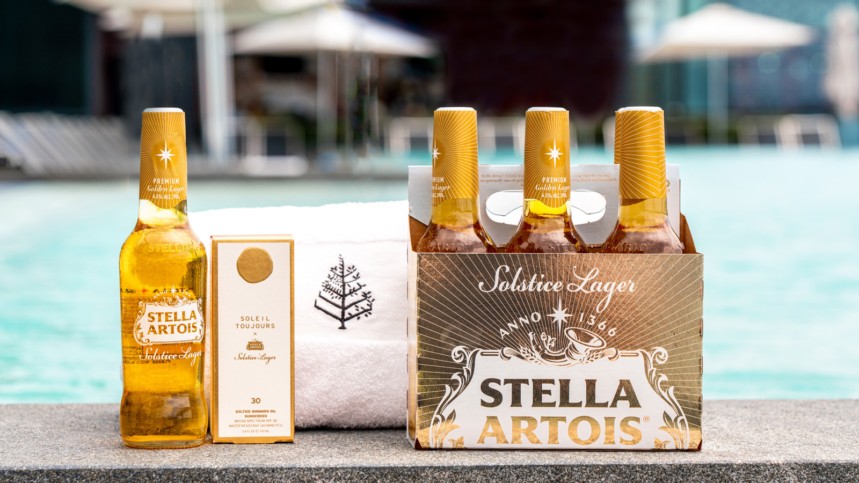 | June 14, 2022, Baltimore, U.S.A.  Savour the Summer with Stella Artois’ and Soleil Toujours’ Latest Collab at Four Seasons Hotel Baltimore  https://publish.url/baltimore/hotel-news/2022/summer-solstice-spa-experience.html

PRESS CONTACTS

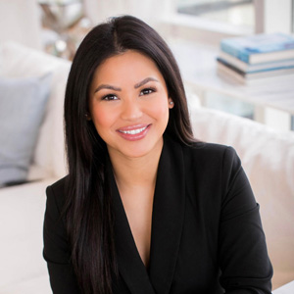 | Christina Criss  Director of Public Relations  200 International Drive  Baltimore  USA  christina.criss@fourseasons.com  +1 410 223 1343

