Four Seasons Resorts Hawaii and Four Seasons Resort Bora Bora Bring Global Wellness Day, June 13, 2020 into Homes of Guests Across the World

Craftspeople from each Resort share their expertise for living well at home, inspired by the tropical destinations of the six diverse Pacific island Four Seasons resorts
June 3, 2020, Toronto, Canada

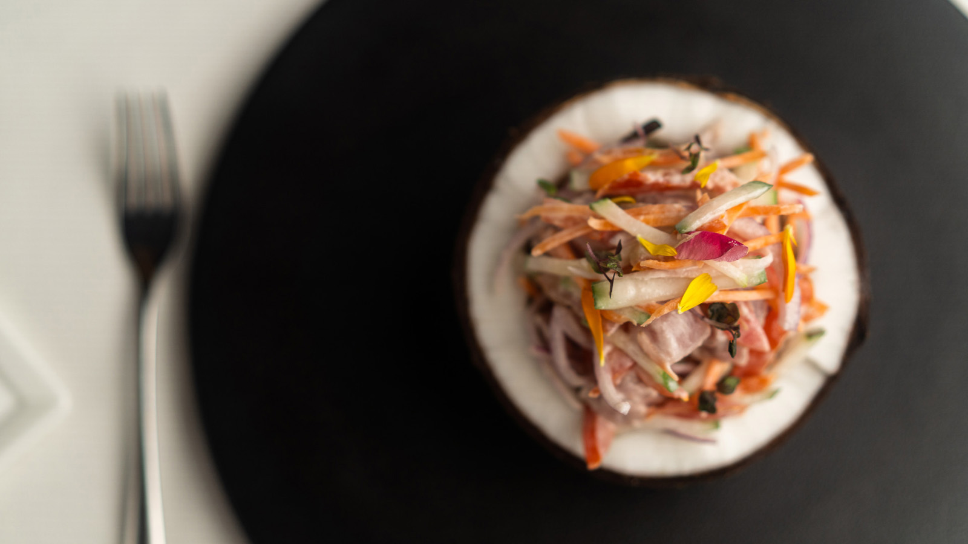 | 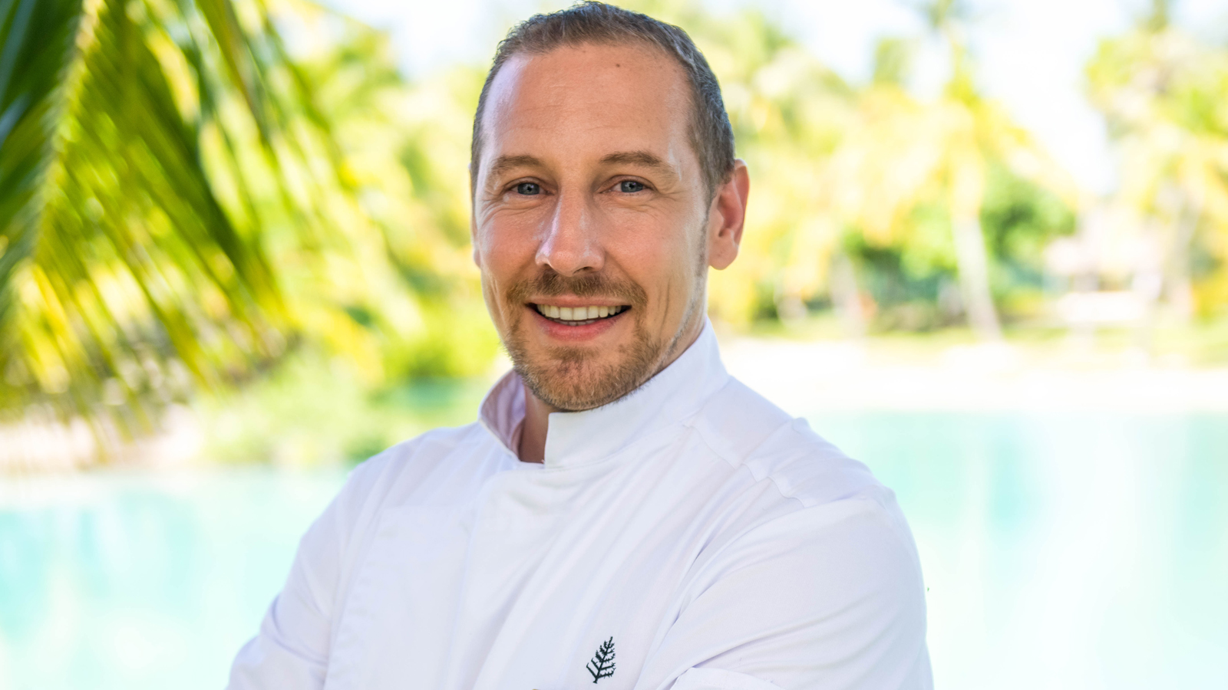

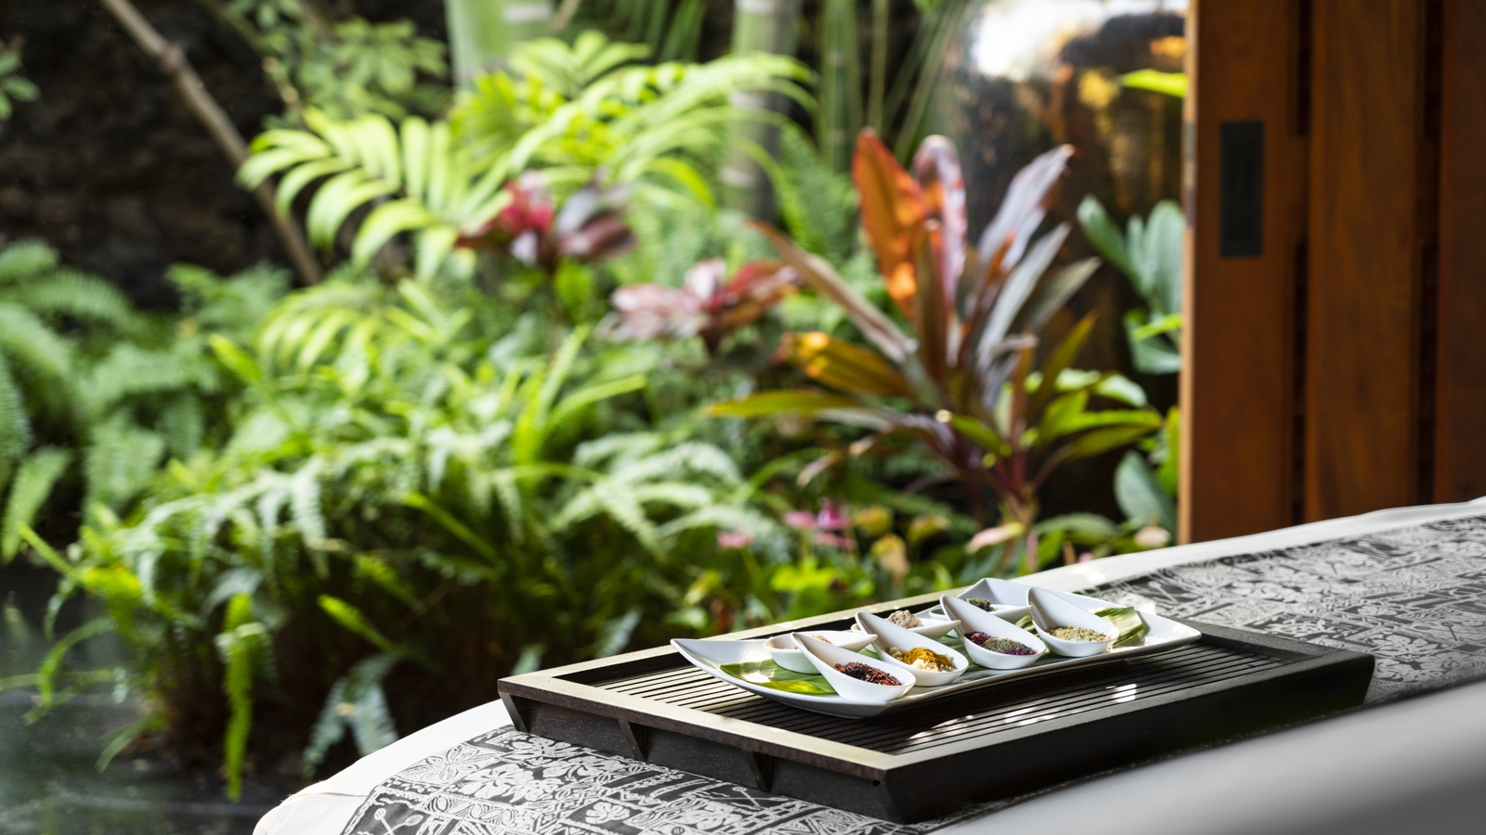 | 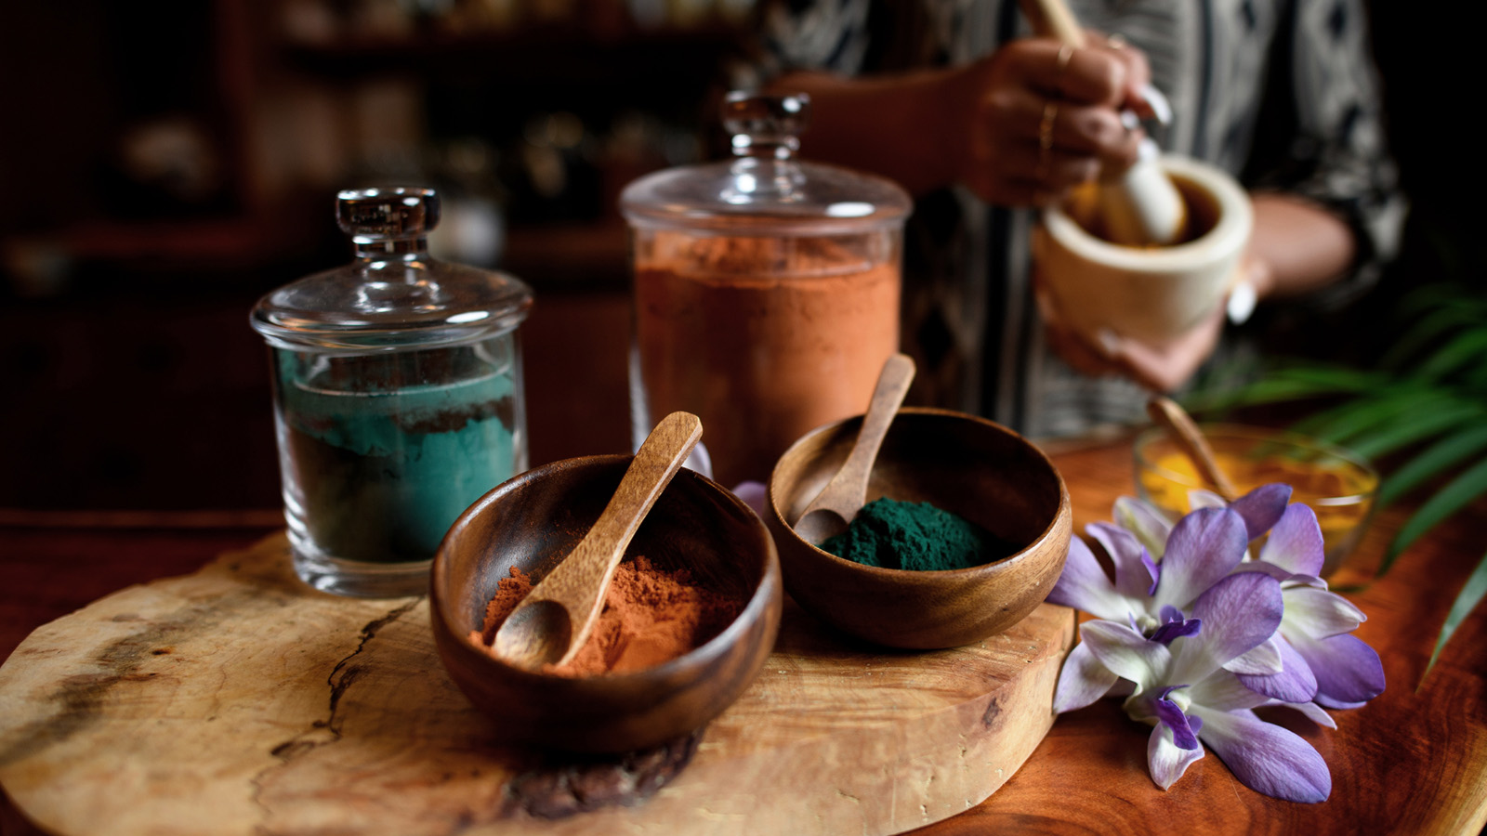

RELATED

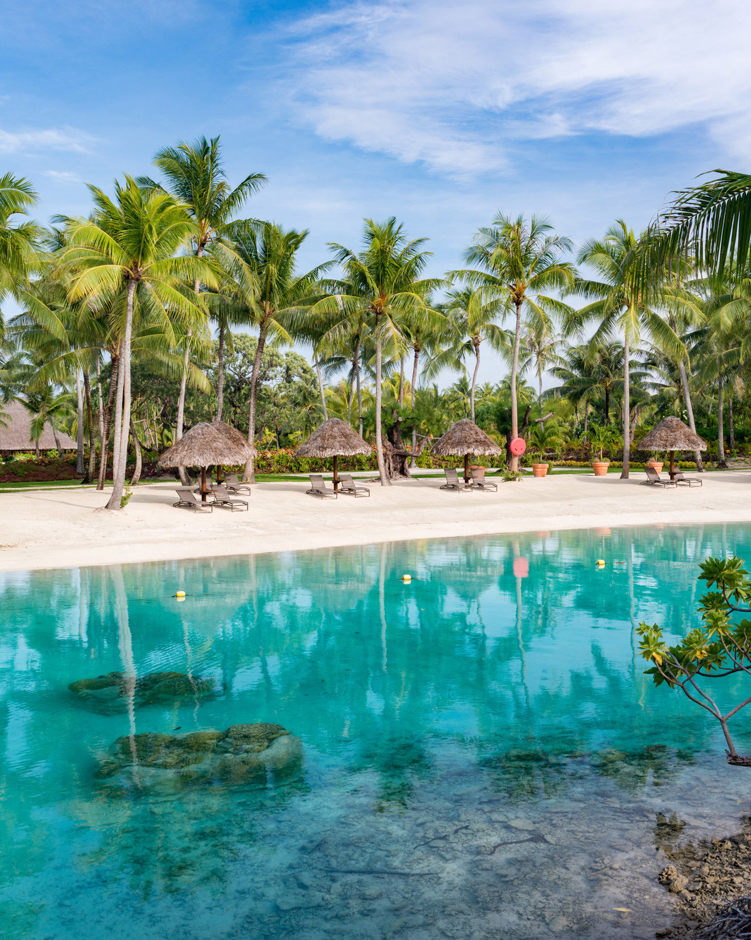 | December 17, 2020, Bora Bora, French Polynesia  Four Seasons Resort Bora Bora Announces Partnership with WiseOceans  https://publish.url/borabora/hotel-news/2020/wiseoceans-partnership.html
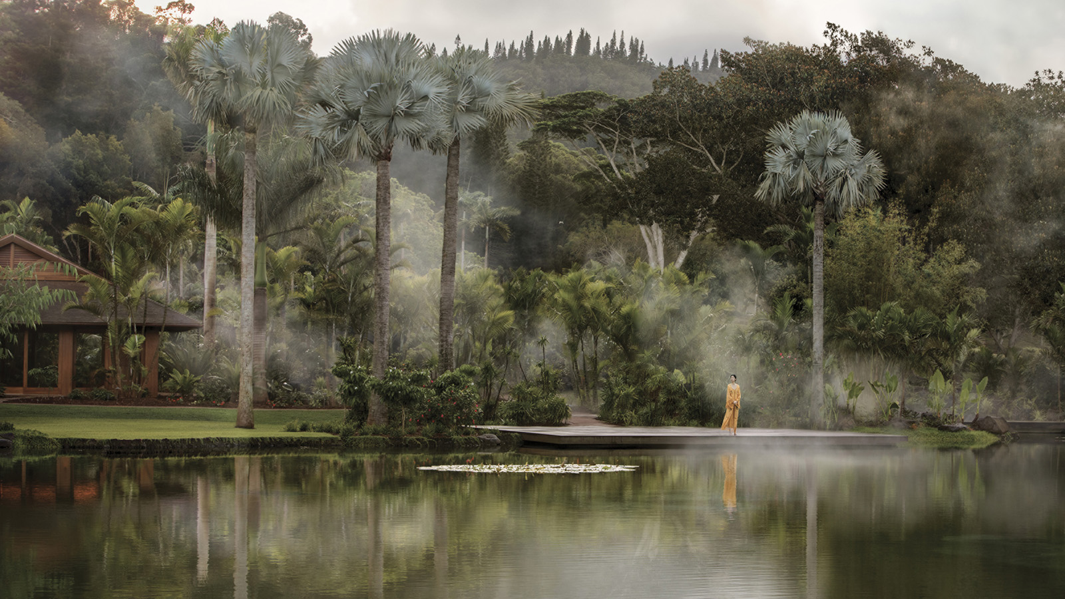 | December 14, 2020, Hawaii, Lanai (Sensei), U.S.A.  Sensei Lanai, A Four Seasons Resort Named to Condé Nast Traveler's Gold List 2021  https://publish.url/sensei/hotel-news/2020/cnt-gold-list.html

PRESS CONTACTS

Morgan Suzuki
Regional Director of Public Relations and Communications
72-100 Ka'upulehu Drive
Kailua Kona
USA
morgan.suzuki@fourseasons.com

1 808 557 5909

Brad Packer
Director of Public Relations
350 South Beverly Drive, Suite 100
Beverly Hills
USA
brad.packer@fourseasons.com

+1 310 712 1493

