A Dubai Favourite, SUQ Brunch at Four Seasons Resort Dubai at Jumeirah Beach Returns in Time for Garden Weather

The elegant brunch presents a rich buffet, live entertainment and a new kids corner
September 28, 2021, Dubai, U.A.E.

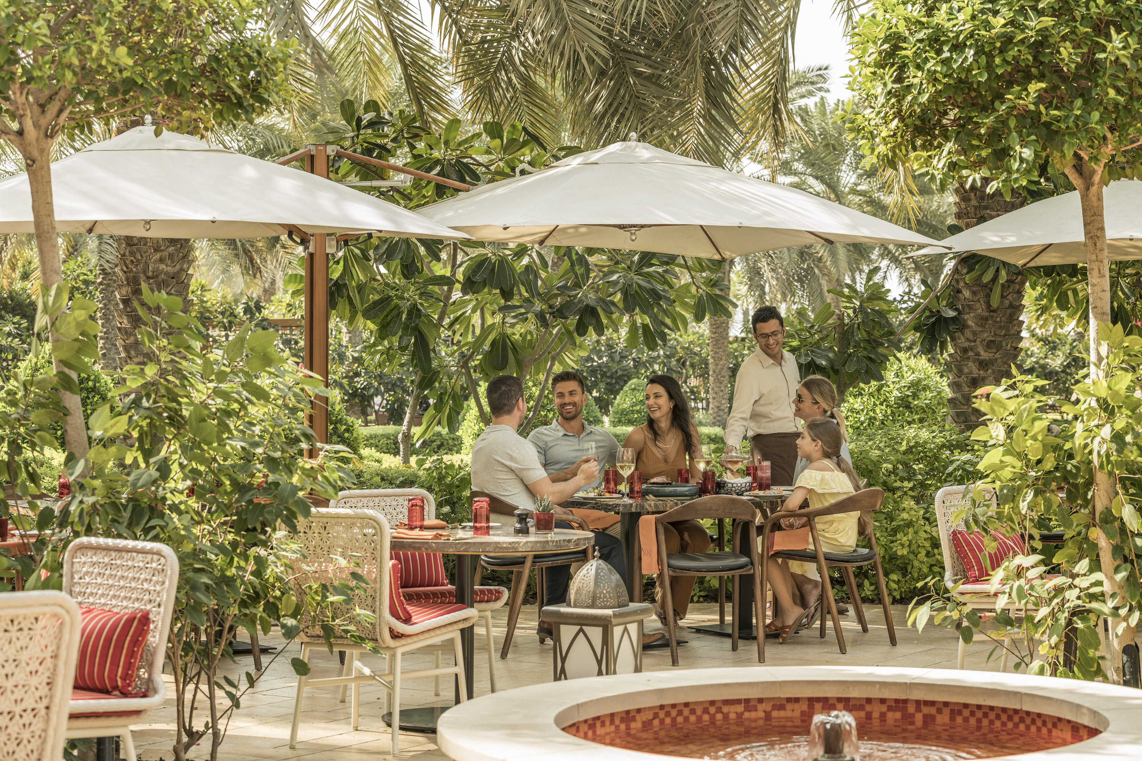
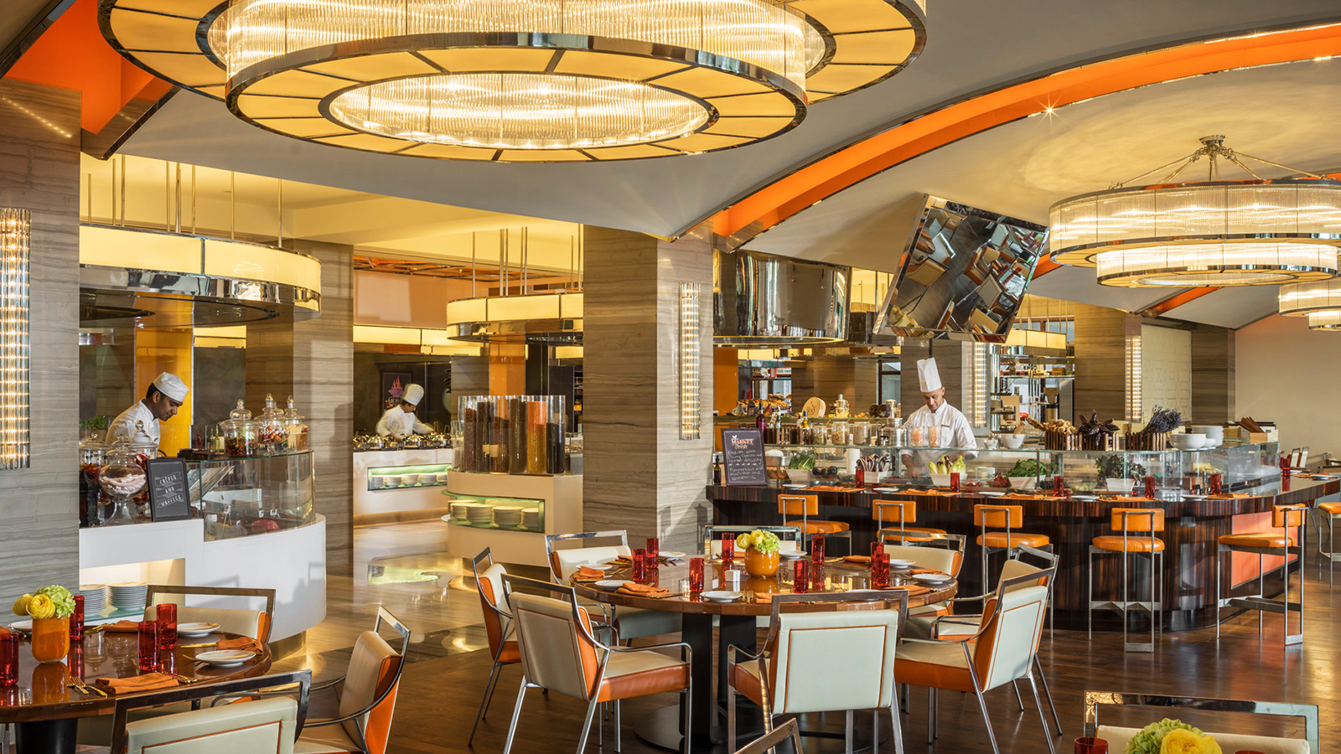 |  | 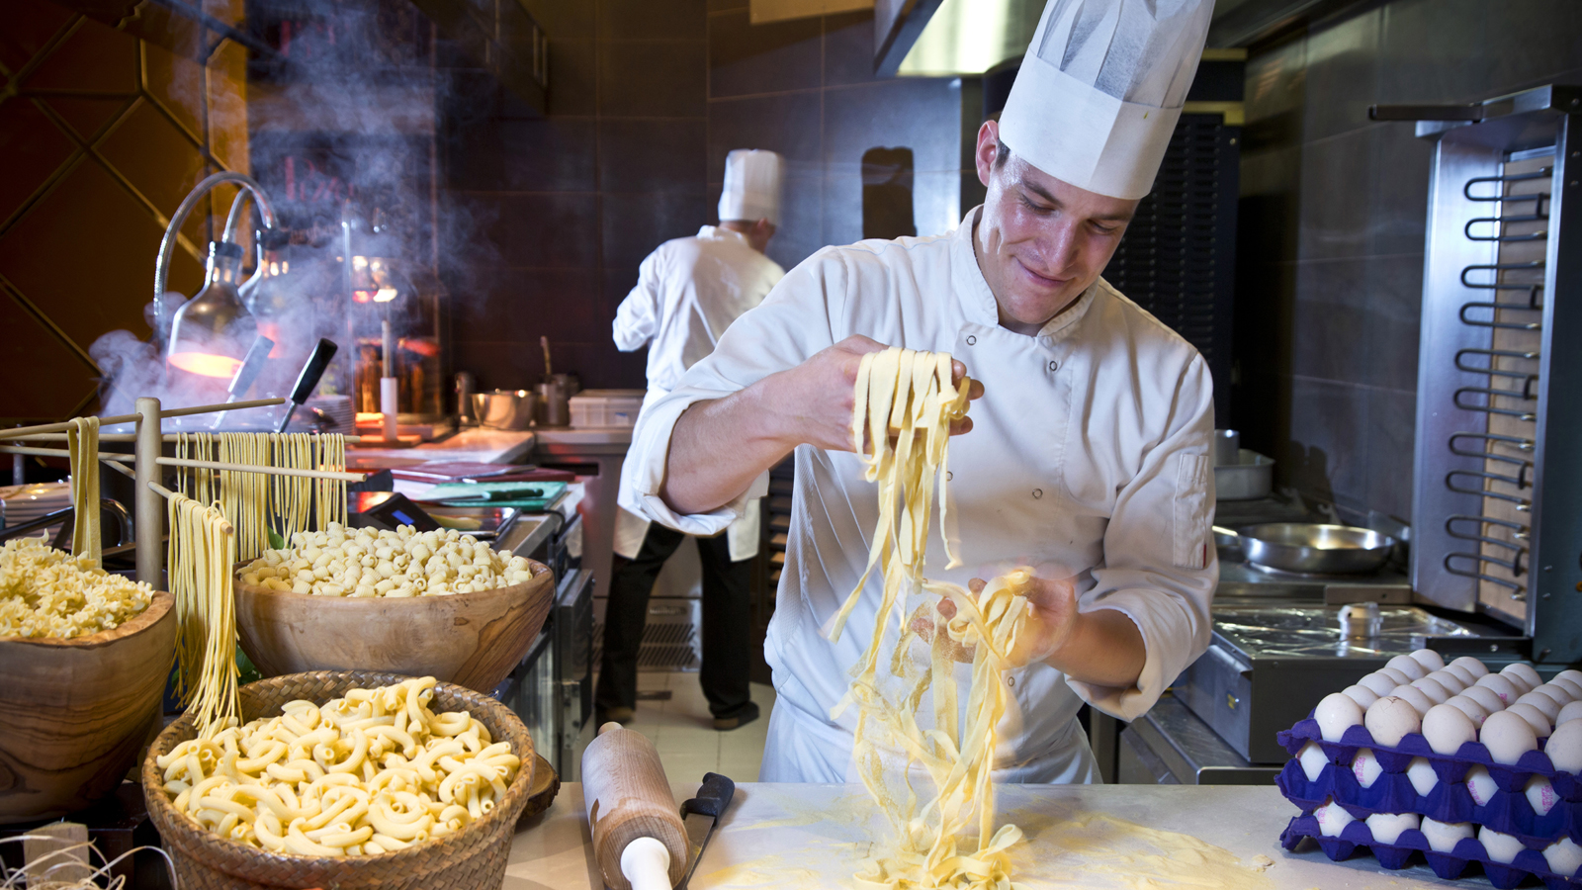
Four Seasons Resort Dubai at Jumeirah Beach is relaunching Friday Brunch at SUQ on October 1, 2021.
The iconic marble staircase at Four Seasons Resort Dubai at Jumeirah Beach guides its guests right to the gateway of the property’s palatial Arabic market. SUQ’s international buffet of sushi, pasta, seafood and more welcomes guests and proudly boasts a pastry corner filled with Chef Nicolas Lambert’s world-renowned creations.
Within this sunshine-hued space, there is a seat for everyone. Music lovers can nestle themselves by the live band, solace seekers can find themselves on the restaurant’s lush green terrace. Parents can also enjoy the scene, yet remain in close proximity to their children by the new kid’s play corner.
Choose from the following brunch packages:
- AED 400 – Including soft beverages
- AED 530 – Including house beverages
- AED 750 – Including bubbly
- AED 190 – Kids package (aged 6 to 12)

RELATED

January 12, 2022, Dubai, U.A.E.
Four Seasons Resort Dubai at Jumeirah Beach and Celebrity Chef Matthew Kenney Launch a New Menu of Plant-Based Masterpieces at Folia
https://publish.url/dubai/hotel-news/2022/new-plant-based-dishes-at-folia.html

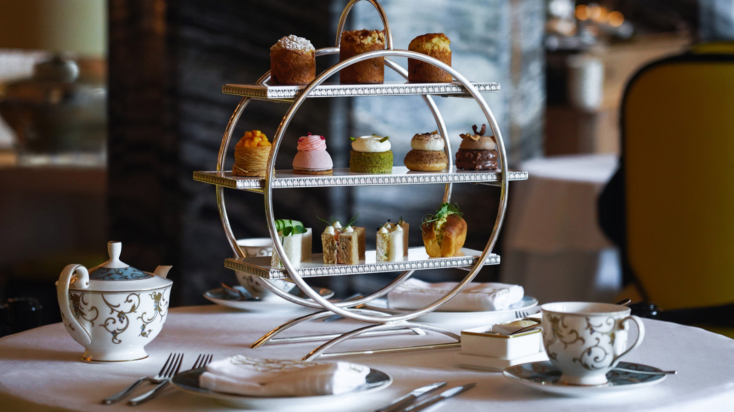 | January 6, 2022, Dubai, U.A.E.  Classic Is Classy: Four Seasons Resort Dubai at Jumeirah Beach Announces a Launch of New Afternoon Tea  https://publish.url/dubai/hotel-news/2022/new-afternoon-tea-at-shai-salon.html

PRESS CONTACTS

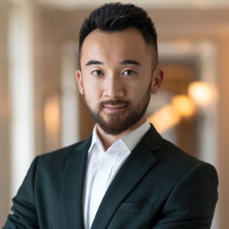 | Mazhit Ismailov  Senior Director of PR and Communications  Jumeirah Road  Dubai  United Arab Emirates  mazhit.ismailov@fourseasons.com  + 971 4 270 7723
Ghaith Adnan
Public Relations and Marketing Manager
Jumeirah Road
Dubai
United Arab Emirates
ghaith.adnan@fourseasons.com

+ 971 4 270 7884

