Reasons to Choose the Presidential Villa at Four Seasons Safari Lodge Serengeti

March 31, 2015, Serengeti, Tanzania

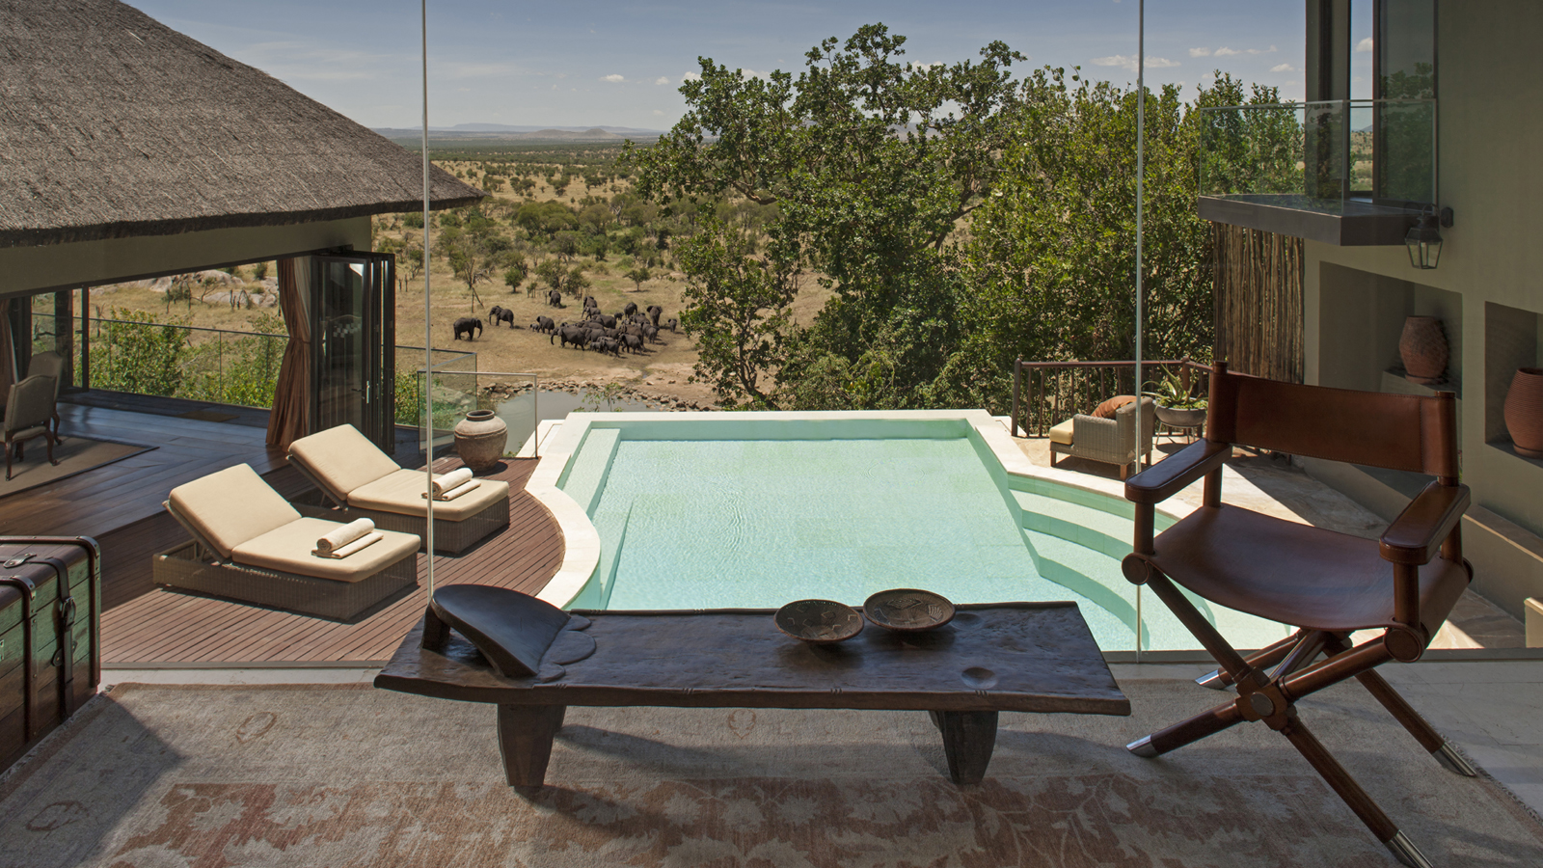
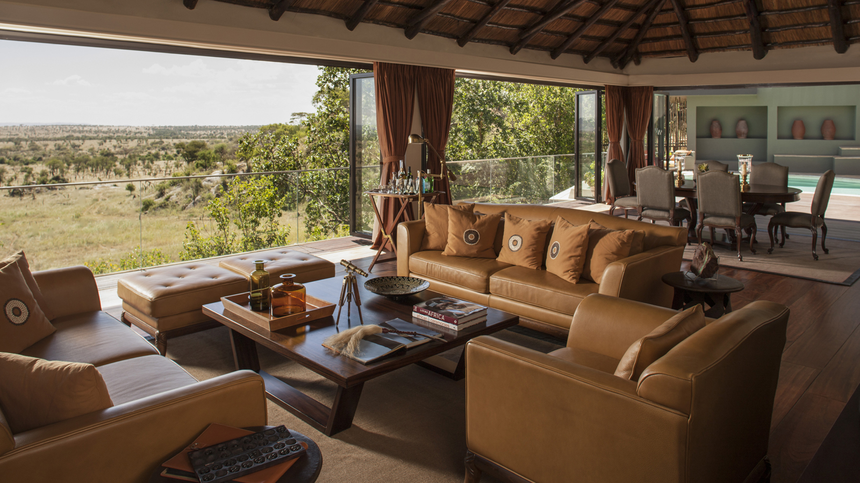 | 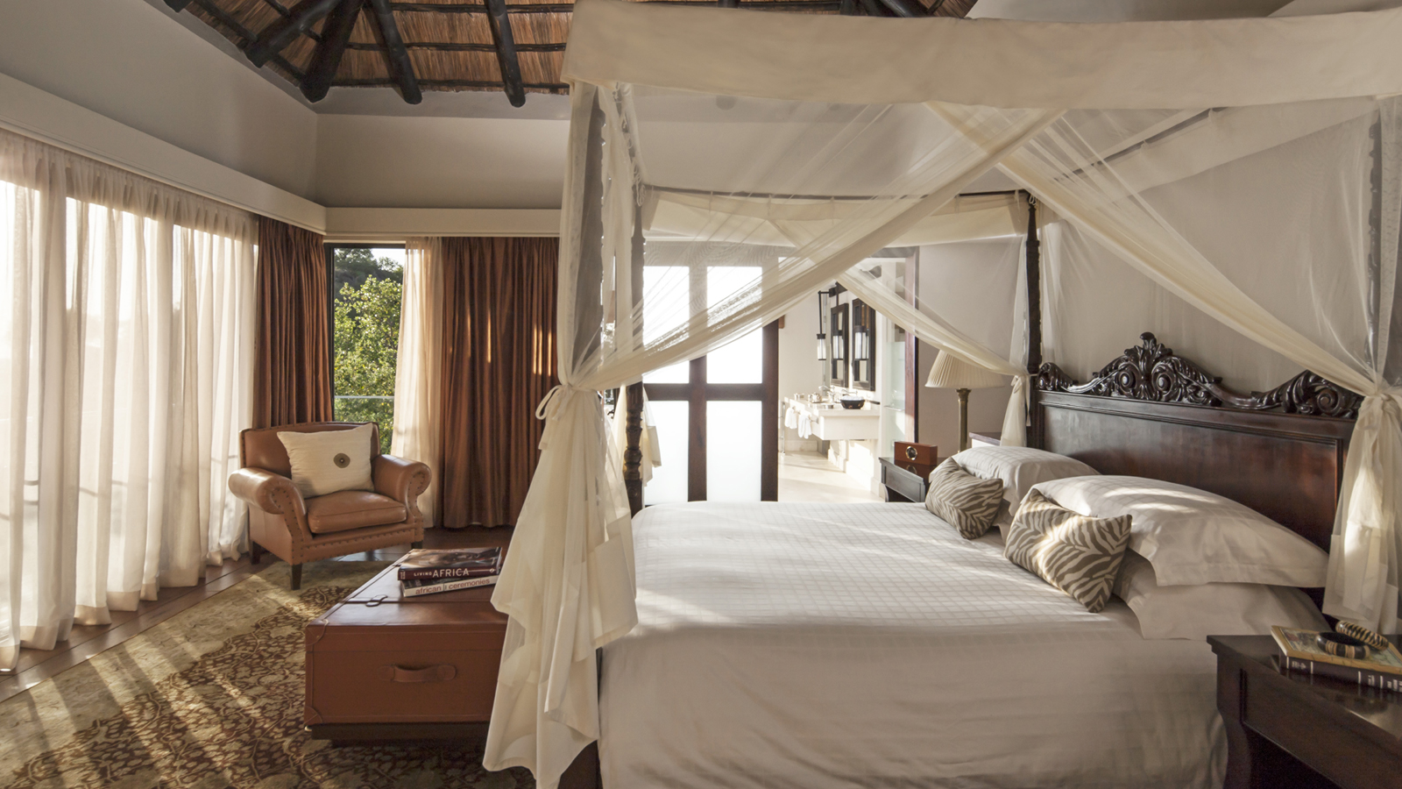 | 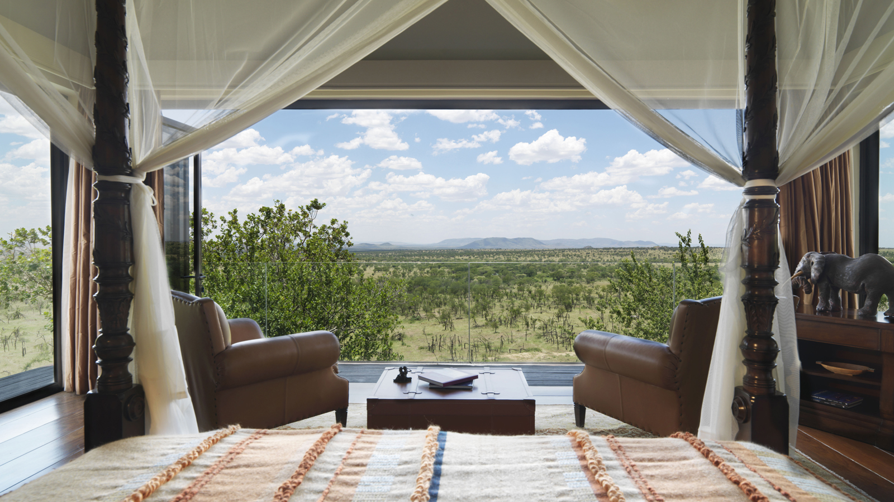
Luxurious and welcoming, the unique Presidential Villa at
Four Seasons
Safari Lodge Serengeti is no ordinary accommodation. Offering direct and exclusive views of its own animal watering hole, the villa features three bedrooms, three bathrooms with deep soaking tubs, one powder room, a full kitchen, dining room, living room, indoor and outdoor shower facilities and a private gym. The 2,605 square foot (242 square metre) Presidential Villa is an idyllic base for groups and families seeking the very best experience of the Serengeti wildlife.
- The views – Guests are within nose-rubbing distance of the family of elephants that are often seen outside of the villa. The Presidential animal watering hole allows guests to watch the congregating wildlife from their private infinity-edge swimming pool, with the Serengeti Plains providing a spectacular backdrop.
- The location –
Four Seasons
Safari Lodge Serengeti is the only luxury resort in central Serengeti. As such, the Presidential Villa is the finest first-class villa accommodation found in north Tanzania. With all the luxuries expected from a
Four Seasons
resort, guests can truly indulge in all that one of the Seven Natural Wonders of Africa has to offer, exploring the plethora of game reserves and the Serengeti National Park, and bearing witness to the unique experience that is the largest land mammal migration in the world.
- The extensive accommodation – The coveted Four Seasons sleep experience begins with the design of all guestrooms and villas, which are created as true sleeping sanctuaries, with double-walled windows for soundproofing, in-room temperature controls, blackout shades and the finest-quality bedding. Known around the globe for its famously comfortable beds,
Four Seasons
is committed to helping guests achieve the perfect slumber. The spacious Presidential Villa at
Four Seasons
Safari Lodge Serengeti comfortably sleeps six people in one master bedroom and two further bedrooms.
- The service – Occupants of the Presidential Villa are waited on hand and foot, with exclusive Butler Service available. The Butlers are on hand to cater to guests’ every need, including arranging bespoke evenings at the Presidential Villa’s exclusive private viewing decks, a menu of personalised culinary specialities to enjoy in the private dining room, or the relaxation of bespoke spa treatments in the comfort and privacy of the villa.

RELATED

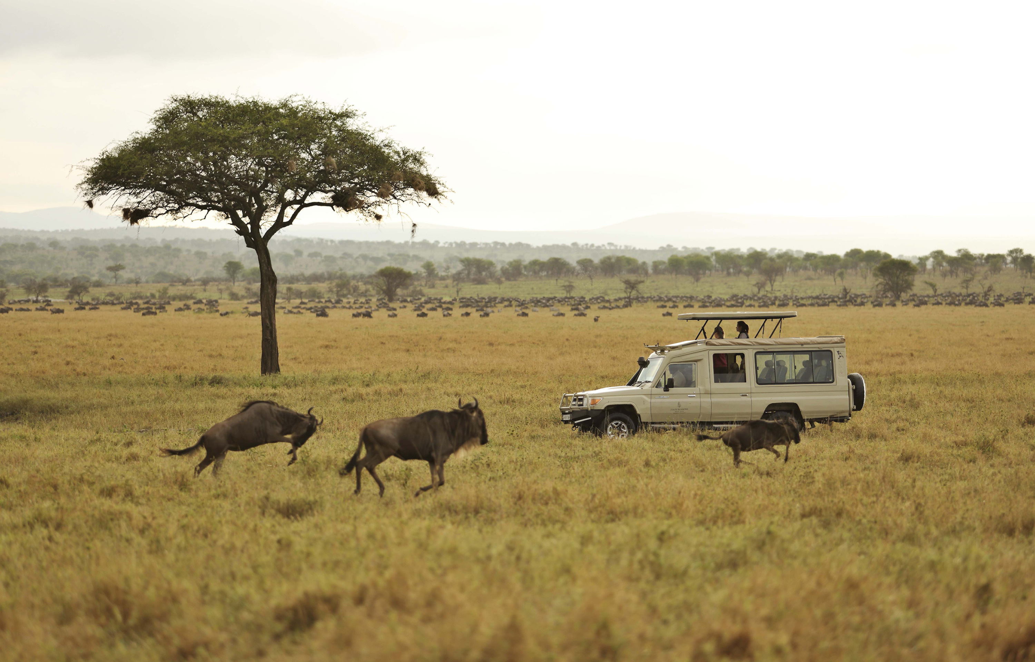 | November 26, 2020, Serengeti, Tanzania  Experience the Very Best of the Serengeti for Longer with Four Seasons Safari Lodge Serengeti  https://publish.url/serengeti/hotel-news/2020/seven-day-itinerary.html
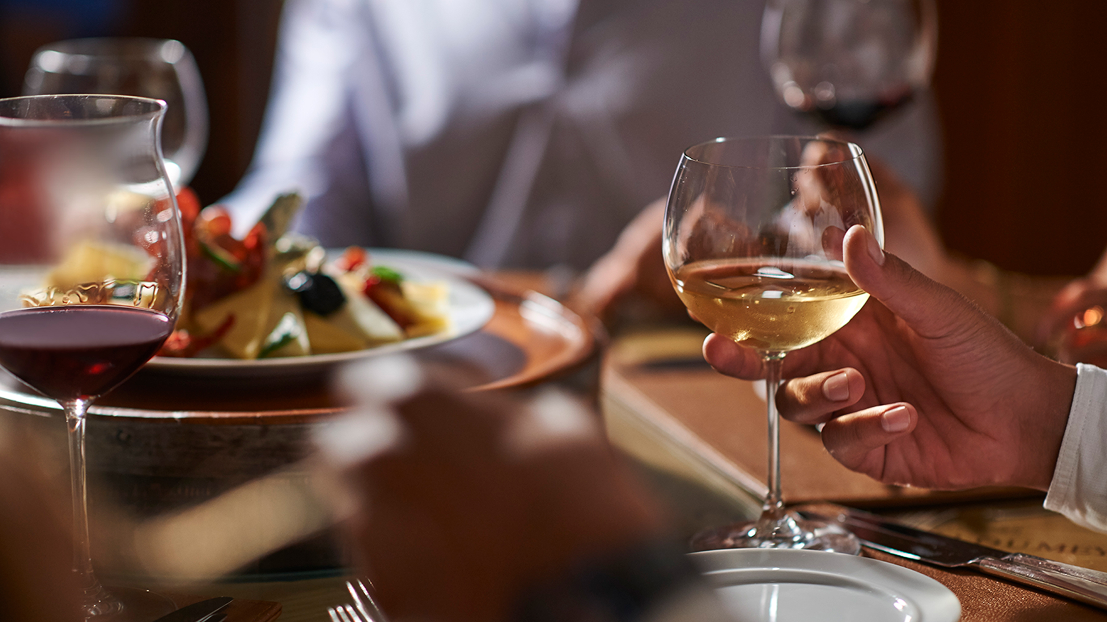 | October 29, 2020, Serengeti, Tanzania  Introducing Tailor-Made Tastings at The Vineyard at Four Seasons Safari Lodge Serengeti  https://publish.url/serengeti/hotel-news/2020/new-dining-experience-the-vineyard.html

PRESS CONTACTS

Debbie Duval
Senior Director of Public Relations and Communications

Beau Champ
Mauritius
debbie.duval@fourseasons.com

(230) 402 3100

