Endless Love at The Spa

July 27, 2022, Alexandria, Egypt

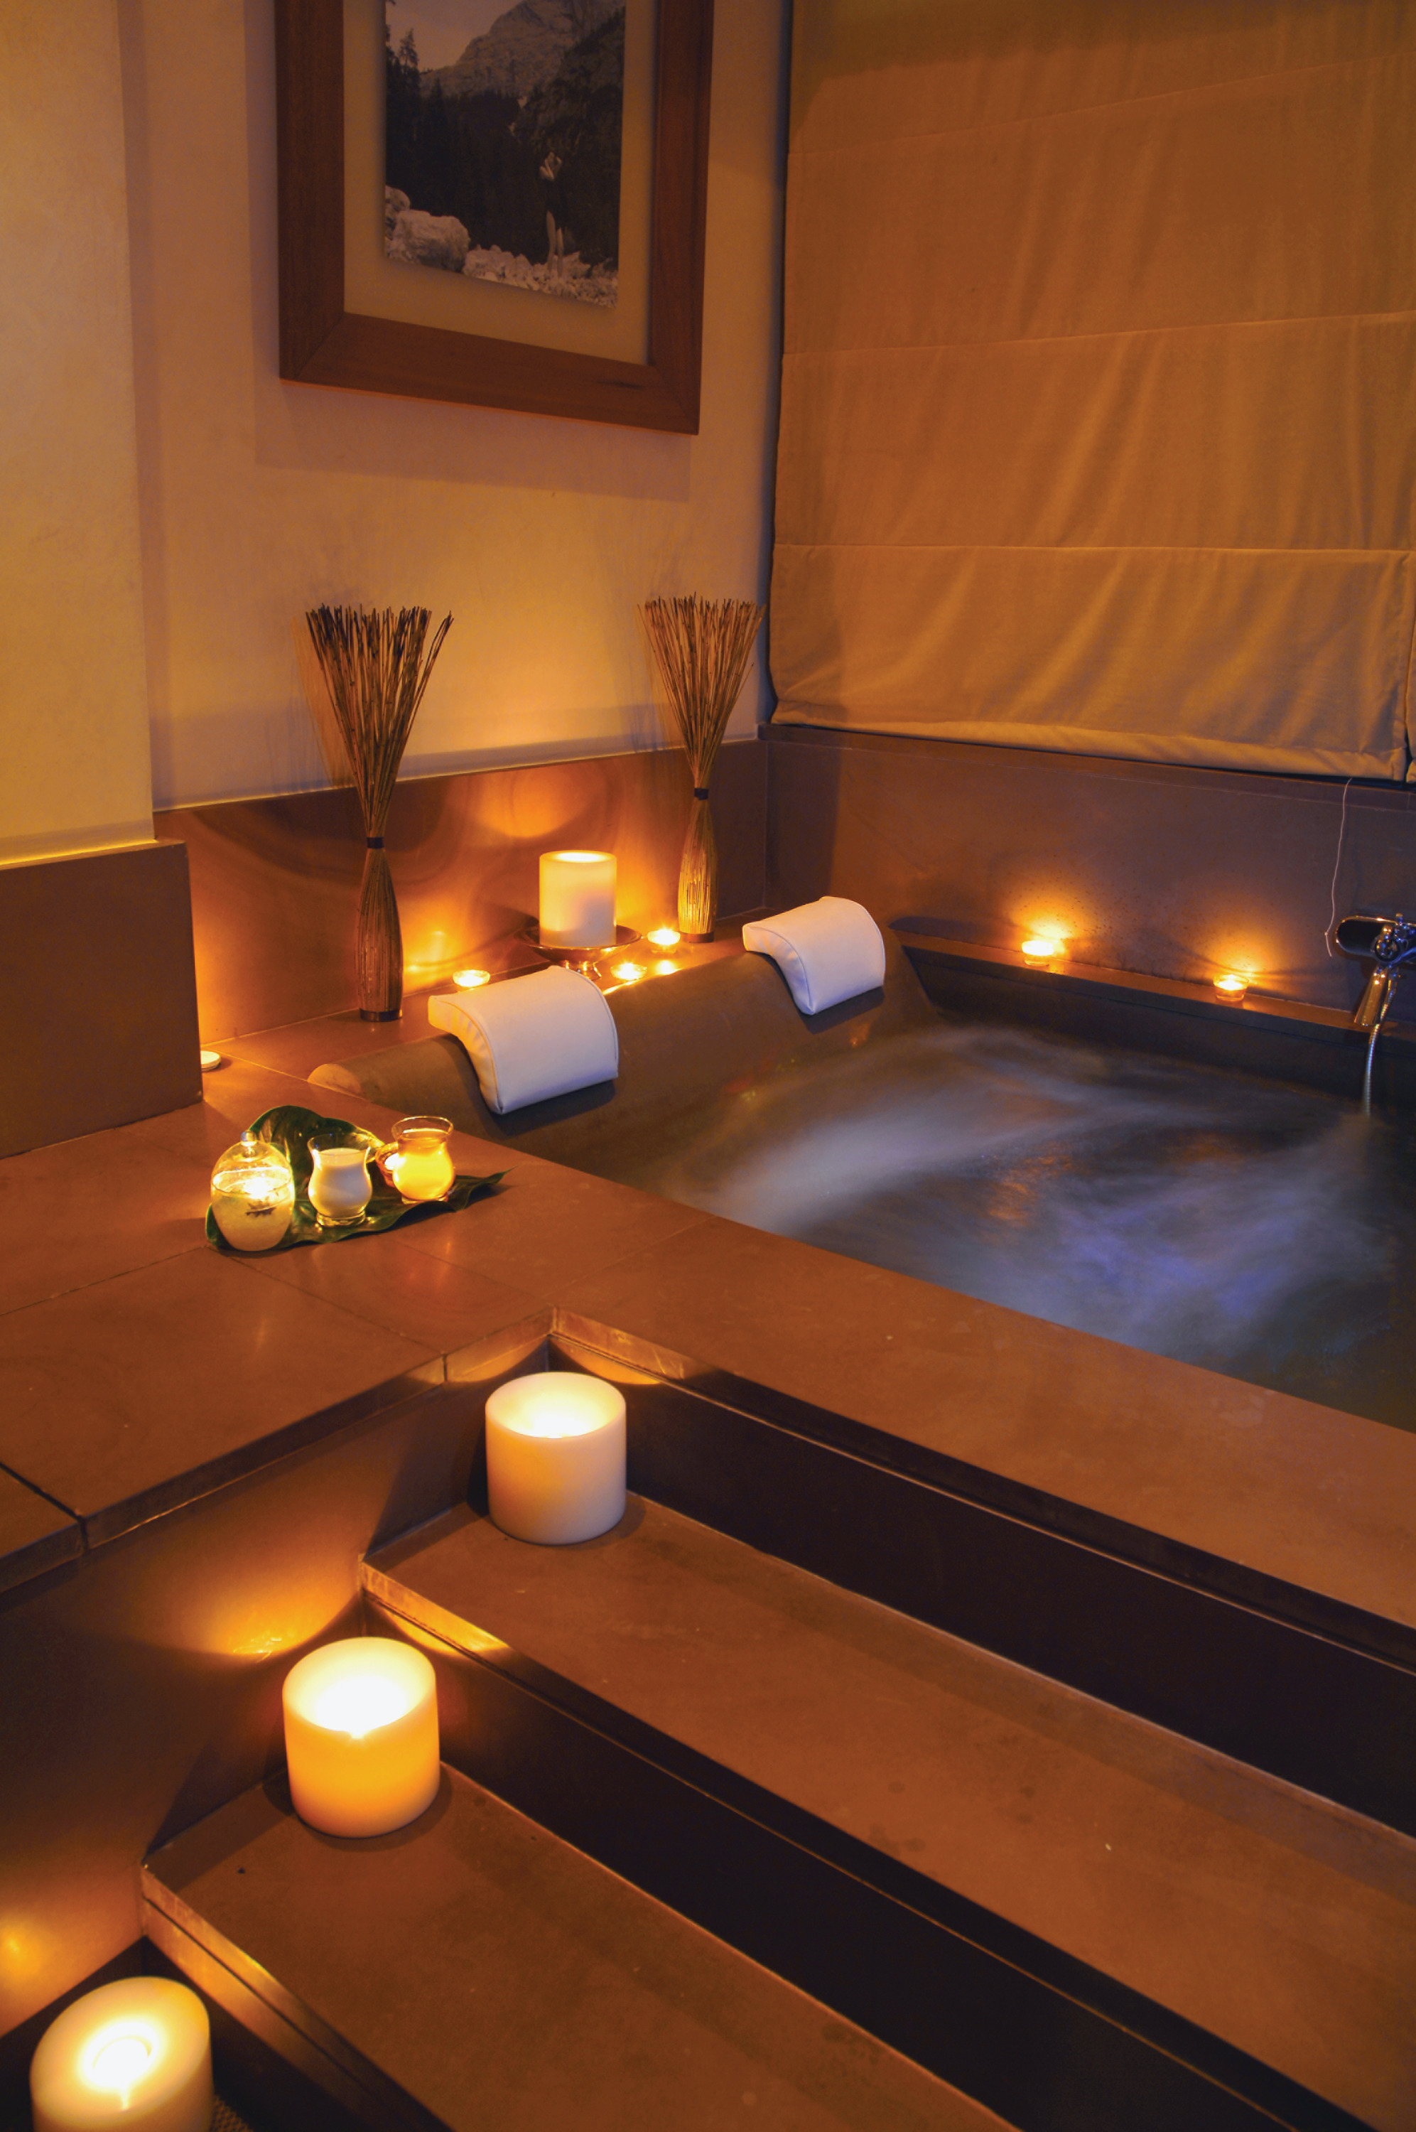
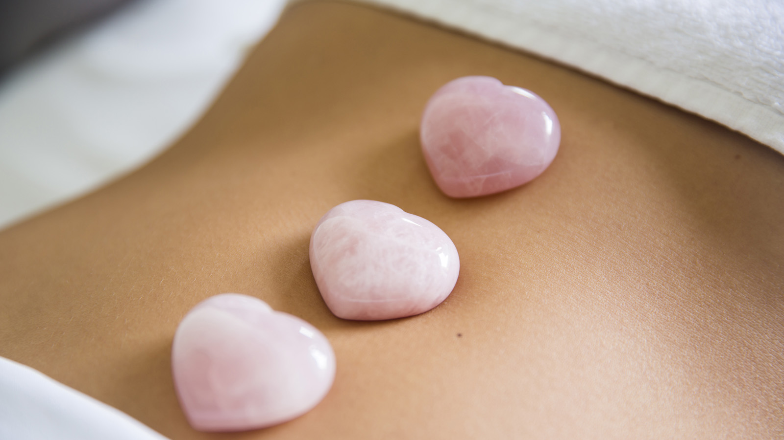
The beautiful Mediterranean city of Alexandria never failed its lovers who came seeking a romantic getaway. Egyptian movies to royal affairs were living witnesses to what this cosmopolitan city was all about when it comes to love and romance stories.
The Spa team at Four Seasons Hotel Alexandria has dedicated an Endless Love Experience to treasure the blessing of love and serenity. This 90-minute treatment begins with a fine selection of strawberries and macaron to entice your love bites. Following this treatment, a massage of your choice with our professional therapist and relaxing music will end with a sea salt bath. Couples who book this experience will receive two personalized bathrobes as a giveaway.

RELATED

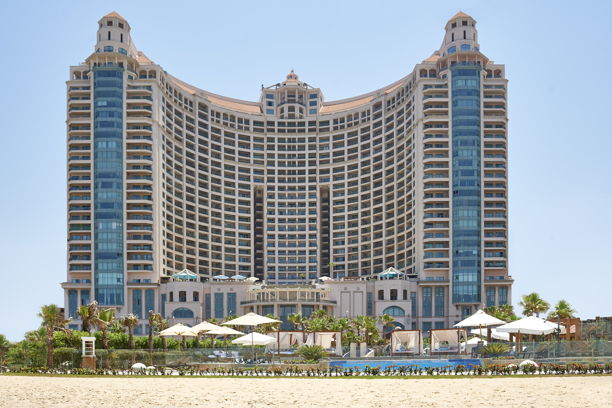 | July 27, 2022, Alexandria, Egypt  Four Seasons Hotel Alexandria at San Stefano Celebrates 15 Years at the Pearl of the Mediterranean  https://publish.url/alexandria/hotel-news/2022/15th-anniversary-special-offers.html
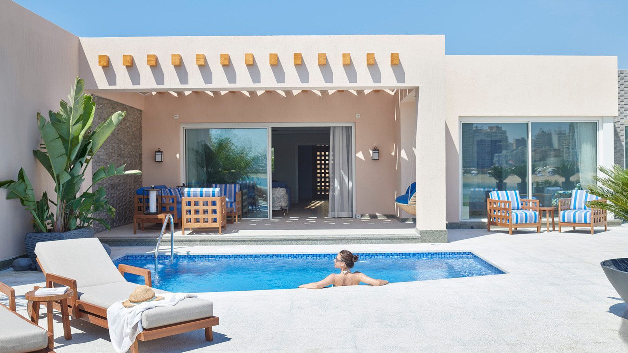 | April 28, 2022, Alexandria, Egypt  Four Seasons Hotel Alexandria at San Stefano Introduces Newly Launched Beach Villas to Bring an Elevated Level of Glamour and Grandeur to Egypt’s Mediterranean Coast  https://publish.url/alexandria/hotel-news/2022/new-beach-villas.html

PRESS CONTACTS

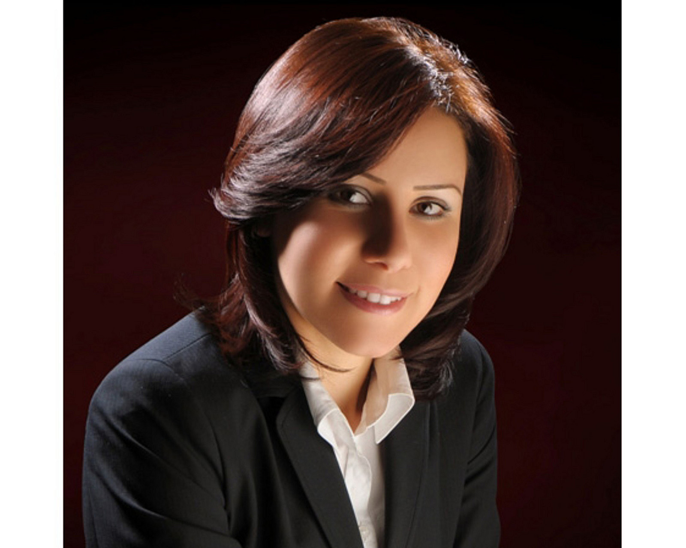 | Sarah Nabil  Director of Public Relations  399 El Geish Road  Alexandria  Egypt  sarah.nabil@fourseasons.com  20 3 581 8000

