Celebrate the Holidays at Four Seasons Hotel New York

Take in the magic of the holidays at Midtown's most iconic Hotel
November 14, 2019, New York, U.S.A.

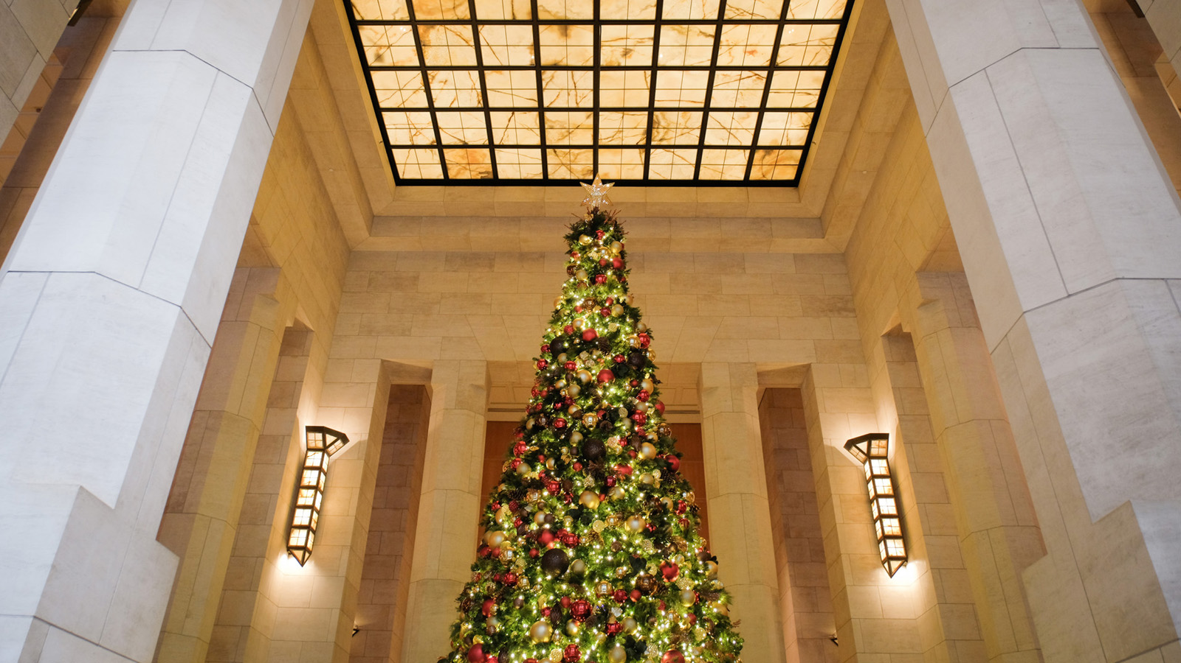
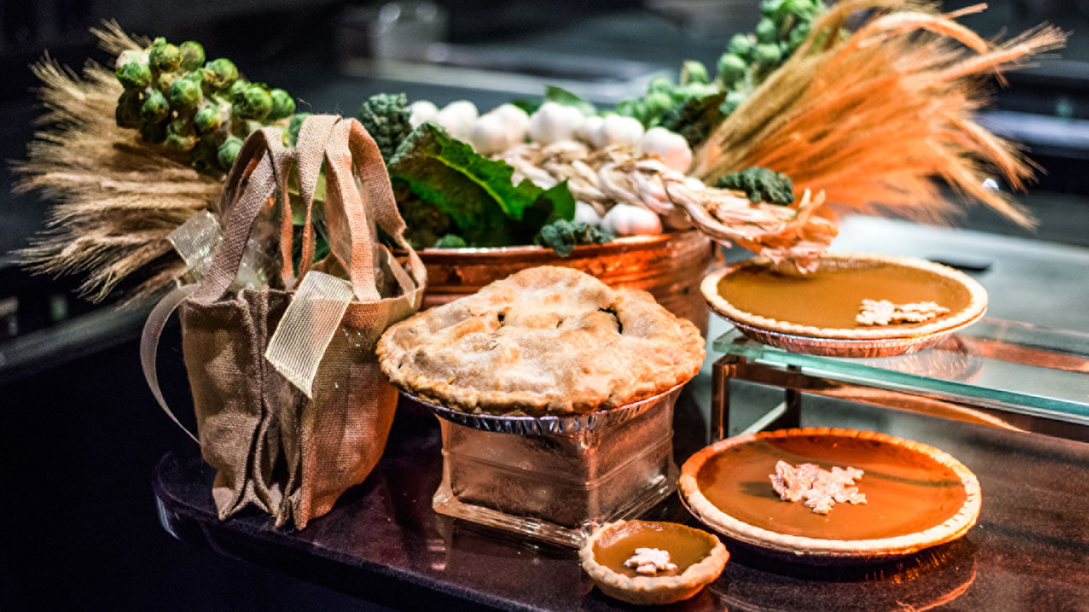 | 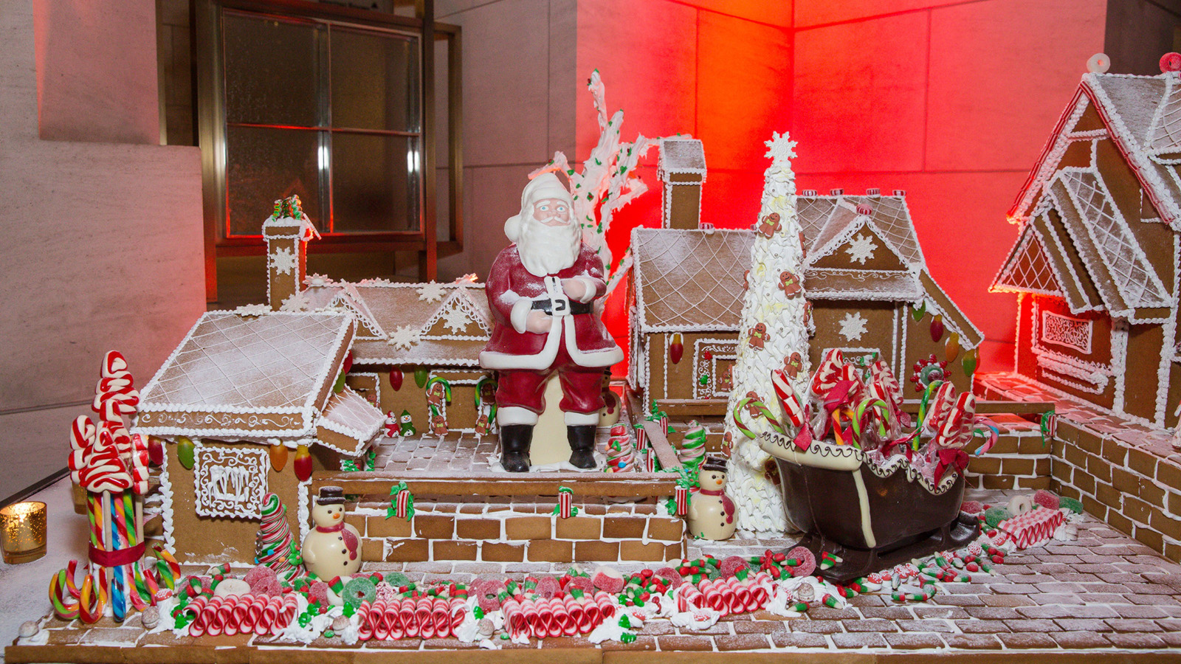 | 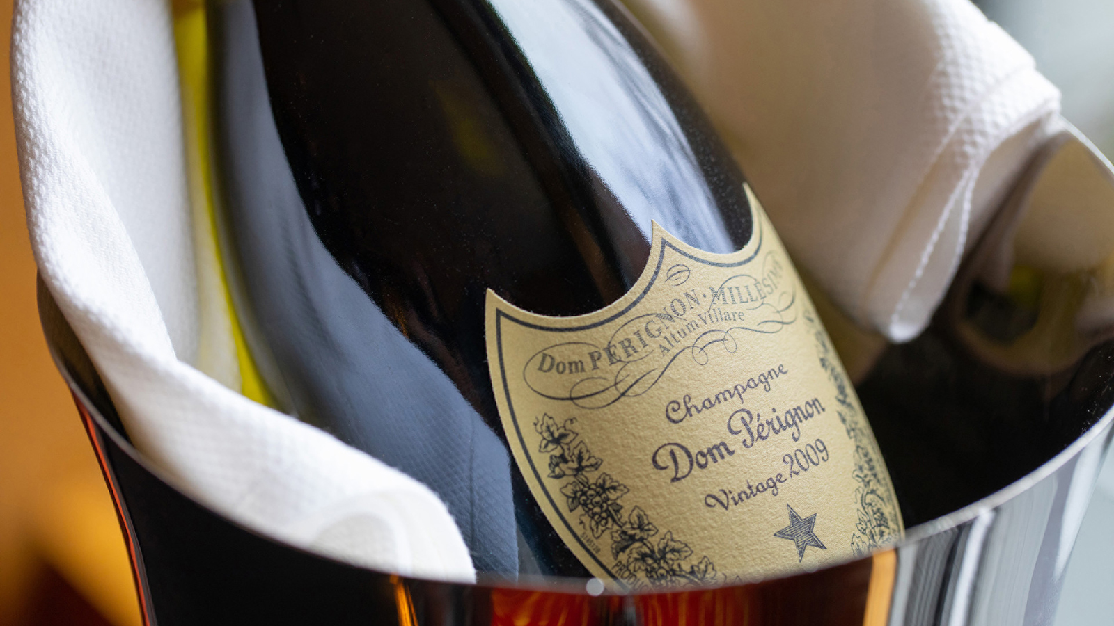
Four Seasons Hotel New York is spreading the holiday spirit this season with festive offerings for every age ­ — specialty menus at The Garden, a New Year’s Eve soiree at Ty Bar, premium selections of Champagne and a one-of-a-kind holiday tree overlooking the I.M. Pei-designed lobby.
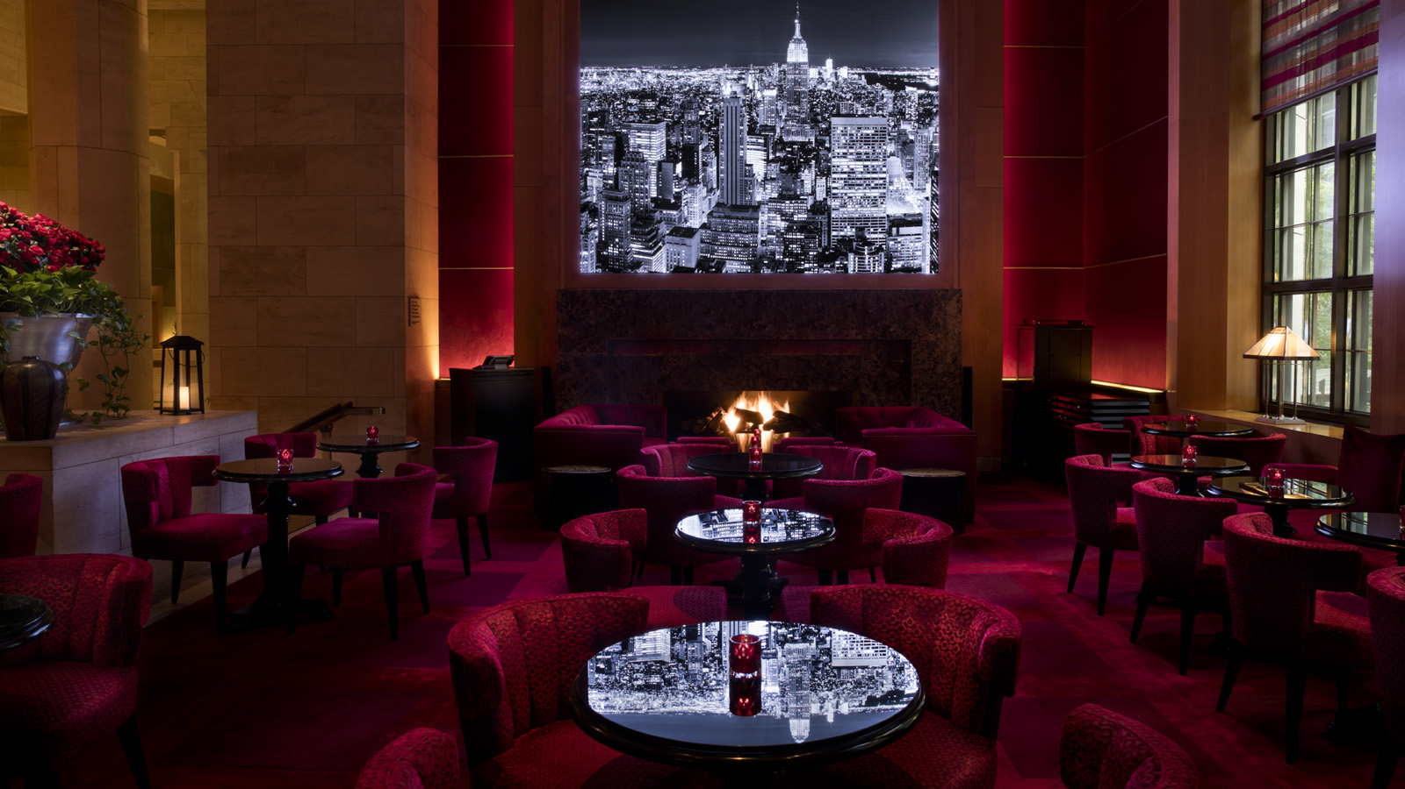 | 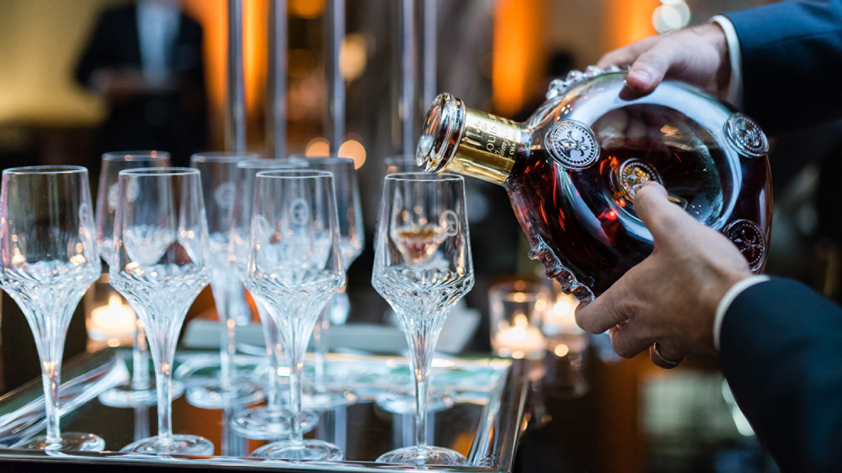 | 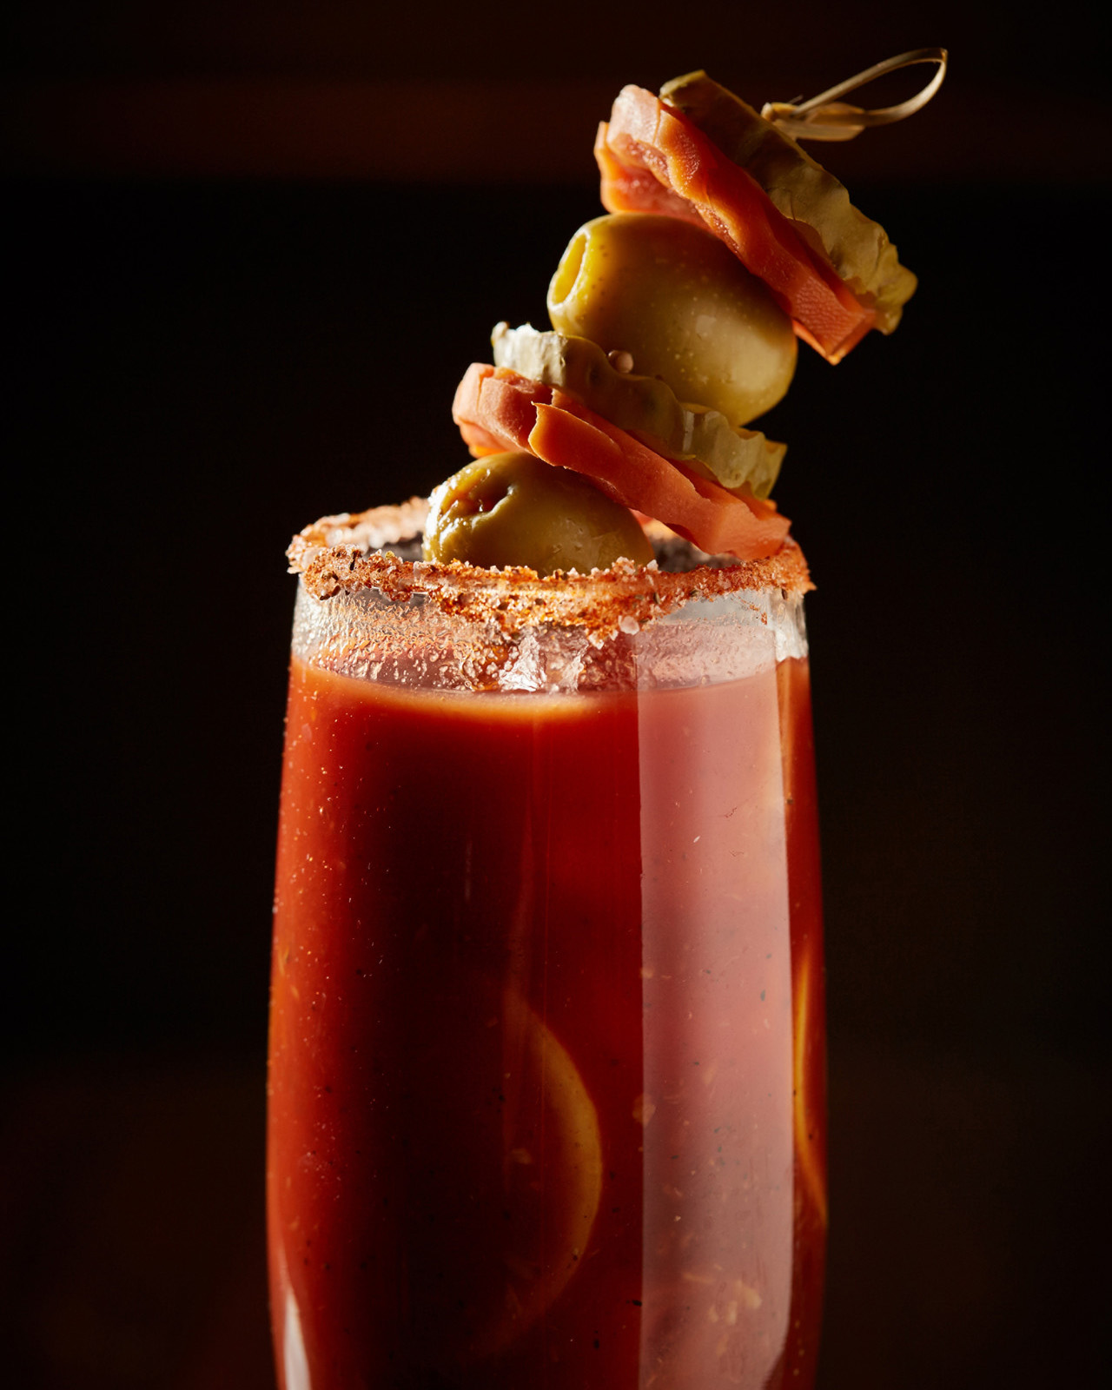
Located in Midtown Manhattan, its central location serves as the perfect starting point for sightseeing the city’s most festive attractions. Steps away from luxurious shopping on Madison and Fifth Avenues, Central Park and the Rockefeller Center, Four Seasons Hotel New York is the perfect place for holiday joy in the Big Apple. Its concierge team of 12 Les Clefs d'Or members can create bespoke itineraries for families looking for access to exclusive experiences in New York City.
Thanksgiving Day at The Garden
Executive Chef John Johnson is celebrating the flavours of the Hudson Valley Harvest this holiday season.
For Thanksgiving, guests can enjoy a prix-fixe three-course Thanksgiving Day menu at The Garden that includes seasonal starters such as flash seared hamachi, terrine of Hudson Valley foie gras, and velouté of delicata squash. Entrées feature traditional favourites such as organic Vermont turkey roast, slow roasted branzino, and squash paccheri. Guests can also indulge in br&ucirc;lée pumpkin pie, chocolate pecan tart or apple caramel cheesecake.
The three course prix-fixe menu is USD 149 per adult and USD 65 per child. Seating times are 12:00 noon, 12:30 pm, 2:00 pm and 2:30 pm and are two hours each.
Christmas Day at The Garden
Guests can enjoy a three-course prix-fixe lunch menu on Christmas Day featuring slow roasted prawns, crispy duck and risotto of wild mushrooms. Crafted by Executive Pastry Chef Jasmina Bojic and her talented pastry team, a gingerbread house showing capturing the holiday spirit in New York City will be on display. A chocolate Christmas tree will also be featured in the dessert menu to indulge in.
The three course prix-fixe menu is USD 149 per adult and USD 65 per child. Seating times are 12:00 noon, 12:30 pm, 2:00 pm and 2:30 pm and are two hours each.
Ring in 2020 at Ty Bar and The Garden
Ring in the New Year in style at Four Seasons Hotel New York, starting with a festive New Year’s celebration at Ty Bar followed by a New Year’s Day Brunch at The Garden featuring a specialty cocktail menu. Additionally, the Hotel will feature the finest champagnes during the most celebratory time of the year. Guests may choose to have a glass or bottle from a selection of Dom Pérignon, Moët Rosé and Ruinart.
New Year’s Eve
Overlooking the hotel’s sweeping I.M. Pei-designed grand lobby, Ty Bar will host a New Year’s Eve experience like no other, featuring live music, premium Champagne, gourmet hors d’oeuvres, and a live broadcast of the New Year’s Eve Ball Drop in Times Square set against the plush red-velvet backdrop of New York City’s most exclusive cocktail lounge. Guests of the evening can dance the night away on the dancefloor and even take a glimpse into their future with a strolling mentalist before ringing in the New Year with a celebratory midnight toast.
Guests can choose from the Ty Bar Experience or the Prestige Experience in the Dom Pérignon and LOUIS XIII Lounge. The soiree will be held from 9:00 pm to 1:00 am.
Ty Bar Experience
- Reserved seating
- Welcome glass of Moët Champagne
- Gourmet bar bites
- Artisanal desserts
- Live music by the Artie Stuart Band
- Strolling mentalist
- Live broadcast of New Year’s Eve Ball Drop in Times Square
- Dom Pérignon midnight toast
- Party favours and farewell gift
USD 495 per person; 18 percent gratuity and 8.875 percent sales tax are additional.
Prestige Experience in the Dom Pérignon and LOUIS XIII Lounge
- Reserved seating in exclusive VIP Lounge
- Welcome glass of Dom Pérignon Rosé
- Free-flowing Dom Pérignon
- Osetra caviar and traditional condiments
- Chef’s special hors d’oeuvres and mini plates
- Artisanal desserts
- Live music by the Artie Stuart Band
- Strolling mentalist
- Live broadcast of New Year’s Eve Ball Drop in Times Square
- Louis XIII midnight toast
- Party favours and deluxe farewell gift
USD 1,000 per person; 18 percent gratuity and 8.875 percent sales tax are additional.
Reservations
For New Year’s Eve reservations, click here or e-mail tybar.nyf@fourseasons.com for more information. To make reservations for Thanksgiving, Christmas or New Year’s Day Brunch at The Garden, call +1 212 758 5700.
Visit the Holiday Happenings webpage for additional details.

RELATED

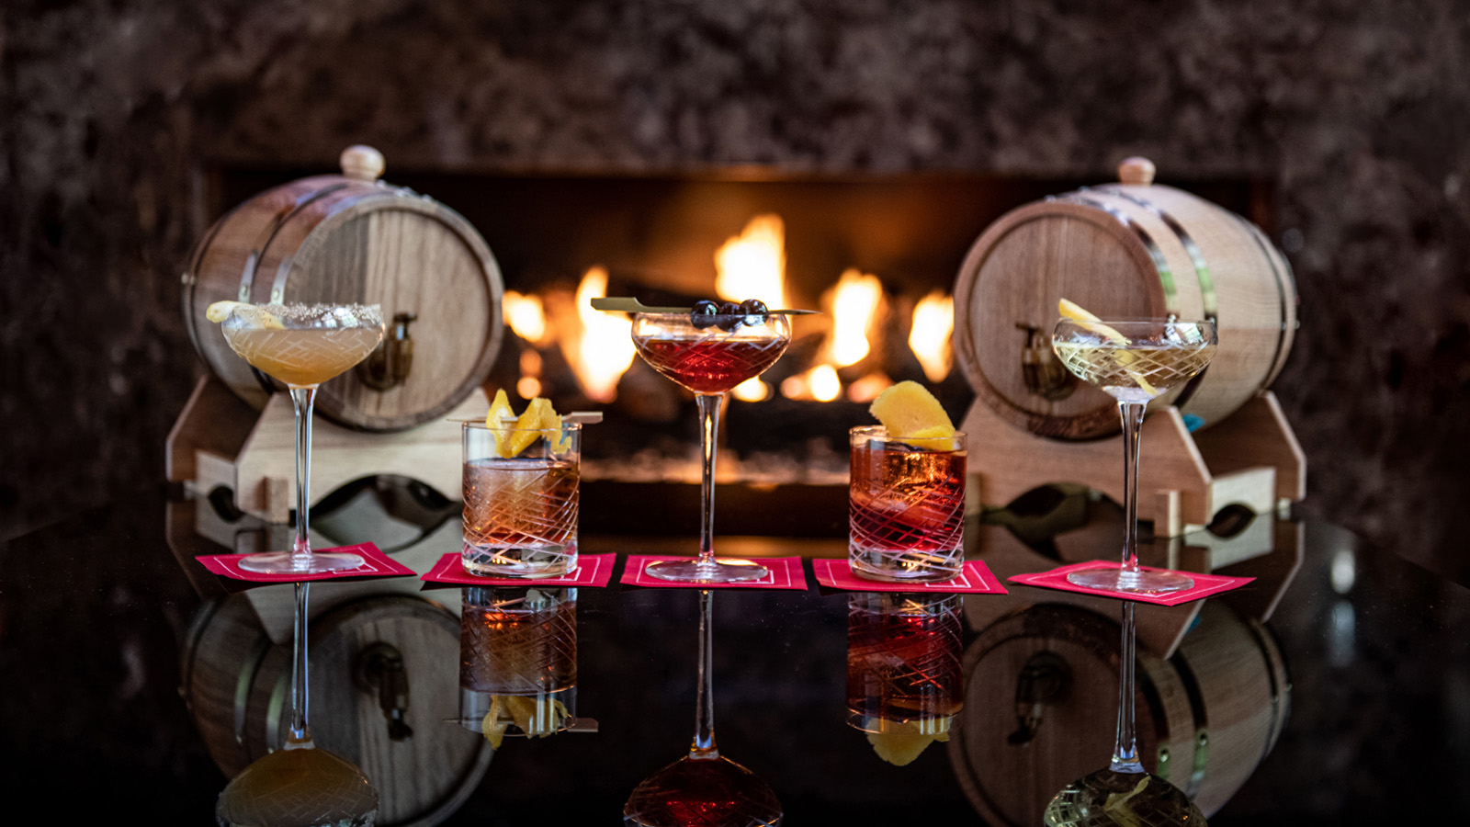 | October 16, 2019, New York, U.S.A.  Ty Bar Presents Barrel-Aged Cocktails at Four Seasons Hotel New York  https://publish.url/newyork/hotel-news/2019/barrel-aged-cocktails.html
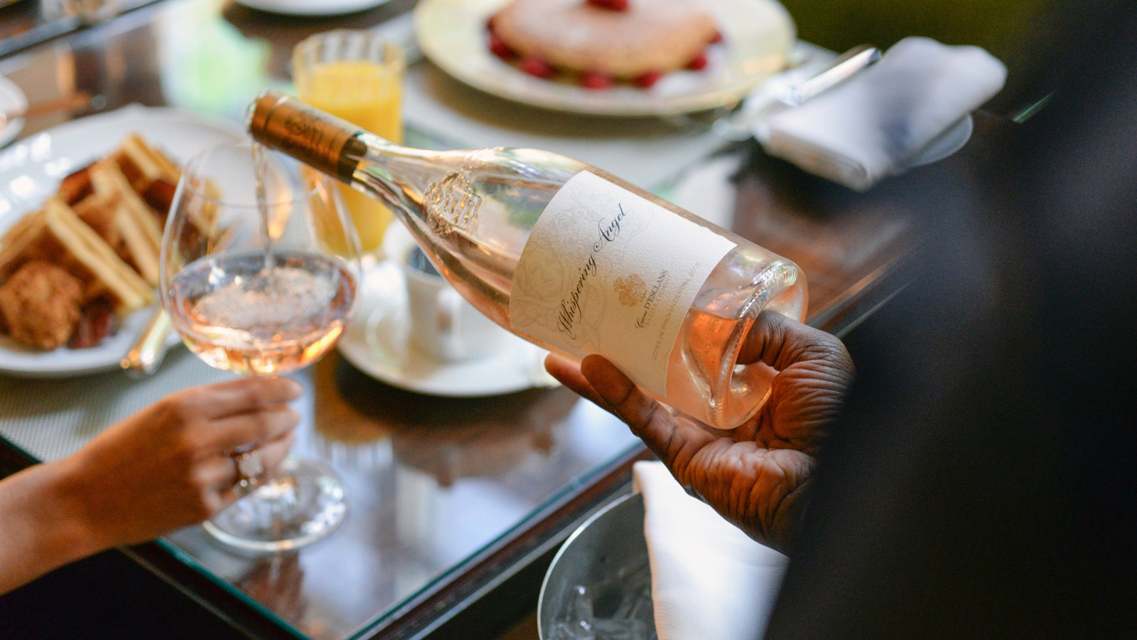 | June 21, 2019, New York, U.S.A.  Sip Rosé for a Cause This Summer at Four Seasons Hotel New York  https://publish.url/newyork/hotel-news/2019/rose-at-the-garden-and-ty-bar.html

PRESS CONTACTS

Nieves Alvarez
Digital Marketing Manager
57 East 57th Street
New York
U.S.A.
nieves.alvarez@fourseasons.com

+1 (212) 350-6207

