Find the Ultimate Work-Life Balance at Four Seasons Resort Seychelles

"Extend Your Stay" with Four Seasons Resort Seychelles and unlock exclusive benefits, including weekly complimentary spa treatments, resort credit and more
December 7, 2020, Seychelles

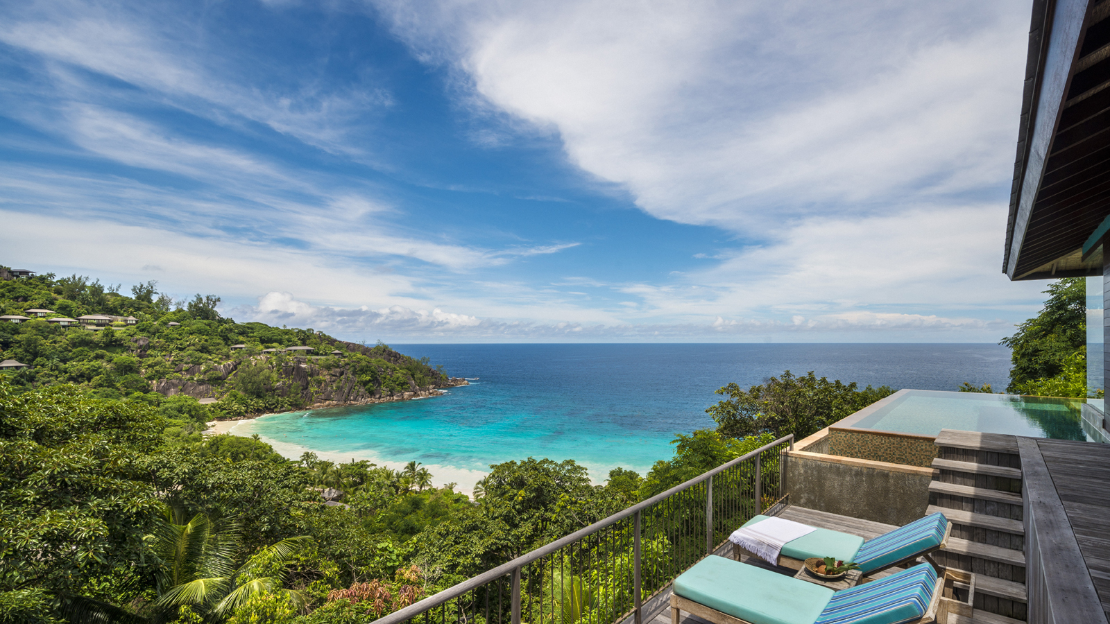
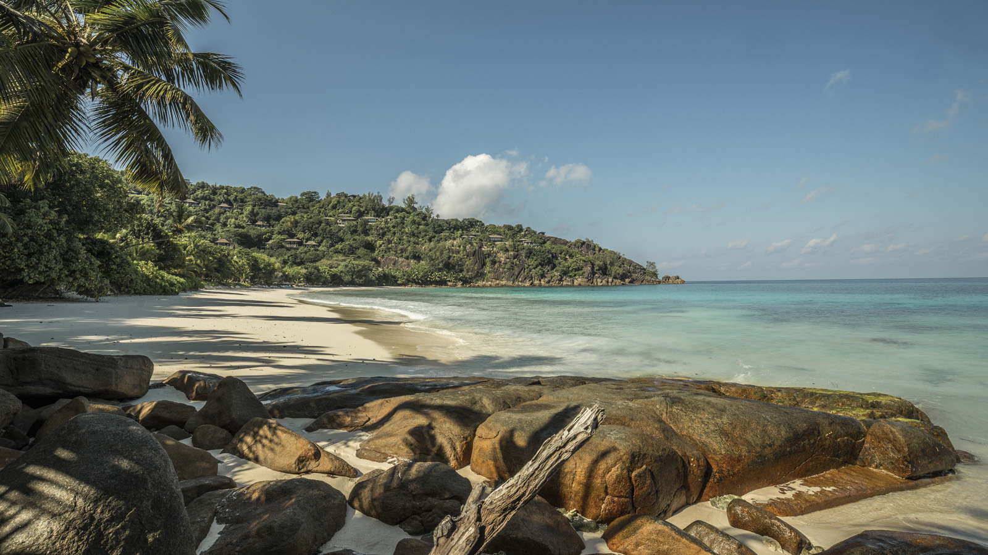 | 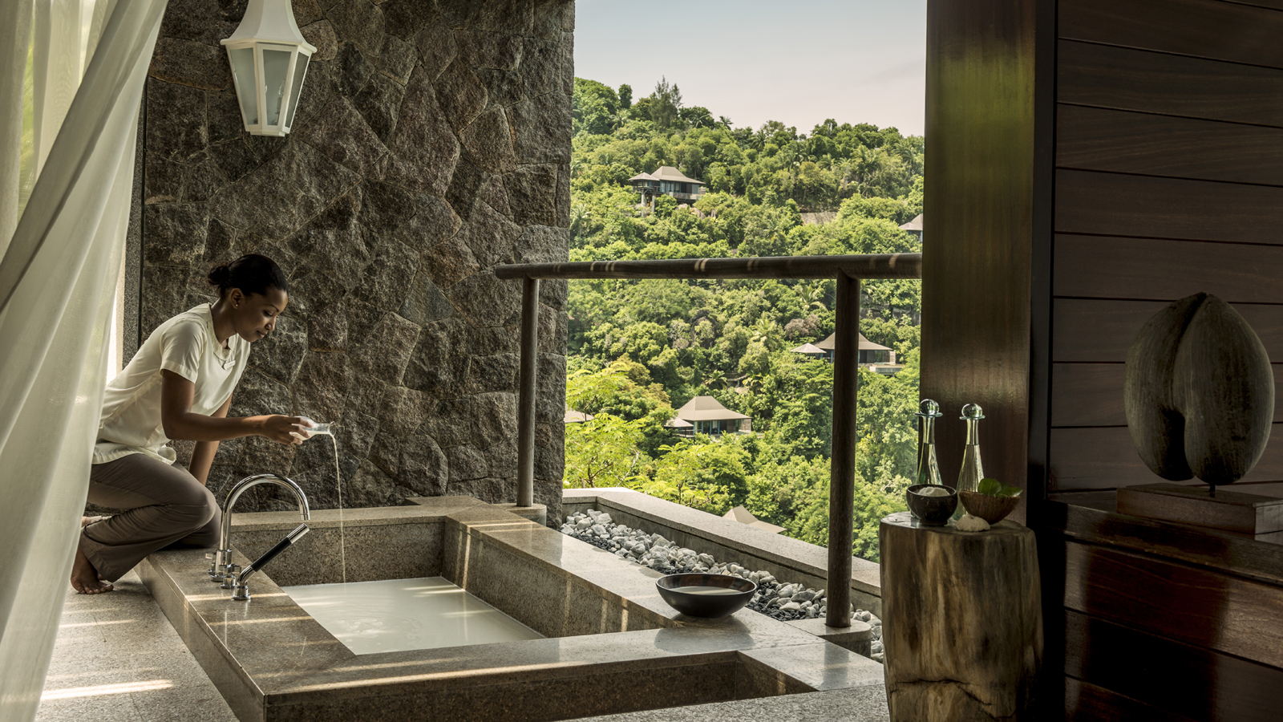 | 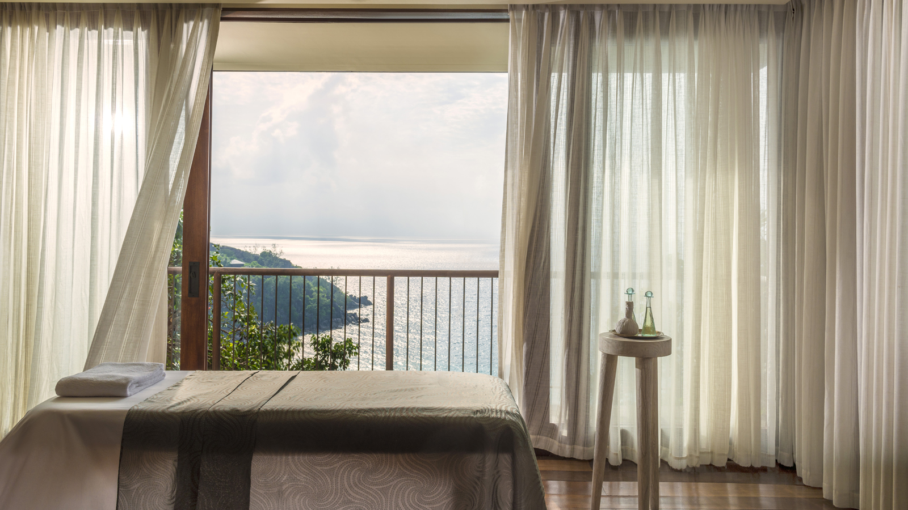
In the picturesque setting of Petite Anse, inspiration is never more than a glance away at Four Seasons Resort Seychelles. With remote and flexible working presently being adopted by many around the world, Four Seasons Resort Seychelles is offering the opportunity for guests to discover one of the most scenic offices in the world, by working from their Villa or Private Retreat and enjoying a number of exclusive benefits as part of the Extend Your Stay campaign.
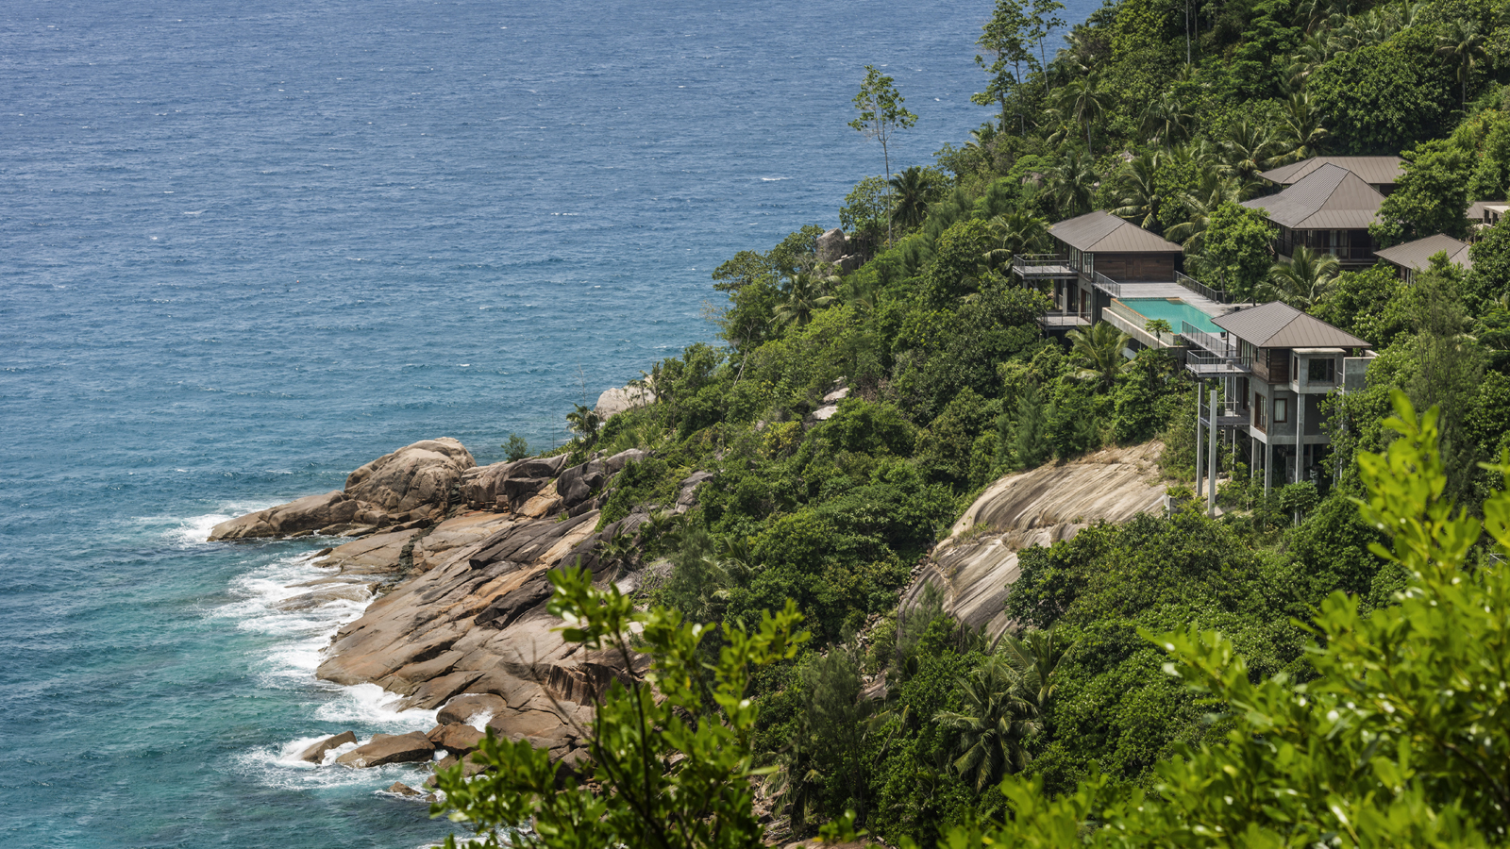
With individual work schedules varying, the all-pool villa Resort looks to offer every opportunity for guests to disconnect and appreciate the beauty and tranquillity of Seychelles, achieving the ultimate work-life balance. Guests staying for 30 days or more will benefit from:
- Two hours of complimentary spa treatments each week (per Villa or Residence)
- A EUR 500 Resort credit per week for Villas and EUR 1000 Resort credit per week for Residences to use towards spa, recreational activities or dining
- Complimentary morning and afternoon healthy in-villa refreshments
- Personal concierge contact throughout a stay
- Private consultation on arrival with the concierge team to tailor all programming options
- Consultations with the Resort’s Chef and Le Syel Spa team to personalise a culinary and wellness plan
- Twice-weekly private fitness training sessions
- Roundtrip transportation between the Resort and airport
- Complimentary premium Wi-Fi connection throughout the stay
“This year has seen an evolution in the way in which so many people are able to work,” says Marcel Oostenbrink, General Manager at Four Seasons Resort Seychelles. “Many are no longer tied to a specific location, and with the guarantee of the essential working space and connectivity taken care of, now have the opportunity to incorporate recreational activities, mindful relaxation, travel, and so much more into daily schedules. Our Extend Your Stay offering is designed with flexibility in mind. Whether guests prefer to take a dip in their private plunge pool between conference calls, look to energise the mind and body by starting the day paddle boarding across the ocean or seek relaxation from guided yoga or meditation, we want to help our guests punctuate each day with time for them.”
Accommodations at Four Seasons Resort Seychelles range from One Bedroom Pool Villas to a collection of spacious and secluded Private Retreats, ranging from Three to Seven-Bedroom Residence Villas.
To make a reservation for the Resort’s Extend Your Stay campaign or for further details, contact the on-site reservation specialists at: reservations.sey@fourseasons.com.

RELATED

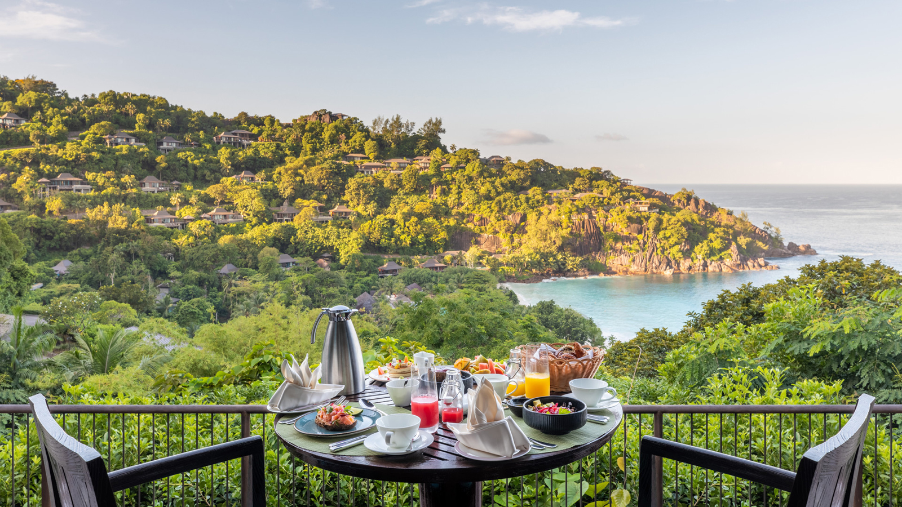 | November 23, 2020, Seychelles  Four Seasons Resort Seychelles Welcomes Guests Back to Paradise  https://publish.url/seychelles/hotel-news/2020/reopening.html
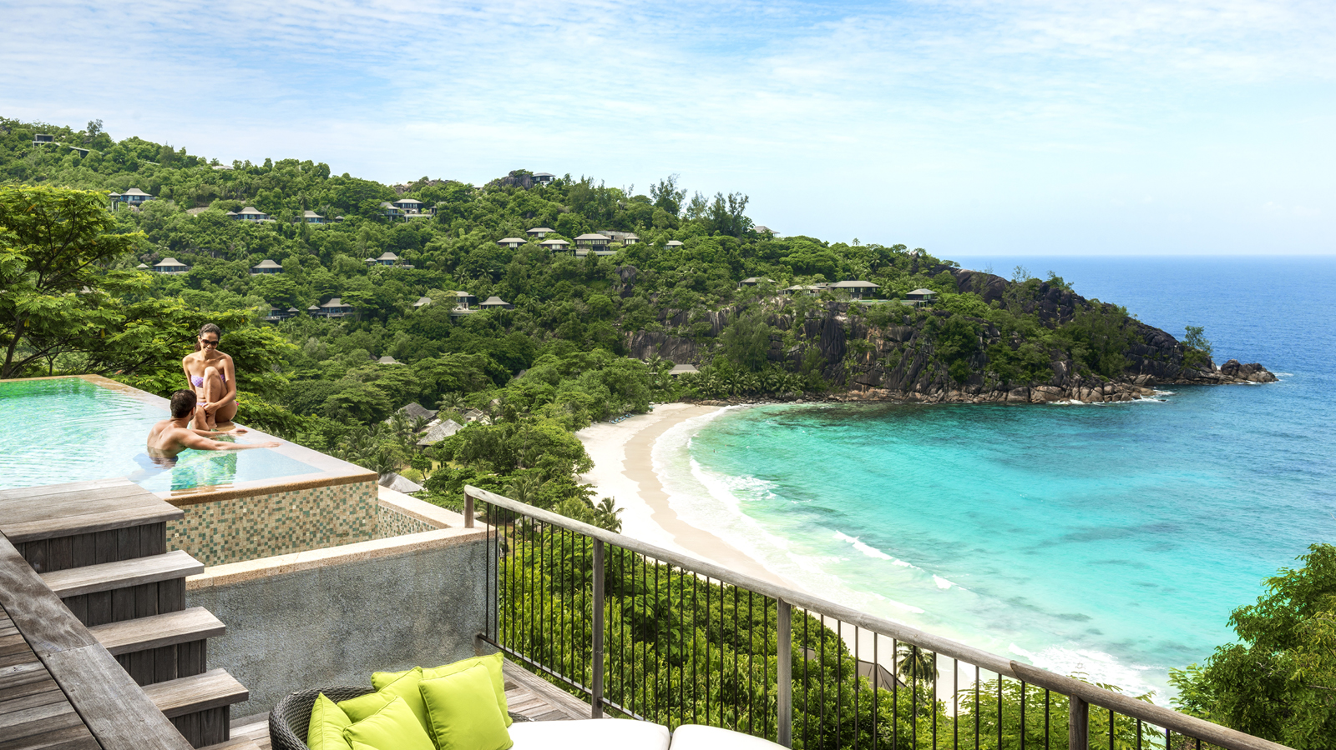 | October 28, 2020, Seychelles  Celebrate the Warmth of the Festive Season at Four Seasons Resort Seychelles  https://publish.url/seychelles/hotel-news/2020/festive-season.html

PRESS CONTACTS

Debbie Duval
Senior Director of Public Relations and Communications

Beau Champ
Mauritius
debbie.duval@fourseasons.com

(230) 402 3100

