Festive Events at Four Seasons Hotel Boston

Boston’s veritable holiday hotel, offering endless fun for guests and locals of all ages
November 7, 2019, Boston, U.S.A.

This December, celebrate with friends and family at Four Seasons Hotel Boston. There is so much to experience for both Hotel guests and locals alike, ages young and old. The lobby’s vibrant, glittering décor is the perfect eye-catching backdrop for each festive happening, from exclusive events and cool pop-ups to specialty cocktails and culinary delights. The “12 Days of Christmas” come to life in every sense, making Four Seasons Hotel Boston a can’t-miss on everyone’s holiday calendar.
Events for Kids
- Teddy Bear Tea: The celebrated holiday tradition returns to the Bristol December 1-23, 2019, with daily celebrity readers, visits to the table from Truffles the Bear, and teddy bear donations to children’s hospitals and charities. Open to the public. Details and reservations: click here.

RELATED

October 30, 2019, Boston, U.S.A.
在波士顿四季酒店庆祝2020中国鼠年新年
https://publish.url/zh/boston/hotel-news/2019/lunar-new-year-2.html

October 30, 2019, Boston, U.S.A.
Celebrate the Year of the Rat in 2020 with Chinese New Year at Four Seasons Hotel Boston
https://publish.url/boston/hotel-news/2019/lunar-new-year.html

PRESS CONTACTS

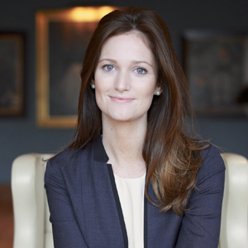 | Maggie Lawler  Director of Public Relations and Communications  200 Boylston Street  Boston  USA  maggie.lawler@fourseasons.com  +1 617 351 2161
Bridget Kearney
Digital Marketing Manager
200 Boylston Street
Boston
USA
bridget.kearney@fourseasons.com

+1 617 351 2205

