Relaxation and Revelry are Key Ingredients to Festive Holiday Celebrations at Four Seasons Resort and Residences Anguilla

Few spaces still available for 2019/2020 festive season
October 9, 2019, Anguilla, West Indies

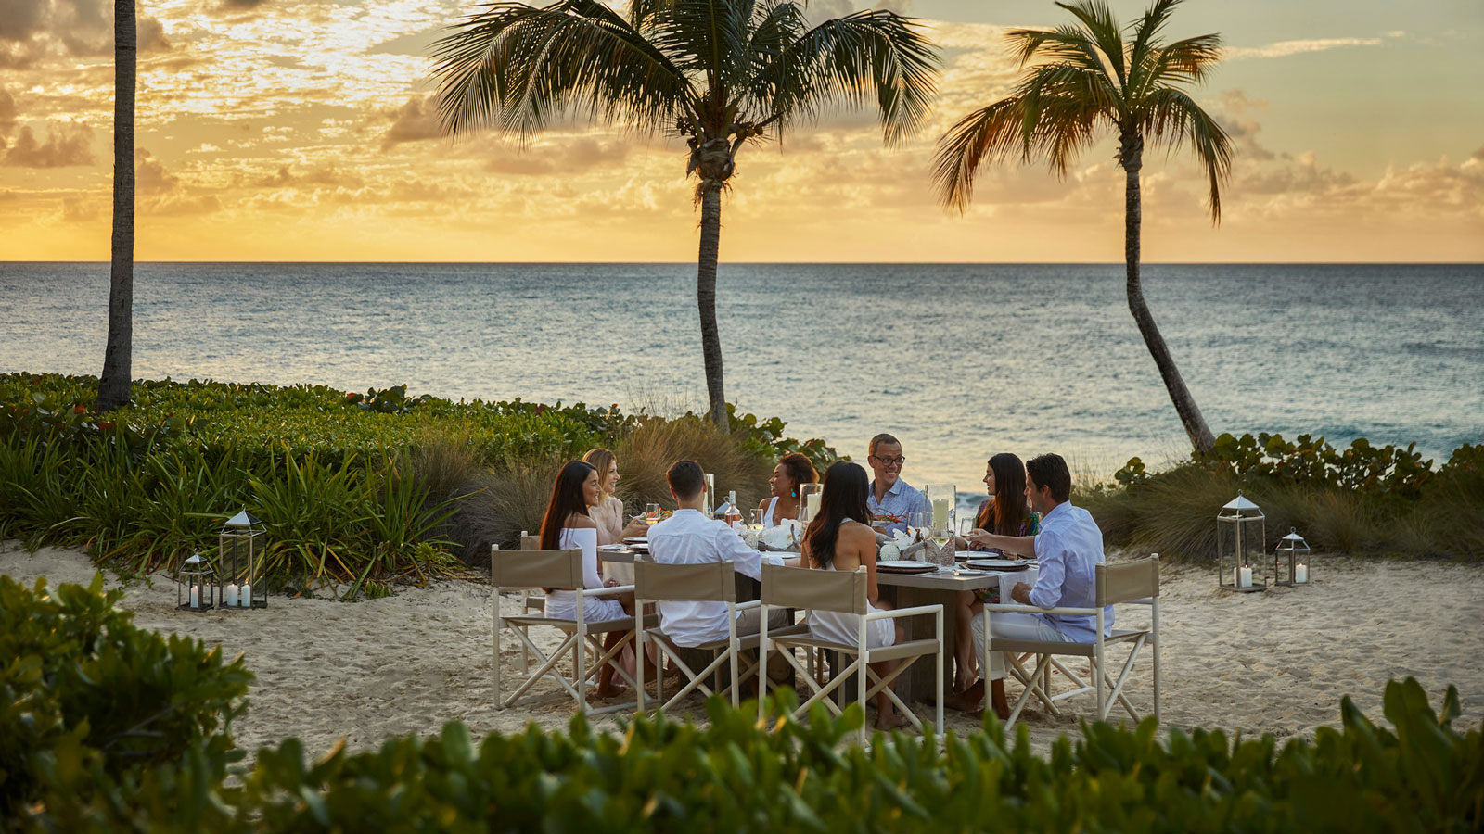
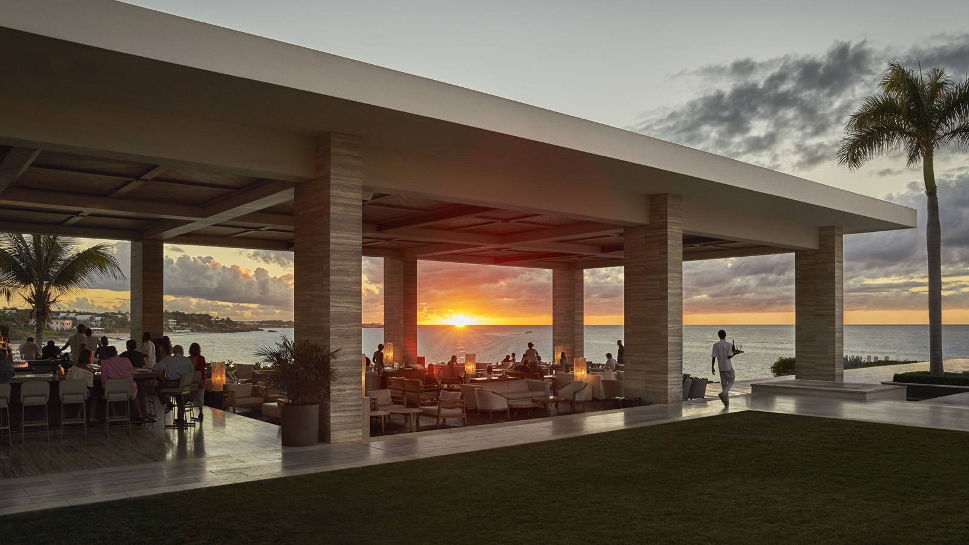 | 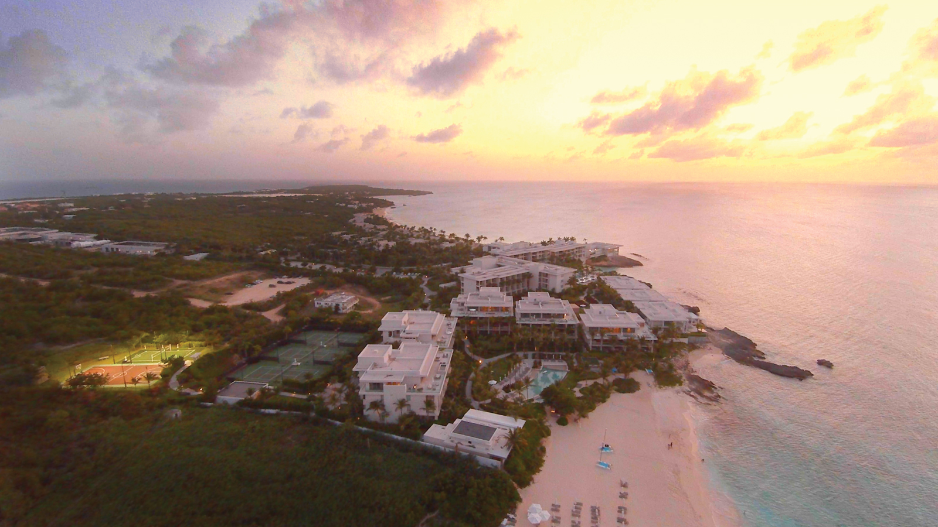
Combining warm sunny days with a dash of delectable dining options plus live nightly entertainment is the perfect recipe for a Caribbean holiday vacation. Four Seasons Resort and Residences Anguilla is a popular choice for those seeking a dose of relaxation plus holiday revelry. It’s also one of the only resorts in the Caribbean to feature nationally acclaimed entertainment and fireworks on New Year’s Eve.
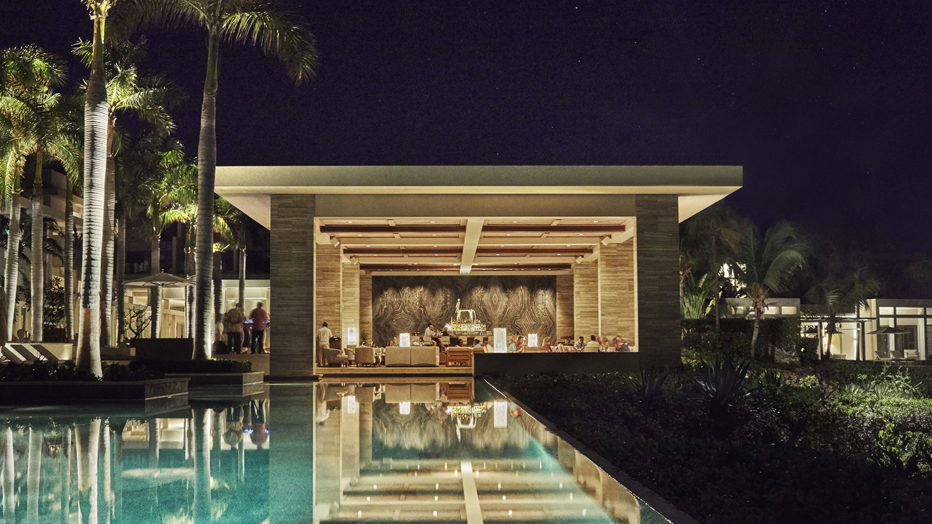 | 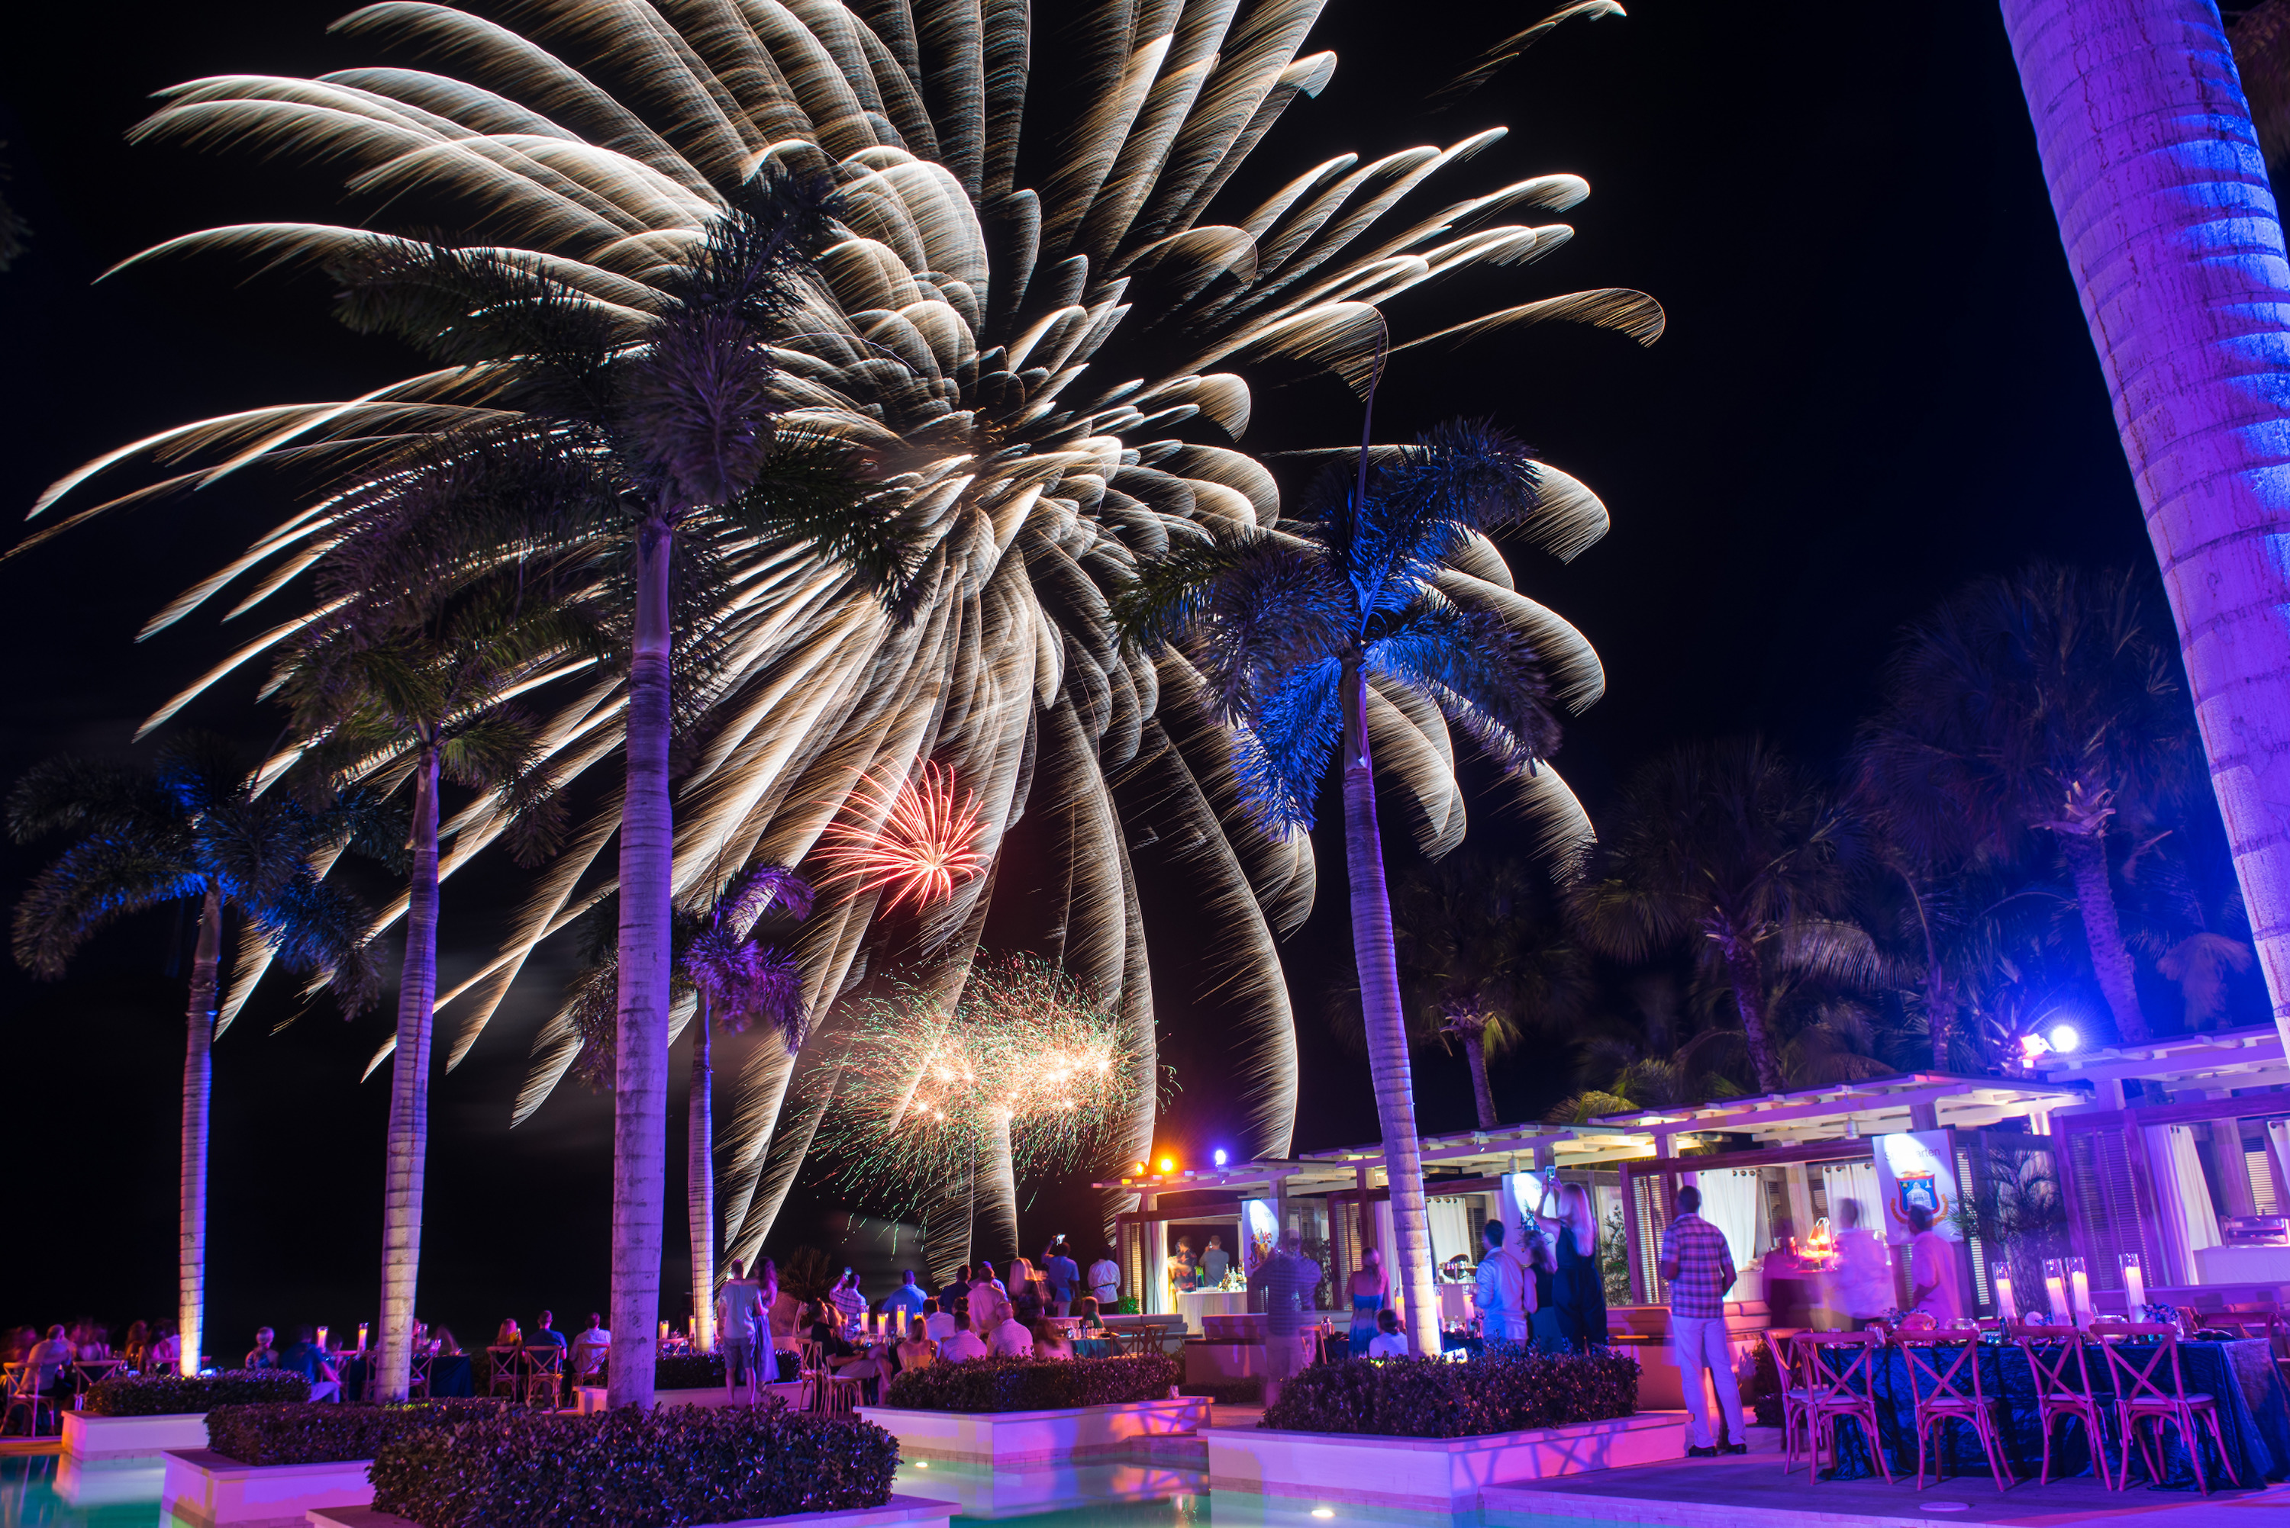
Anguilla proudly boasts more than 30 beaches, exceptional hospitality, and a variety of activities both on land and sea. In fact, Anguilla was named the best island in the Caribbean, Bermuda and the Bahamas by Travel + Leisure magazine for the third consecutive year (2017, 2018 and 2019).
This festive season, predominantly December 21, 2019 through January 4, 2020, is a time for family and friends to gather together to make memories while celebrating the dawn of a new year. Limited space is still available. Inquiries should be directed to festive.anguilla@fourseasons.com.
New Year’s Eve WOW
This year’s featured band is St. Lucia. This nationally acclaimed band recently released their new single "Walking Away” and has performed at festivals including Coachella, Lollapalooza and Governors Ball Outside Lands.
At 12:00 midnight, fireworks will light up the Anguillan sky and the party continues with the LA-based vocalist-instrumentalist Spencer Ludwig, who has gained national recognition for his funky jazz and R&B-infused pop sound and electric live performances.
Festive Fun on Land and Sea
The activity schedule offers options for all ages. From rock-wall climbing to rowing, basketball to bike riding, snorkeling to sailing, there’s always something to do at Four Seasons Resort Anguilla. Fitness enthusiasts can take waterfront yoga classes and fast-paced spinning classes, plus heart pumping SOCA dance classes.
Bling and More at The Boutique
During the holidays, The Boutique will feature exclusive pieces that will only be available on the island. The Boutique is perfect for last-minute gifts while getting a sneak peek at the coming season’s fashion trends.
Style and Fitness
Festive spa experiences include waterfront couples massage, hydrating facials, soothing foot massages, sunblock application and healing energy treatments. In addition, a full range of salon services will be offered in the Resort's Spa including eyelash extensions, make-up application, and blow dry styling.
Fun for the Little Ones
Kids of all ages have a variety of options to choose from this season – cooking classes, tennis lessons, cookie decorating are just some of the fun activities offered. The complimentary Kids for All Seasons program, daily for kids 5-12, also has nightly parties and movies too. Kids also enjoy a visit from Santa via an Anguilla race boat, and he usually brings along his Anguilla “reindeer” (goats!).

RELATED

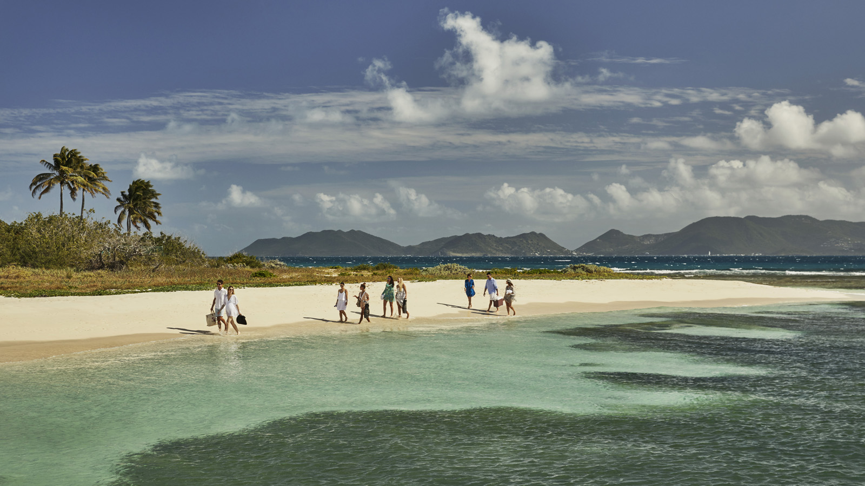 | May 9, 2019, Anguilla, West Indies  Celebrate Global Wellness with Island-Inspired Dance Classes and Local Health Remedies at Four Seasons Resort and Residences Anguilla  https://publish.url/anguilla/hotel-news/2019/global-wellness-day.html
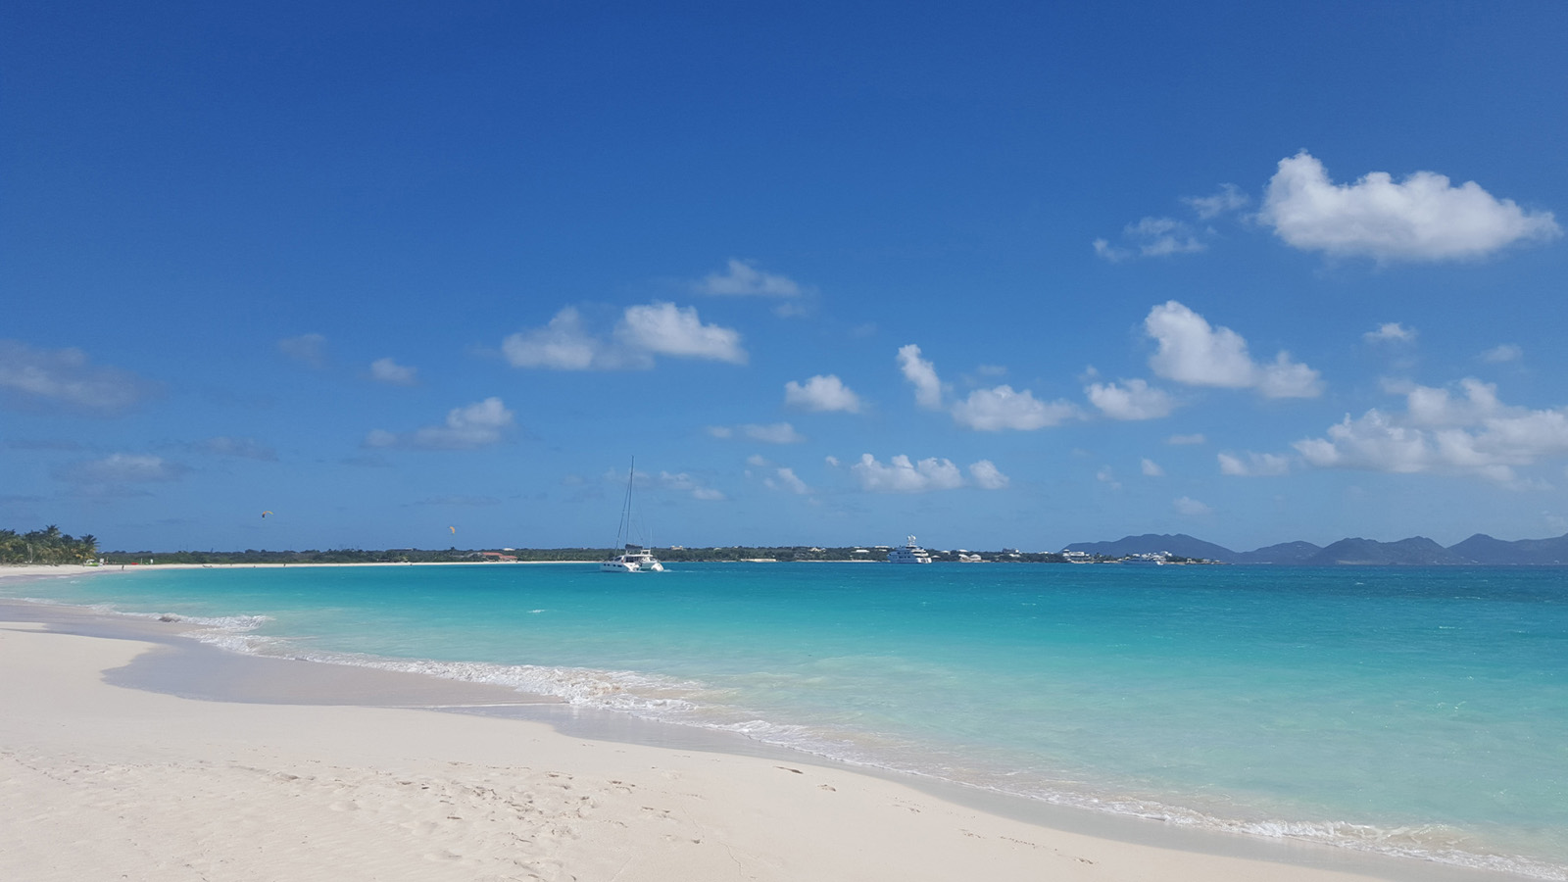 | April 25, 2019, Anguilla, West Indies  Four Seasons Resort and Residences Anguilla Celebrates Summer with All Things Anguilla 2019  https://publish.url/anguilla/hotel-news/2019/summer-calendar-and-activities.html

PRESS CONTACTS

Suzanne Willis
Director of Public Relations and Communications
Barnes Bay, P.O. Box 8028
West End
Anguilla
suzanne.willis@fourseasons.com

+1 (239) 287-7070

