BOURBON STEAK at Four Seasons Hotel Washington, DC Reopens Its Doors

Georgetown’s hottest patio is back, bigger and better than ever
June 22, 2020, Washington, DC, U.S.A.

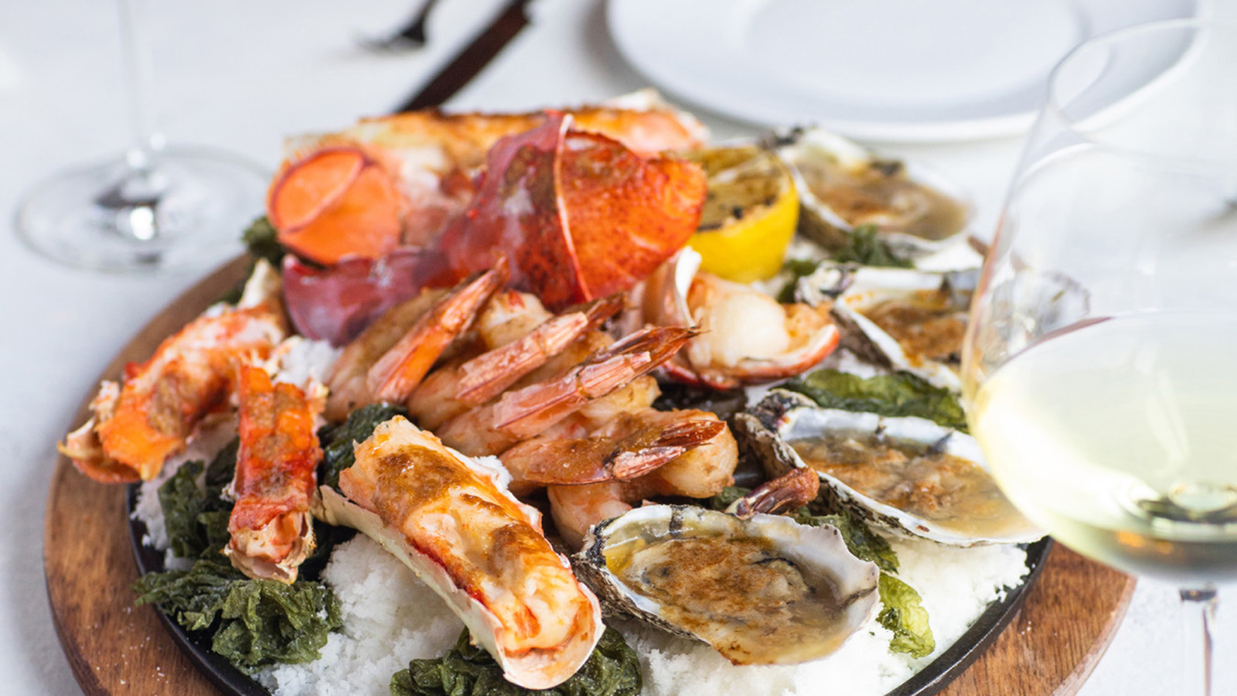
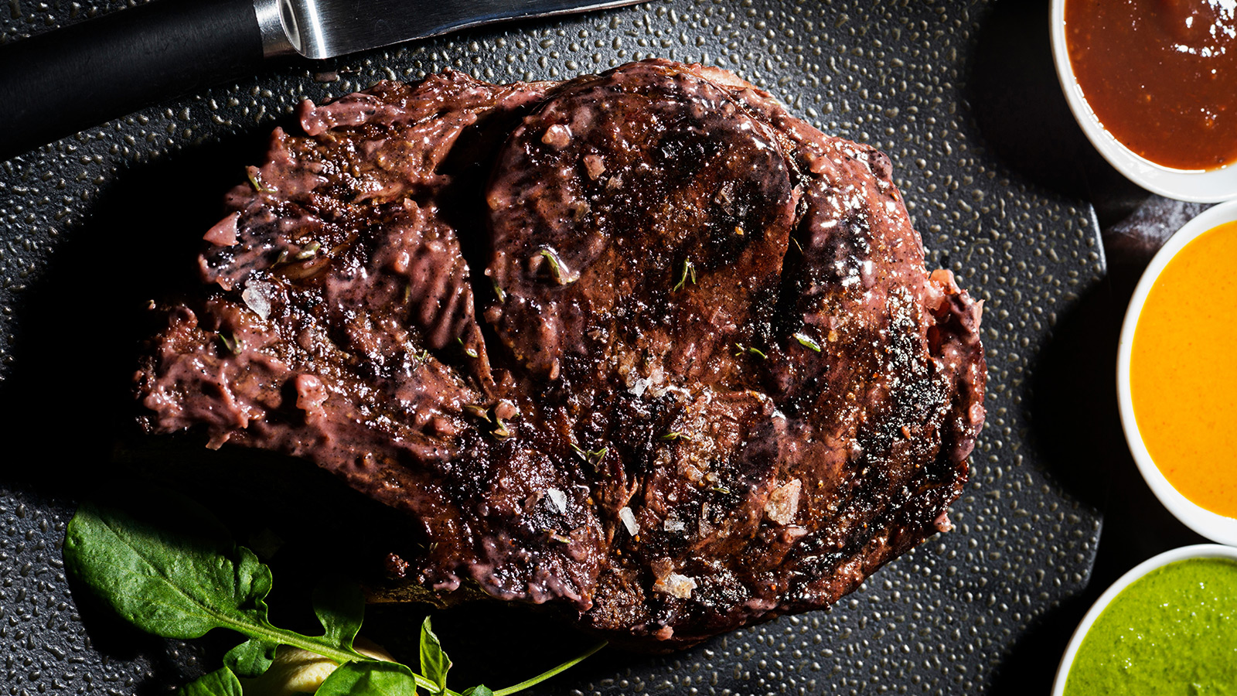 |  | 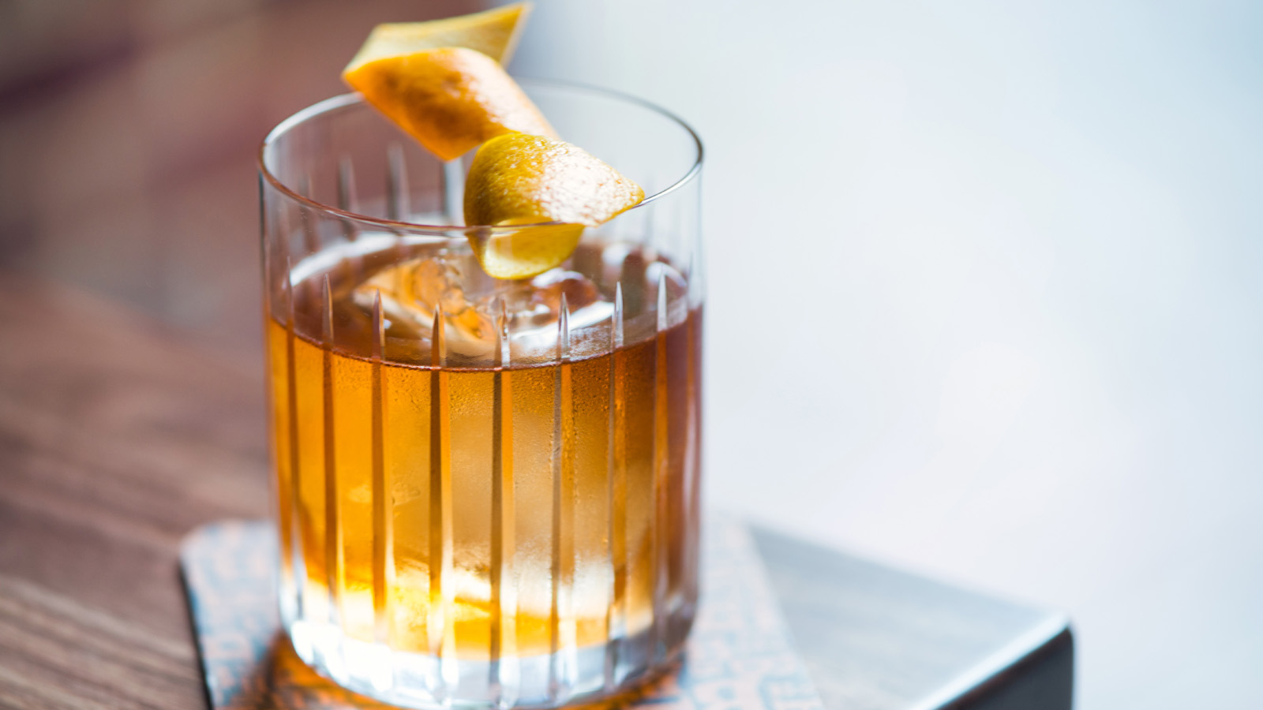
The team of BOURBON STEAK DC is excited to welcome guests back safely and securely to the one of the best patios in DC, just in time for summer fun. The patio has been extended to include both the front and the back patios of Four Seasons Hotel Washington, DC, offering more space for guests to linger over their favourite craft cocktails and legendary steaks.
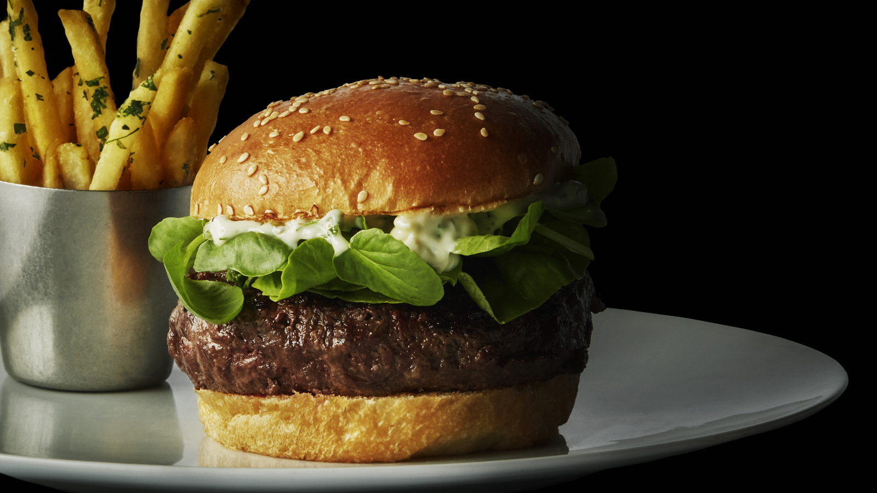 | 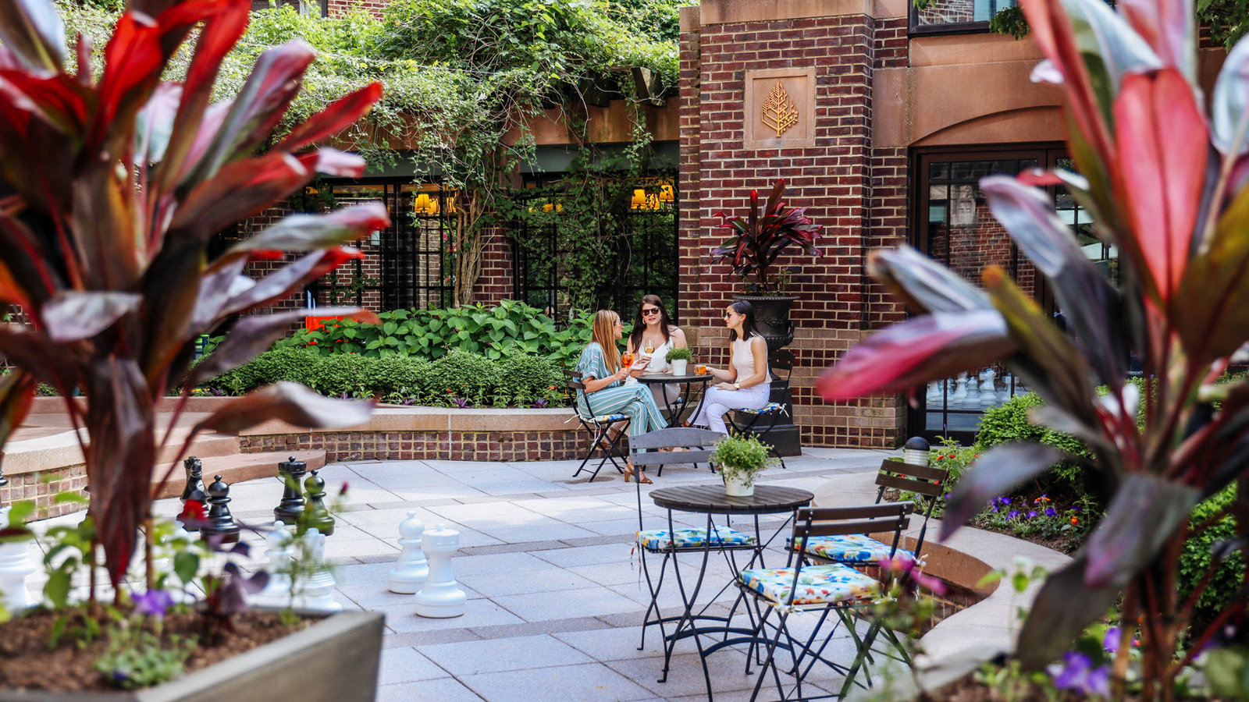 | 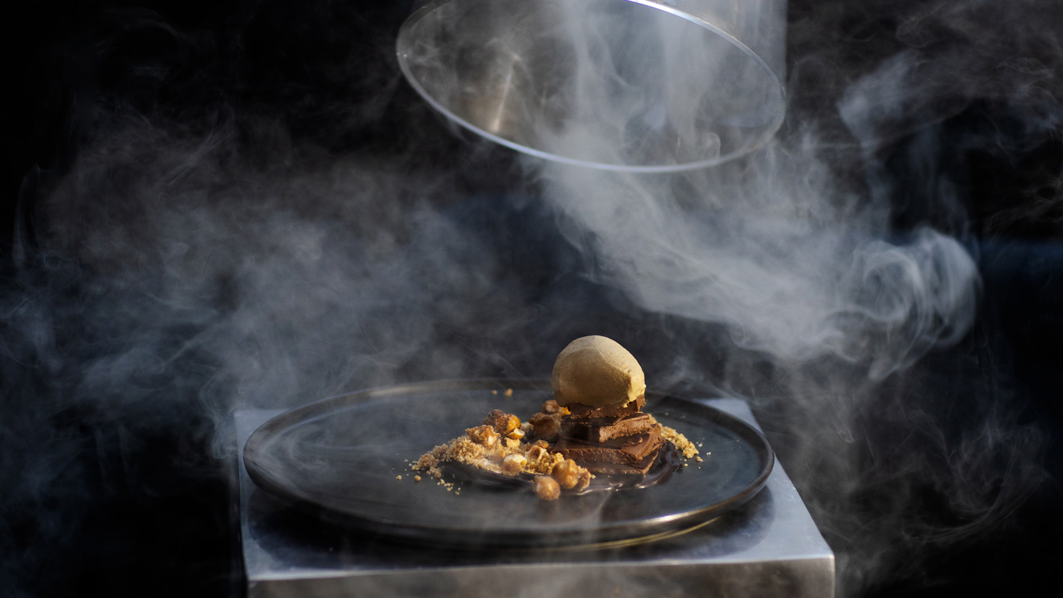
Famed, award-winning Chef Michael Mina brings back many of his favourite dishes, such as the miso-glazed shellfish platter, hand-cut steak tartare and buttery smooth wagyu steak. And of course, the duck fat fries and truffle bread are ready to be served in abundance.
New dishes on the menu, such as a lobster salad served with pole beans, prosciutto crisp and crème fraîche, will refresh the palate this summer. The truffle caesar salad made with baby gem lettuce and topped with a garlic streusel is a luxe version of a steakhouse classic. The newest steak on the menu, the Australian wagyu filet, is sure to become an instant favourite with its depth of flavour and melt-in-your-mouth texture.
BOURBON STEAK General Manager David Van Meerbeke says, “I can’t express how excited the entire team is to re-open BOURBON STEAK. We have missed seeing our guests and we have missed seeing each other. Welcoming back our regular guests feels like welcoming back family – we look forward to treating them to an epic dining experience!”
The safety and security of guests and employees remains top priority and, as such, BOURBON STEAK and Four Seasons Hotel Washington, DC have embarked on an enhanced health and safety program, Lead With Care, to provide ongoing, real-time guidance on the evolving COVID-19 situation. Grounded in health care expertise and enabled by access to leading technologies and tools, Lead With Care sets out clear procedures that educate and empower employees to take care of guests and each other. Through the Lead With Care program, Four Seasons Hotel Washington, DC will focus on enhancing cleanliness, guest comfort and safety and employee training.
Starting June 26, 2020, new hours of operation will be Wednesday through Friday, 5:00 to 10:00 pm and Saturday and Sunday, 3:00 to 10:00 pm for lounge, patio and dinner service.
Reservations are recommended – call BOURBON STEAK at +1 202 342-0444 or book online.

RELATED

June 10, 2020, Washington, DC, U.S.A.
Four Seasons Hotel Washington, DC Kicks Off Its 40th Annual Race to Beat Cancer on Global Wellness Day as a Community Virtual Challenge
https://publish.url/washington/hotel-news/2020/race-to-beat-cancer-kickoff.html

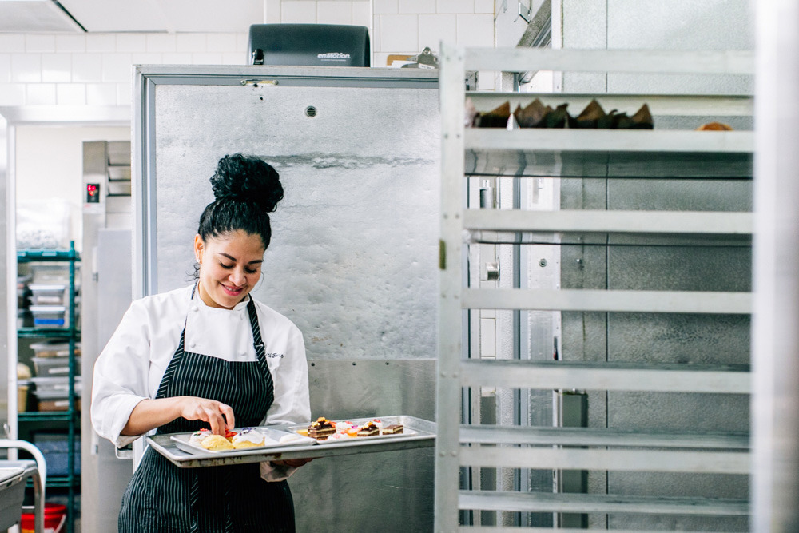 | May 6, 2020, Washington, DC, U.S.A.  Four Seasons Hotel Washington, DC and Mina Group Launch Relief Fund to Assist Furloughed Employees  https://publish.url/washington/hotel-news/2020/relief-fund.html

PRESS CONTACTS

Anina Belle Giannini
Director of Public Relations
2800 Pennsylvania Avenue N.W.
Washington
U.S.A.
aninabelle.giannini@fourseasons.com

+1 202 944 2074

