Grand-Hôtel du Cap-Ferrat, A Four Seasons Hotel, Launches Le Cap’s Christmas Takeaway

Michelin-starred Chef Yoric Tièche and Pastry Chef Florent Margaillan have created a festive menu for guests to enjoy delectable culinary delights over the Christmas season in the comfort of their own homes
October 19, 2020, Saint-Jean Cap-Ferrat, France

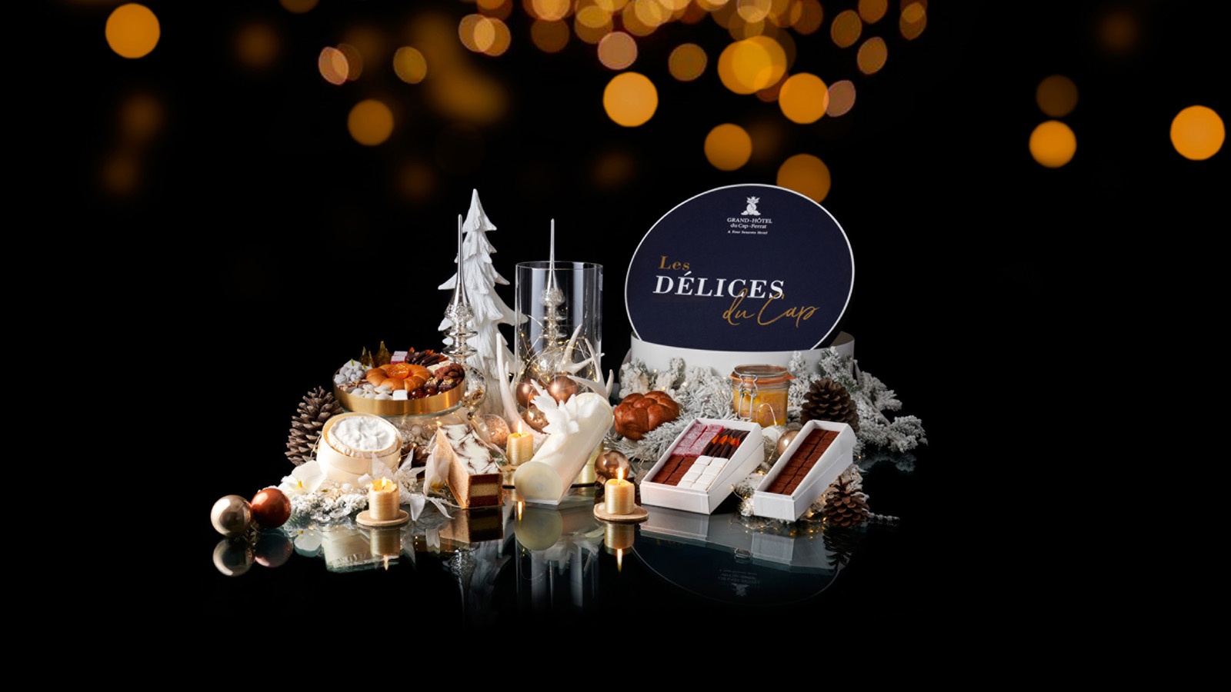
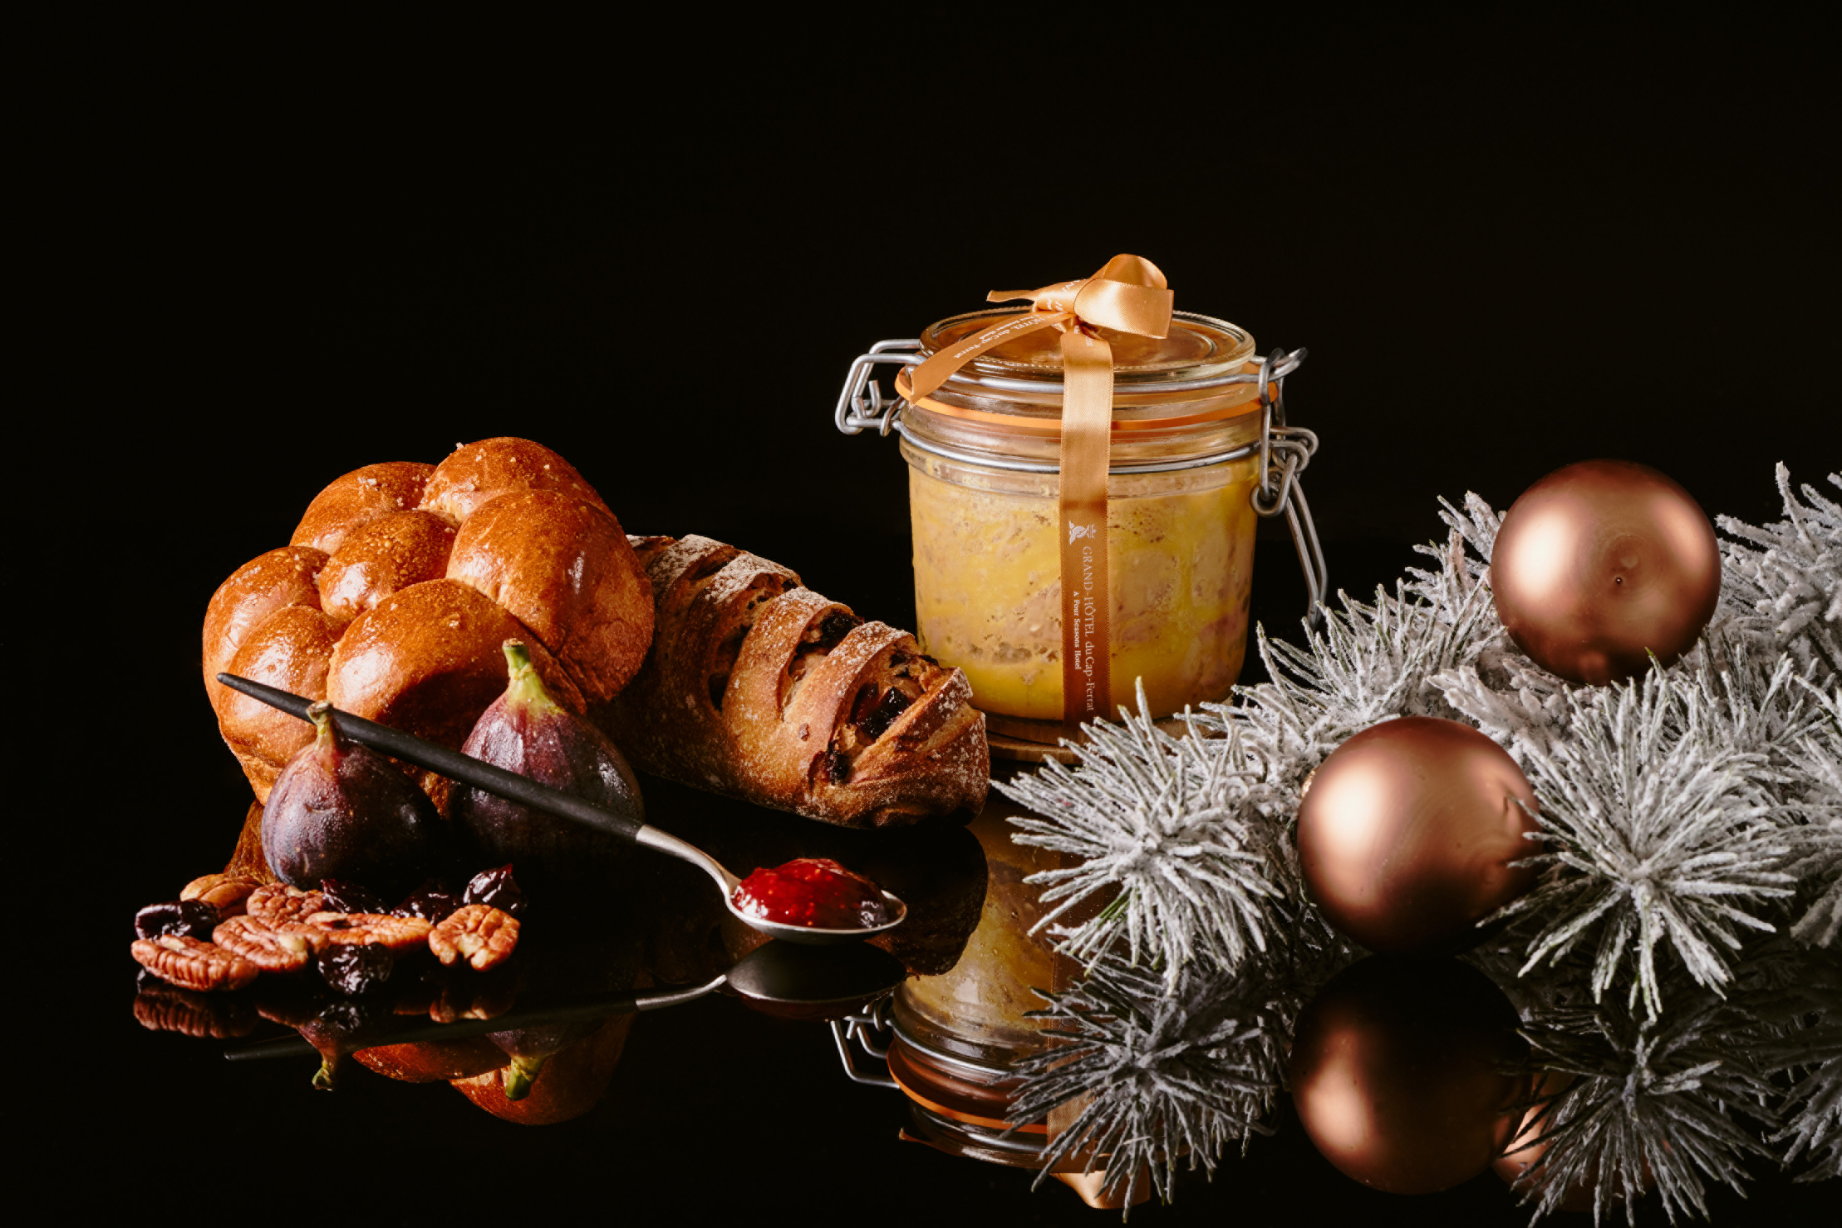 | 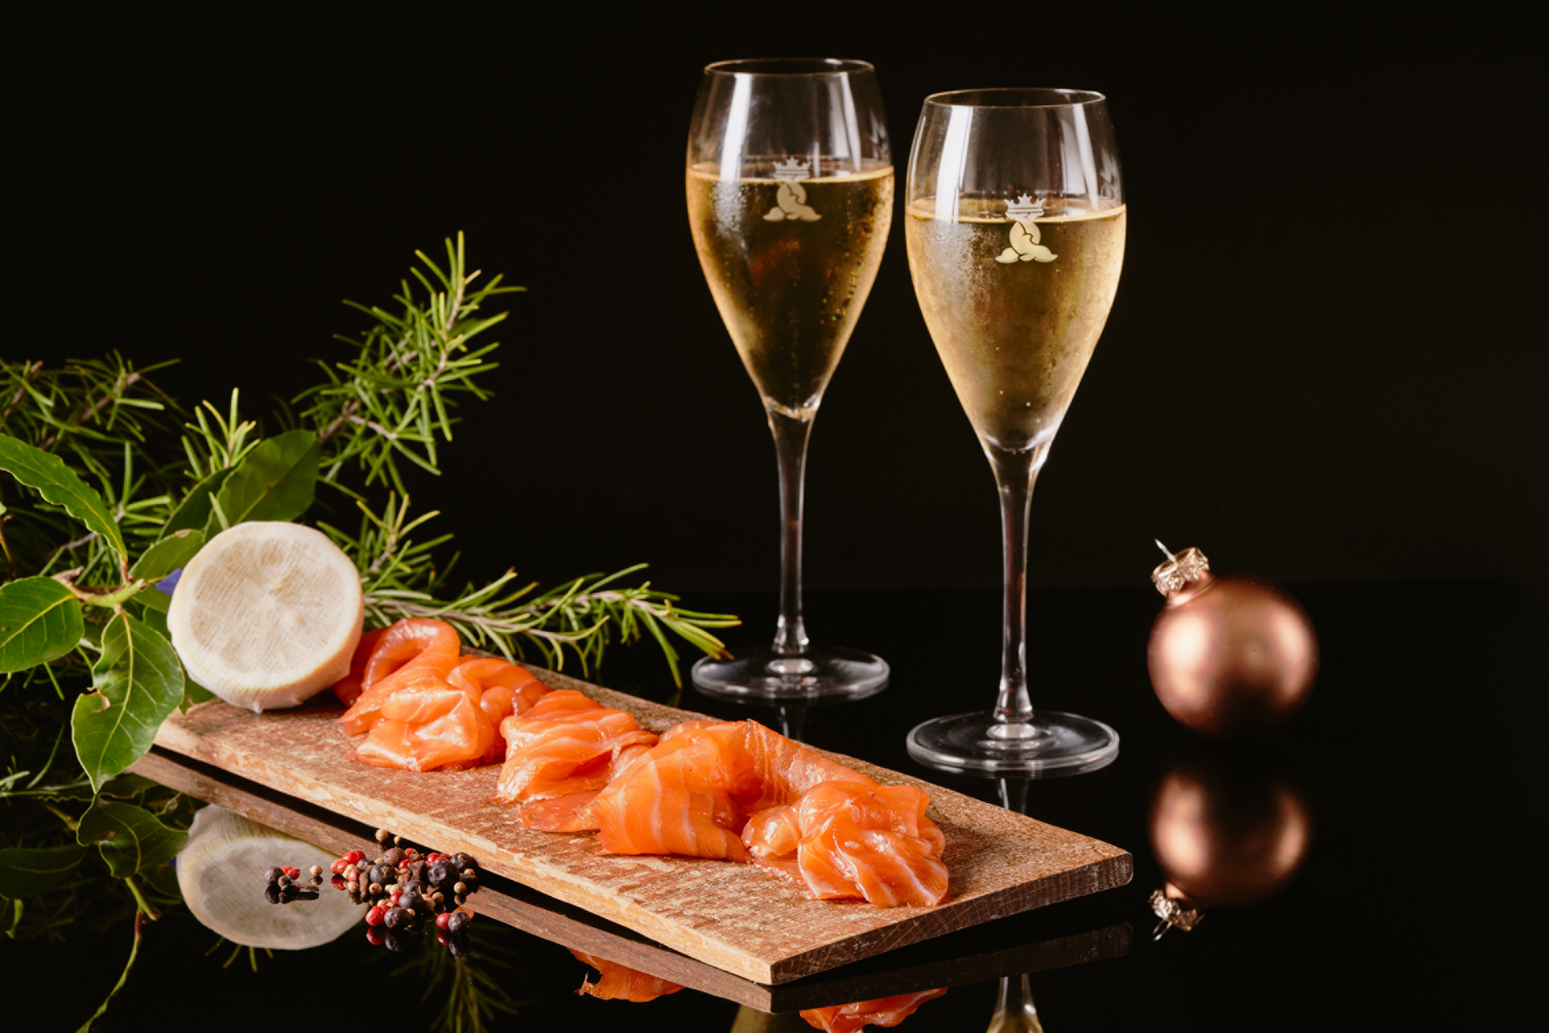 | 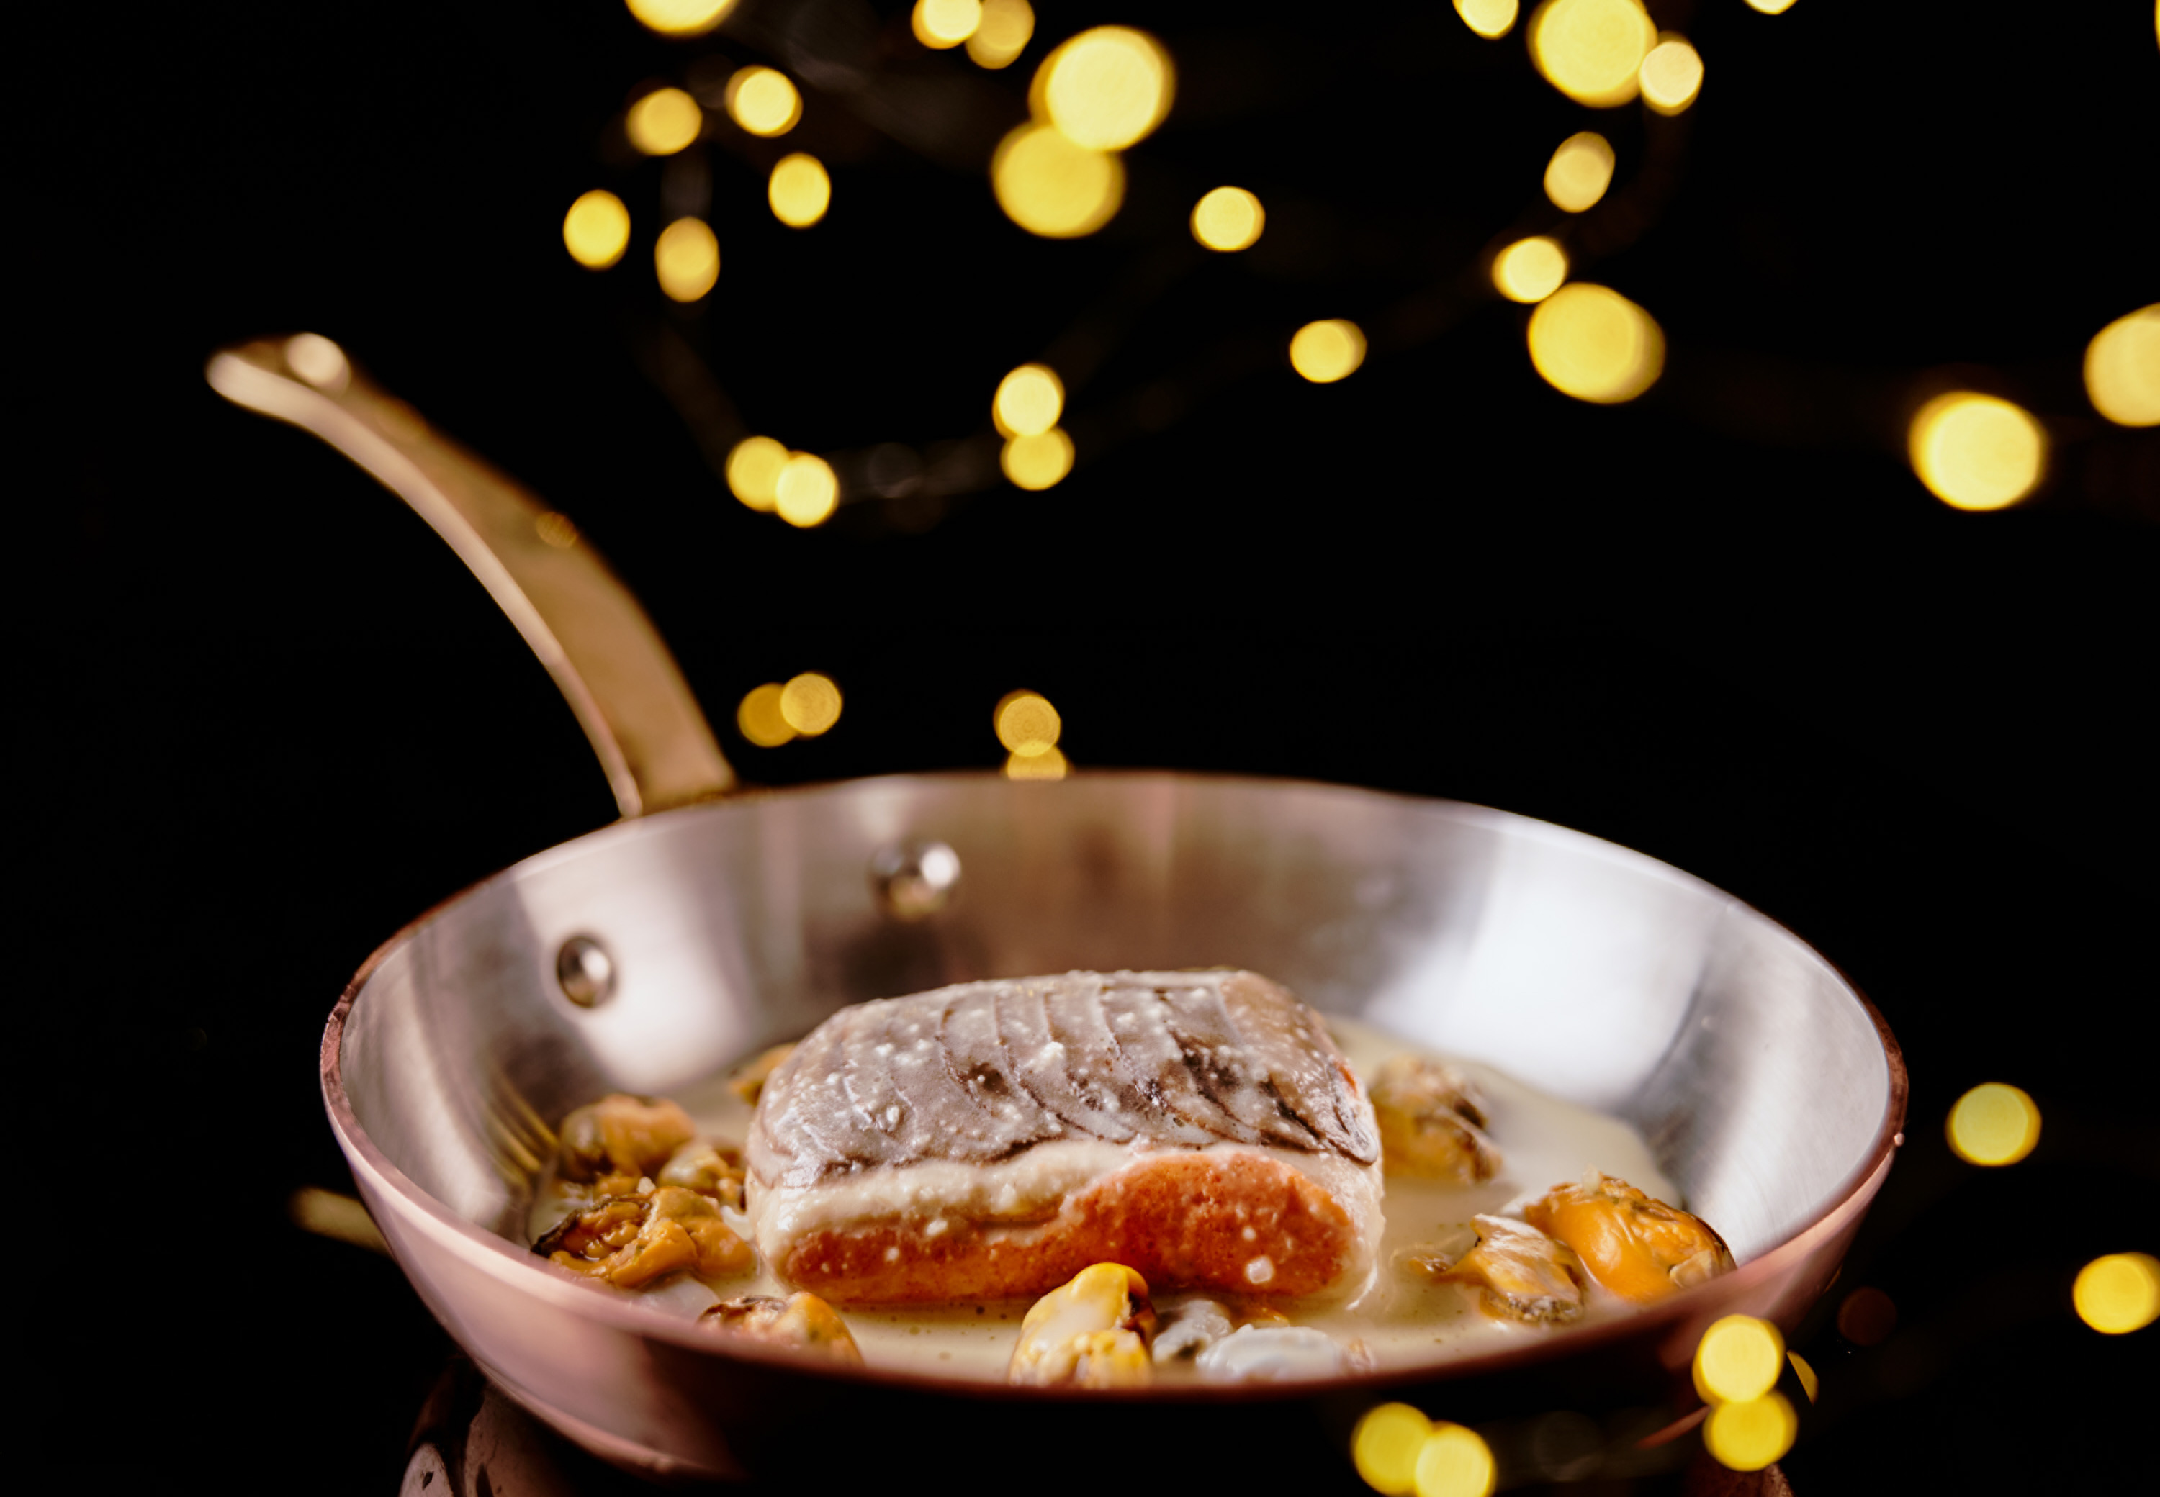
While Grand-Hôtel du Cap-Ferrat, A Four Seasons Hotel, will close its doors on November 1 for the 2020 season, the Hotel’s celebrated chefs will continue to work their culinary magic, creating a gastronomic offer for the festive season. Dishes can be enjoyed at home, with delivery service available within selected areas between Nice and Monaco.
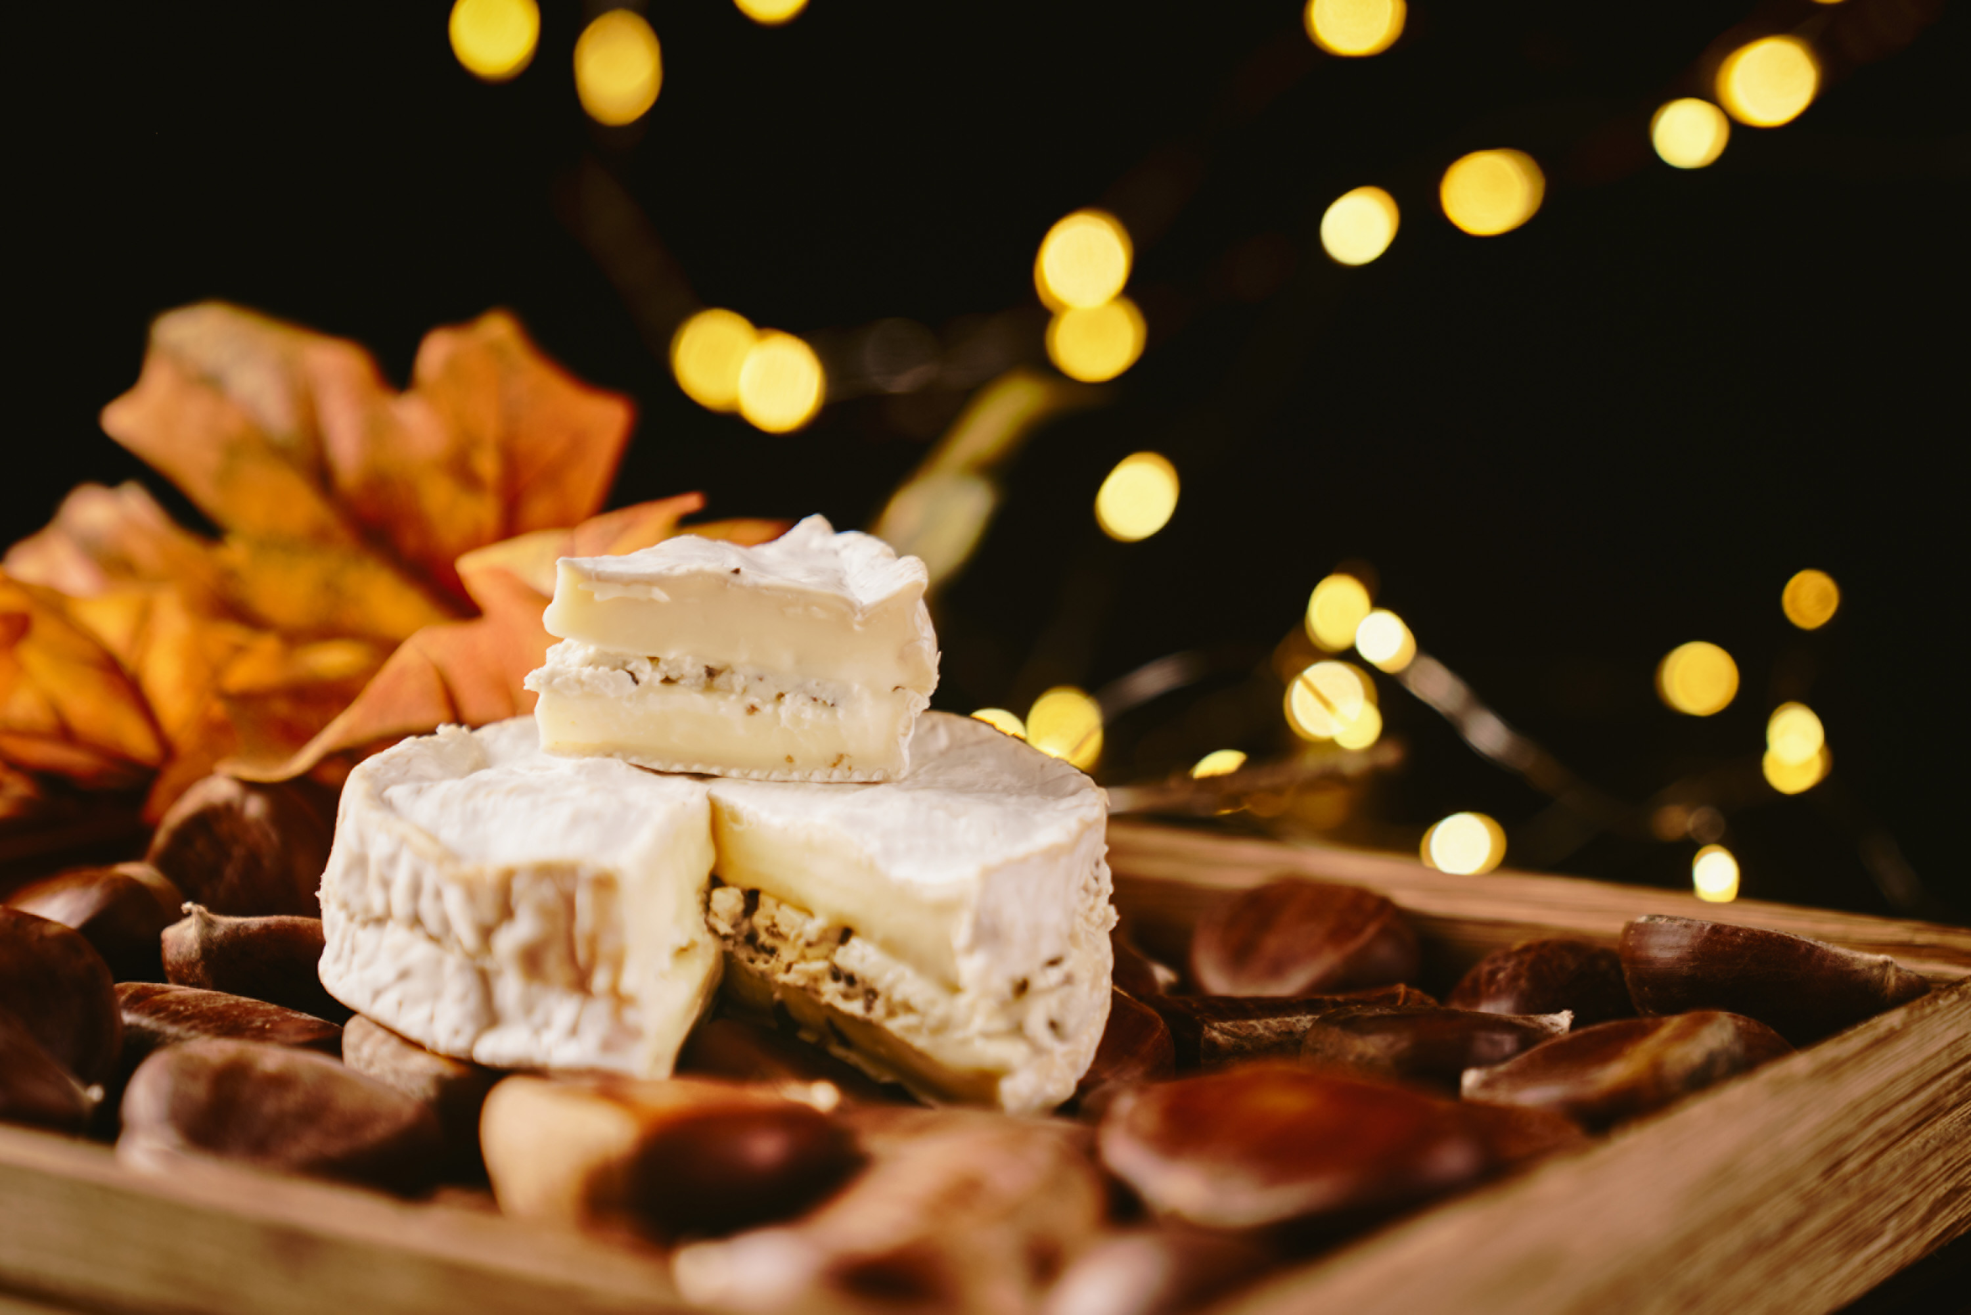 | 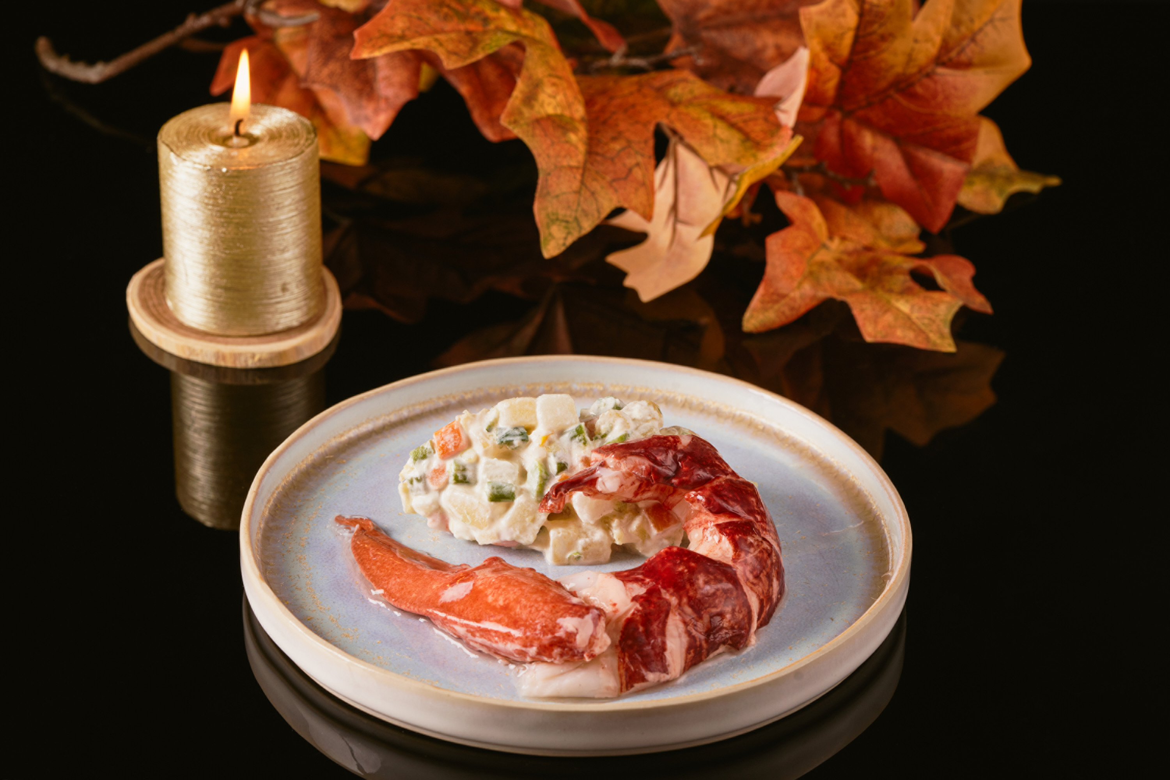 | 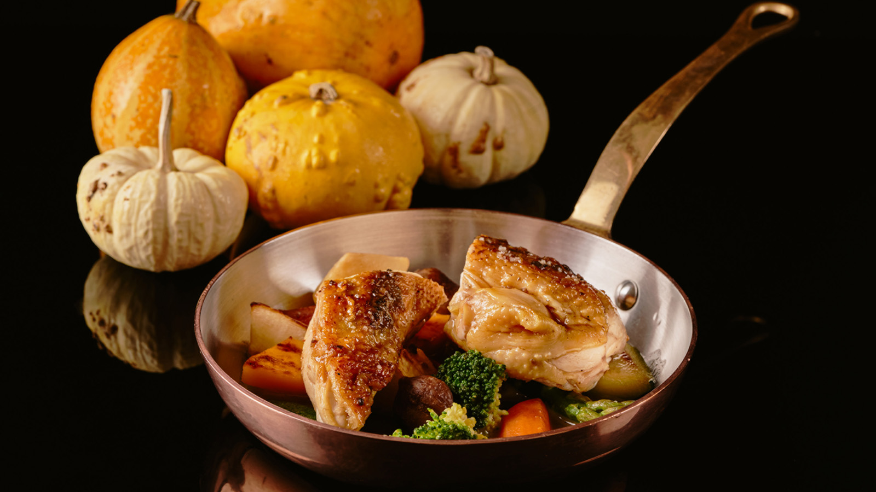
Chef Yoric Tièche wishes to make end-of-year celebrations more convivial than ever, with joyous family gatherings fully embracing the spirit of Christmas. Featuring seafood and Provençal specialities, Tièche’s festive menu is home delivered, with detailed dish descriptions provided to enhance the gastronomic experience. Dishes are portioned and feature easy-to-assemble trimmings, making them very simple to put together at home.
The menu includes a number of traditional festive dishes such as homemade IGP certified French duck foie gras, and home-smoked salmon from the Faroe Islands seasoned with pink pepper. The Chef’s much-loved fish and seafood dishes take pride of place, including a half Breton blue lobster served with Russian salad, Breton scallops with Champagne buttered leeks, and wild sole fillet with shellfish à la marinière. Meat lovers can opt for the free-range chicken breast with truffles.
Pastry Chef Florent Margaillan, crowned French Dessert Champion 2010, has created a Yule log inspired by local Meyer lemons, highlighting the importance of citrus fruits in the area. Florent uses sustainably sourced lemons from Joëlle Etienne’s farm in the Var department. His log brings out the fruit's delicate, juicy taste, featuring a shortbread, cream, biscuit, and smooth and silky mousse, all made with lemon, complemented by a centre infused with icy mint that is freshly picked from the Hotel’s herb garden.
Sweet tooths must not miss Florent Margaillan’s selection of traditional Christmas sweet delights, including his platter of 13 Provençal desserts, and a gingerbread-style Christmas cake with a lemon centre. A selection of gourmet assortment boxes completes the offer, with Christmas treats and chocolate truffles made with Florent’s signature 69 percent dark chocolate, a bespoke blend created for the Grand-Hôtel du Cap-Ferrat by renowned French chocolate manufacturer Valrhona.
Le Cap’s Christmas Takeaway is available by pre-order only. Menus must be ordered before December 20, 2020 and delivery service is available within selected areas between Nice and Monaco. Free delivery for orders over EUR 100, with dishes delivered before 12:00 noon on December 23 and 24, 2020. Pick-up from the Hotel can also be organised upon request.
Le Cap’s festive menu offers guests the chance to discover the talent of the culinary team of Grand-Hôtel du Cap-Ferrat, A Four Seasons Hotel, before the Hotel re-opens its doors on March 5, 2021.
To place an order:
- Tel: 04 93 76 50 50
- Email: reservations.capferrat@fourseasons.com
Le Cap’s Delights
All pricing is in EUR.
Savoury Delights
- Homemade IGP certified French duck foie gras – 200g terrine - 45
- Home-smoked salmon from the Faroe Islands seasoned with pink pepper 200g - 35
- Half Breton blue lobster served with Russian salad - 39
- Breton scallops with Champagne buttered leeks - 35
- *Wild sole fillet with shellfish à la marinière - 40
- *Free-range Maison Lino chicken breast with truffles - 42
- Unpasteurised truffle camembert (250g) with homemade walnut bread - 32
*Served with pan-fried young seasonal vegetables
All of Le Cap's savoury festive dishes are prepared using fresh French ingredients.
Sweet Delights
Sweet treats are made with 69 percent dark chocolate.
- Meyer Lemon / Icy Mint Yule Log – serves 8 - 82
- Platter of 13 Provençal Desserts – 750g - 72
- Christmas Cake – 350g - 35
- Christmas Assortment Box – orangettes, truffles, nougat, marzipan – 500g - 55
- Chocolate Truffle Assortment Box featuring Florent’s Signature Chocolate – 250g - 35

RELATED

October 19, 2020, Saint-Jean Cap-Ferrat, France
Le Grand-Hôtel du Cap-Ferrat, A Four Seasons Hotel lance « Les Délices du Cap »
https://publish.url/fr/capferrat/hotel-news/2020/christmas-takeaway-menu-2.html

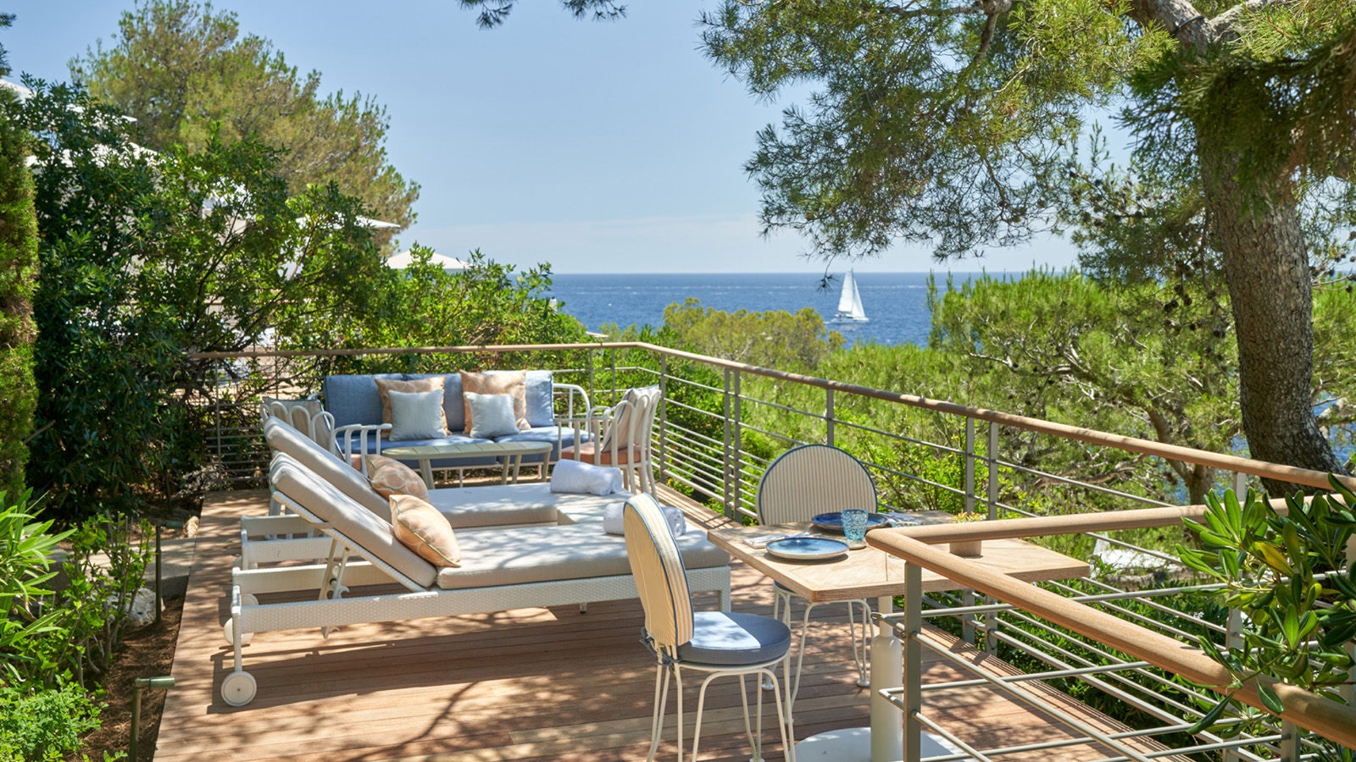 | October 9, 2020, Saint-Jean Cap-Ferrat, France  Le Grand-Hôtel du Cap-Ferrat, A Four Seasons Hotel est Elu « Top Hotel en France et Monaco » dans le Classement « Readers’ Choice Awards 2020 » du Magazine Americain Condé Nast Traveler  https://publish.url/fr/capferrat/hotel-news/2020/top-hotel-in-france-2.html

PRESS CONTACTS

Aurore Escrihuela
Public Relations Manager
71 Boulevard du General de Gaulle
Saint-Jean Cap-Ferrat
France
aurore.escrihuela@fourseasons.com

+33 (0)4 93 76 50 10

Caroline Mennetrier
Director of PR and Marketing Communication
71 Boulevard du General de Gaulle
Saint-Jean Cap-Ferrat
France
caroline.mennetrier@fourseasons.com

+33 6 26 39 96 76

