Five Steps to Wellness for 2020

Wellness Manager McKenzie Cassidy shares expert tips for those seeking a greater sense of wellbeing this winter
January 13, 2020, Boston One Dalton, U.S.A.

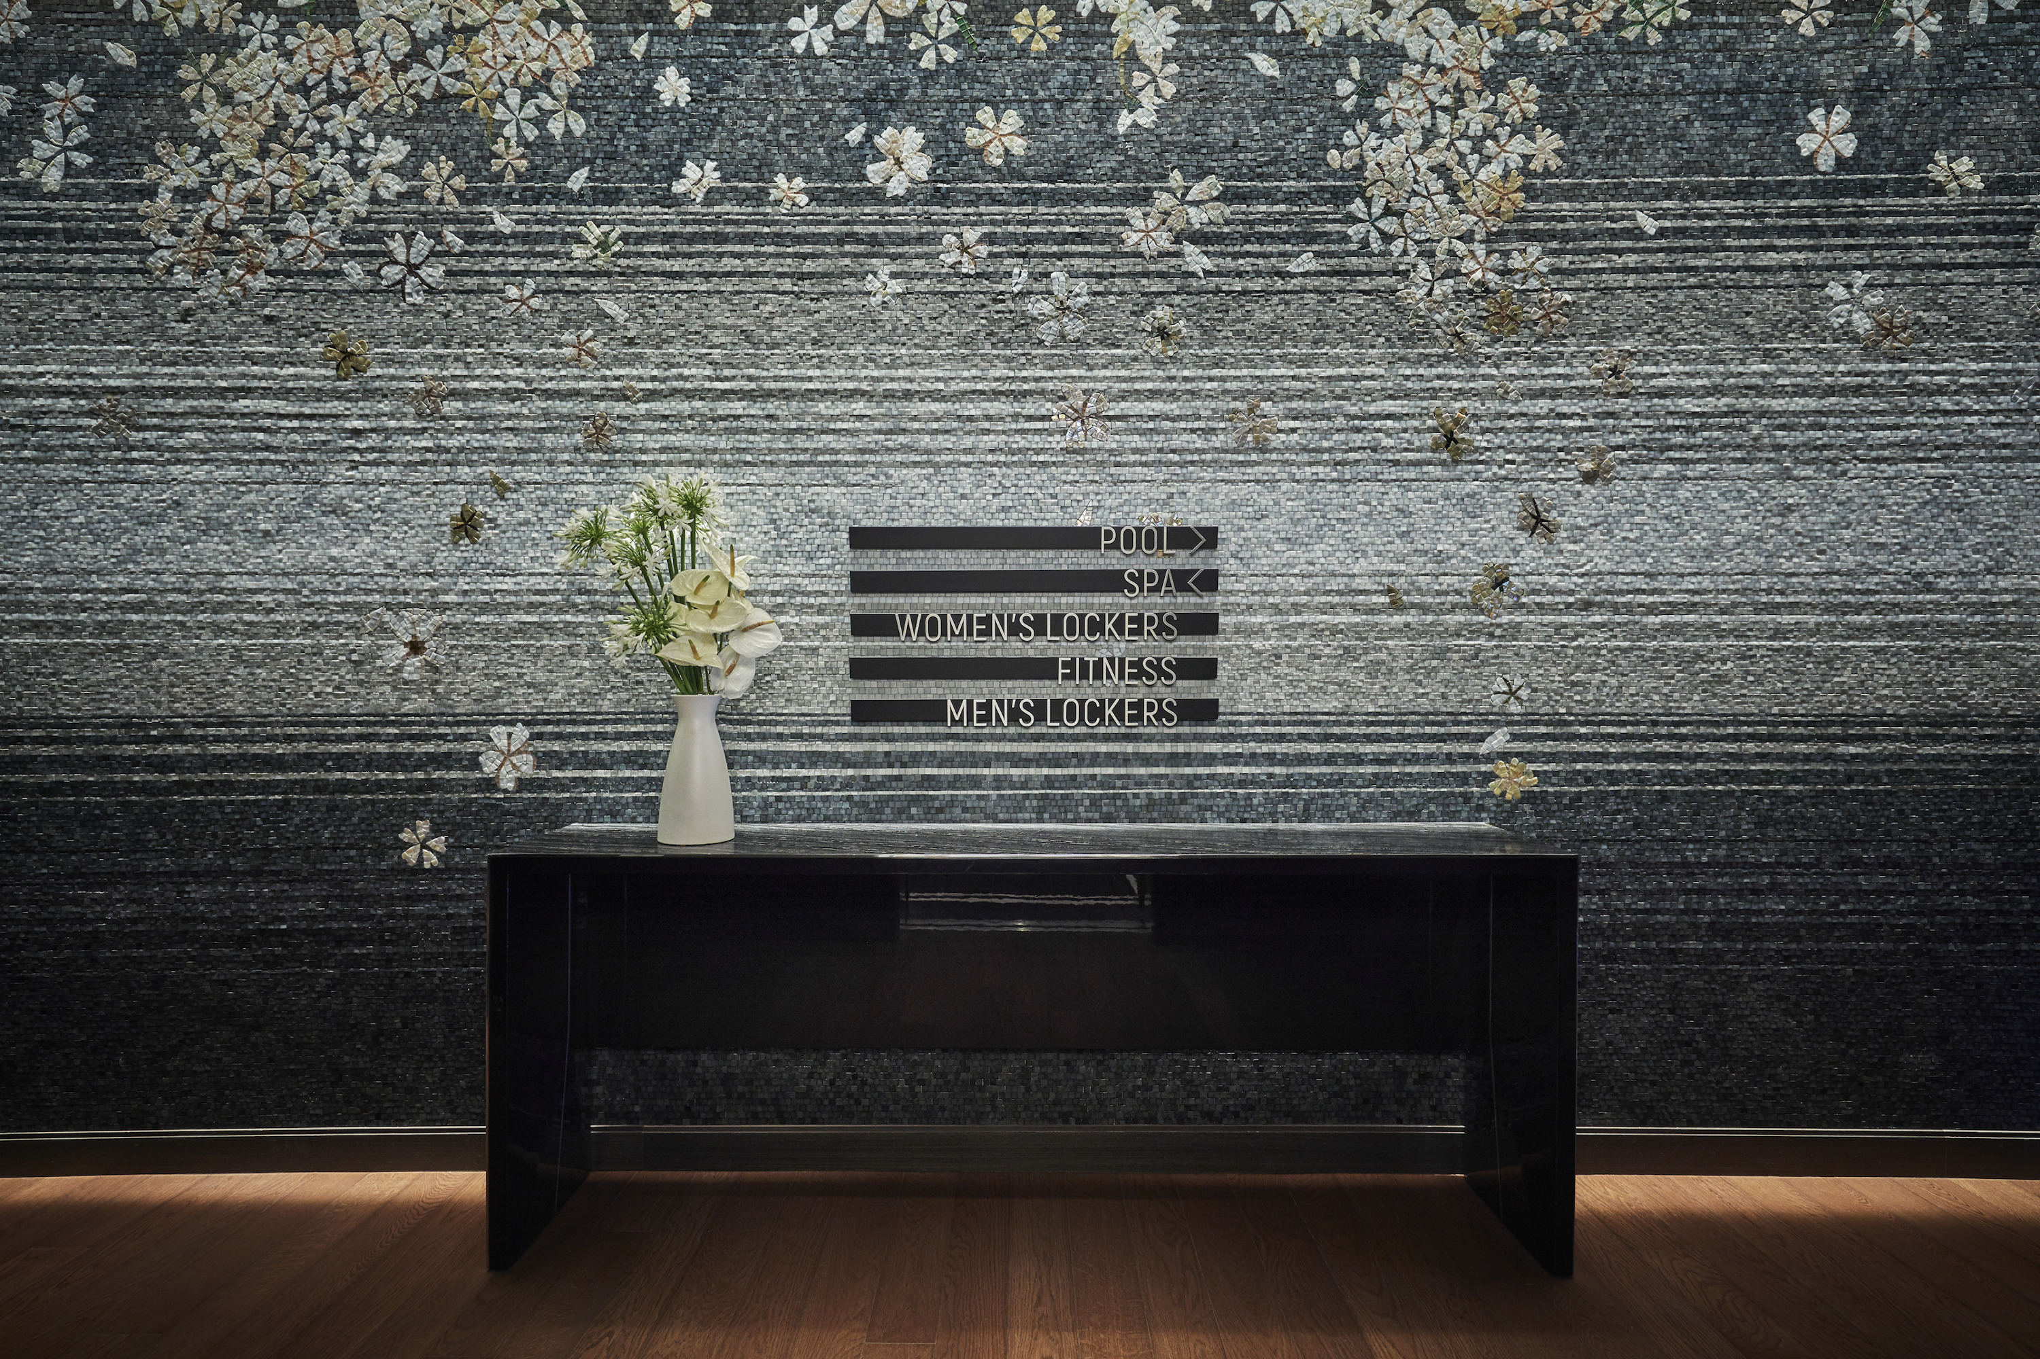
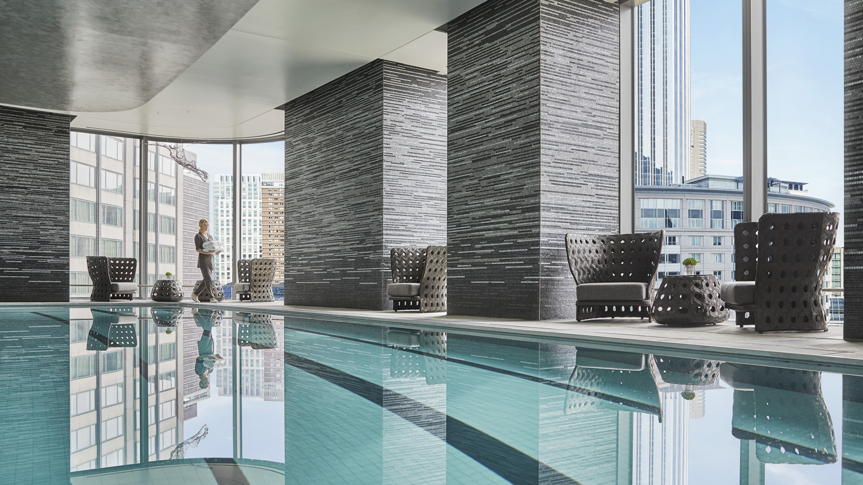 | 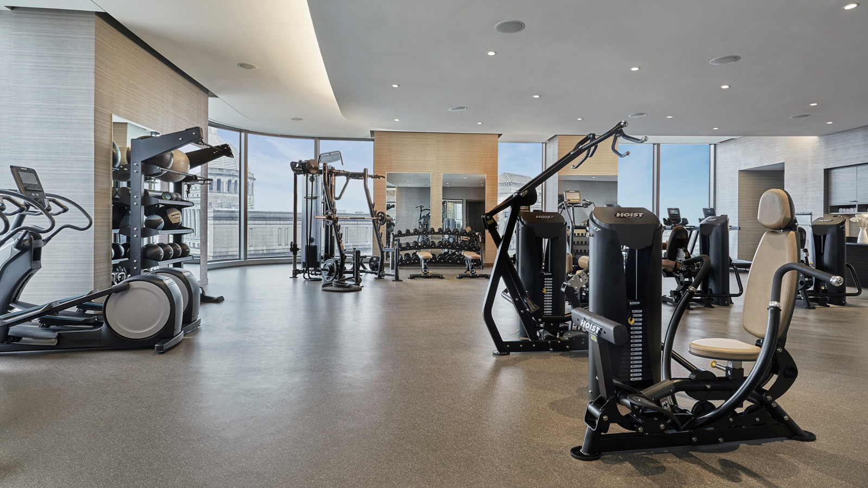 | 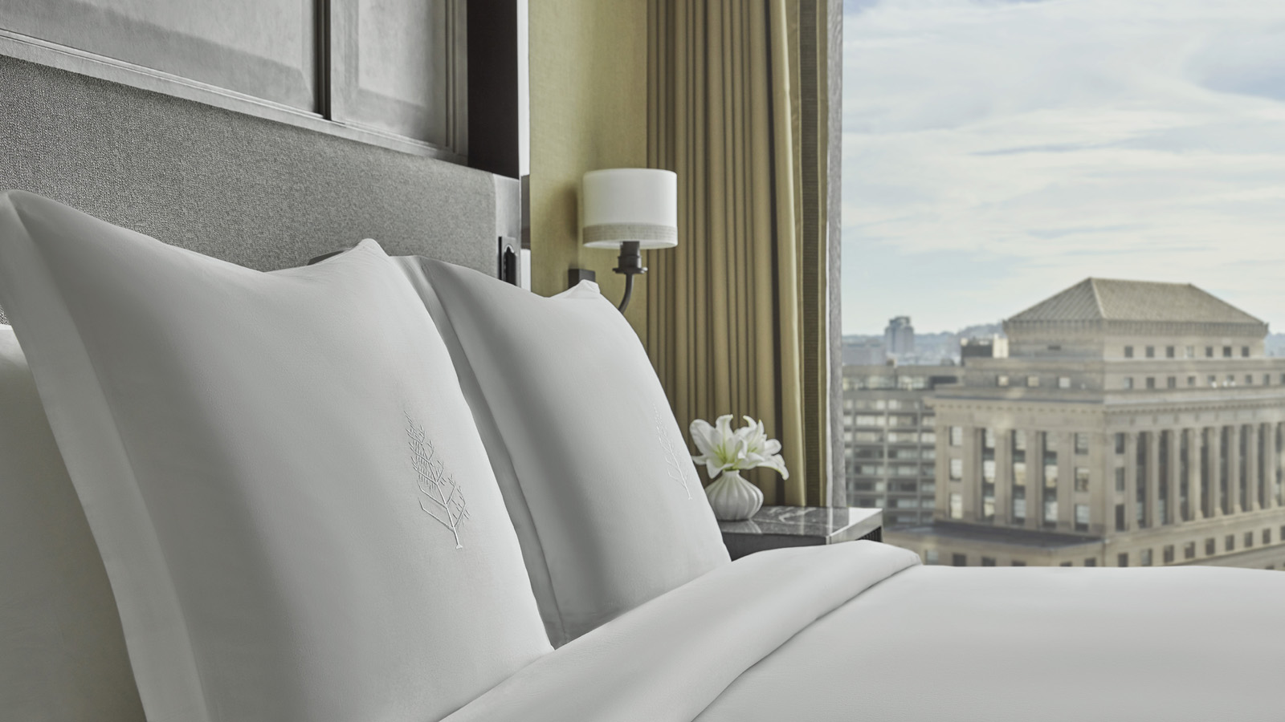
The Wellness Floor at One Dalton is dedicated in its passion for guiding guests to an increased sense of wellbeing. Taking a lead role in this initiative is Wellness Manager McKenzie Cassidy, who ensures her team of experts at Four Seasons Hotel One Dalton Street, Boston delivers guests the perfect environment to focus upon rebalancing both body and mind.
A signpost to The Wellness Floor’s philosophy, McKenzie spends time with the guests that she interacts with on a daily basis, ensuring that outside of the time they spend on property at One Dalton’s pristine, state-of-the-art spa facilities, that they are doing their utmost to look after themselves.

RELATED

November 25, 2019, Boston One Dalton, U.S.A.
Four Seasons Hotel One Dalton Street, Boston Unveils Its Inaugural Program of Holiday Season Events
https://publish.url/onedalton/hotel-news/2019/festive-season.html

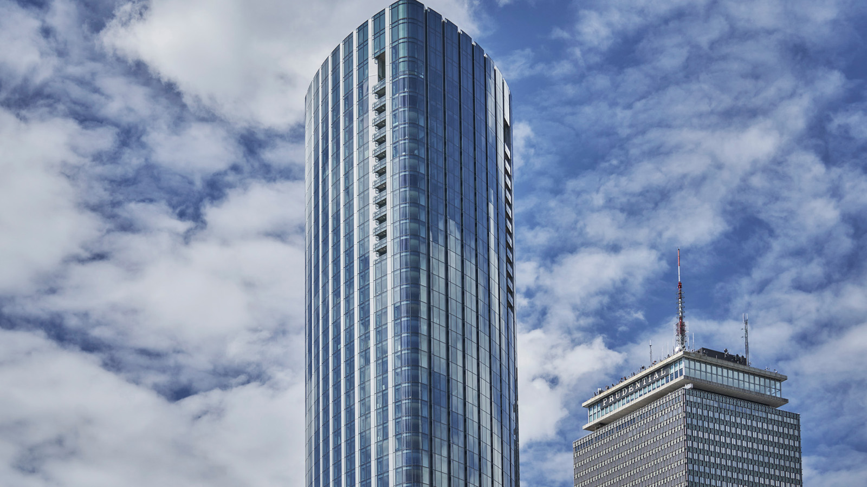 | October 29, 2019, Boston One Dalton, U.S.A.  Four Seasons Hotel One Dalton Street, Boston Welcomes the Season of Fall with New Stay Offers  https://publish.url/onedalton/hotel-news/2019/fall-and-winter-stay-offers.html

PRESS CONTACTS

Robert Chinman
Director of Public Relations
1 Dalton Street
Boston
USA
robert.chinman@fourseasons.com

+1 857 233 6950

Katie Eldemery
Digital Marketing Coordinator
1 Dalton Street
Boston
USA
katie.eldemery@fourseasons.com

