Love Flourishes to New Heights with Four Seasons Hotel Chicago

Marvel at elevated dining and cocktail experiences perched amid the backdrop of the most loved views of the city’s skyline
February 2, 2023, Chicago, U.S.A.

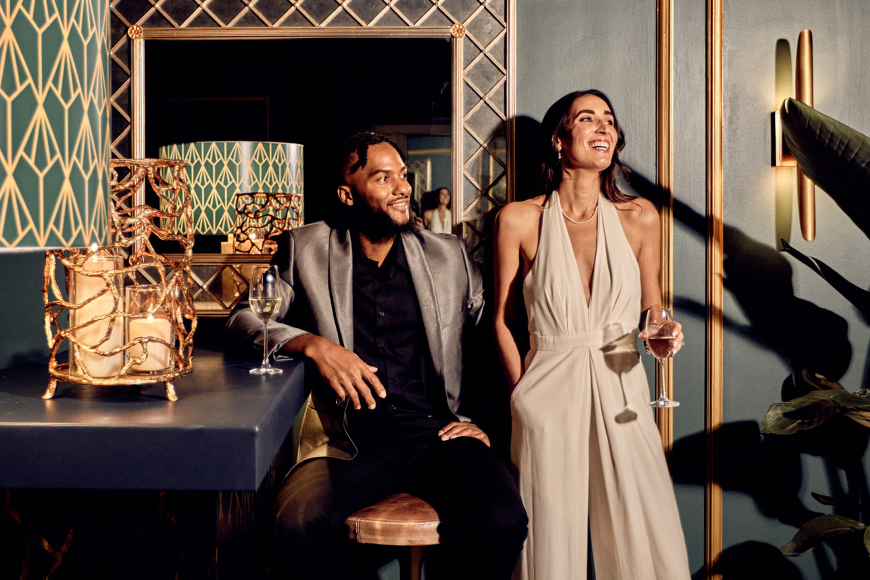
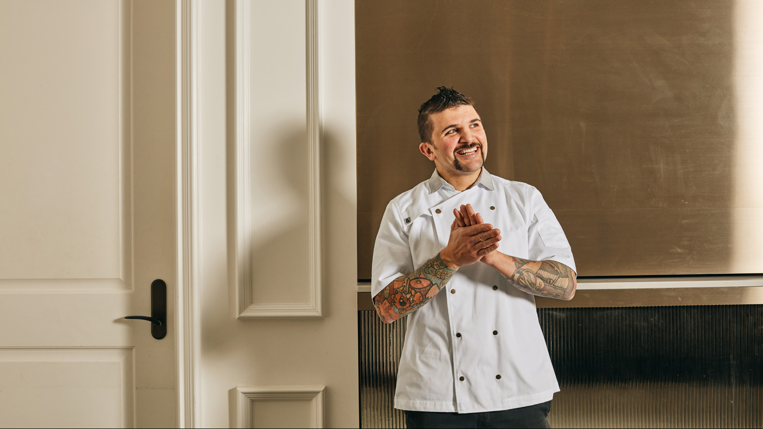 | 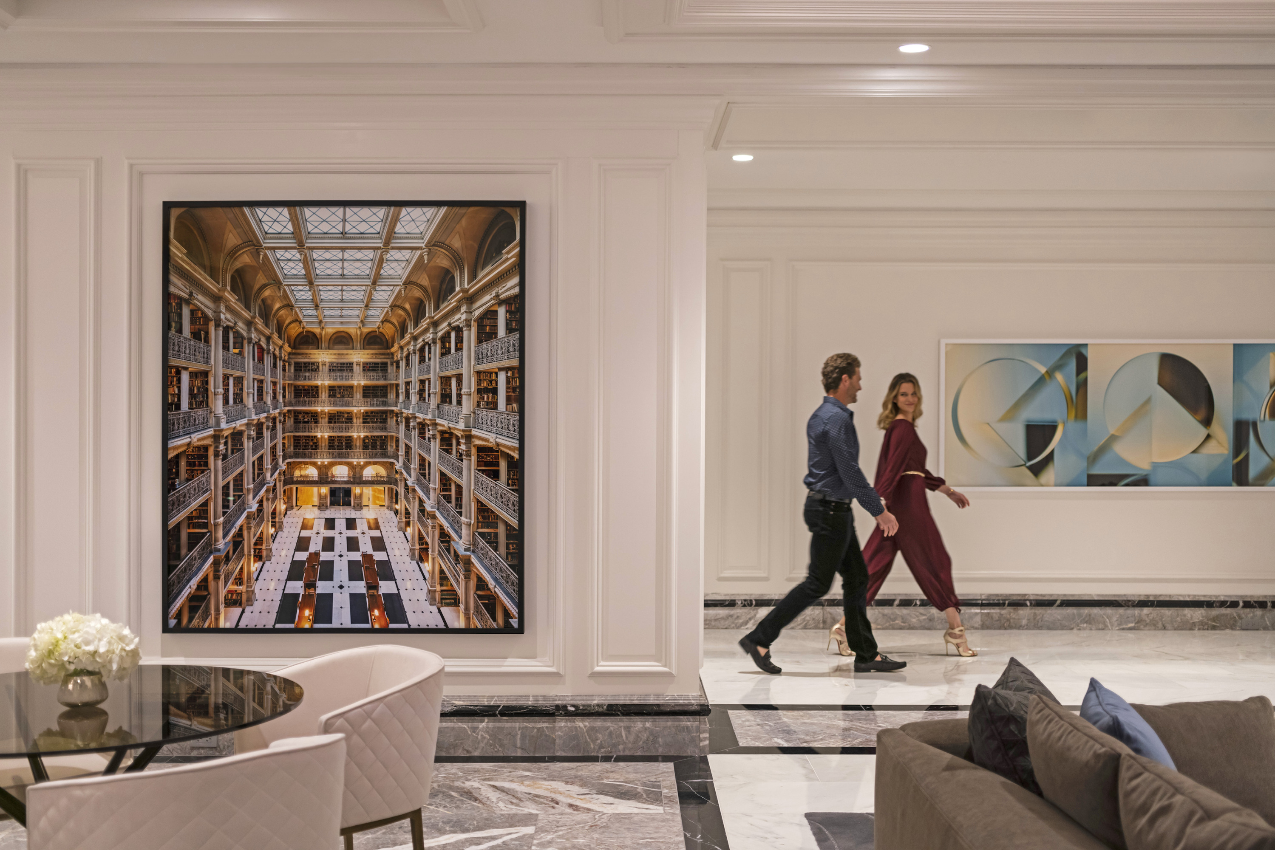 | 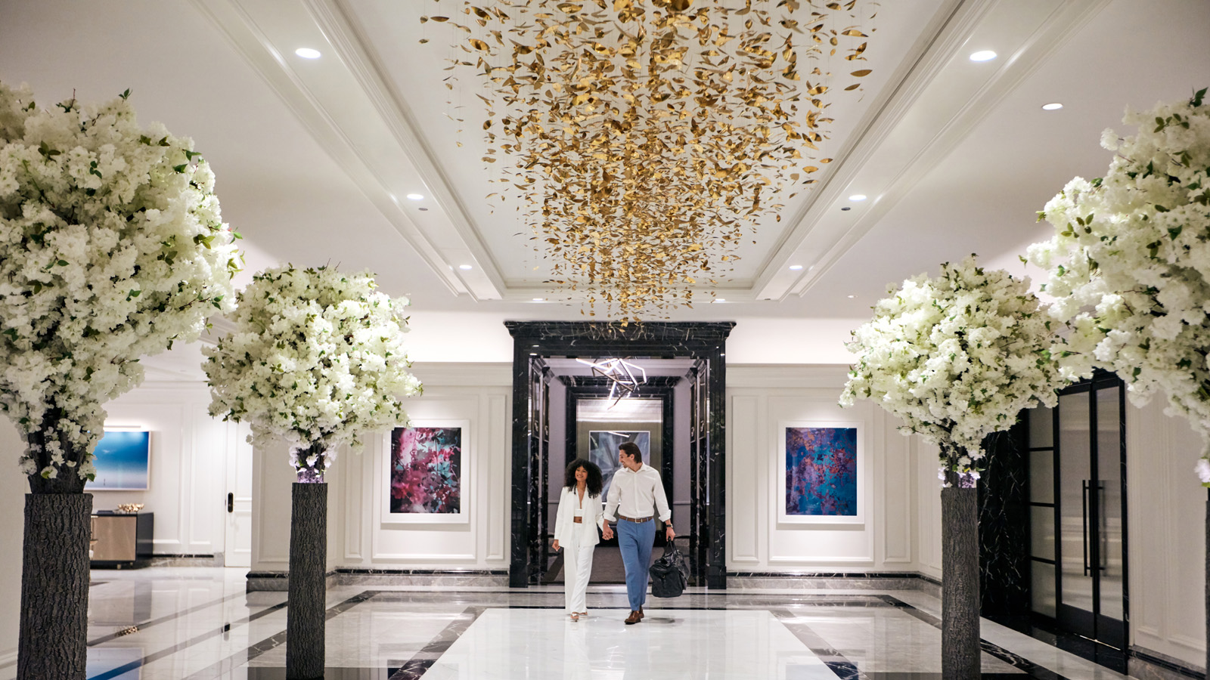
This February, love is soaring at Four Seasons Hotel Chicago. Guests will enjoy curated experiences with their amore, from a first-of-its-kind tasting menu in the heart of the city and speakeasy cocktails perched above the clouds, to live music from renowned-Chicago musicians and special activities for couples and families alike.
Adorn Bar & Restaurant
Join Executive Chef Richie Farina for a true act of romance as he debuts his vision for Adorn with select dishes from his upcoming spring menu. Chef Farina’s intimate six-course tasting menu preview is brimming with delicious ingredients, masterful technical bites and intrigue, leaving guests with unexpected twists throughout the dining spectacular.
Be one of the first to experience Chef Farina’s menu between Monday, February 13 and Sunday, February 19, 2023. Guests dining on Valentine’s Day Tuesday, February 14 will be treated to an extra serving of whimsy with an edible love note from Adorn.
To make a reservation book online, or call 312 280 8800.
Mile High Cocktail Club
Floating 46 stories above the Magnificent Mile sits the Mile High Cocktail Club. Impress loved ones and travel through the clouds to the highest speakeasy experience in Chicago, where guests can visit the Seven Wonders of the World in one evening. Cosy up at this coveted cocktail lounge this Valentine’s Day and sip on handcrafted spirits curated for the perfect pre-dinner soirée or nightcap.
Reservations are required and limited. This experience is available until April 1, 2023. To secure a table at #ClubMH, book online or call 312 280 8800.
For guests looking to further elevate date night, interactive cocktail classes with mixology guidance from Four Seasons experts in the elusive Mile High Cocktail Club are available on Saturdays in February at 3:00 pm. Discover how to craft the perfect Espresso Martini and classic Negroni or No-Groni. Class is limited to eight people and reservations are required. Make a night of it and stay after class for dinner with a USD 50 dining credit for Adorn Restaurant’s a la carte offerings. Book online to reserve the cocktail class experience for two.
Live in the Lounge
At the intersection of food, art, style and music, guests are invited to revel in romance with a curated soundtrack by the Live in the Lounge residency. Live in the Lounge features recognised musician and DJ performances with international influences. Saturdays and Sundays, guests can enjoy a roster of varied musical styles from South American guitarists and veterans of the Chicago jazz scene to DJs who spin house, funk, and disco. Taken together, these artists produce a rhythm that celebrates both the Hotel and the city’s eclectic energy and history.
Valentine’s Activities
For young guests, or those young at heart, a variety of activities will be available ensuring everyone feels celebrated this Valentine’s Day.
Set a date for game night with access to the Game Room or choose an adventure from the In-Room Console Library, where one can become an air-hockey aficionado or explore the world of VR. Kids and adults alike will enjoy playing a variety of in-room video games or hosting the ultimate tournament on the thirty-second floor, which features foosball, shuffleboard and air hockey. Contact the concierge team on 312 280 8800 to learn more about the in-room game menu.
Four Seasons juniors are invited to get into the spirit of the season with a chance to make February-themed crafts with the interactive artist station. Available on Fridays in February between 3:00 and 5:00 pm.
Cherish a Day Spent Together with a 36-Hour Staycation
Romanticize the day and discover more with an extended 36-hour escape. Maximize a stay on the Magnificent Mile and check in as early as 9:00 am, plus a guaranteed late check-out until 9:00 pm the following day allowing guests to make the most of a day in Chicago. Explore offers online, or call 312 280 8800.

RELATED

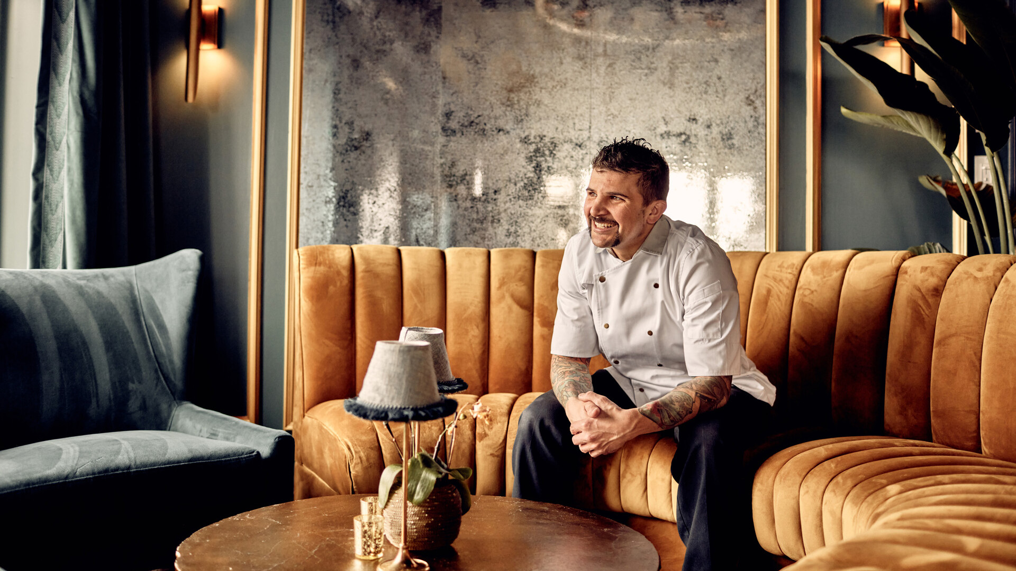 | January 5, 2023, Chicago, U.S.A.  Four Seasons Hotel Chicago Welcomes Richie Farina as Executive Chef of Adorn Bar & Restaurant  https://publish.url/chicago/hotel-news/2023/new-executive-chef-richie-farina-at-adorn.html
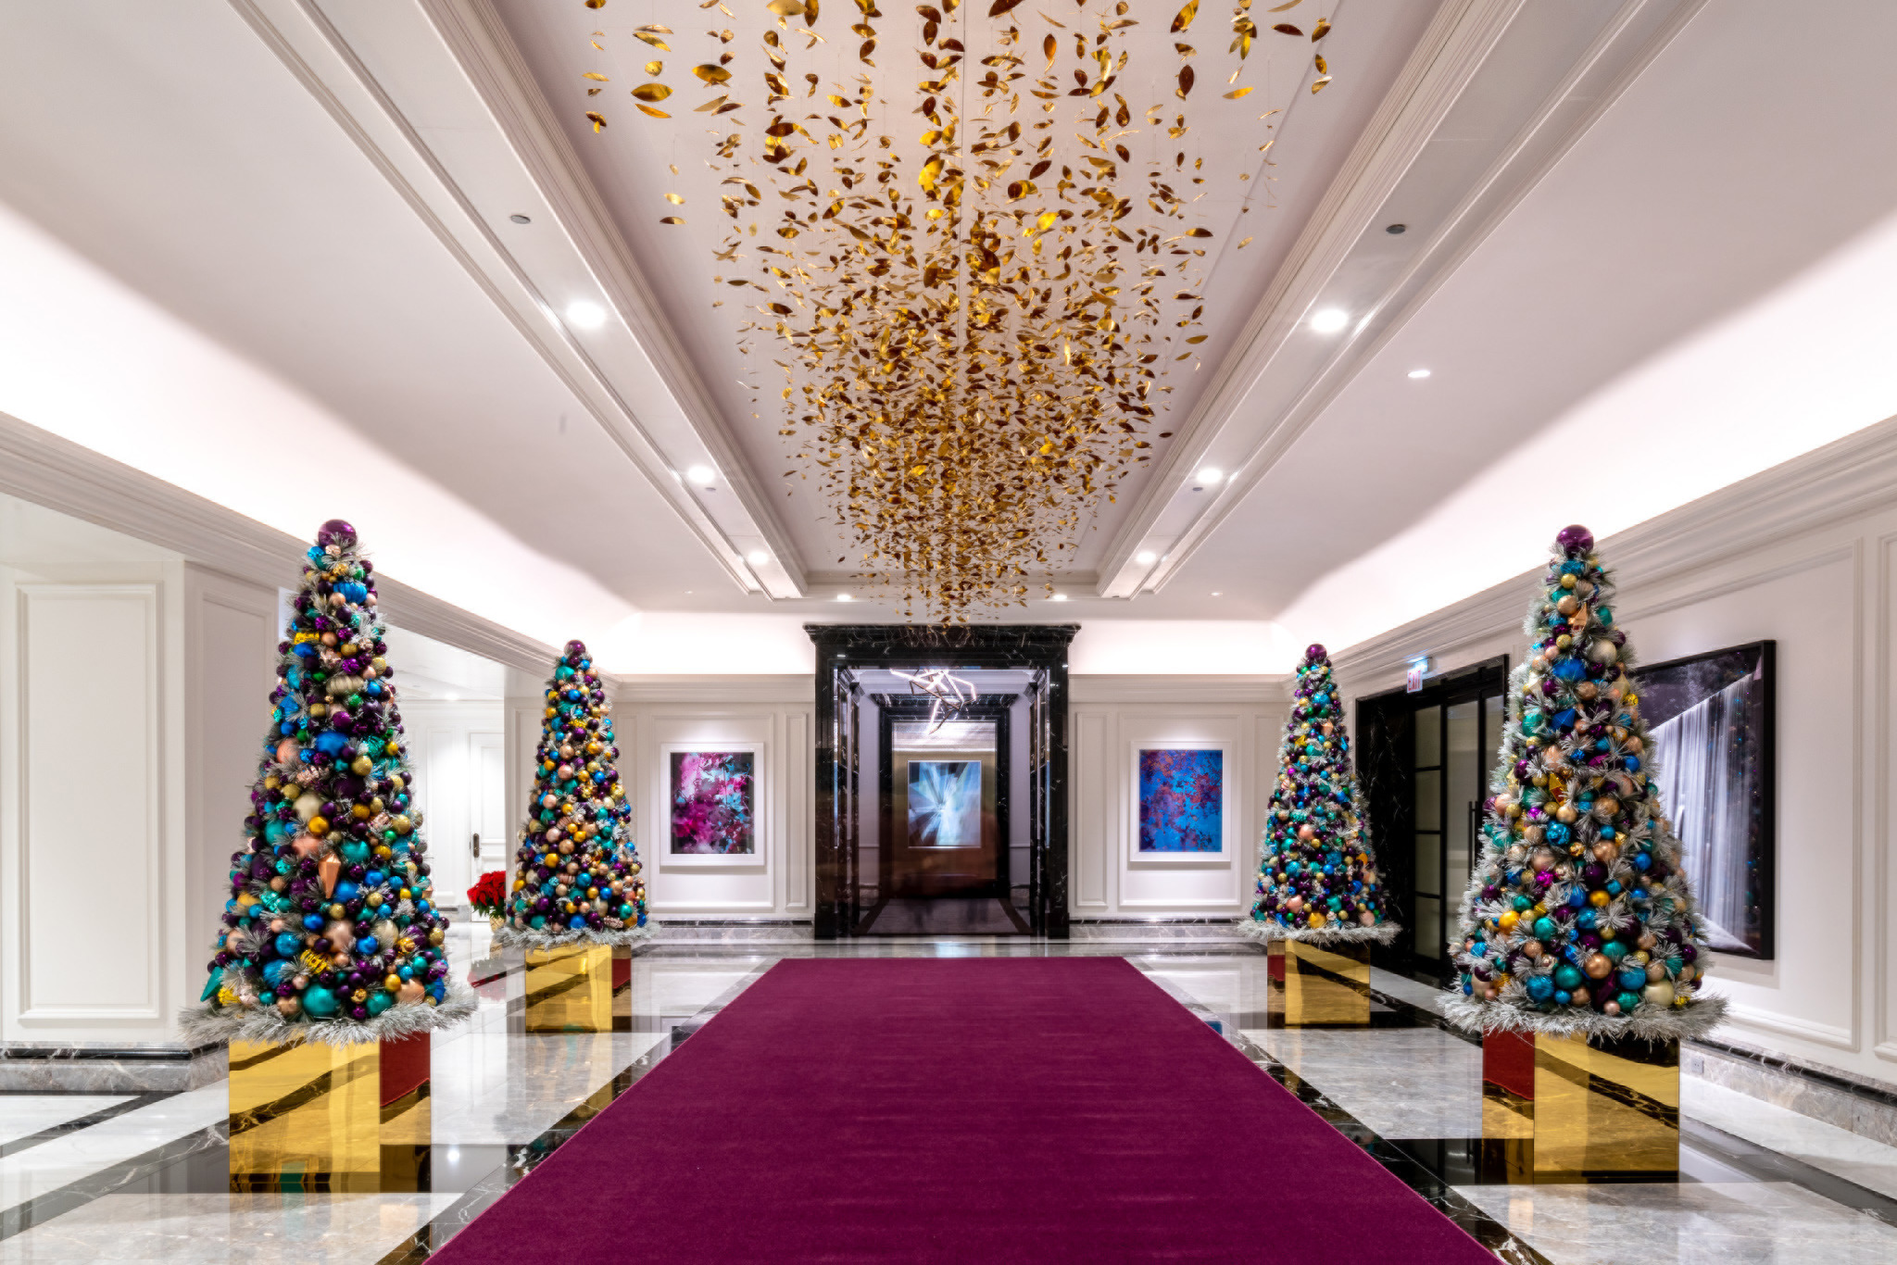 | October 31, 2022, Chicago, U.S.A.  Holiday Celebrations That Sparkle at Four Seasons Hotel Chicago This Winter  https://publish.url/chicago/hotel-news/2022/festive-season.html

PRESS CONTACTS

Ciara Merouan
Director of Public Relations
120 East Delaware Place
Chicago
USA
ciara.merouan@fourseasons.com

+1 312 649 2373

