Three Expert Brands to Discover at Le Spa at Four Seasons Hotel George V, Paris

September 11, 2018, Paris, France

Le Spa at Four Seasons Hotel George V, Paris has carefully selected three internationally recognised expert brands offering tailor-made, results-based treatments to beautify both body and spirit:
- Swiss Perfection, a Swiss brand, is dedicated to providing the finest and most advanced anti-ageing solutions. Swiss Perfection is the first brand to apply vegetal cellular extraction technology to cosmetics with its signature compound Cellular Active IRISA.
- Dr Burgener Switzerland is the creation of Doctor of Biology Pauline Burgener, a specialist in skin science and aging. Pauline Burgener has developed her own product line as well as an innovative method allowing analysis of individual skin metabolism and the development of the most effective treatment. Dr Burgener Switzerland combines the purest and most efficient natural ingredients such as gold, green caviar, collagen, AHA fruit acids and royal jelly with the latest in anti-ageing technologies.
- Alaena by Dr Peres France, developed in France by a dermatologist and a plastic surgeon, is the first organic cosmetic line based on elements originating from biotechnology. During treatment, patented assets, based on five organic sprouted seeds, accelerate cell renewal resulting in an anti-ageing effect. Alaena’s ethical values are strictly respected from the selection of raw materials, including production methods, to their simple packaging.

RELATED

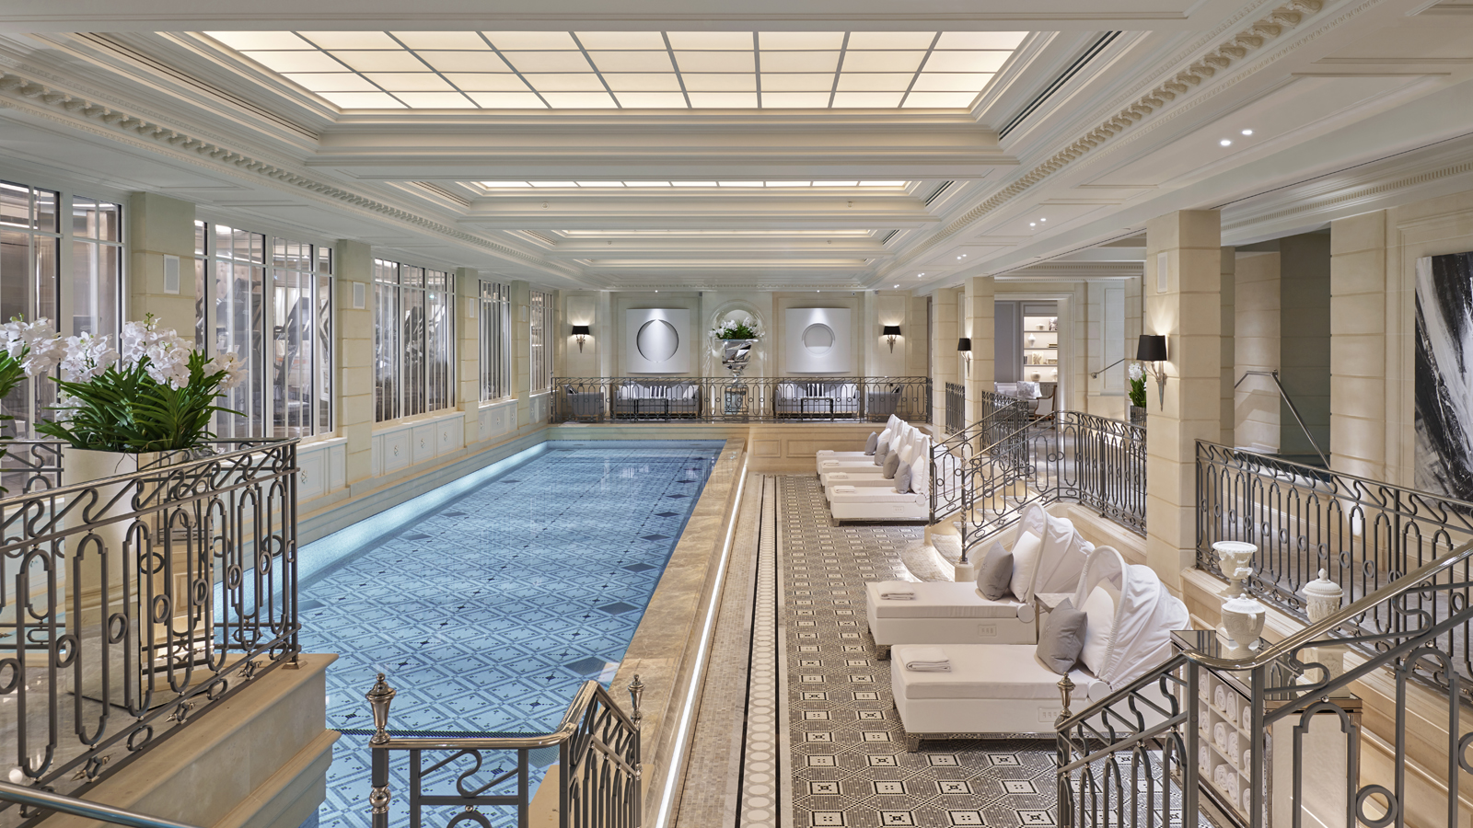 | June 6, 2018, Paris, France  Ouverture du nouveau Spa au Four Seasons Hotel George V : 720 m² luxueusement aménagés et dédiés au bien-être  https://publish.url/fr/paris/hotel-news/2018/all-new-le-spa-debuts-2.html
June 6, 2018, Paris, France
Introducing the All-New Le Spa at Four Seasons Hotel George V, Paris, a Luxurious Space Dedicated to Wellness
https://publish.url/paris/hotel-news/2018/all-new-le-spa-debuts.html

PRESS CONTACTS

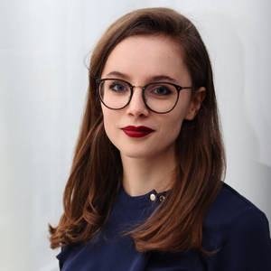 | Amandine Devaux  Digital Manager  31, avenue George V  Paris  France  amandine.devaux@fourseasons.com  +33 1 49 52 70 76
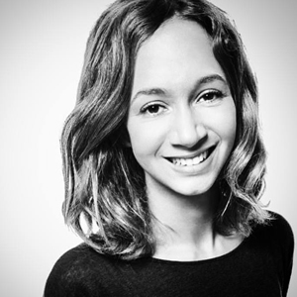 | Samuelle Dorol  Public Relations and Communications Manager  31, avenue George V  Paris  France  samuelle.dorol@fourseasons.com  +33 1 49 52 71 69

