Experience Desert Romance This February at Four Seasons Resort Scottsdale at Troon North

Spa for two and celebratory Talavera menu highlight month of love
January 18, 2023, Scottsdale, U.S.A.

Love is in the air at Four Seasons Resort Scottsdale at Troon North. This February, plan a romantic Sonoran Desert getaway, choosing from indulgent treatments in the Spa, energizing outdoor fitness classes, al fresco dining and cozy time together in spacious casita guest room and suite accommodations.
“The Sonoran Desert is the perfect backdrop for a romantic getaway to remember,” says General Manager Kelley Moreton. “Our concierge team can help craft the ideal romantic itinerary – whether you prefer adventure, relaxation or wellness. Begin the day soaring above the desert in a sunrise hot air balloon ride, lounge poolside in a private cabana and savour a meal together al fresco in our Talavera restaurant before stargazing.”
The Spa is featuring the “Love Me, Love Me Not” couples massage, concluding with a glass of sparkling wine, throughout the month of February 2023. Pricing begins at USD 520 per couple for a 60-minute treatment. Indulge together in a relaxing treatment, and then enjoy a complimentary chocolate treat in Proof following the Spa experience.
Chef de Cuisine Jesus Figueroa presents a celebratory meal for one special night in Talavera on Tuesday, February 14, 2023. Begin with an oyster on the half shell, with beet gazpacho, mint, basil and fizzy blackberry foam. Then, savour an octopus carpaccio, featuring heart of palm salad, citrus and rose petal-Calabrian chili chimichurri. The main course offers a choice of fruta del mar – with diver scallops, Skull Island prawns, king crab, caviar and delicately poached lobster tail – or cocoa-rubbed bison tenderloin with a pomegranate dark chocolate jus. For the table, enjoy crispy red bliss potatoes and butter-poached white asparagus with Manchego cheese and thyme. For dessert, indulge in Executive Pastry Chef Yudith Bustos’ creation, “Love is in the Air,” with raspberry lychee mousse, vanilla cake and Champagne gelée. The menu is available from 5:00 to 9:00 pm, at a cost of USD 165 per person, not inclusive of tax and gratuity. Reservations are required; with the special one-night engagement, only the set menu will be available.
Plan a Sonoran Desert getaway focused on romance with the Experience More package, offering a USD 100 credit with every two paid consecutive nights. Spend lazy days lounging poolside, relaxing in the comfort of a luxury cabana by the two-tier, heated saltwater pool. Guests also can take part in a weekly calendar of activities, including Margarita demonstrations, craft beer tasting in Proof, guided hikes to nearby Pinnacle Peak and a rotating schedule of outdoor fitness and wellness classes.
Reservations may be booked online.

RELATED

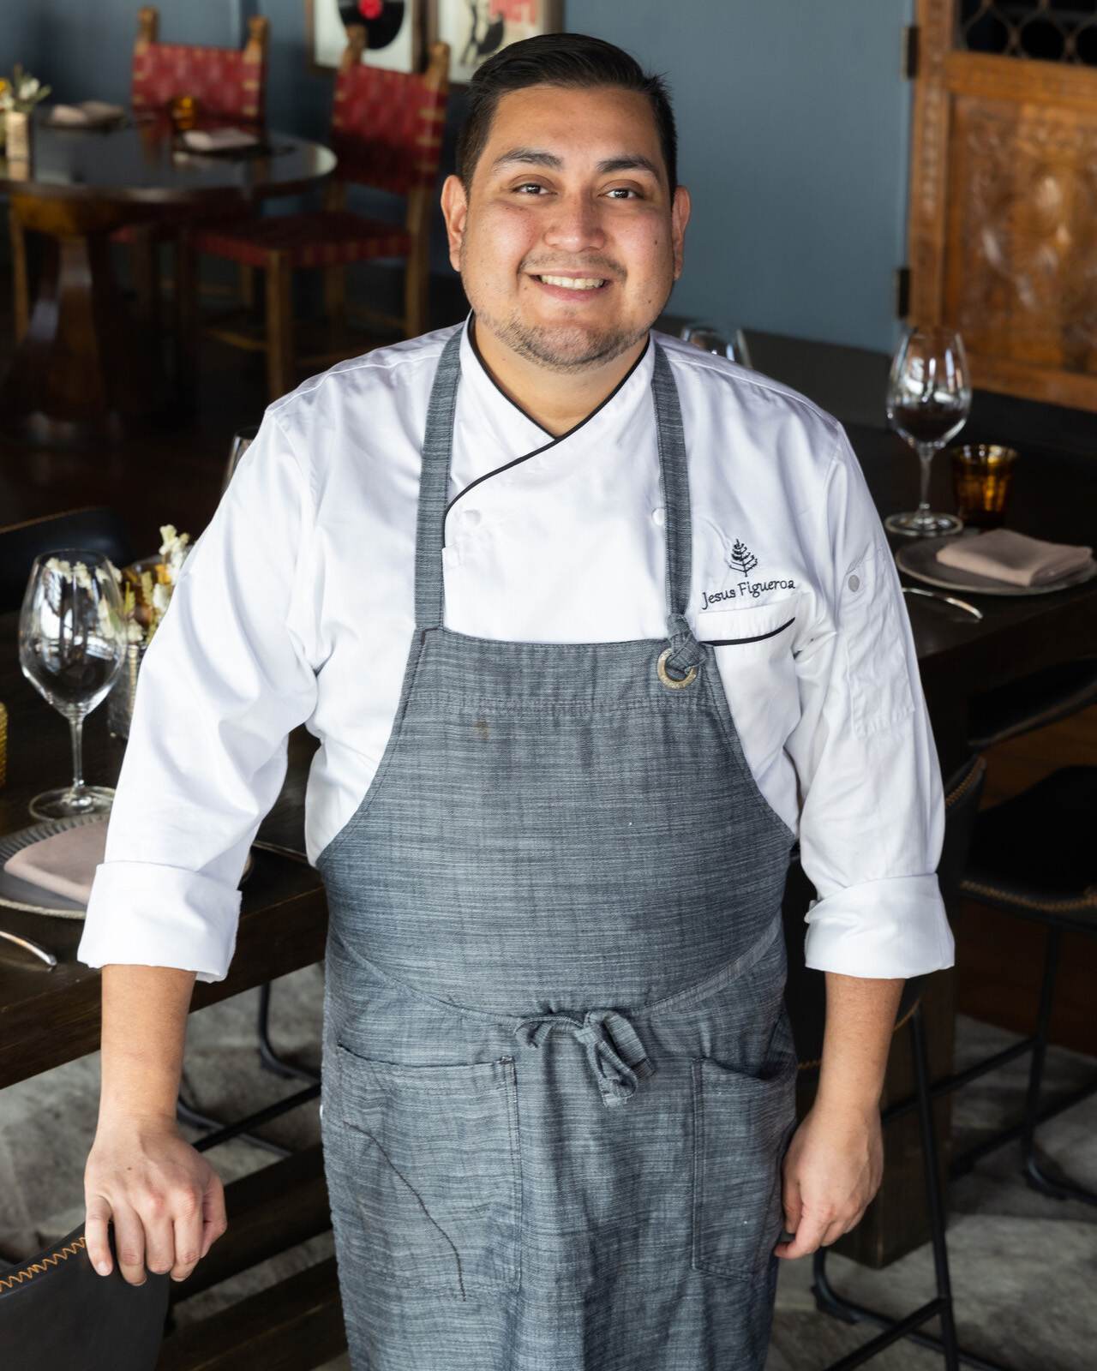 | January 4, 2023, Scottsdale, U.S.A.  New Talavera Team at the Helm at Four Seasons Resort Scottsdale at Troon North  https://publish.url/scottsdale/hotel-news/2023/new-chef-de-cuisine-and-general-manager-at-talavera.html
December 22, 2022, Scottsdale, U.S.A.
Sophisticated Sonoran Desert Getaway for a Bachelorette Celebration to Remember at Four Seasons Resort Scottsdale at Troon North
https://publish.url/scottsdale/hotel-news/2022/bachelorett-bash-package.html

PRESS CONTACTS

Kim Cole APR
Director of Public Relations
10600 East Crescent Moon Drive
Scottsdale
USA
kim.cole@fourseasons.com

+1 480 980 8773

