Four Seasons Resort and Residences Anguilla Announces “Suite Returns” Special Offer

Couples hosting their wedding at the idyllic resort with supporting room nights will receive a complimentary five-night stay in a suite to celebrate their first wedding anniversary
March 31, 2021, Anguilla, West Indies

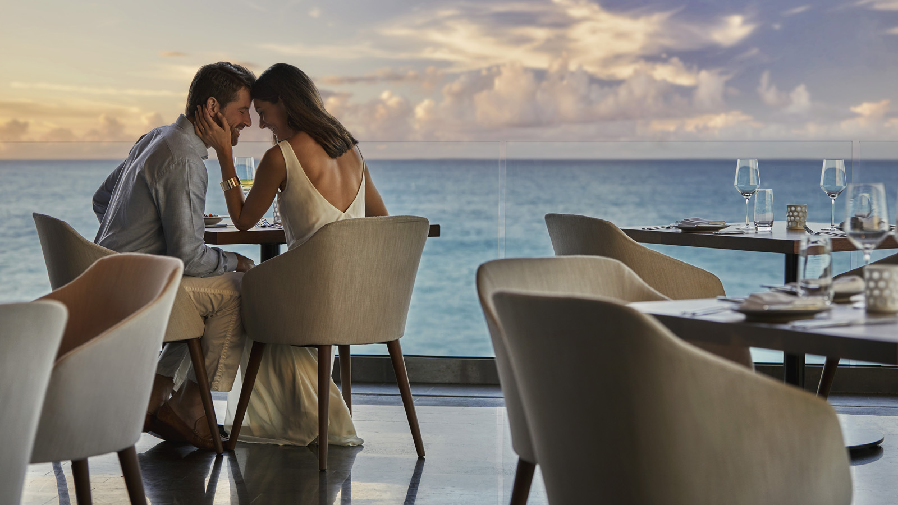
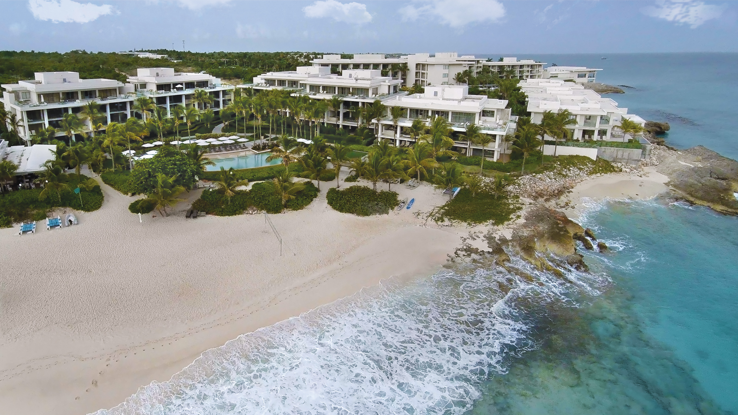 |  | 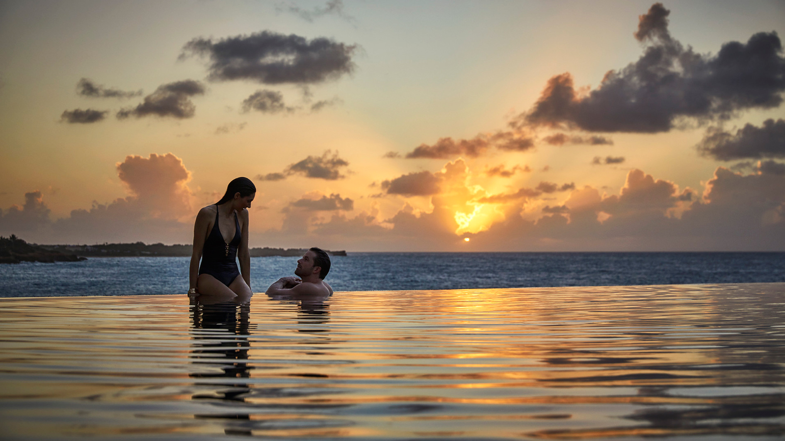
Four Seasons Resort and Residences Anguilla, the spectacular beachfront resort located on the Caribbean’s most relaxed and welcoming island, has unveiled a Suite Returns special offer inviting couples to not only celebrate their nuptials at the Resort but to then return for a complimentary first anniversary stay.
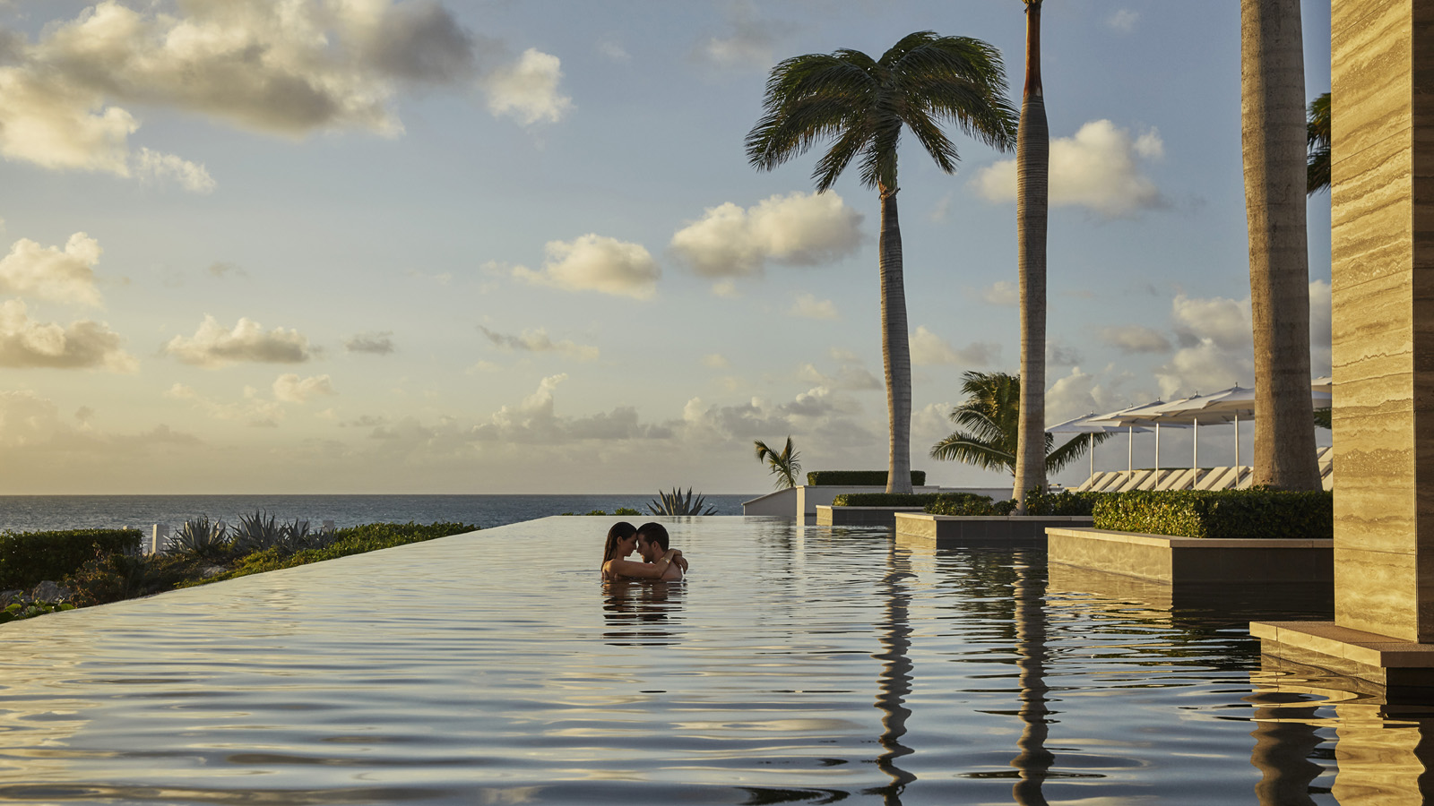
Ideal for those currently seeking a tropical wedding location, the Suite Returns offer invites couples who host a wedding at the Resort with 100 room nights or more to then receive a complimentary five-night stay in a One-Bedroom Ocean-View Suite, a romantic dinner for two and a bottle of champagne to celebrate their first anniversary.
Encircled by the pristine Barnes Bay and Meads Bay beaches, Four Seasons Resort and Residences Anguilla blends serene landscapes with warm service and stylish accommodation to make it the perfect venue at which to celebrate with one's nearest and dearest. The Resort’s dedicated events team is on hand to curate the wedding of dreams. be it barefoot on the golden sands or in the utmost privacy of a contemporary beachfront villa.
Couples returning to the Resort for their first wedding anniversary will do so in ultimate style, staying five nights in a one-bedroom ocean-view suite, compliments of Four Seasons Resort and Residences Anguilla. The suite comes complete with airy dining and living areas, a kitchenette and sundeck with a private plunge pool. A bottle of champagne and romantic dinner for two at SALT, the Resort’s signature restaurant, is also included.
The Suite Returns special offer at Four Seasons Resort and Residences Anguilla is valid for new weddings only confirmed April 1 to December 15, 2021, for arrival May 1, 2021 through December 15, 2022. A minimum of 50 people and 100 room nights must be consumed. The anniversary stay can be consumed within one year of the wedding for five nights in a One-Bedroom Ocean-View Suite. Blackout dates and terms and conditions apply.
For booking inquiries, contact Colleen Harrigan via colleen.harrigan@fourseasons.com

RELATED

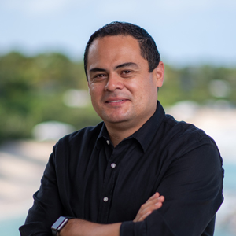 | February 2, 2021, Anguilla, West Indies  Four Seasons Resort and Residences Anguilla Announces Diego Angarita as General Manager  https://publish.url/anguilla/hotel-news/2021/new-general-manager-diego-angarita.html
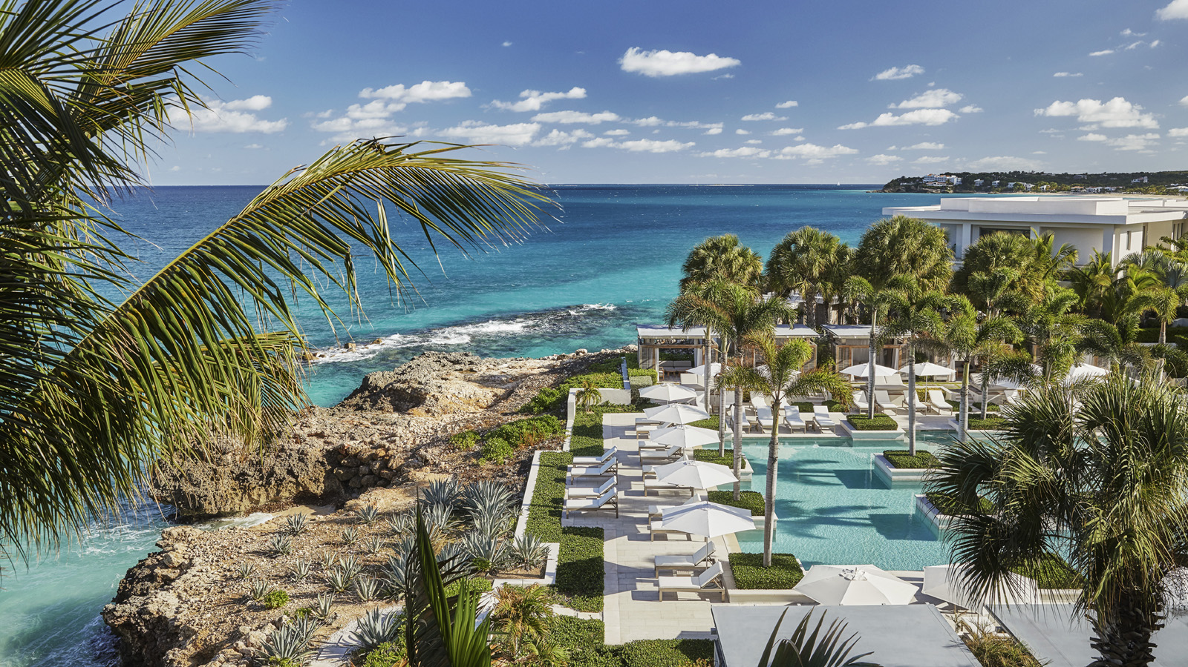 | January 29, 2021, Anguilla, West Indies  Four Seasons Resort and Residences Anguilla Provides On-Site Testing in Response to Latest CDC Travel Guidelines  https://publish.url/anguilla/hotel-news/2021/on-site-pre-travel-testing.html

PRESS CONTACTS

Diane Yost
Director of Sales and Marketing
Barnes Bay, P.O. Box 8028
West End
Anguilla
diane.yost@fourseasons.com

786 252 9483

