Four Seasons Hotels and Resorts Expands in Mexico with Innovative and Experiential Tented Resort in Punta Mita

Located along the Pacific shores of the Riviera Nayarit, the Resort will offer programming that enhances guest wellbeing and connects them with the beauty and traditions of the destination
February 15, 2022, Toronto, Canada

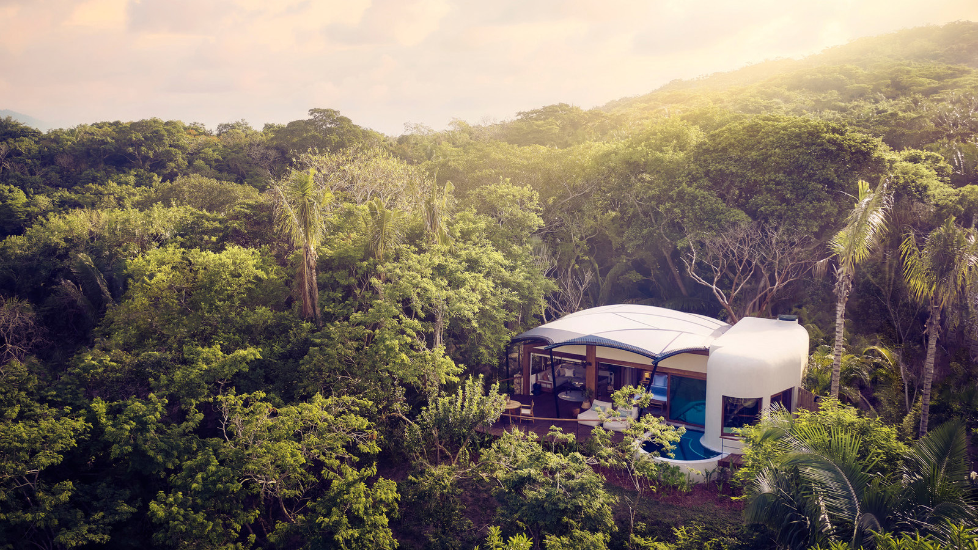
Four Seasons Hotels and Resorts, one of the world's leading luxury hospitality companies, announces plans for an innovative resort concept focusing on highly customizable itineraries led by personal guides, sustainable design and programming inspired by the nature and history of Mexico. The new luxury tented resort will be an expansion of the existing Four Seasons Resort Punta Mita in an untouched enclave within the Resort community.
Set to open in late 2022, Naviva®, A Four Seasons Resort, Punta Mita, Mexico will offer a collection of 15 luxury tents nestled in the lush forests of the Riviera Nayarit with sweeping views of the Pacific Ocean. Inspired by the idea of naturaleza viva, or “live naturally,” the Resort is deeply integrated into its natural surroundings, inviting guests to connect with the land, sea, fellow guests, and most importantly, themselves.
“The Naviva Resort will be an exceptional retreat for those seeking highly individualized service, curated wellness experiences and artful culinary offerings that reflect the culture and character of Mexico,” says Bart Carnahan, President, Global Business Development and Portfolio Management, Four Seasons Hotels and Resorts. “This is an ambitious and innovative new project for our brand, with every detail focused on the wellbeing of the guests, the sustainability of the design and the celebration of the destination.”
The Naviva Resort Experience
Ahead of arrival, guests will be matched with a personal guide to create a bespoke itinerary based on their specific needs and desires, choosing from a range of experiences or simply relaxing in their beautiful surroundings. The Resort guides have been selected for their care, intuition and discernment, along with their knowledge of the destination. The guides will assist in creating custom itineraries and personalizing experiences, while also providing the space and freedom for guests to unwind and explore on their own.
Guests will be immersed in the natural design from the moment of arrival, meeting their guides on a cocoon-inspired bamboo bridge overlooking a 30-foot (9 metre) ravine. The design aesthetic continues with butterfly-inspired guest tents perched on hillsides, each with private pools and expansive decks, and many with outdoor gardens.
The onsite programming has been thoughtfully curated with the support of local experts and has been designed to allow for heightened personalization – such as one-on-one interactions with the Resort executive chef; personal training sessions in the outdoor gym experience; private dinners with sweeping ocean views and bespoke menus; or exploring Mexico’s hidden wine and spirits scene. Guides offer intuitive partnership and knowledge to help guests truly understand and connect with their experiences.
The Naviva Resort is perfect for solo travellers, couples or those travelling with close friends and loved ones. With most offerings included as part of the stay, and digital disconnection highly encouraged, guests will be able to fully relax, rejuvenate, explore and get the most out of their journey.
About Naviva, A Four Seasons Resort
The property will celebrate its natural surroundings through an organic aesthetic and design, with sustainable elements including solar panels, efficient water systems and natural drainage, electric vehicles, upcycled artwork and locally sourced products, materials, produce and ingredients.
Luxury Frontiers, international experts in the design of innovative and experiential resorts, has been selected to help bring the Naviva Resort to life and create a sustainable, low-impact sanctuary. The design of the property will allow for seamless movement between indoor and outdoor living, ultimately creating an environment that is ideal for an immersive and transformational journey.
The Resort will feature an expansive pool inspired by the enveloping jungle, access to a secluded beach, spa pods that offer customizable treatments featuring products made from local ingredients, a cliffside yoga pavilion and an outdoor gym. In addition, supported by knowledgeable guides, guests will be able to experience the restorative power of an onsite temazcal.
The onsite restaurant, Copal, will be a farm-to-table open-air Mexican grill house overlooking the seascapes of Punta Mita, and will serve fresh homegrown produce and bountiful sea catches on a rotating seasonal menu. With the open kitchen as the epicentre of the space, guests will be able to witness traditional cooking techniques at work.
In addition to onsite programming and experiences, guests will have full access to Four Seasons Resort Punta Mita, including the restaurant and bar offerings, additional spa and fitness facilities, and beach and pool access.
Naviva, A Four Seasons Resort, Punta Mita, Mexico will be located less than an hour's drive from Puerto Vallarta International Airport, where daily inbound and outbound international flights are available. The Naviva Resort will be an expansion of Four Seasons Resort Punta Mita and joins Four Seasons growing collection of properties in Mexico, which include Four Seasons Hotel Mexico City, Four Seasons Resort Los Cabos at Costa Palmas and the upcoming Four Seasons Resort Tamarindo and Four Seasons Resort and Residences Cabo San Lucas at Cabo Del Sol.

RELATED

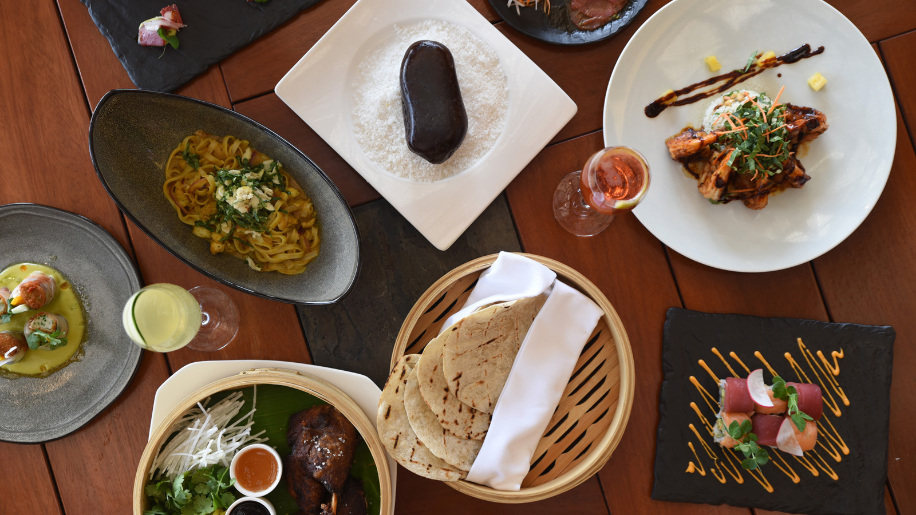 | February 1, 2022, Punta Mita, México  Aramara, the Asian Restaurant at Four Seasons Resort Punta Mita, Named One of the Greatest Restaurants in Mexico in 2022  https://publish.url/puntamita/hotel-news/2022/aramara-named-among-best-restaurants-in-mexico.html
February 1, 2022, Punta Mita, México
Aramara, el Restaurant Asiático de Four Seasons Resort Punta Mita, es Reconocido Como Uno de los Grandes Restaurants de México en 2022
https://publish.url/es/puntamita/hotel-news/2022/aramara-named-among-best-restaurants-in-mexico-2.html

PRESS CONTACTS

Sarah Tuite
Vice President, Corporate Public Relations
1165 Leslie Street
Toronto
Canada
prsm@fourseasons.com

+1 416 441 4350

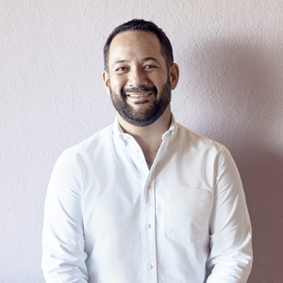 | Miguel Peregrina  Director of Public Relations  Punta Mita, Bahia de Banderas  Nayarit  Mexico  miguel.peregrina@fourseasons.com  +52 329 29160000

