Celebrate Eid al-Adha with an Island Escape at Four Seasons Resort Seychelles

June 30, 2022, Seychelles

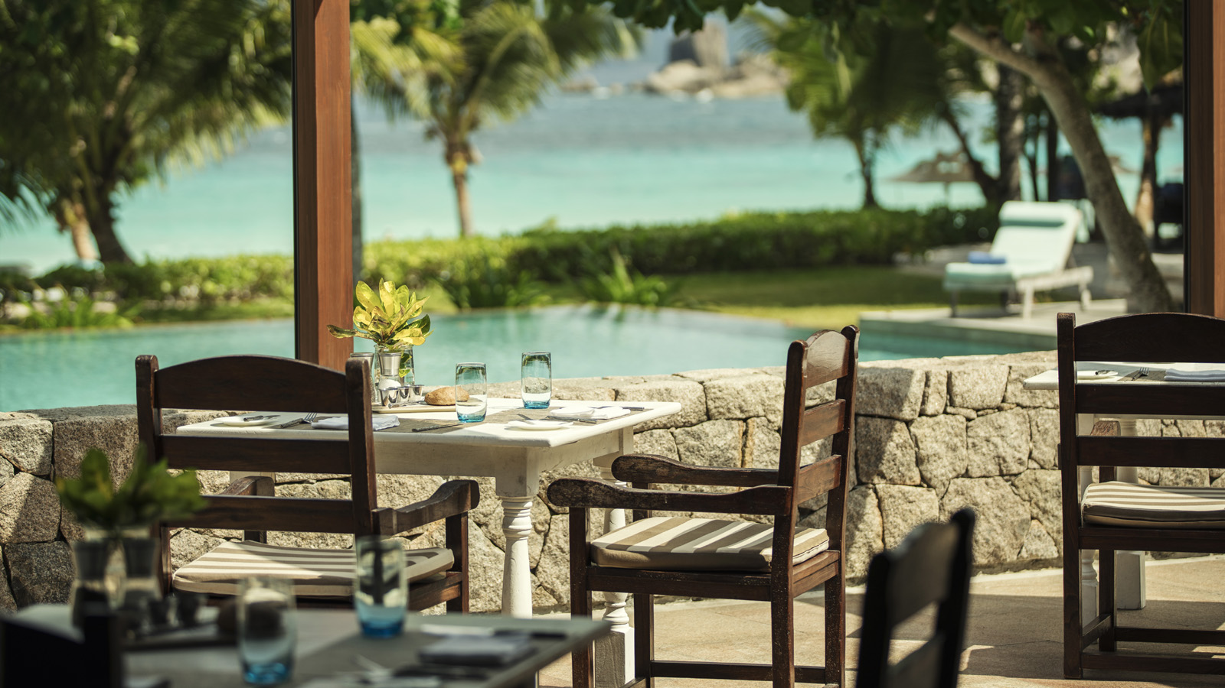 | 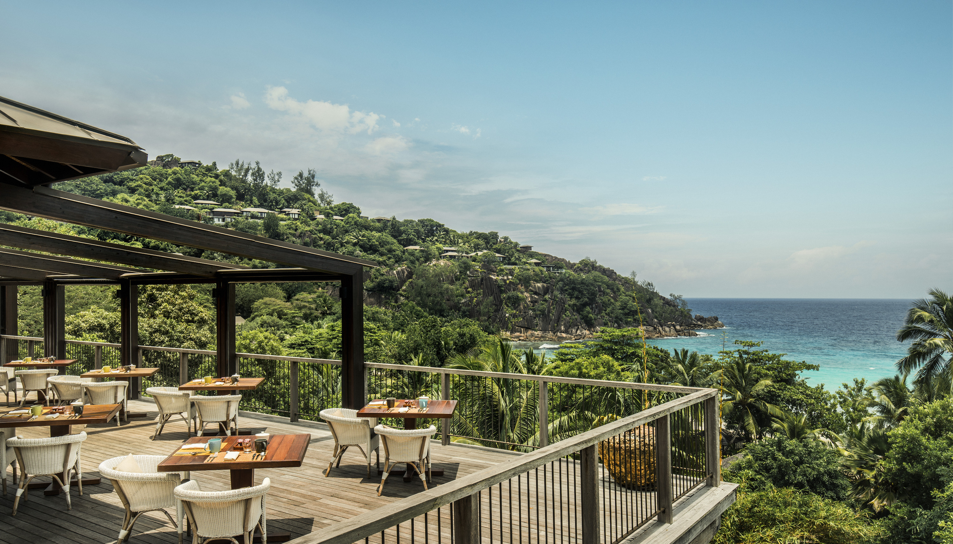 | 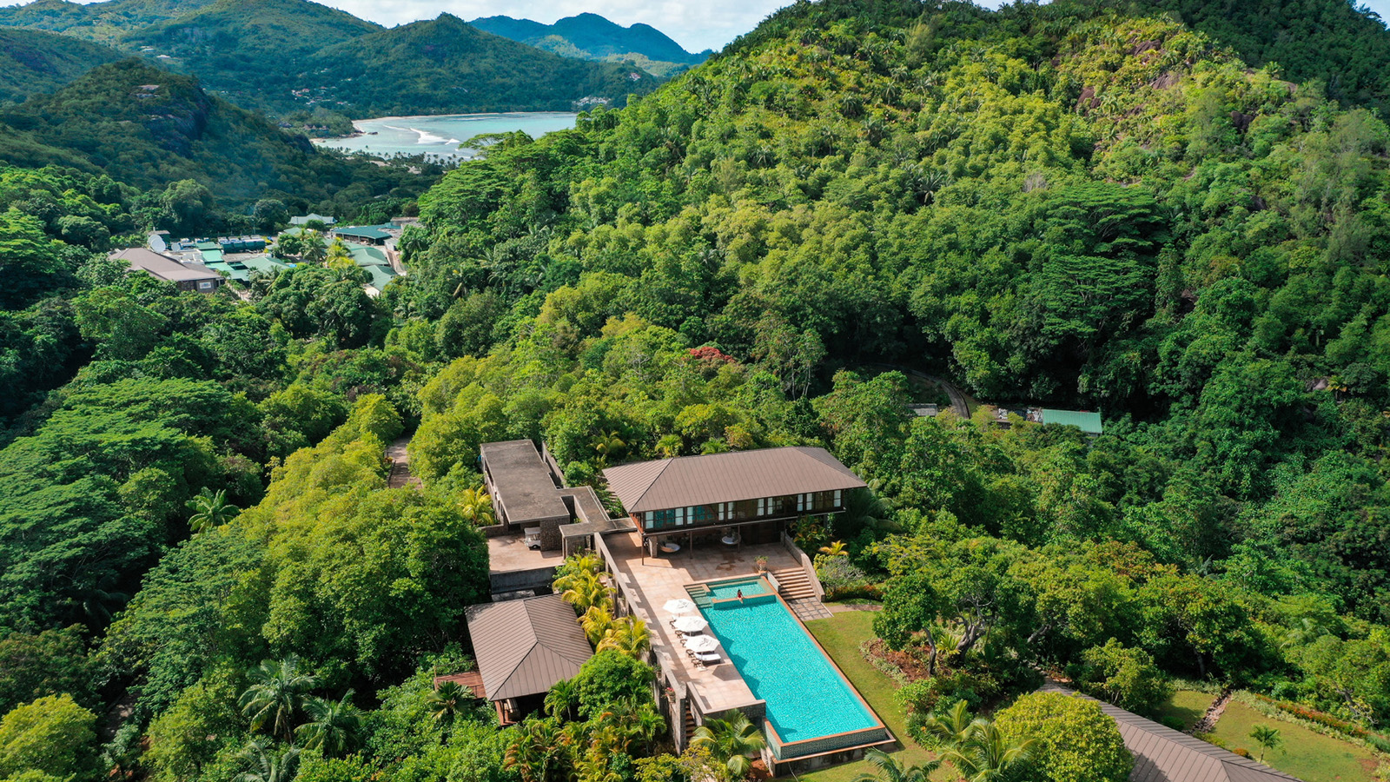
This Eid al-Adha, guests are invited to lose themselves in total seclusion, tropical beauty and protected ocean life with a celebratory holiday at Four Seasons Resort Seychelles where dining highlights, such as a Seafood Soirée and 1001 Nights themed buffet, a week-long kids’ activity schedule and spa and wellness offerings await.
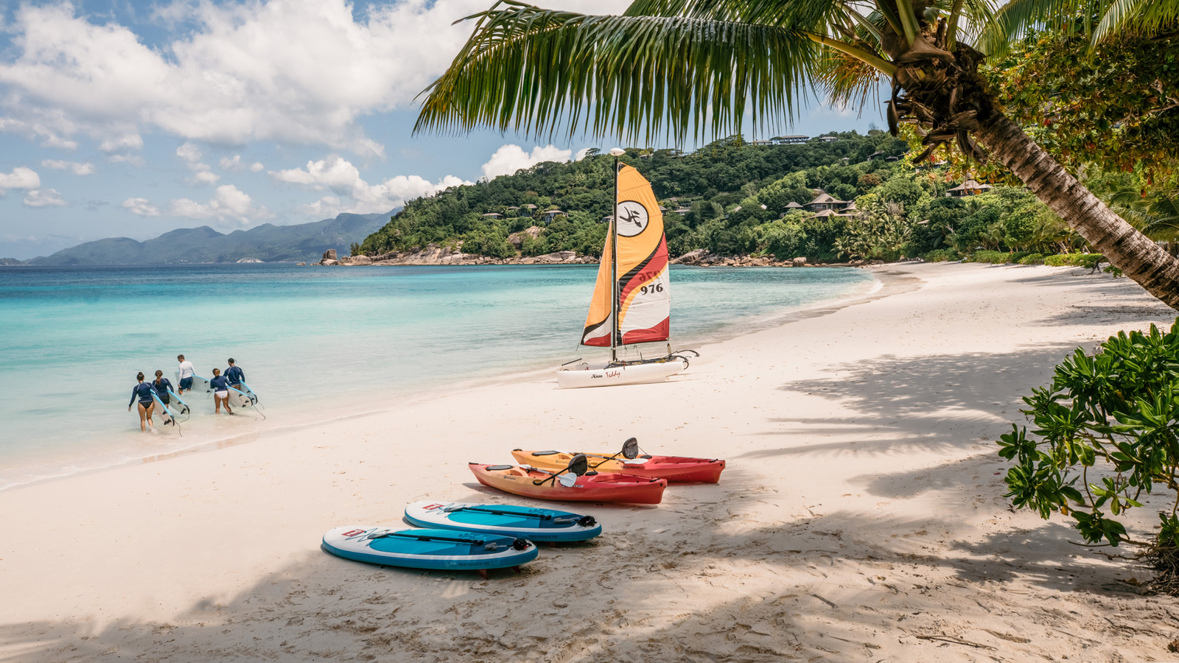
Home Away from Home
Far removed from modern distractions, guests can celebrate the holy festivities in isolated luxury and privacy with friends and family, with accommodation options ranging from one-bedroom treetop Villas to multi bedroom Suites and Private Retreats. The magic of Seychellois sunsets and natural, lush surroundings create for the ideal island escape where families and friends can create unforgettable memories as they enjoy the warm tropical weather with lazy days at Petite Anse beach or gatherings in the privacy of their villa.
Feast for the Senses
On July 9, 2022, the Resort’s chefs will take guests on a culinary journey around the ocean with a Seafood Soirée at the hillside restaurant ZEZ. As a special addition, a mezze station featuring Arabic staples will be found to start the celebrations in true island style.
To keep the festivities alive, on July 10, 2022 a more traditional dining experience will be found at the poolside restaurant Kannel, where an Arabian-themed night sets the mood for dinner. With stunning views of the Indian Ocean and gentle breeze, guests can indulge in delights such as a carving station, a barbecue selection with premium meats and seafood, biryani, kofta, tagine, harra and more. At Kannel Bar, a vast selection of shisha flavours will also be available to enjoy before or after dinner.
Height of Wellbeing
Located at the uppermost point of the Resort, Le Syel Spa invites guests to release stress and soothe their bodies with Starlit Serenity, an exclusive after-hours night spa experience available to just one individual or couple per night and located at the spa rooftop, under a blanket of stars.
For those seeking a unique wellness experience, NuCalm, the Spa’s latest offering, comes as a perfect pairing to any treatment. This one-of-a-kind treatment, which is not found elsewhere in the Indian Ocean, is a patented neuroscience technology. NuCalm is clinically proven to lower stress and improve sleep quality without medication. Comprised of five components, (biosignal processing discs, headphones, light-blocking eye mask, neuroscience-based soundtracks and an Apple iPod touch smart device) guests can choose from three programs: relax, recover and restore.
Busy Schedule for Little Ones
Kids can participate in an interactive Kids For All Seasons program, which features fun-filled themed programs, arts and crafts, movie nights, face painting, culture talks, sandcastle creation, coconut hunting and painting, fishing catch and release and more.

RELATED

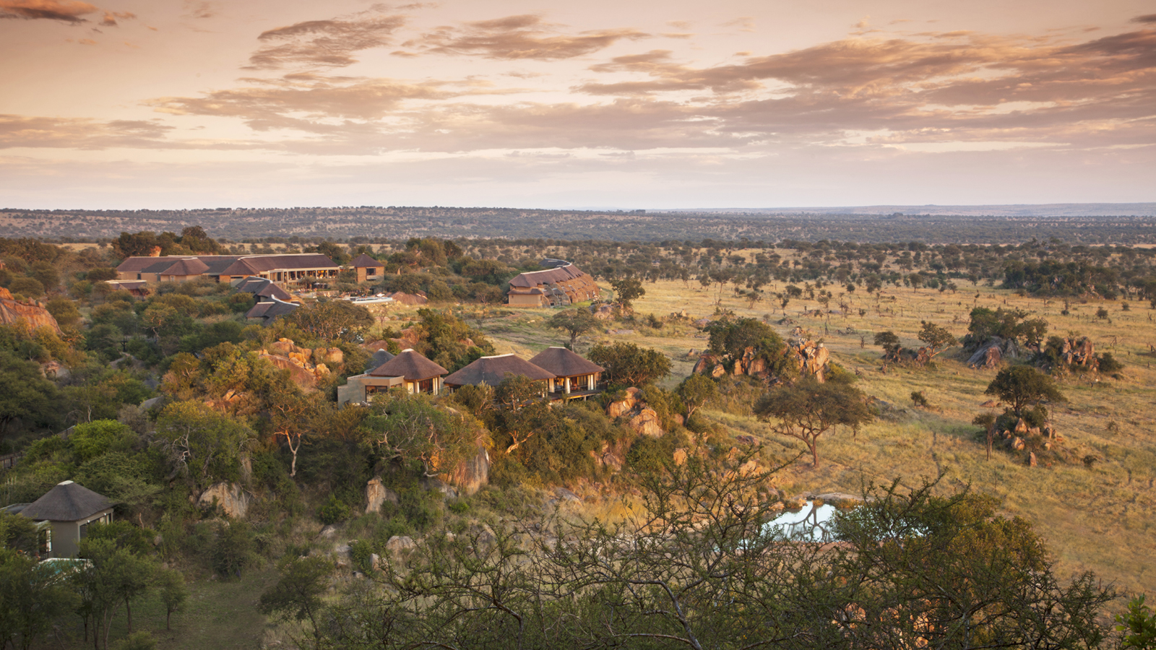 | June 20, 2022, Serengeti, Tanzania  Four Seasons Safari Lodge Serengeti Welcomes Joao Santos as a Visiting Practitioner this July and August  https://publish.url/serengeti/hotel-news/2022/visiting-massage-therapist-joao-santos.html
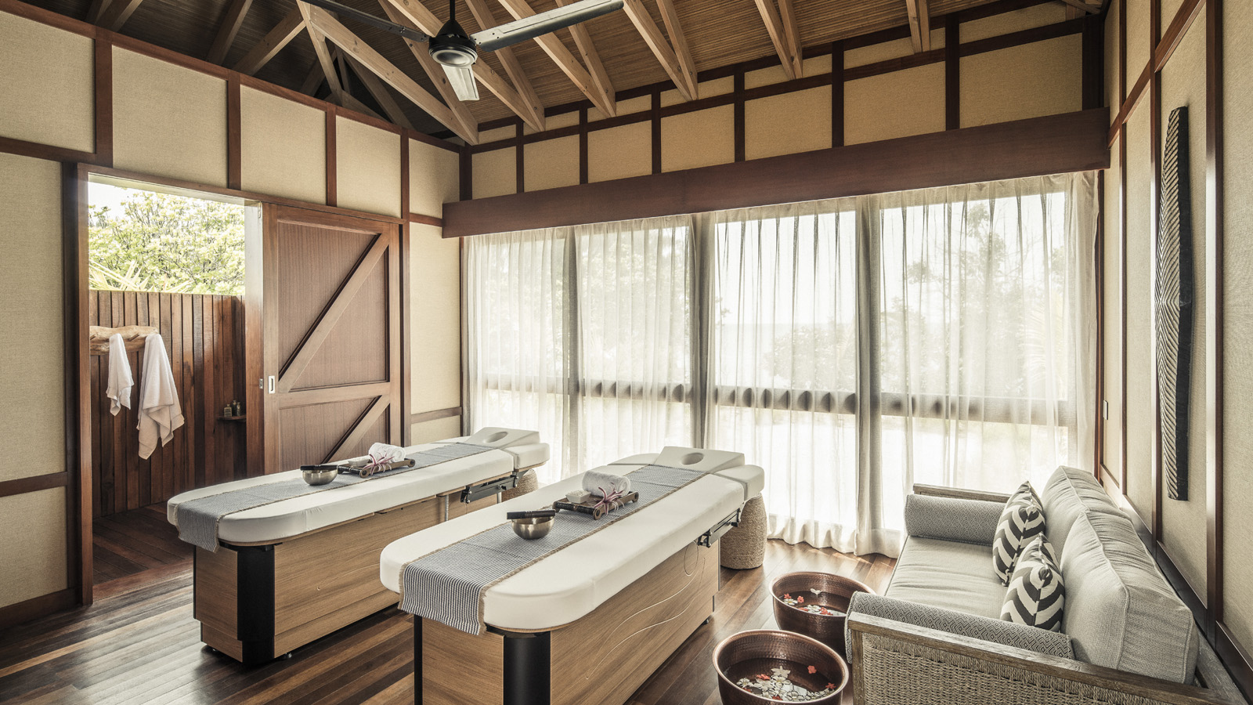 | June 9, 2022, Seychelles, Desroches Island  The Circle of Connection Spa at Four Seasons Resort Seychelles at Desroches Island Unveils the Beauty of Africa Through a New Treatment Menu in Time for Global Wellness Day  https://publish.url/seychellesdesroches/hotel-news/2022/new-spa-treatment-menu.html

PRESS CONTACTS

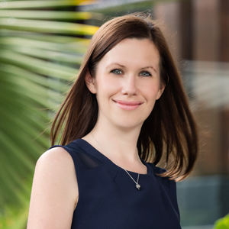 | Debbie Duval  Senior Director of Public Relations and Communications  Beau Champ  Mauritius  debbie.duval@fourseasons.com  (230) 402 3100

