Four Seasons Resort and Residences Jackson Hole Completes Resort Renovation to Kick Off Summer 2022 Season

Bringing a new level of elevated mountain luxury to Jackson Hole’s premier Five-Star, Five-Diamond resort
June 15, 2022, Jackson Hole, U.S.A.

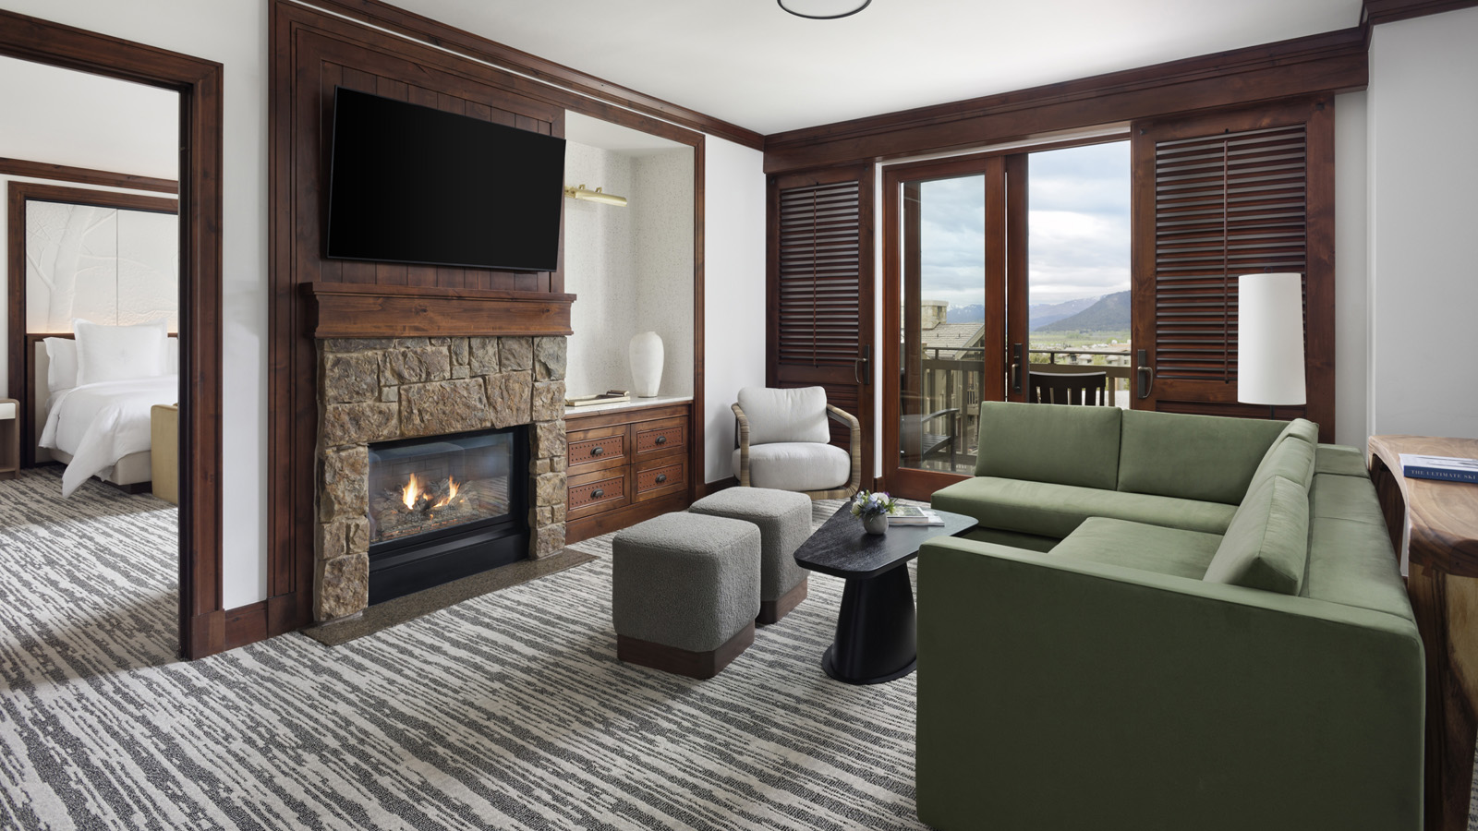
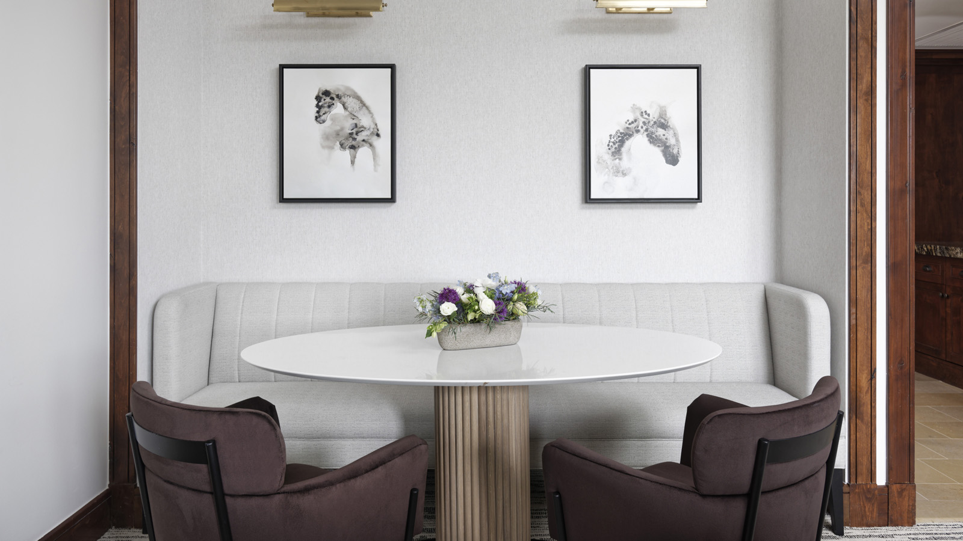 | 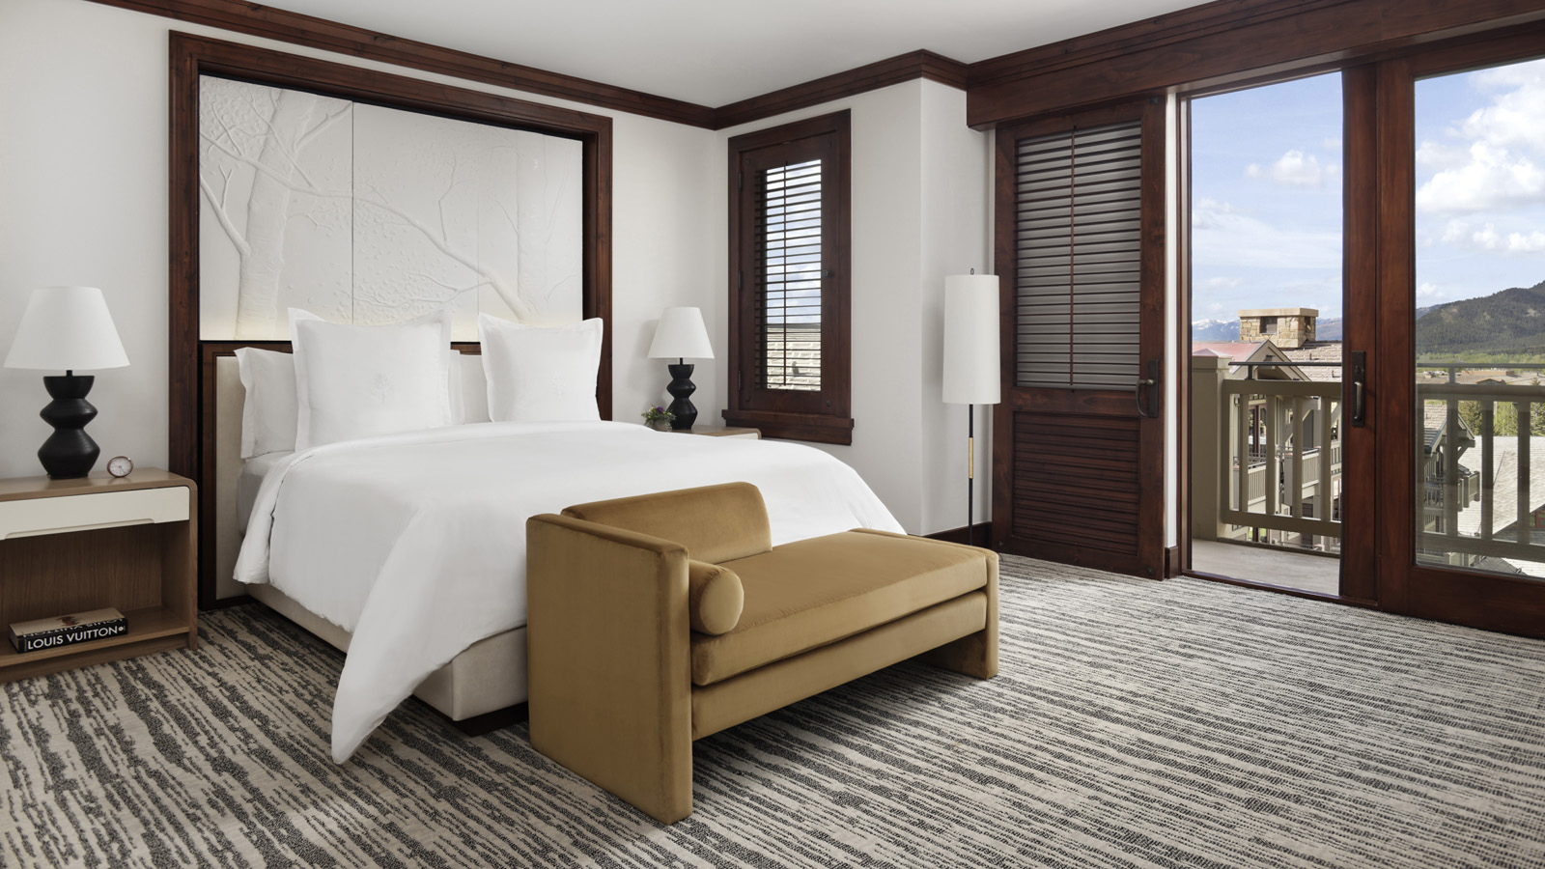 | 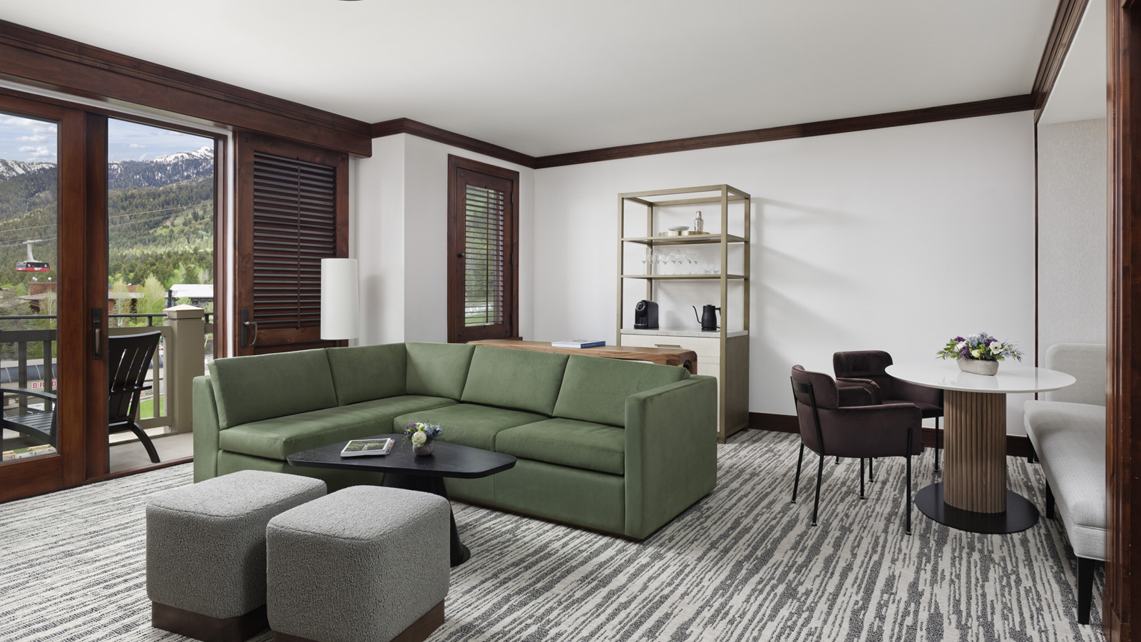
Four Seasons Resort and Residences Jackson Hole welcomes the summer 2022 season with the debut of a full-scale guest room and suite renovation, inspired by the natural grandeur of its dramatic mountain setting.
“Everywhere you turn in Jackson Hole, you are enveloped by stunning natural beauty and dramatic landscape,” says General Manager Ryan Grande. “Our vision was to bring the warmth, beauty and grandeur of our surroundings into the guest room experience in a modern fashion. With subtle colours and the incorporation of earth elements, woods and metals, we are paying homage to our mountain home’s unique beauty.”
Designed by Wimberly Interiors, the newly refreshed guest rooms, suites and public hallways enhance the luxury mountain experience with natural elements set against a subtle earth tone palette. The renovation included all new vanities and mirrors, furniture, artwork, beds, lighting, wall coverings, carpet and private bar. A well-defined work area allows guests to remain productive, with top-of-the-line new technology for communication and entertainment. The latest renovations build upon recent enhancements in Westbank Grill and Ascent Lounge within the past five years.
“For nearly 20 years, we have been honoured to serve our guests with outstanding service and amenities,” says Grande. “We are thrilled to continue that tradition with beautiful new accommodations and public spaces.”
To best experience its newly enhanced guest rooms and suites this summer, Four Seasons Resort and Residences Jackson Hole encourages guests to enjoy the Experience More package, which offers a USD 100 Resort credit with every three paid consecutive nights. The Resort credit may be applied to in-room dining, restaurant dining, and spa experiences.
For Resort reservations click here.

RELATED

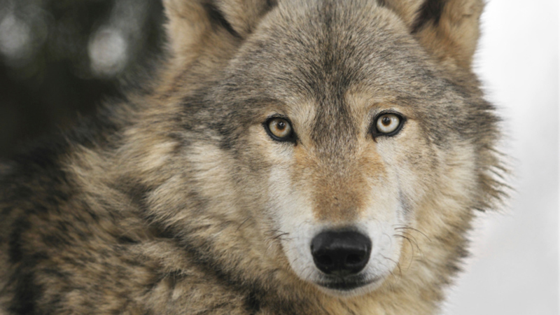 | June 8, 2022, Jackson Hole, U.S.A.  Immersive Encounter with Yellowstone Wolf Population Launches This Fall at Four Seasons Resort and Residences Jackson Hole  https://publish.url/jacksonhole/hotel-news/2022/day-with-wolves.html
May 2, 2022, Jackson Hole, U.S.A.
Celebrate Global Wellness Day and Summer Solstice at Four Seasons Resort and Residences Jackson Hole
https://publish.url/jacksonhole/hotel-news/2022/global-wellness-day-and-summer-solstice.html

PRESS CONTACTS

Kim Cole APR
Director of Public Relations
7680 Granite Loop Road, PO Box 544
Teton Village
USA
kim.cole@fourseasons.com

+1 480 980 8773

