Hop to Four Seasons Hotel Westlake Village for Easter Celebrations in the Conejo Valley

March 9, 2023, Los Angeles, Westlake Village, U.S.A.

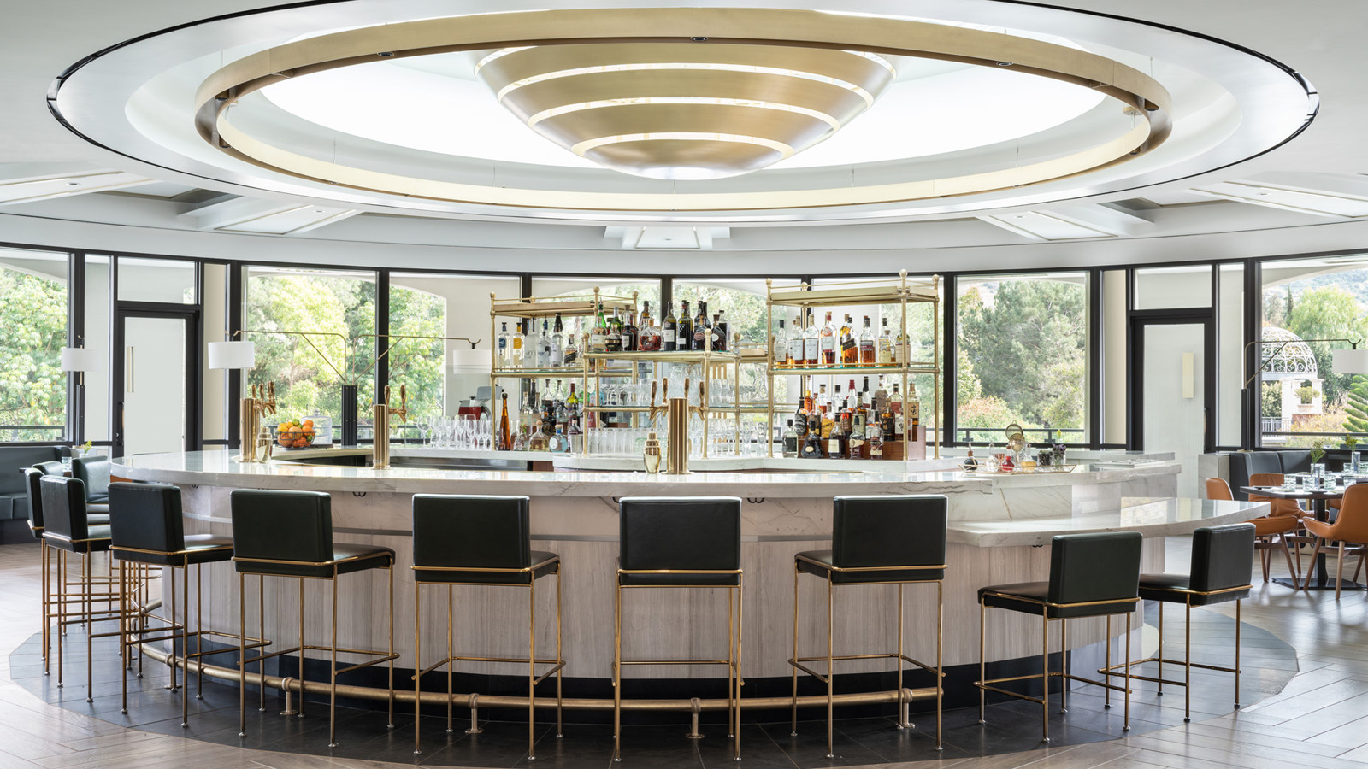
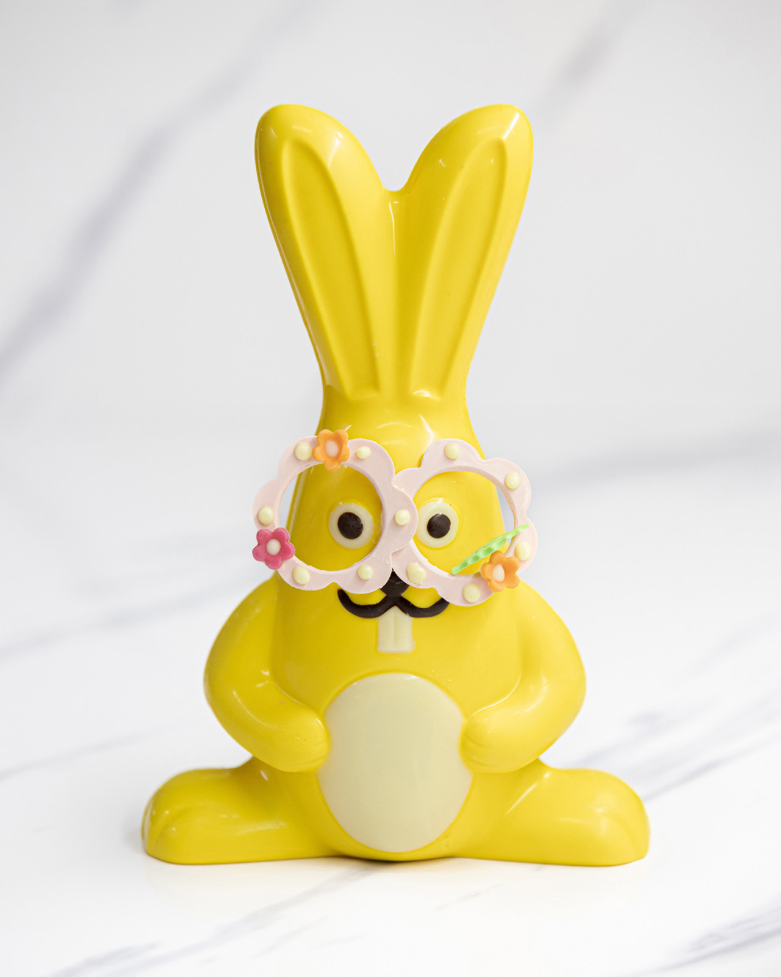 | 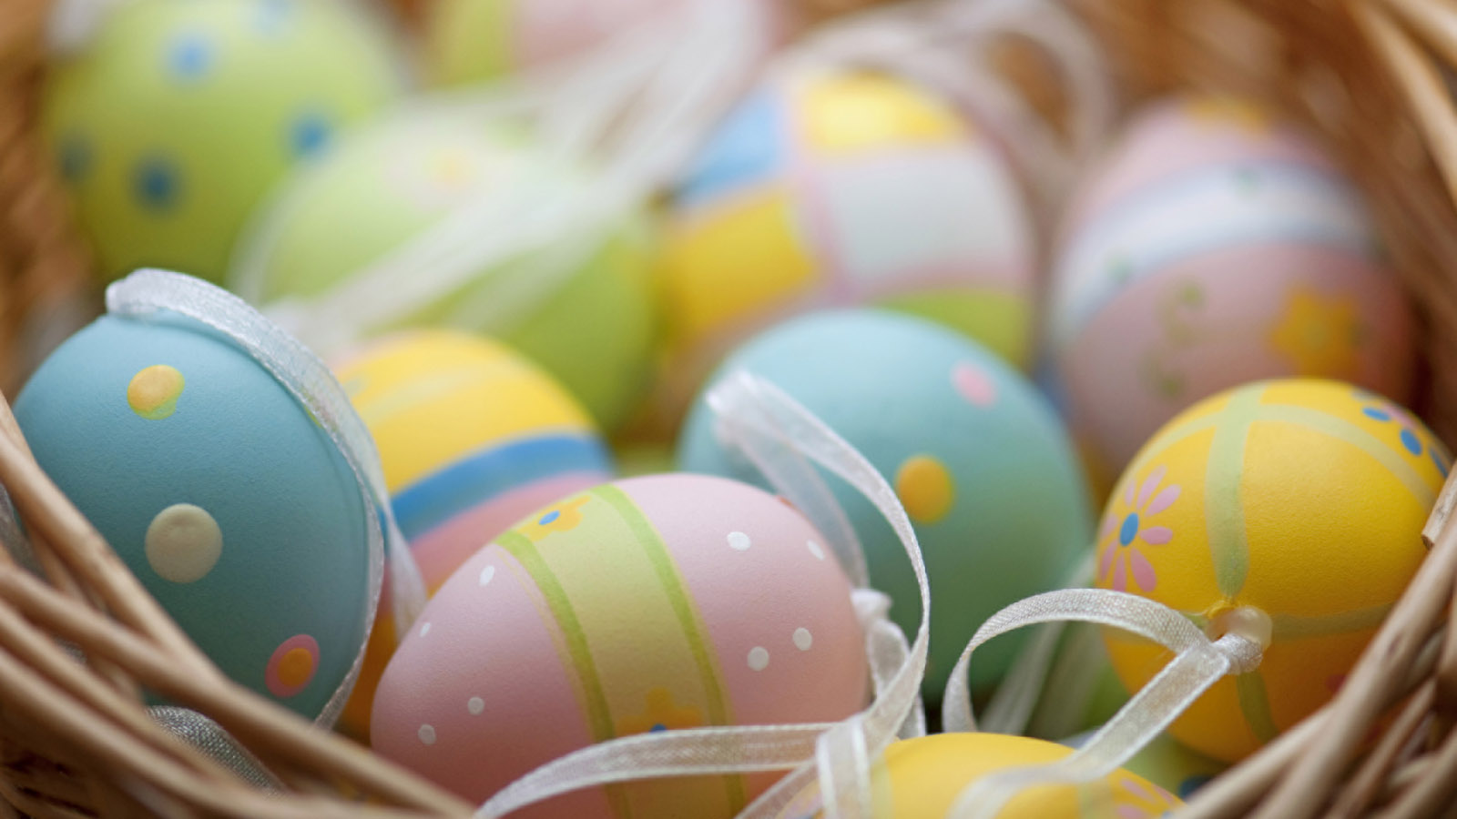
Four Seasons Hotel Westlake Village celebrates the Easter holiday with seasonal dining and family-friendly activities in honour of the region’s namesake.
Tucked within Los Angeles County’s northern city limits, the Conejo Valley earned its name from the early Spanish settlers who inhabited the region in the late 1800s and discovered the large population of desert cottontail and brush rabbit species (conejo is Spanish for rabbit). Today, bunnies abound in the nature immersed southern California destination.
Coin & Candor Easter Brunch
Chef Jesus Medina presents a seasonally-inspired Easter Brunch inside Coin & Candor, a California brasserie. The four-course prix fixe menu offered Sunday, April 9, 2023 is USD 112 per person plus tax and gratuities. Also offered on this day is the a la carte children’s menu featuring kids' classics. Reservations may be made online.
Coin & Candor Easter Brunch Menu
Amuse Bouche
- Oyster - pickled apple, milk, meyer lemon
Appetizer (choice of)
- Weiser Farm Melon – spicy pumpkin seeds, cucumber, prosciutto, smoked honey vinaigrette
- Strawberries – rhubarb, arugula, goat ice cream, Ojai olive oil
- Stone Fruit and Tomatoes – burrata, watercress, Thai basil
- Pan Seared Scallop – artichoke, asparagus, osteria caviar, peas
Entr&eacute;e (choice of)
- Spring Lamb Rib – labneh, herb salad, pickles, chipotle harissa, jus
- Pork Cheeks – soubise, cherry, plums, turnips
- Lobster – celery root, peas, chanterelles, jus
- Spring Risotto – peas, spring onion, fennel, parmesan
Dessert (choice of)
- Robin’s Egg mango passion Bavarian, phyllo nest, white chocolate ganache
- Garden Carrot Cake cream cheese cremeux, spiced caramel, pineapple sorbet
- Chocolate Nest dark chocolate, flourless gateau, vanilla bean ice cream
Festive Easter Offerings on Sunday, April 9, 2023
All activities are available to overnight Hotel guests and Coin & Candor brunch guests.
- Pictures with the Easter Bunny - The Easter Bunny will be available for pictures inside the Hotel from 10:00 am to 1:00 pm.

RELATED

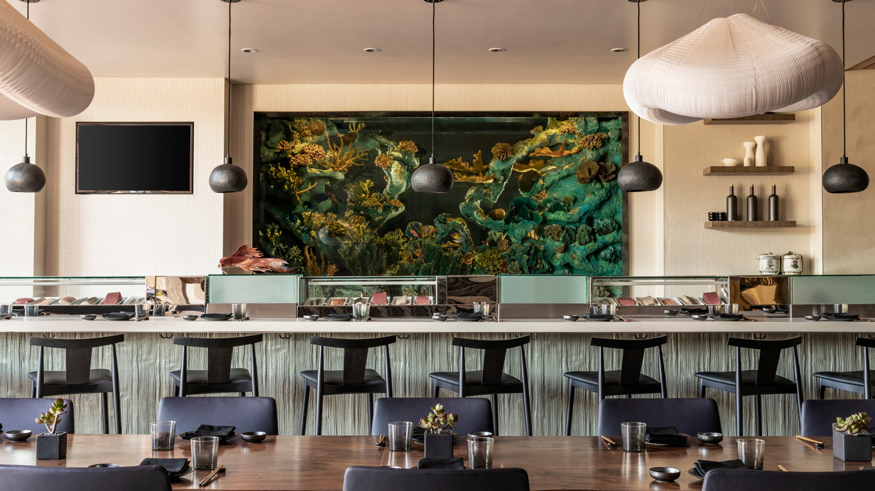 | March 1, 2023, Los Angeles, Westlake Village, U.S.A.  Onyx Reopens Inside Four Seasons Hotel Westlake Village  https://publish.url/westlakevillage/hotel-news/2023/onyx-reopening.html
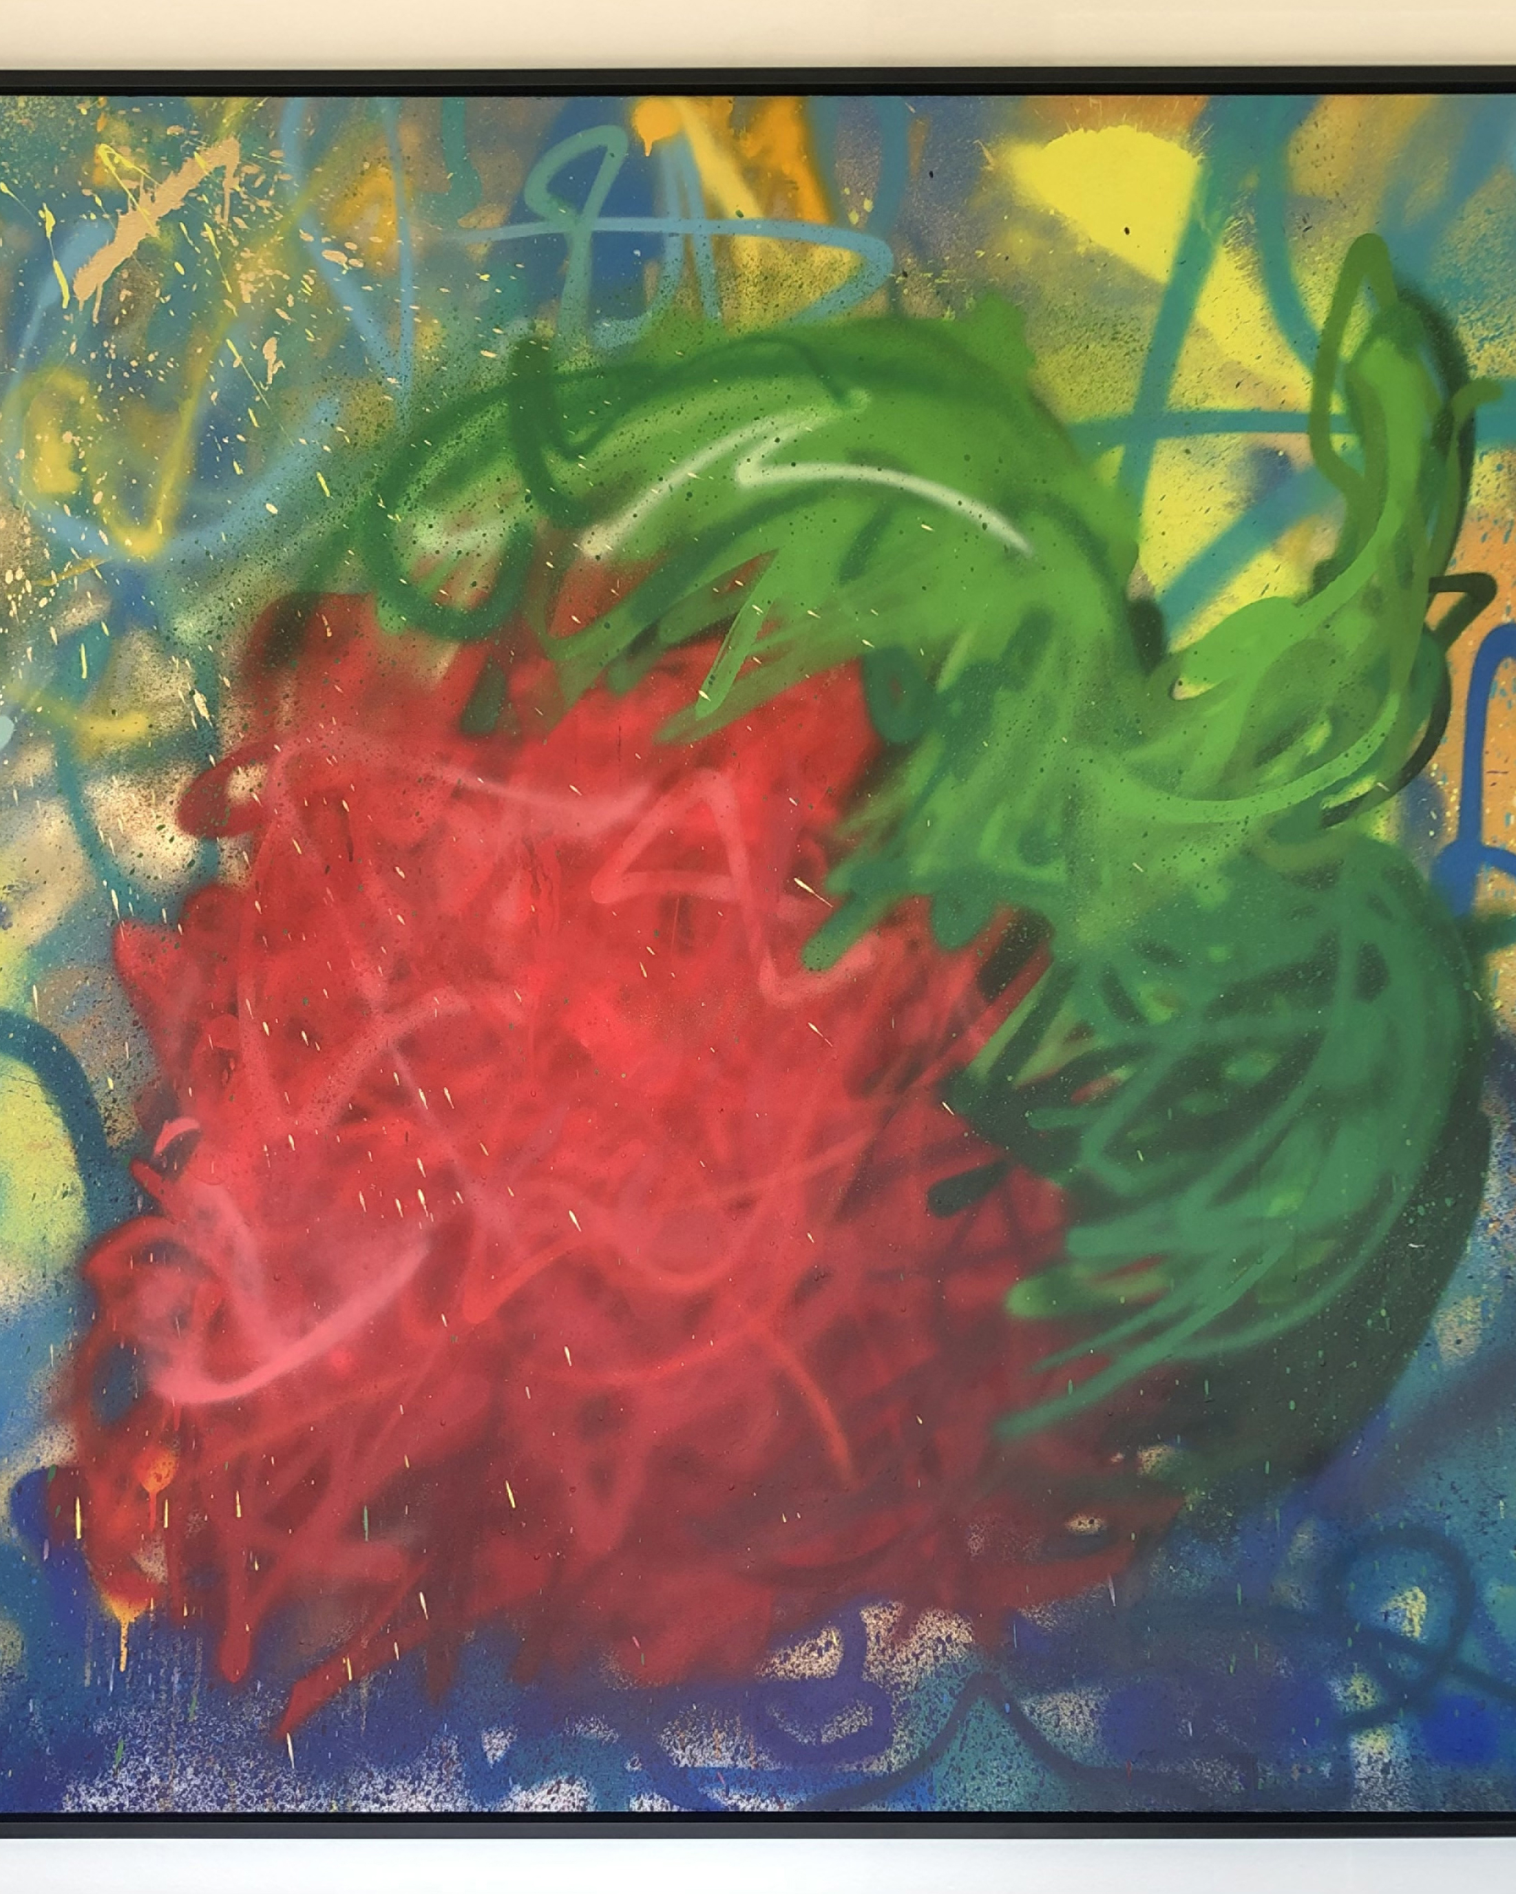 | January 30, 2023, Los Angeles, Westlake Village, U.S.A.  Street Artist MegZany Debuts Bold Fine Art Collection Inside Four Seasons Hotel Westlake Village  https://publish.url/westlakevillage/hotel-news/2023/art-collaboration-with-megzany.html

PRESS CONTACTS

Jacqueline Kerns and Harley Potter
Public Relations & Communications Team
Two Dole Drive
Westlake Village
USA
publicrelations.westlakevillage@fourseasons.com

+1 818 575 3089

