Four Seasons Hotel San Francisco Recognised as #1 Hotel in San Francisco in Condé Nast Traveler’s 2019 Readers’ Choice Awards

October 7, 2019, San Francisco, U.S.A.

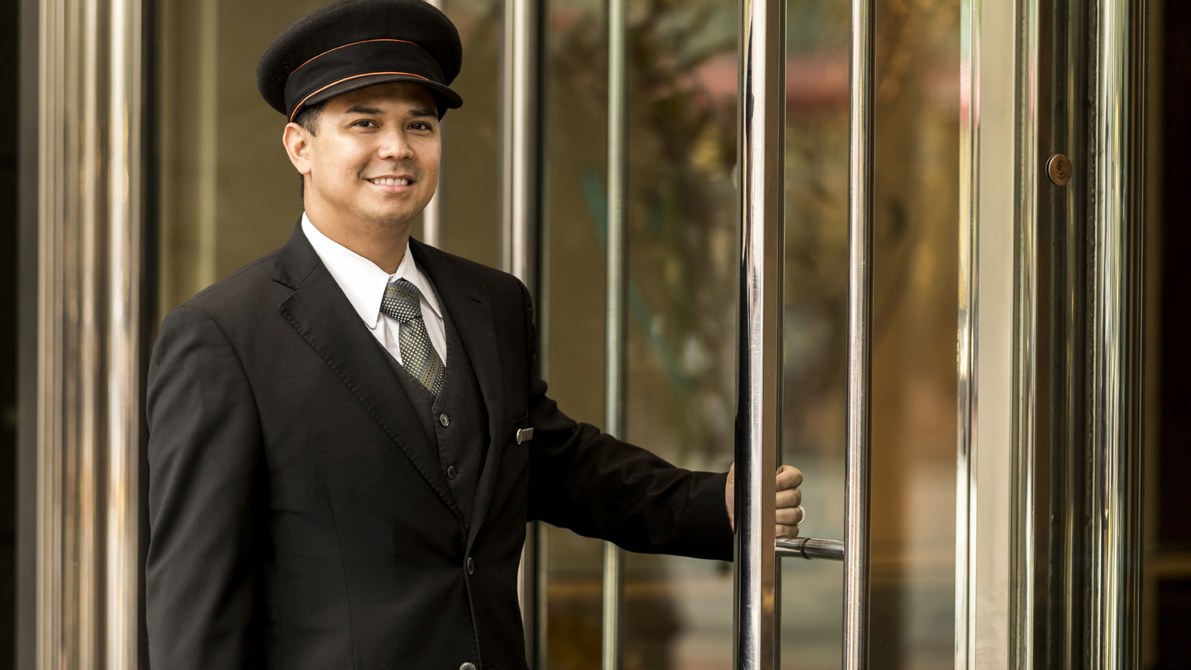
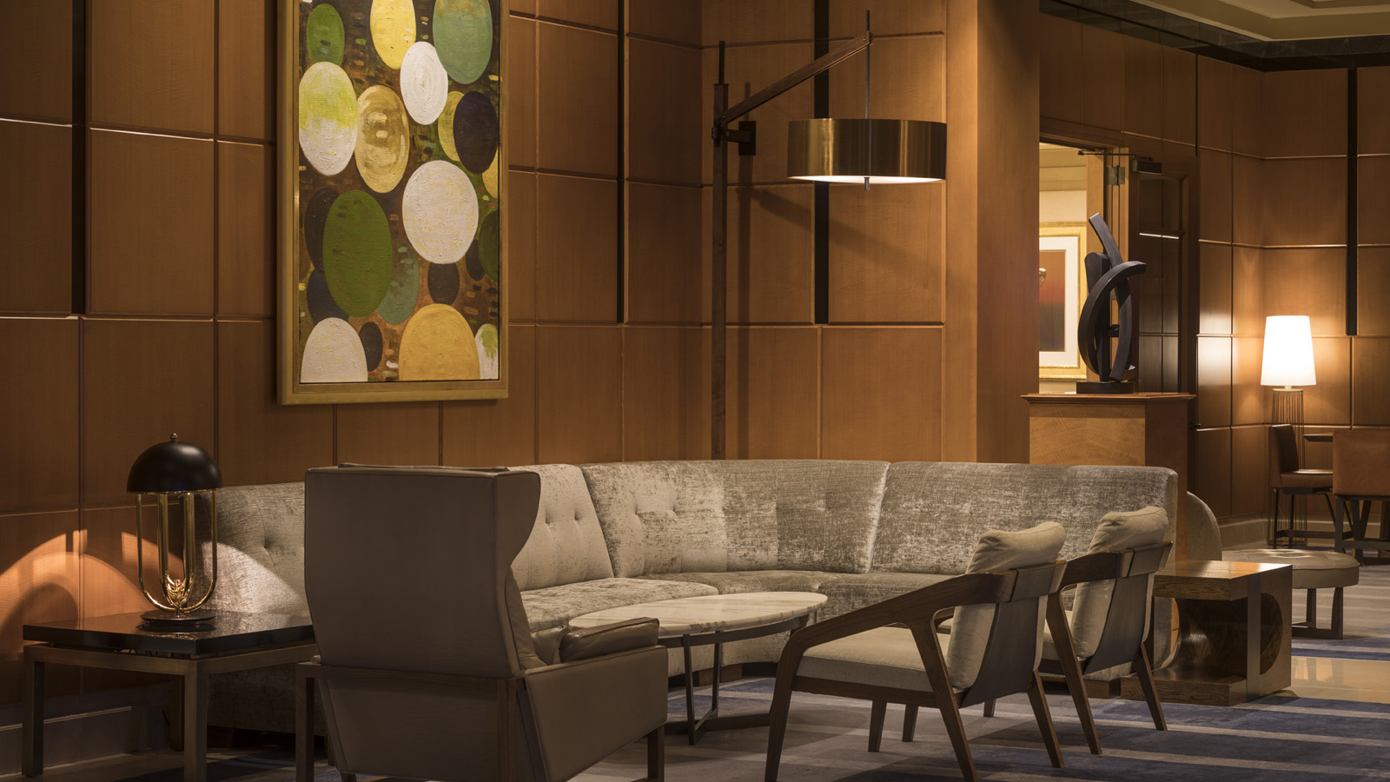 | 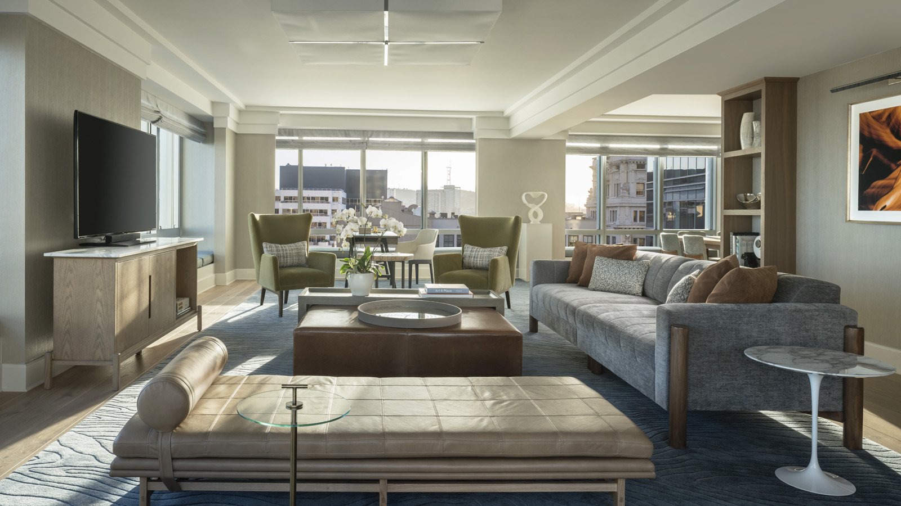 | 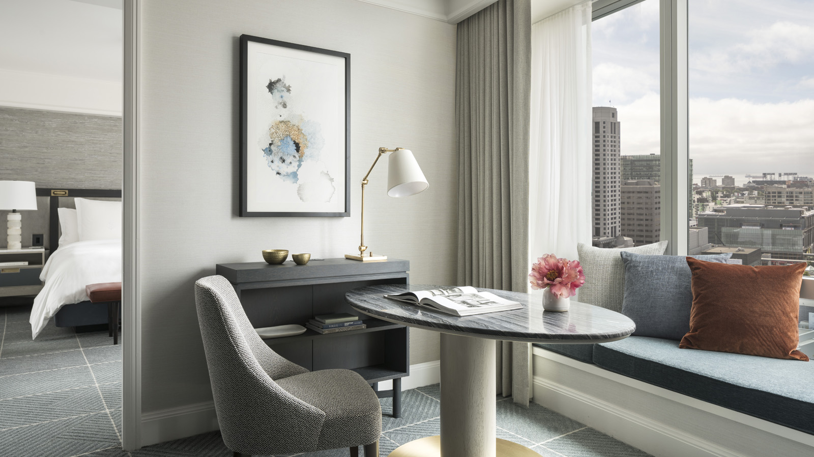
Condé Nast Traveler today announced the results of its annual Readers’ Choice Awards with Four Seasons Hotel San Francisco recognised as the #1 Hotel in San Francisco.
“We greatly value our relationship with our guests, and we take pride in providing excellent service and best accommodations for travellers. We are deeply honoured to be recognised by them as the number one hotel in the city,” says Joerg Rodig, general manager of Four Seasons Hotel San Francisco.
The award comes as the downtown hotel celebrates its 18th anniversary and continues to be the only Forbes Travel Guide Five-Star Hotel in San Francisco.
“I appreciate each member of the team and it’s their focus and commitment to upholding Four Seasons core values that makes this such an incredible place to call your home away from home,” continues Rodig.
Surrounded by the innovative tech hub and the arts and culture district, the sophisticated Hotel’s central location is steps from top museums and the latest start-ups. The world-class team at the Hotel keeps the 277 guest rooms and suites welcoming for travellers, whether couples who enjoy the elevated urban retreat or business travellers who seek the Hotel’s proximity to Moscone Center.
Add to that a Les Clefs d'Or concierge team; views of downtown and the Financial District; California cuisine at MKT Restaurant and access to Equinox Sports Club and it’s easy to see why the Hotel is consistently recognised as one of the best.
More than 600,000 Condé Nast Traveler readers across the globe submitted a recording-breaking number of responses rating their travel experiences to provide a full snapshot of where and how we travel today. The Condé Nast Traveler Readers’ Choice Awards are the longest-running and most prestigious recognition of excellence in the travel industry and are commonly known as “the best of the best of travel.”
For more information on Four Seasons Hotel San Francisco, MKT Restaurant, or extraordinary San Francisco experiences visit the Hotel online or call 415 633 3000.

RELATED

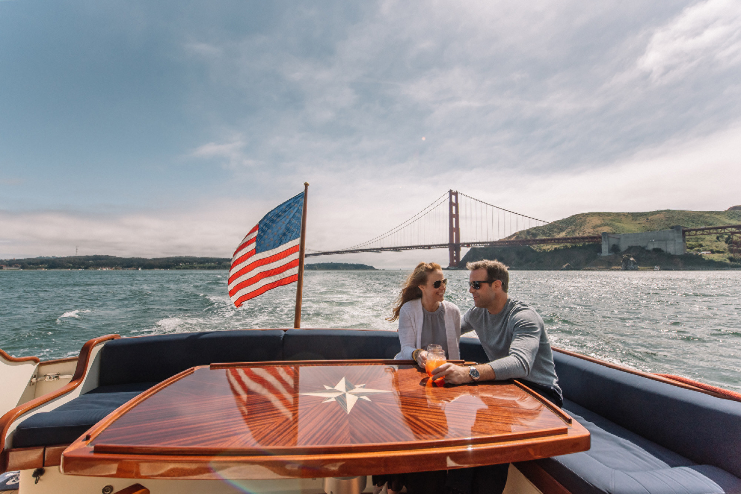 | September 16, 2019, San Francisco, U.S.A.  Uncover the Best of the Bay Through a Collection of New Experiences Exclusive to Guests at Four Seasons Hotel San Francisco  https://publish.url/sanfrancisco/hotel-news/2019/new-experiences.html
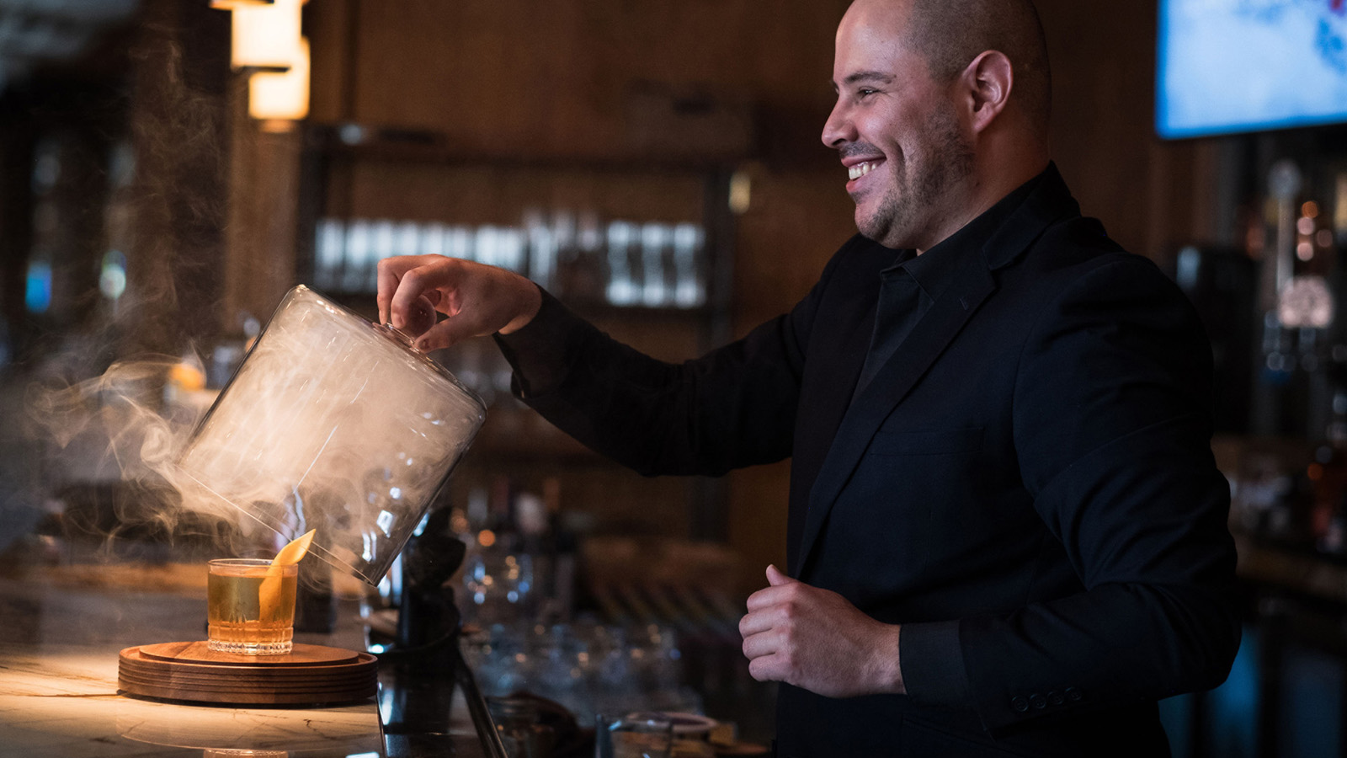 | July 24, 2019, San Francisco, U.S.A.  MKT Bar Debuts “Fog City Tales” at Four Seasons Hotel San Francisco  https://publish.url/sanfrancisco/hotel-news/2019/fog-city-tales-cocktail-menu.html

PRESS CONTACTS

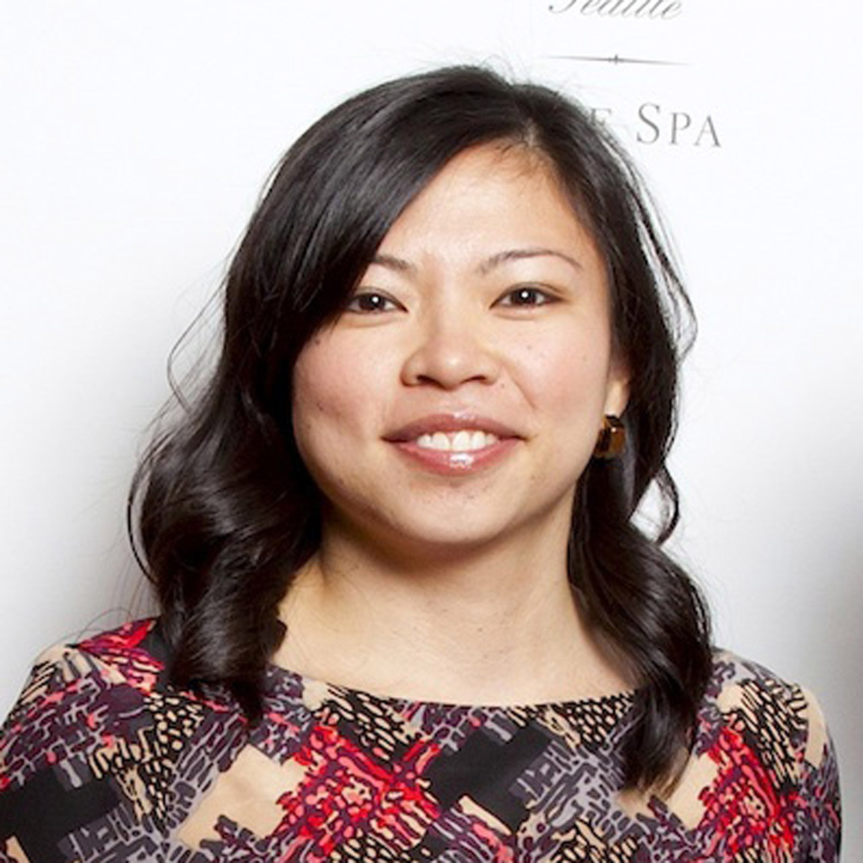 | Meg Paynor  PR Consultant  757 Market Street  San Francisco  U.S.A.  meg@paynorpr.com  1 (206) 913-3848

