Welcome to Paradise: Four Seasons Resort Oahu at Ko Olina Reopens March 11, 2021

Oahu’s famed oceanfront resort welcomes guests back to experience an exciting new era of redefined luxury anchored by enhanced health and safety protocols
February 18, 2021, Hawaii, Oahu, U.S.A.

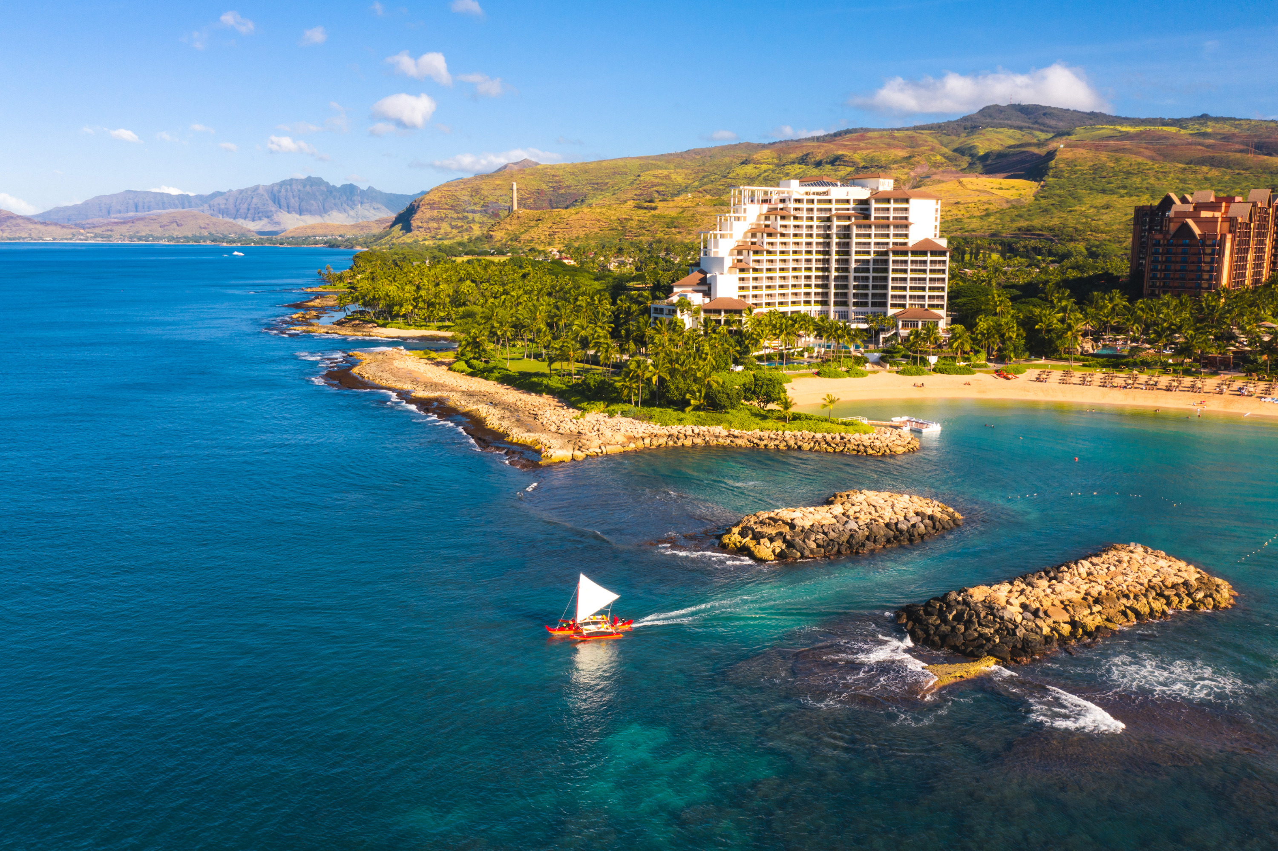
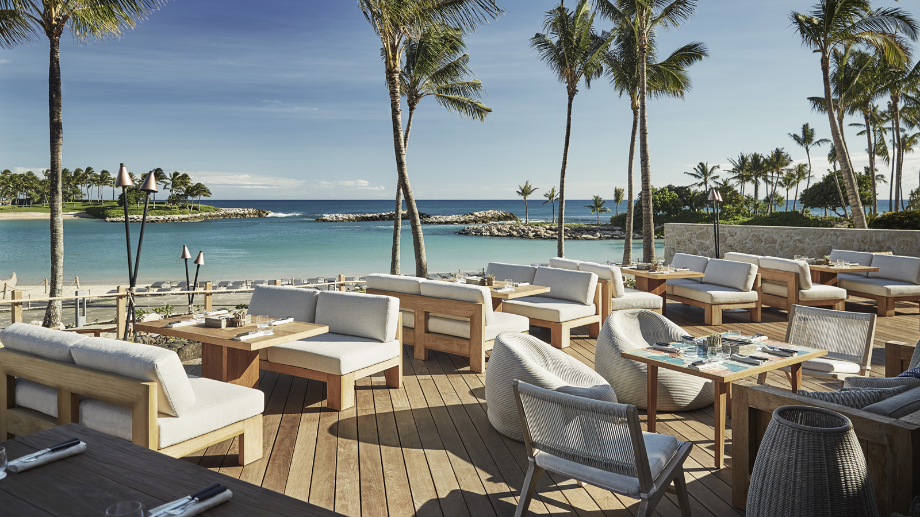 | 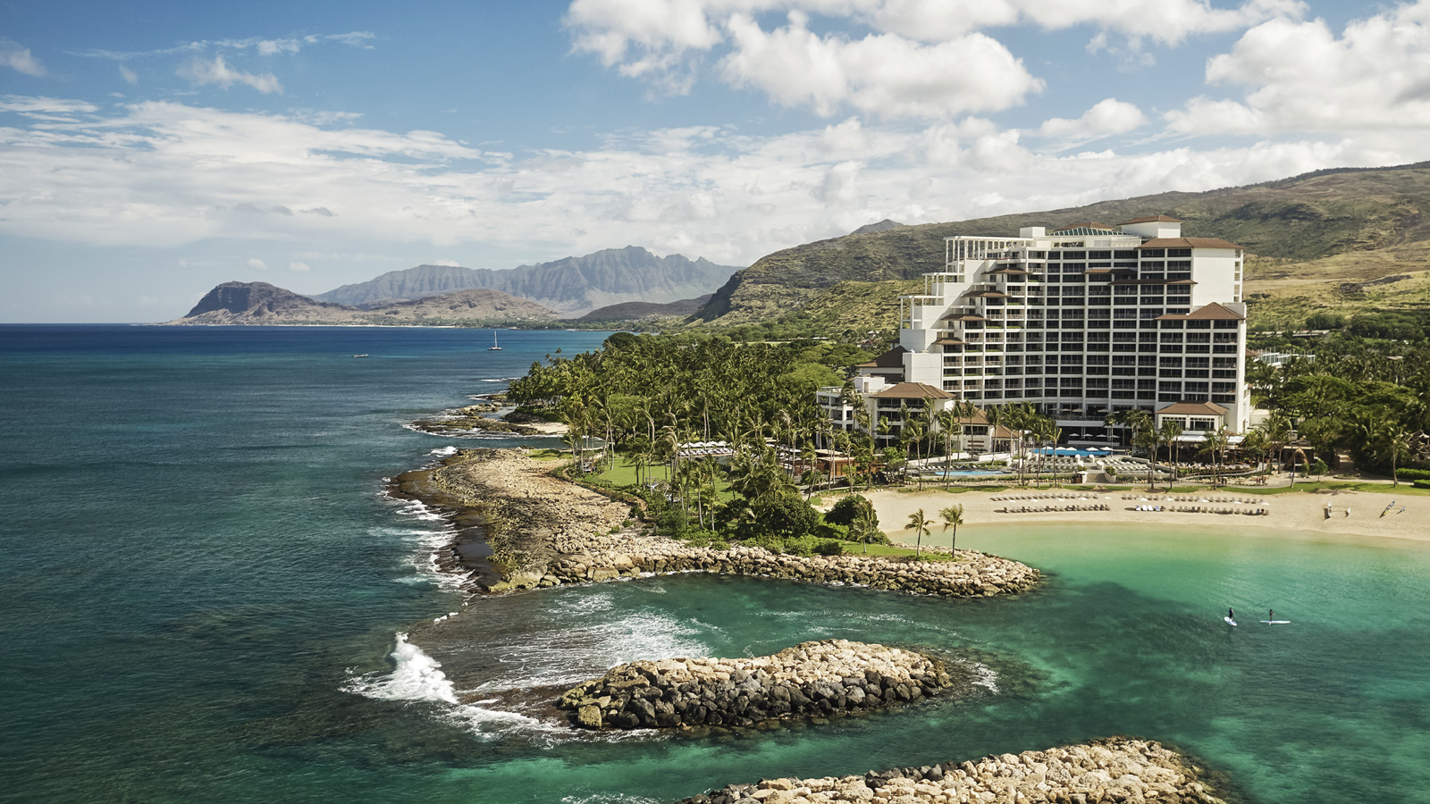 | 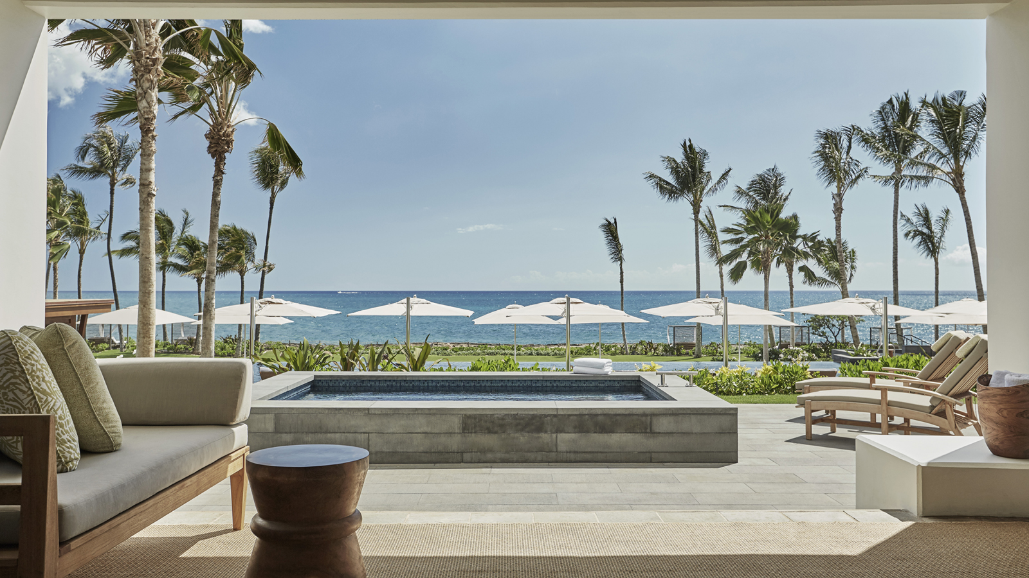
Four Seasons Resort Oahu at Ko Olina, an award-winning oceanfront resort on Oahu’s tranquil and secluded western coastline, will welcome guests back to paradise safely on March 11, 2021. Escape-seekers in search of transformative experiences can revel in a collection of new Four Seasons experiences ranging from reimagined culinary concepts and enhanced outdoor wellness programs, to refreshed guest rooms – all cemented by the island’s gracious hospitality and unparalleled service. Whether discovering Oahu for the first time, or rediscovering the allure of the island once again, Four Seasons invites guests to celebrate the reopening with a Fourth Night Free offer. One more day to reset, reconnect, and indulge in paradise.
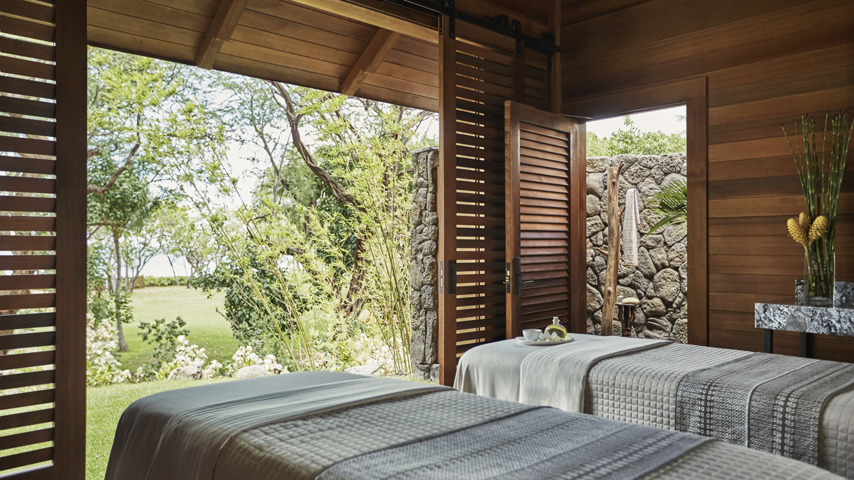
Four Seasons Resort Oahu is ideally set within the exclusive resort community of Ko Olina, a 642-acre (260 hectare) sun-drenched canvas encompassing four emerald-blue lagoons teeming with tropical marine life. Guests have access to myriad outdoor and open-air offerings within the community, including Ko Olina Marina, a gateway to ocean adventure and exploration; Ko Olina Golf Club, an 18-hole championship course designed by Ted Robinson and home to the LOTTE Championship LPGA event; and a scenic 1.5 mile (2.4 kilometre) seaside jogging pathway. Guests are invited to bask in the Resort’s outdoor playground and discover a sense of connection and belonging through an expansive array of activities and offerings – from shopping and artisan workshops, to standup paddle boarding and traditional Hawaiian canoe sailing, to yoga and spa treatments – all within steps of the Resort.
“On behalf of the entire Four Seasons team, we are thrilled to welcome guests back to our incredible Resort this spring, anchored by our strict health and safety protocols, and innovative new technologies,” says Michael Mestraud, General Manager of Four Seasons Resort Oahu at Ko Olina. “Our world-class amenities and personalised service, matched by Ko Olina’s remote location, is an ideal haven for guests to relax in nature and feel reassured, away from today’s challenges.”
Lead With Care
Four Seasons Resort Oahu will reopen featuring Four Seasons Hotels and Resorts new Lead With Care program. Grounded in health care expertise and enabled by access to leading technologies and tools, the Lead With Care program is focused on providing care, confidence and comfort to all Four Seasons guests, employees and residents within the new COVID-19 environment. The new program outlines clear procedures that educate and empower Four Seasons employees to take care of guests and each other.
Additionally, the Resort has invested in Needlepoint Bipolar Ionization technology, a state-of-the-art air purification system, throughout the Resort. All guest rooms, suites and the Spa feature this patented technology, which safely cleans the air and is 99.4 percent effective at eliminating COVID-19 on stagnant surfaces within 30 minutes.
While guests will see many of the enhanced Lead With Care procedures, behind-the-scenes measures have also taken place through employee training, additional food handling protocols, and enhancements to ventilation systems and other back-of-the-house operations. In addition, Four Seasons App and Chat will give guests the option of contactless engagement throughout their stay and further allow guests to control how they engage with team members – limiting face-to-face interactions while maintaining the highest levels of Four Seasons service that guests know and love.
Island Living
Featuring 370 spacious accommodations, Four Seasons Resort Oahu offers a range of spacious guestrooms and suites that reflect the ultimate in luxury island living. Whether for a multi-generational or multi-family escape, a new work-from home “office,” or simply seeking an unforgettable getaway to cultivate connections, the Resort features a collection of accommodations for a home-away-from-home experience in paradise. Additionally, guests can enjoy island living at its best with the Extended Stay program, designed exclusively for stays of 30 days or more.
Reimagined Culinary
Upon reopening, the Resort will debut a collection of distinct new culinary experiences to complement the Resort’s five restaurants and bars. Guests can sip innovative cocktails and indulge in light bites at Mina’s Beach Club – the all-new toes-in-the sand experience by James Beard Award-winning Chef Michael Mina located directly on the beach; savour a new plant-based inspired concept at La Hiki; and enjoy the stylish swim-up bar, Dr. Mai Tai’s, located at the water’s edge of the famed infinity pool. Set on the Ocean Lawn, the Resort will also showcase a flavourful Hawaiian barbeque dinner concept on Monday evenings. Signature restaurants Noe Italian and Mina’s Fish House will showcase their acclaimed menus, as well as introduce specialty nights to further expand guests’ palettes.
Naupaka Spa and Wellness Center
Guests are invited to reset and rejuvenate at Naupaka Spa and Wellness Center with new physically distanced indoor and outdoor fitness offerings, including morning yoga on the Ocean Lawn, five tennis courts, and readapted spa treatments grounded by Lead With Care safety practices. Naupaka Spa invites guests to connect to nature and rejuvenate in private, open-air outdoor hale (traditional huts) for a rejuvenating massage, while overlooking the Pacific Ocean.
Adventures in Nature
From mauka to makai (land to sea), guests are invited to take advantage of Oahu’s pristine playground and experience adventures in nature. Discover a collection of Hawaii pursuits reflective of the area’s deeply rooted traditions and relationship to the land and ocean. From sailing along the western coastline on a traditional outrigger canoe to watching the sunrise from Ka’ena Point, Oahu is an inspiring backdrop to bask in the outdoors. The Concierge can assist with arranging a bespoke day of adventure.
Family Time
The calm, swimmable lagoons and beaches, abundance of outdoor pursuits, art and cultural workshops, and all matched by the fully outfitted Camp Kohola – the Resort’s complimentary Kids For All Seasons club - creates a haven for children of all ages. Whether travelling with toddlers, tweens, or teens – Four Seasons cultivates connections and belonging for families. A sampling of activities includes Hawaiian jewellery making, hula lessons, art classes, Ko Olina Golf Academy, seasonal Proper Rideshop Skateboard camp, baby and child room amenities, on-site professional photographers, and much more.
Discover Four Seasons Resort Oahu at Ko Olina and let the story unfold. To make a reservation, book online or call 808 679 0079.

RELATED

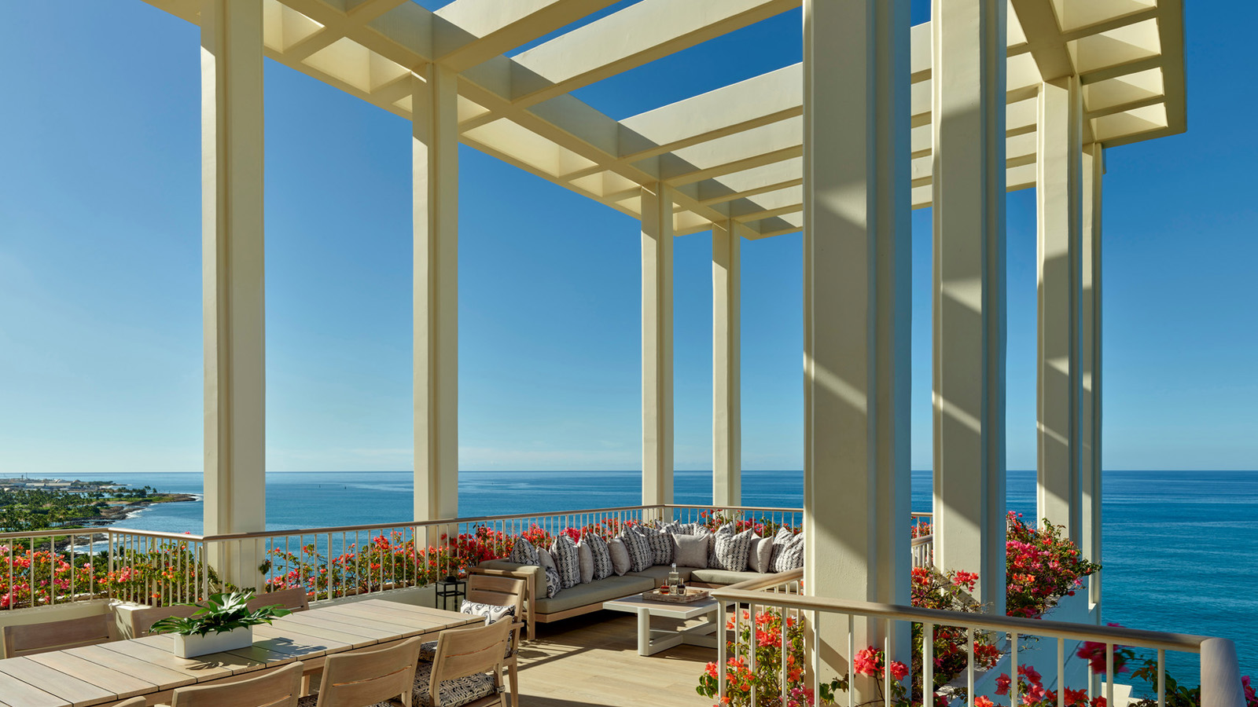 | December 13, 2021, Hawaii, Oahu, U.S.A.  Four Seasons Resort Oahu at Ko Olina Unveils Reimagined Penthouse Suite  https://publish.url/oahu/hotel-news/2021/renovated-penthouse-suite.html
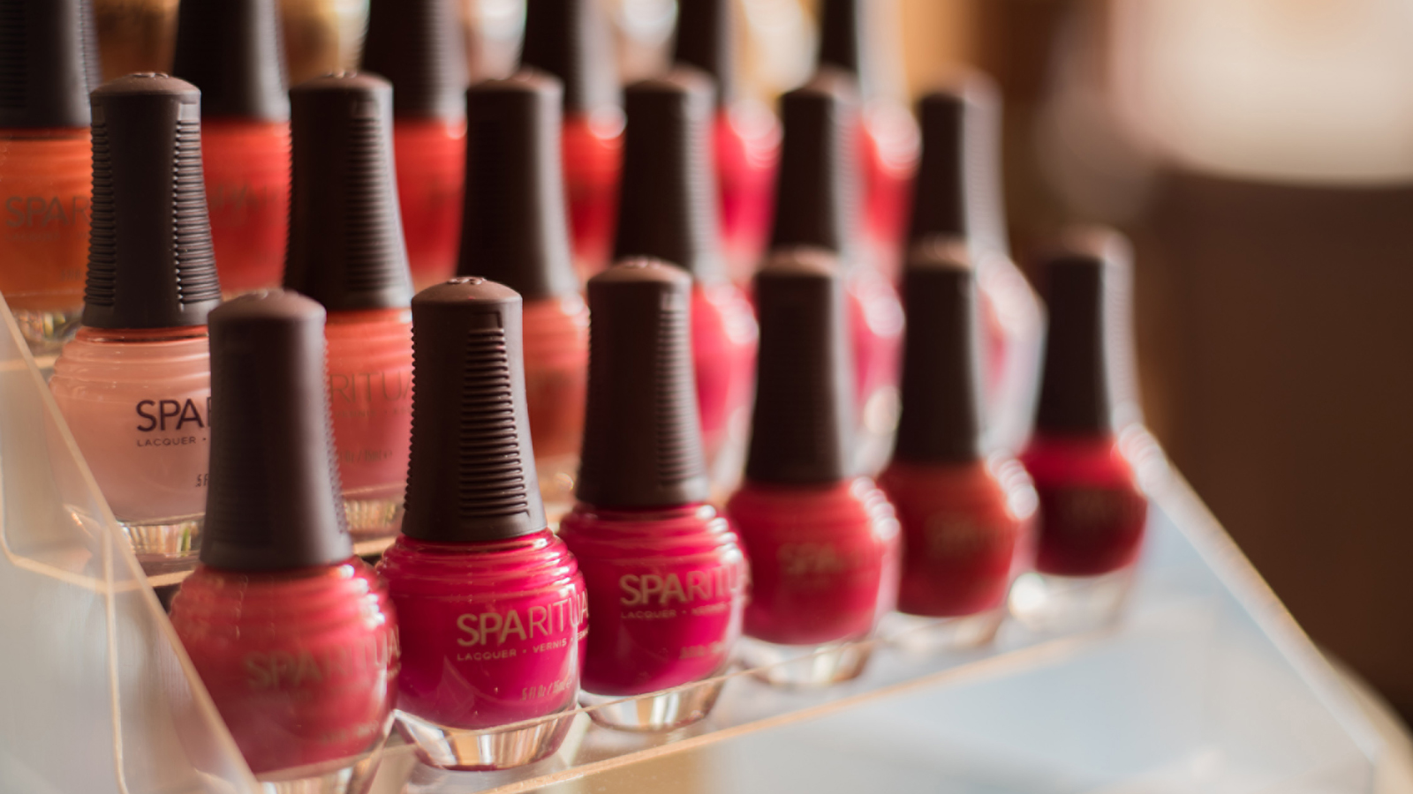 | December 13, 2021, Hawaii, Lanai, U.S.A.  Hawanawana Spa at Four Seasons Resort Lanai Introduces Sound of Color  https://publish.url/lanai/hotel-news/2021/sound-of-color-spa-treatment.html

PRESS CONTACTS

Michelle Edwards
Director of Public Relations and Marketing Communications
92-1001 Olani Street
Kapolei
USA
michelle.edwards@fourseasons.com

+1 808 679 3364

