The Ocean Club, A Four Seasons Resort, Recognised with Condé Nast Traveler 2019 Readers’ Choice Award

October 7, 2019, Paradise Island, Bahamas

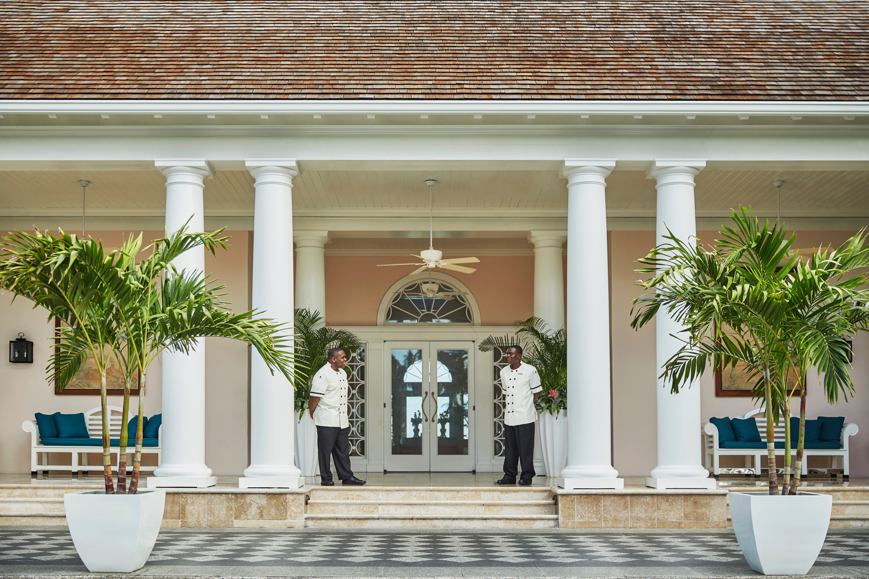
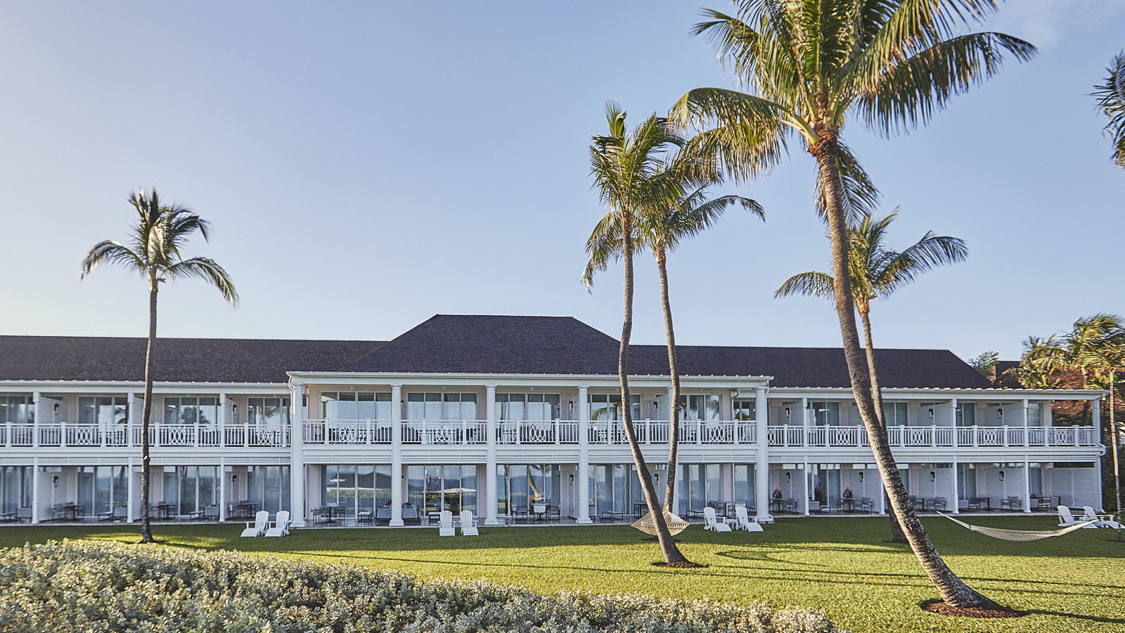 | 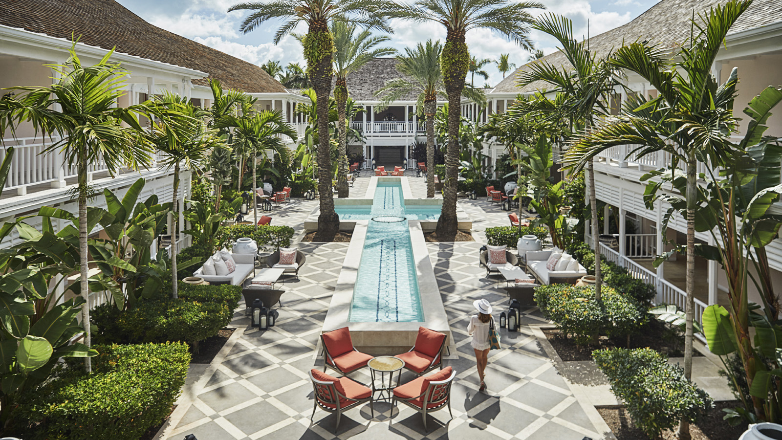 | 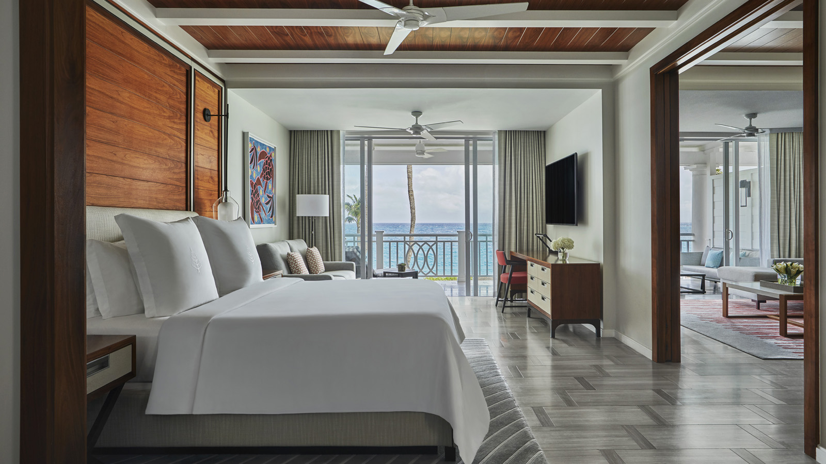
Condé Nast Traveler today announced the results of its annual Readers’ Choice Awards, which included The Ocean Club, A Four Seasons Resort, Bahamas among its top ranked resorts.
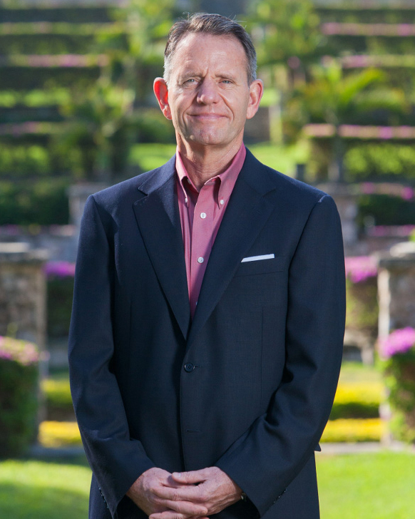
“It seems the legend of James Bond remains strong for The Bahamas, with The Ocean Club, A Four Seasons Resort recognized as the 007th Top Resort in The Atlantic,” says General Manager John Conway. “The Ocean Club is a haven for the most discerning travellers; offering glamorous solace in an atmosphere of being among family. To the guests who have named us to this prestigious list, we offer our sincerest ‘thanks!’ The announcement comes at a time when travel to The Bahamas has never meant so much. And in return, we say, ‘From The Bahamas, with love.’ “
The Resort, surrounding Paradise Island and Nassau were unaffected by the recent storm that left devastation to life and property on the northern islands of Grand Bahama and The Abacos. The need for relief is ongoing, with the Resort sending financial contributions to International Medical Corps and volunteers to work with World Central Kitchen.
For current offers and best available rates, book online. A featured package, available through December 21, 2019 is the Stronger Together offer, which includes a USD 200 donation from the Resort to International Medical Corps.
More than 600,000 Condé Nast Traveler readers across the globe submitted a recording-breaking number of responses rating their travel experiences to provide a full snapshot of where and how we travel today. The Condé Nast Traveler Readers’ Choice Awards are the longest-running and most prestigious recognition of excellence in the travel industry and are commonly known as “the best of the best of travel.”

RELATED

September 6, 2019, Paradise Island, Bahamas
How You Can Support Hurricane Dorian Relief Efforts with The Ocean Club, A Four Seasons Resort, Bahamas
https://publish.url/oceanclub/hotel-news/2019/hurricane-dorian-relief-efforts.html

September 3, 2019, Paradise Island, Bahamas
Statement from The Ocean Club, A Four Seasons Resort, Bahamas
https://publish.url/oceanclub/hotel-news/2019/hurricane-dorian.html

PRESS CONTACTS

Monica Majors
Director of Public Relations and Communications
777 Yamato Road, Suite 502
Boca Raton
USA
monica.majors@fourseasons.com

561-931-0614

