Celebrate Easter with Four Seasons Hotel Hong Kong

March 31, 2022, Hong Kong, China

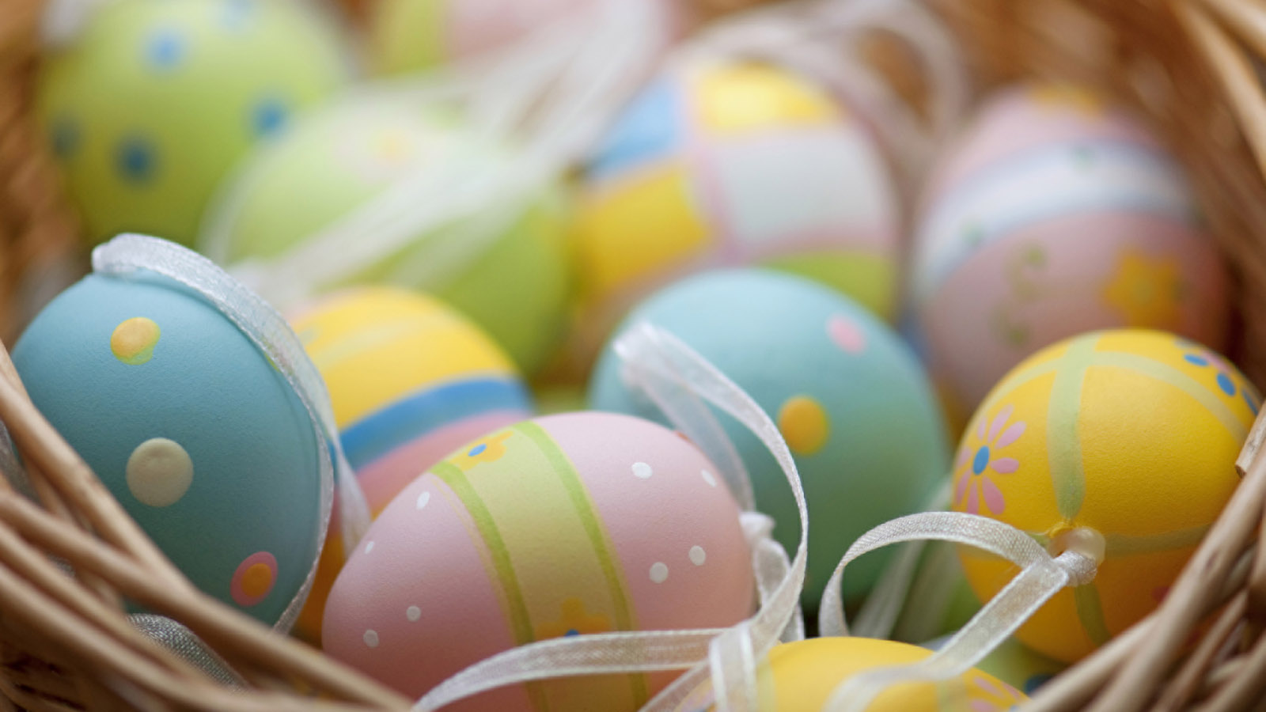
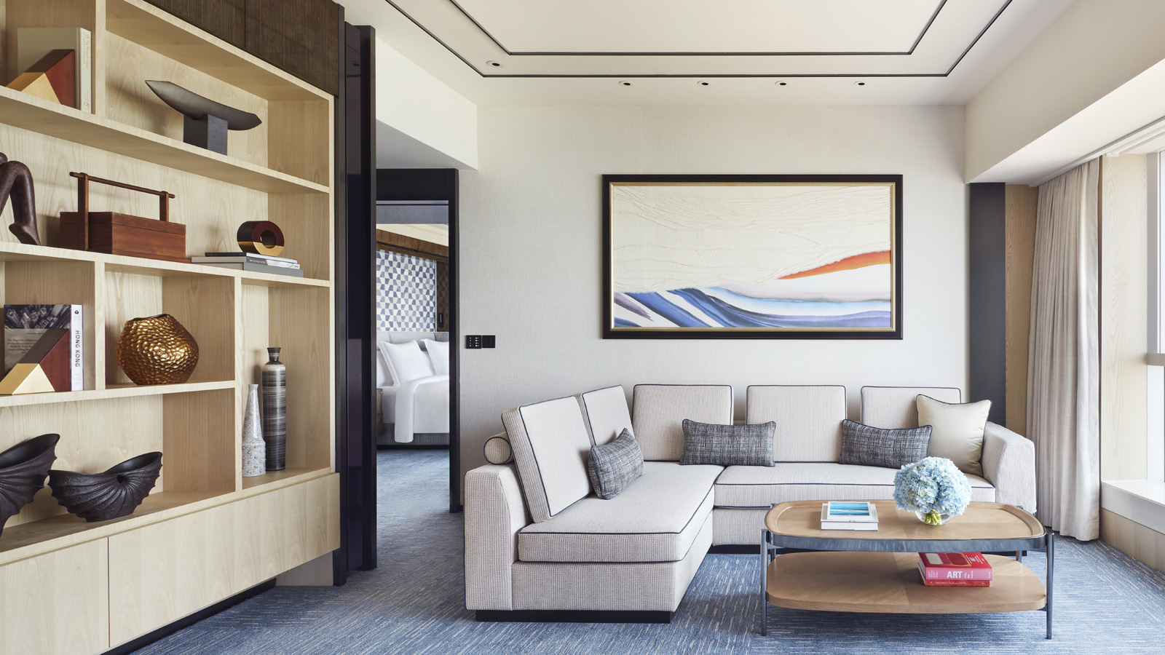 | 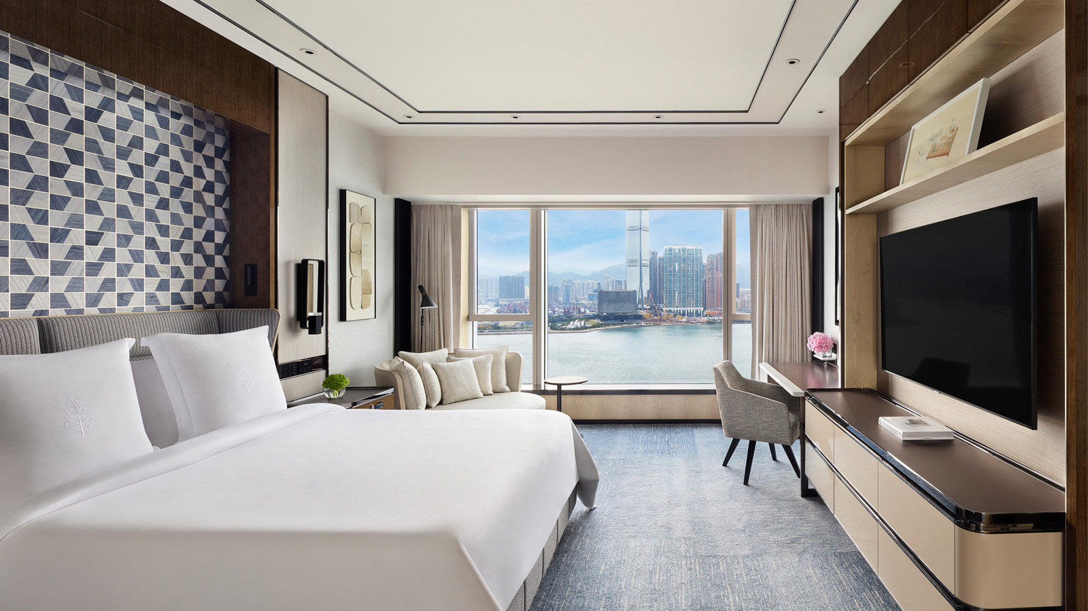
This Easter, Four Seasons Hotel Hong Kong is welcoming local holiday makers with a host of family-friendly activities and chef-curated culinary enjoyments, including a fun-filled Easter-themed staycation, a whimsical Afternoon Tea at The Lounge, an aromatic afternoon treat at Gallery, a sumptuous buffet lunch at ARGO, as well as a collection of roasted meat and interactive “Crack Me” Easter smash eggs on the Hotel’s e-shop. At Four Seasons Hotel Hong Kong, this Easter is bound to be full of joy and laughter.
Family Fun Staycation
From April 1 to April 18, 2022, Four Seasons Hotel Hong Kong is turning its newly renovated guest rooms into a fun-filled kid’s paradise. Upon arrival, have a taste of what awaits with an in-room garden-themed afternoon tea, where butterfly cupcakes, macarons with funny faces, and strawberry marshmallow lollipop are served together with the Hotel’s signature scones for a complete experience.
Carry on the fun with more activities the Hotel has prepared for the family, including Easter egg and cookie painting that will bring out the little artist in the kids and a scavenger hunt that will put the child's creativity to test, before indulging in a wonderful playtime in bubble baths and in the in-room tent to guarantee a night of good sleep and sweet dreams.
For guests who are staying for two or more nights can receive HKD 1,000 Hotel credit to enjoy extended culinary offerings or savings on room rates. With a selection of board games available throughout the stay at Concierge, the staycation promises to put a smile on every family member’s face.
Book Easter Family Fun Staycation and enjoy the following inclusions:
- Daily breakfast for two adults and two children aged six and below at designated Hotel restaurants
- One set of garden-themed in-room afternoon tea for two adults and two children per stay featuring butterfly cupcakes, funny face macarons and strawberry marshmallow lollipops
- In-room welcome amenities for kids: BBQ set, a starry flashlight, colouring books, crayons and colour pencils, bubble bath set
- One DIY Easter cookie decoration kit per stay
- One complimentary rollaway bed per stay
- Selection of board games such as Scrabble, UNO Flip, Monopoly and Stick Stack are available at Concierge
- Overnight parking at a special rate of HKD 450 per vehicle
- For stays during Easter weekend: complimentary in-room virtual activities, including Easter egg painting, Easter bag decoration, and scavenger hunt activity with a complimentary gift upon completing the hunt
- For stays in Suites: glamping adventure tent set-up
- For stays of two or more nights: a nightly HKD 1,000 Hotel credit starting from the second night of stay
Package rate starts from HKD 2,900. Price is subject to 10 percent service charge. For reservations, call 3196 8333 or email res.hongkong@fourseasons.com.
A Whimsical Easter Afternoon Tea at The Lounge
From April 10 to 18, 2022, The Lounge will delight guests with an afternoon tea filled with three tiers of sweets and savouries that are almost too cute to eat. Begin the experience with the carrot cake – designed to be a visual entertainment, the classic carrot cake is placed between two pieces of crunchy almond biscuits with an added layer of decadent cream cheese frosting to resemble a petit sandwich. Together with the use of vibrant colours, one must bite into it to confirm it is a delicious edible treat instead of a beautiful prop.
Other equally amusing treats include mango sphere and coconut jelly cake that takes on the look of a sunny-side up egg, and chocolate cream and mukrat lime curd shaped as a lime. Enhance the joy by visiting the live cooking station where Easter chocolate egg with chocolate espuma and hot cross bun lemon gelato sandwich are offered.
Easter Afternoon Tea is available from April 10 to 18, 2022 from 3:00 to 6:00 pm at HKD 698 per set (for two persons) on April 10, 2022; HKD 658 per set (for two persons) on April 11 to 14, 2022; and HKD 498 per set (for one person) with live cooking station on April 15 to 18, 2022. Prices are subject to 10 percent service charge. The tea set is also available for takeaway at HKD 698 per set (for two persons).
For enquiries, call dining reservations at (852) 3196 8882 or email dining.hkg@fourseasons.com.
An Aromatic Easter Afternoon Treat at Gallery
From April 15 to 18, 2022, Gallery will elevate its popular afternoon treats experience by introducing a live cooking station where aromatic crêpes suzette with Madagascar vanilla gelato will be cooked and served à la minute. Complemented by treats such as barbecued goose puff with bonito flakes and fraises et vanille, the experience will end on a high note with a cup of artisanal coffee from Omotesando Koffee, a pot of bespoke rare tea from Yu Tea House or free-flow champagne at an additional price.
The Easter Afternoon Treat is available from April 15 to 18, 2022 from 3:00 to 6:00 pm at HKD 448 per person. Free-flow champagne is available at an additional price of HKD 388 per person. Price is subject to 10 percent service charge.
For enquiries, call dining reservations at (852) 3196 8882 or email dining.hkg@fourseasons.com.
Sumptuous Easter Buffet Lunch at ARGO
Have a relaxing buffet lunch at ARGO with an array of delectable festive dishes abound. Look out for the carving station where slow roasted apricot-harissa leg of lamb and Okinawa black sugar glazed gammon ham are featured, with honey glazed carrot with cumin to complete the enjoyment. Guests can also enjoy devilled egg, Easter macarons and hot cross buns, among other irresistible offerings.
The Easter Buffet Lunch is available from April 15 to 18, 2022 from 12:00 noon to 2:30 pm at HKD 728 per adult and HKD 364 per child aged 5 to 11 years old. Prices are subject to 10 percent service charge.
For enquiries, call dining reservations at (852) 3196 8882 or email dining.hkg@fourseasons.com.
“Crack Me” Easter Smash Eggs and Roast Specials on e-Shop
Amp up one’s home celebration with Four Seasons “Crack Me” Easter smash eggs on e-Shop where one can watch their children’s faces light up when they crack open the adorable chocolate sheep sitting on a bed of red velvet cake to reveal a combination of sweet delights, including marshmallow and Easter chocolate eggs. Other themes include Chocolate Bunny on Lemon and Vanilla Cake, and Chocolate Carrot on Carrot Cake. “Crack Me” Easter smash egg is priced at HKD 1,560 for 2 pounds and HKD 2,340 for 3 pounds.
Other festive treats include:
- Hot Cross Bun – HKD 35 per piece
- Rabbit Carrot Bread – HKD 35 per piece
- Giant Easter Cookies – HKD 480 per piece
- Easter Icing Cookies – HKD 48 per piece
- Mini Easter Chocolate Eggs – HKD 175 per box of 10, HKD 310 per box of 25
E-shop is also offering perfect roasted meat for those who wants to take a break from cooking this festival. Roasted leg of lamb is marinated with yoghurt, fresh herbs and lemon and roasted to perfection to deliver a layered flavour, while roasted Argentinian grass-fed beef tenderloin is a classic that never fails to impress. Each roasted meat comes with one’s choice of hearty side dishes such as roasted root vegetables, creamy mashed potato and roasted pumpkin wedges. Classic beef wellington with green peppercorn sauce is also available on e-Shop.
- Classic Roasted Argentinian Grass-Fed Beef Tenderloin – HKD 2,180 for 3 persons
- Roasted Leg of Lamb Marinated with Yoghurt, Fresh Herbs and Lemon – HKD 2,080 for 3-5 persons
- Classic Beef Wellington with Green Peppercorn Sauce – HKD 3,880 for 4-5 persons
For enquiries, contact the Hotel’s Cake Shop at (852) 3196 8159 or email cakeshop.hongkong@fourseasons.com or order online.

RELATED

March 31, 2022, Hong Kong, China
和香港四季酒店一起慶祝復活節
https://publish.url/zh_hant/hongkong/hotel-news/2022/easter-2.html

March 31, 2022, Hong Kong, China
和香港四季酒店一起庆祝复活节
https://publish.url/zh/hongkong/hotel-news/2022/easter-3.html

PRESS CONTACTS

Mandy Li
Acting Assistant Director of Public Relations
8 Finance Street, Central
Hong Kong
China
mandy.li@fourseasons.com

(852) 3196 8888

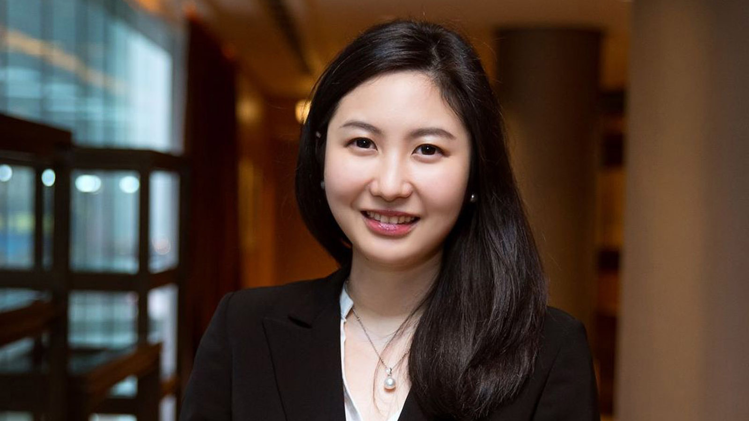 | Priscilla Chan  Assistant Public Relations Director  8 Finance Street, Central,  Hong Kong  China  priscilla.chan@fourseasons.com  (852) 3196 8307

