A Unique Journey Under the Stars as “Wings Open Air Cinema” Opens at Four Seasons Hotel Istanbul at the Bosphorus

June 24, 2022, Istanbul at the Bosphorus, Turkey

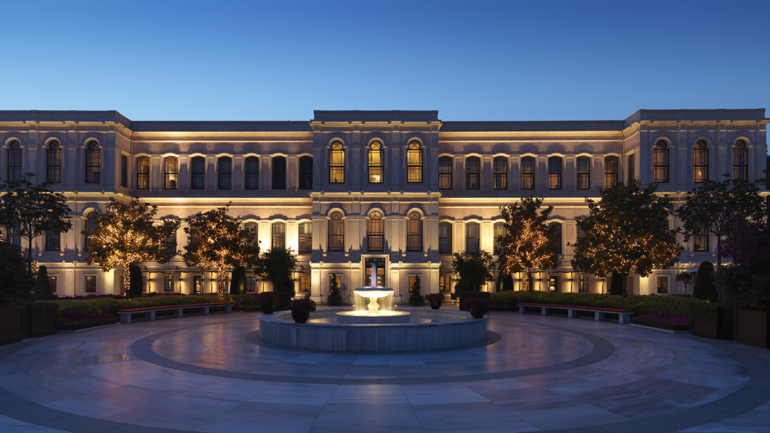
Four Seasons Hotel Istanbul at the Bosphorus is bringing back the open air cinema experience to its terrace along the stunningly beautiful Bosphorus in partnership with Wings, the shop-and-fly card program of Akbank. “Romantic Movies by the Bosphorus with Wings” in July 2022 and “Oscar Movie Nights by the Bosphorus with Wings” in August 2022 will feature some of the most memorable examples of each theme on the big screen at 9:30 pm every Monday night.
The expansive terrace of Four Seasons Hotel Istanbul at the Bosphorus, which has become the place to meet for entertainment, will show movies including House of Gucci, Last Night in Soho, West Side Story, and Mamma Mia! We’re Going Again, along with Academy Award-winning films Bohemian Rhapsody, Dunkirk, Whiplash, and Joker.
Open air cinema will be open to Hotel guests and all movie fans. Tickets will be sold at the Hotel and popcorn will be served for guests to make the most of watching these outstanding movies.
Romantic Movies by the Bosphorus with Wings
- June 27 - House of Gucci
- July 11 - Last Night in Soho
- July 18 - West Side Story
- July 25 - Mamma Mia! Here We Go Again
Oscar Movie Nights by the Bosphorus with Wings
- August 8 - Joker
- August 15 - Dunkirk
- August 22 - Bohemian Rhapsody
- August 29 - Whiplash
Reservations: Aqua.Bosphorus@fourseasons.com.

RELATED

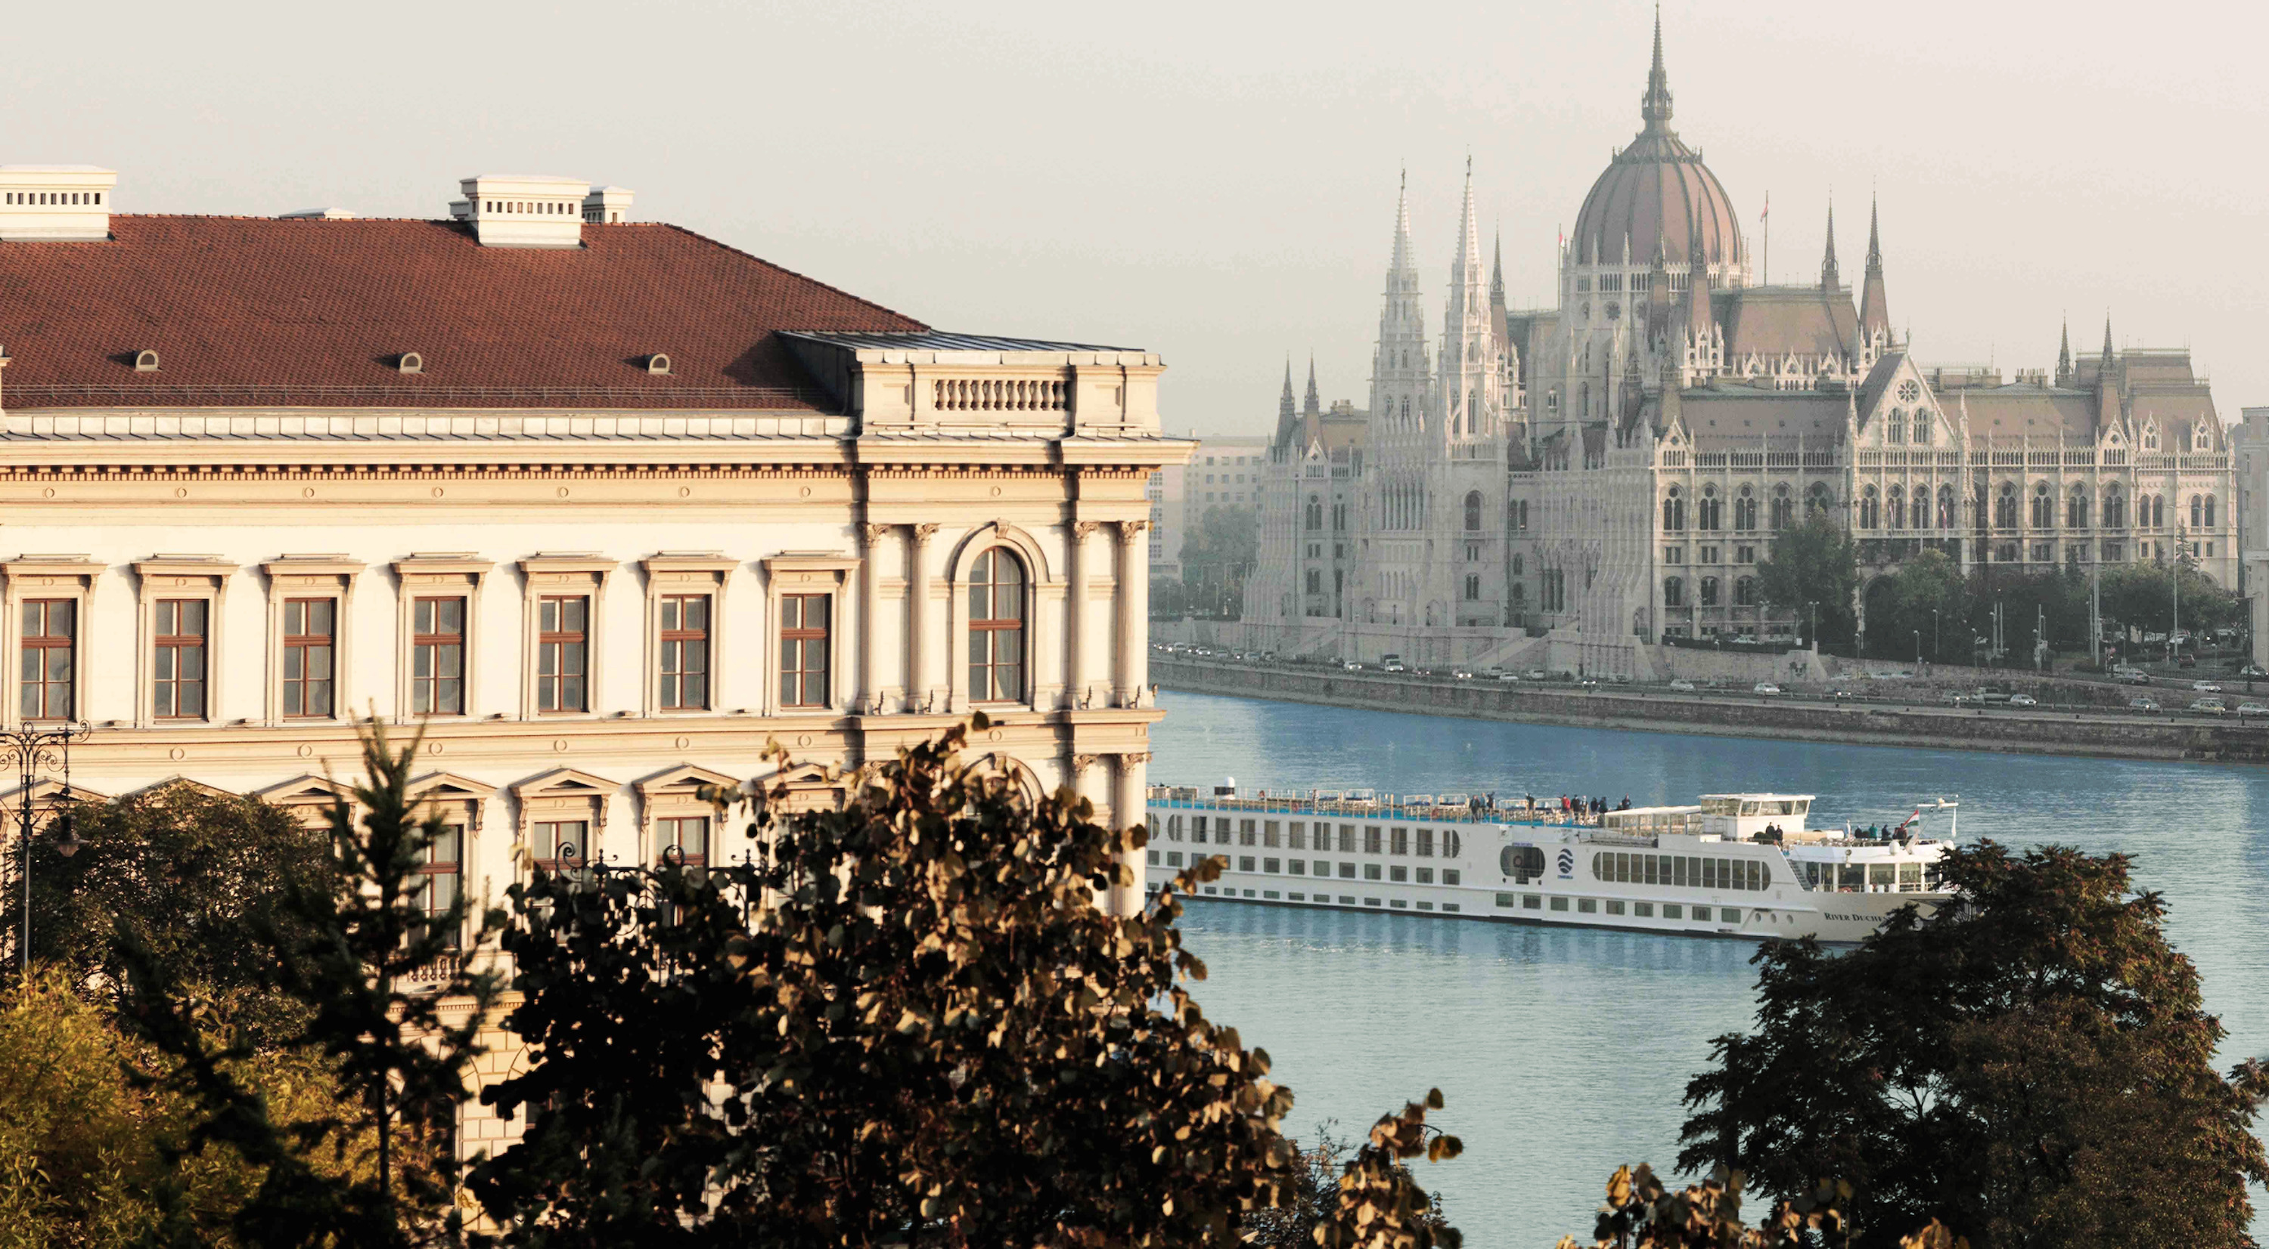 | June 7, 2022, Toronto, Canada  四季酒店推出“风光之路”旅行路线，欧洲慢行生活全新启程  https://publish.url/news-releases/2022/scenic-routes-in-europe-3.html
June 7, 2022, Toronto, Canada
Four Seasons apresenta Rota Cênica pela Europa com experiências exclusivas e inéditas em oito hotéis
https://publish.url/news-releases/2022/scenic-routes-in-europe-2.html

PRESS CONTACTS

Sibel Benli
Senior Director of Public Relations and Communications
Çırağan Cad. No. 28
Istanbul
Turkey
sibel.benli@fourseasons.com

90 (212) 381 41 35

