Theme Park Heaven

A playground for all ages
August 30, 2013, Shenzhen, China

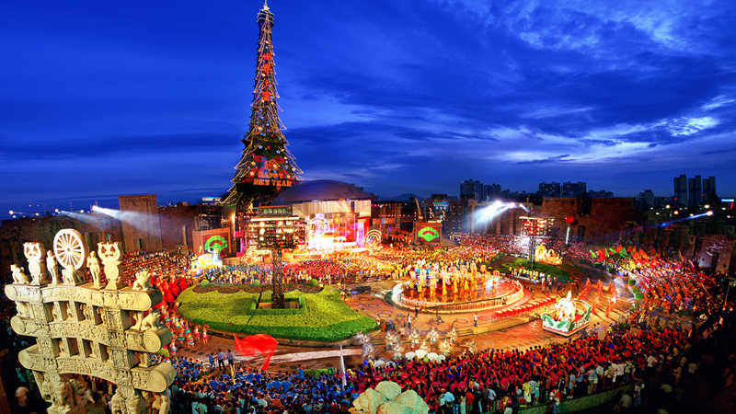
For theme park aficionados of all ages, Shenzhen is a dream come true. Happy Valley features thrilling roller coasters, Splendid China Folk Village is home to a stunning display of sample architecture and culture from China’s various provinces and ethnicities, and Window of the World has miniature and meticulous reproductions of 130 of the world’s most famous sights, including Giza’s pyramids, the Eiffel Tower and the Taj Mahal. One truly has to see it to believe it!
Ask the concierge at Four Seasons Hotel Shenzhen to help plan a day in Shenzhen's famous theme parks.

RELATED

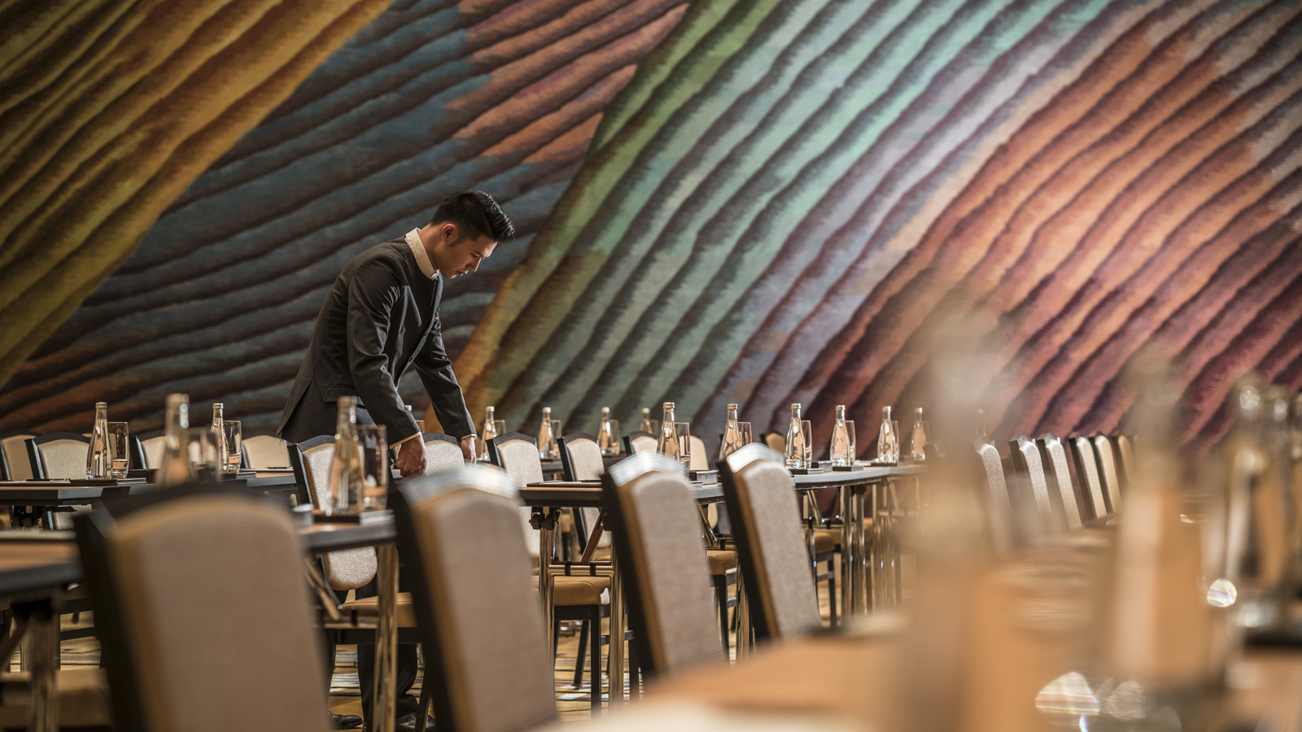 | March 29, 2019, Beijing, China  Nine More Value-Add Privileges for Meeting Planners at Four Seasons Hotels in China  https://publish.url/china-by-four-seasons/hotel-news/2019/meetings-with-more-package.html
March 29, 2019, Beijing, China
九款超值礼遇为四季会议更添精彩
https://publish.url/zh/china-by-four-seasons/hotel-news/2019/meetings-with-more-package-2.html

PRESS CONTACTS

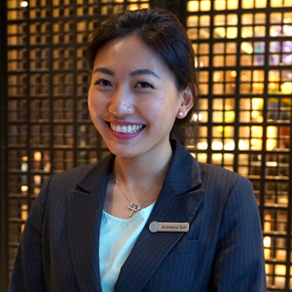 | Andreana Soh  Director of Public Relations and Communications  138 Fuhua Third Road, Futian District  Shenzhen  China  andreana.soh@fourseasons.com  +86 755 8826 8831

