Make Every Moment Count in 2020 at Four Seasons Resort The Nam Hai, Hoi An

Curated experiences invite guests to #FSTakeYourTime
February 25, 2020, Hoi An, Vietnam

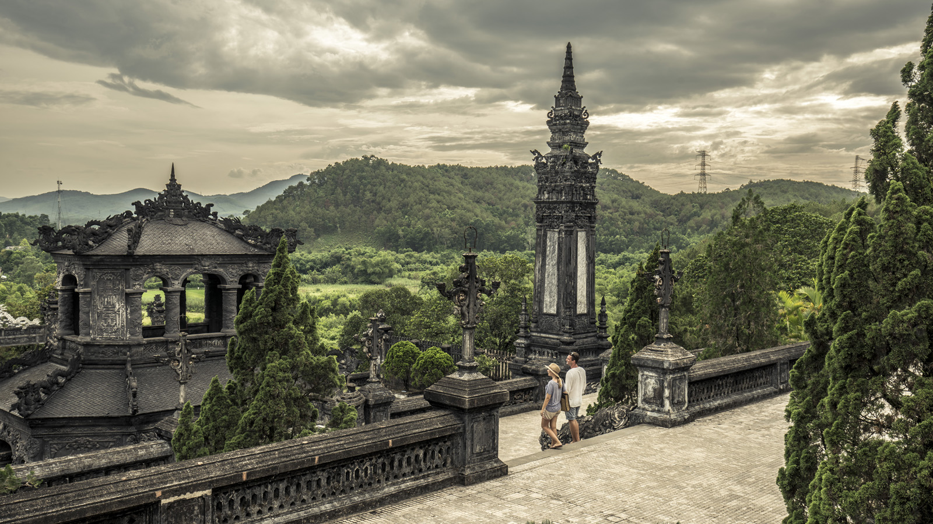
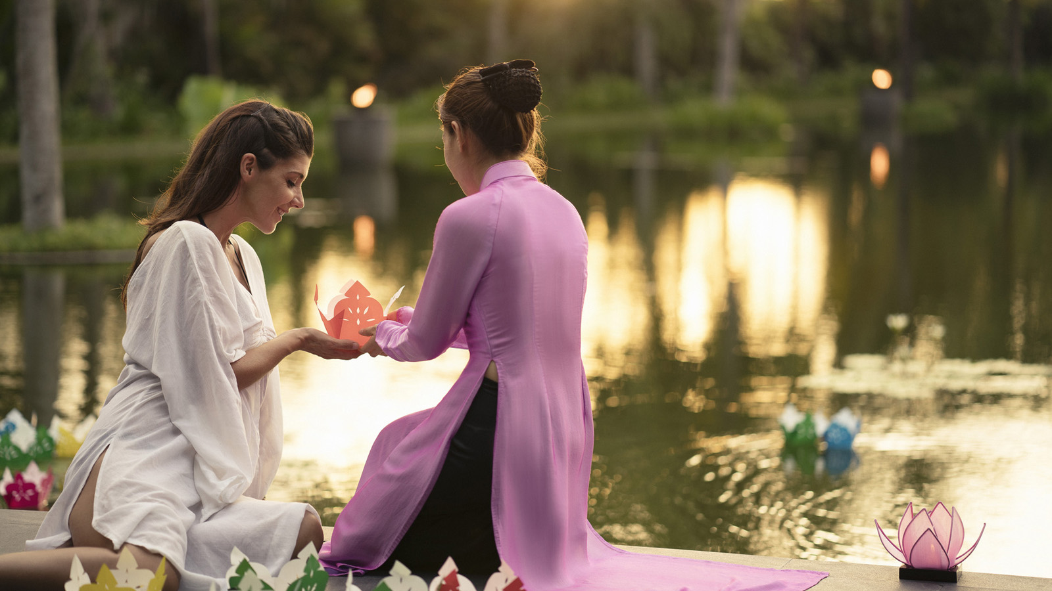
Inspired by 2020’s Leap Year “gift” of an extra day, Four Seasons Resort The Nam Hai, Hoi An is inviting guests to make the most of every moment with its #FSTakeYourTime activities: experiences that encourage them to step outside their comfort zone and discover transformation through mindful awareness, from resonant singing bowls to sacred rituals.
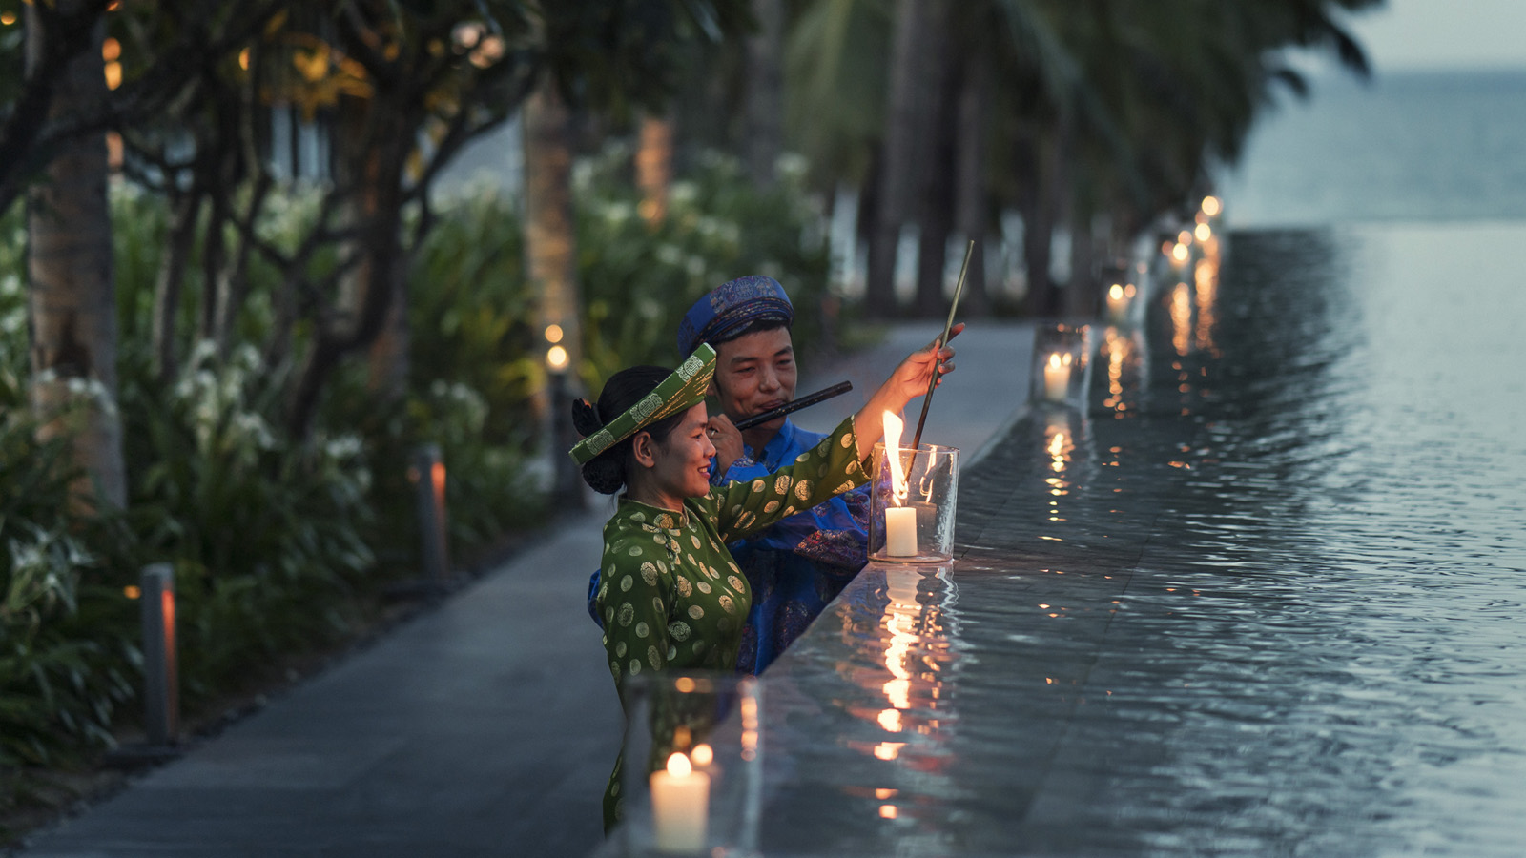
“With the pace of life increasing year on year, #FSTakeYourTime encourages the sense of wonder found through dedicating yourself to the present,” comments Bryan Ruch, Resort Manager. “We know from experience here at The Nam Hai that guests relish the opportunity to slow down and discover the Resort’s deeply mindful approach alongside its vibrant cultural connections. These moments of mindfulness are not only good for our health, but they fuse bonds with our families and the communities we visit, and widen our perspective of what’s possible.”
At The Nam Hai, heartfelt moments of personal transformation are woven into the Resort’s ethos, from The Heart of the Earth Spa’s earth-attuned healing experiences guided by the teachings of renowned Zen master Thich Nhat Hanh, to the traditional Thap Nen Illumination Ritual performed daily for health, happiness and luck.
Guests are invited to practise mindfulness every evening with the Spa’s Goodnight Kiss to the Earth – an end-of-day gratitude ritual of floating wishing candles to the resonant music of singing bowls. And an in-villa wellness menu, Interbeing, facilitates further exploration of “the great interconnectedness” through a curated collection of awareness-expanding scents, Interbeing meditations and more.
Further immersive and transformative experiences include The Nam Hai Cooking Academy, which prides itself on giving guests the chance to step outside their comfort zone by learning something new. From harvesting ginger and mangoes grown on the on-site farm to cooking under the tutelage of Vietnamese cuisine custodian Chef Hien Huynh, guests take home a connection to the local culture as well as culinary skills.
#FSTakeYourTime activities are helpfully categorised based on the time guests have available to play and explore. These Daily Discoveries include an hour to fall under the spell of beguiling local city Hoi An at night, as illuminated lanterns entice visitors through ancient streets lively with sensory delights. Or the ultimate in time-stretching magic: a whole day spent exploring The Imperial City of Hue, Vietnam’s last empire. Once an enormous complex of temples, palaces, imperial offices, residences and abundant gardens, its majestic jewel – a city within a city within a city – offers a mesmerising insight into the past.

RELATED

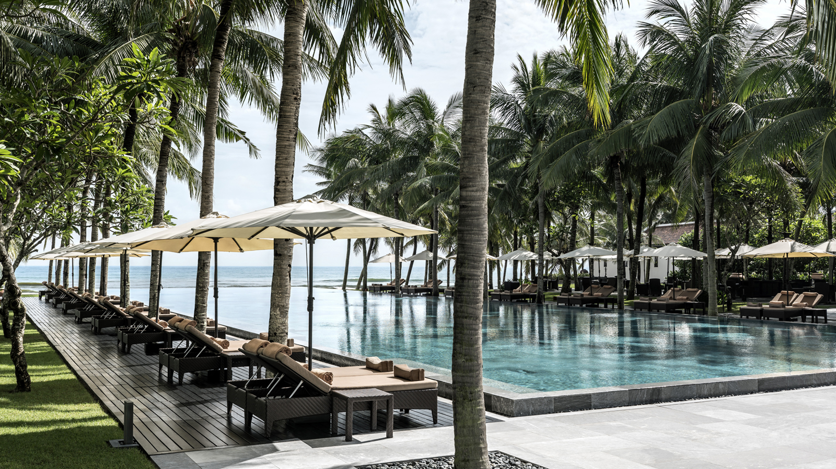 | February 18, 2020, Hoi An, Vietnam  Four Seasons Resort The Nam Hai, Hoi An, Vietnam Retains Its Forbes Five Stars Status  https://publish.url/hoian/hotel-news/2020/forbes-five-star-hotel.html
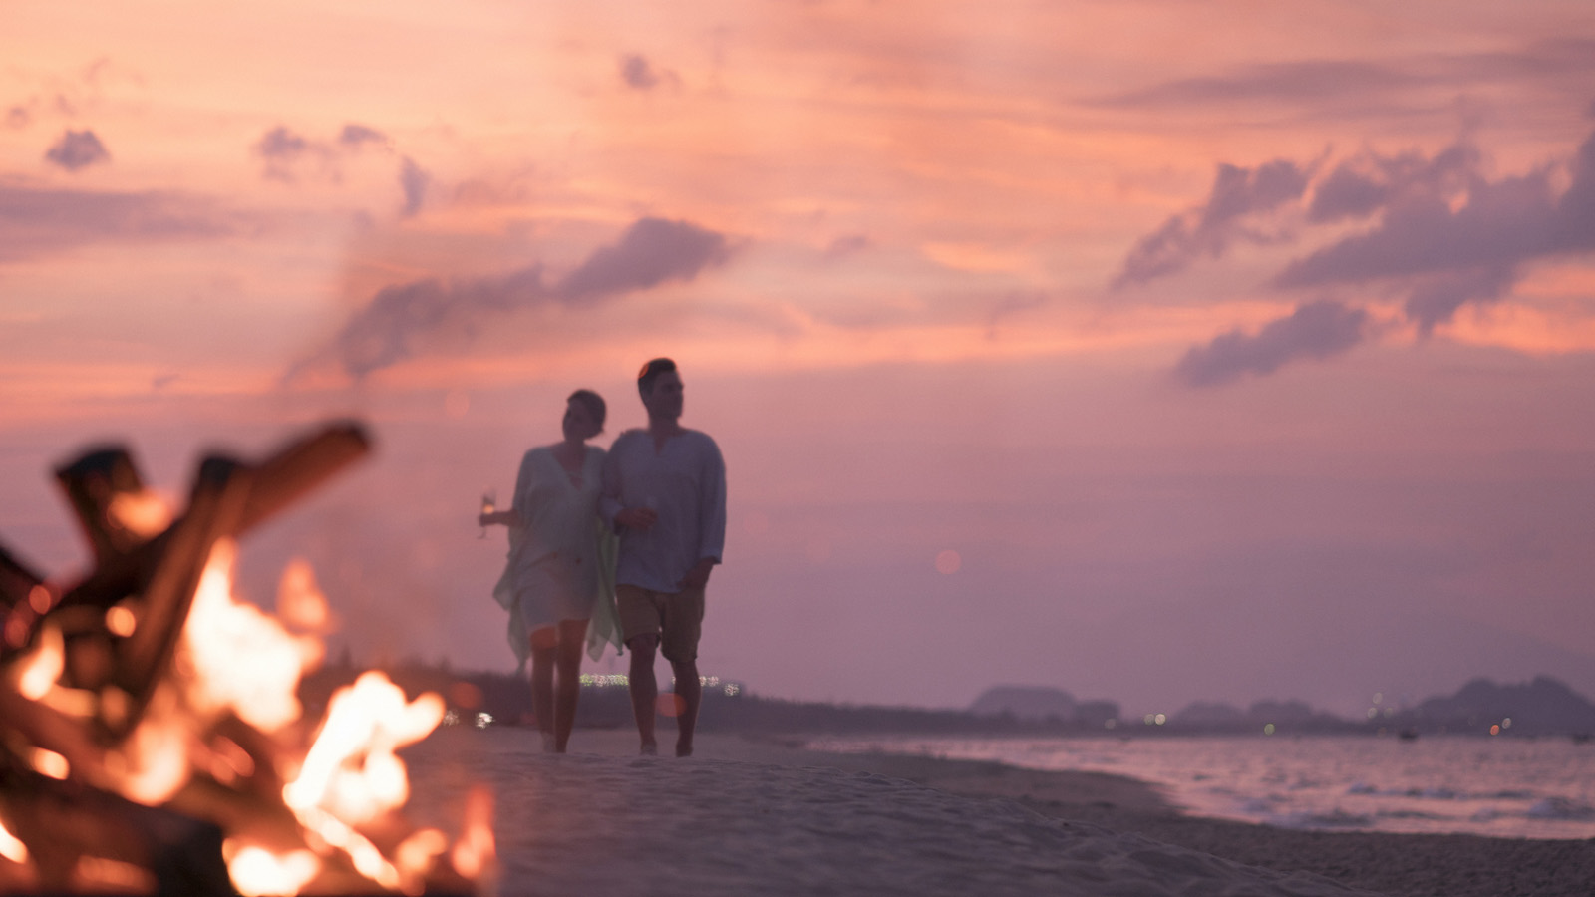 | January 25, 2020, Hoi An, Vietnam  A Vietnamese Seaside Valentine at Four Seasons Resort The Nam Hai  https://publish.url/hoian/hotel-news/2020/valentines-day.html

PRESS CONTACTS

Vu Ho
Public Relations & Communications Executive
Block Ha My Dong B, Dien Duong Ward
Dien Ban Town
Vietnam
vu.ho@fourseasons.com

+84 235 394 0000

