The Elite Choice: Four Seasons Hotel Kyoto Offers Hotel Residence Services

February 8, 2021, Kyoto, Japan

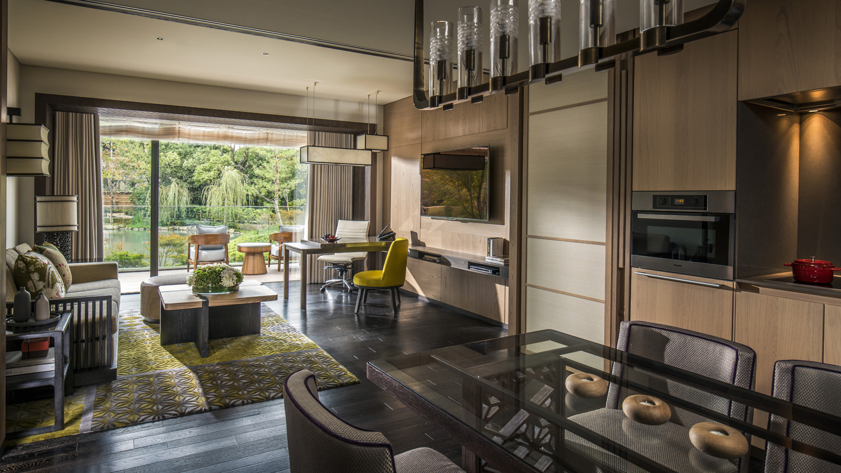
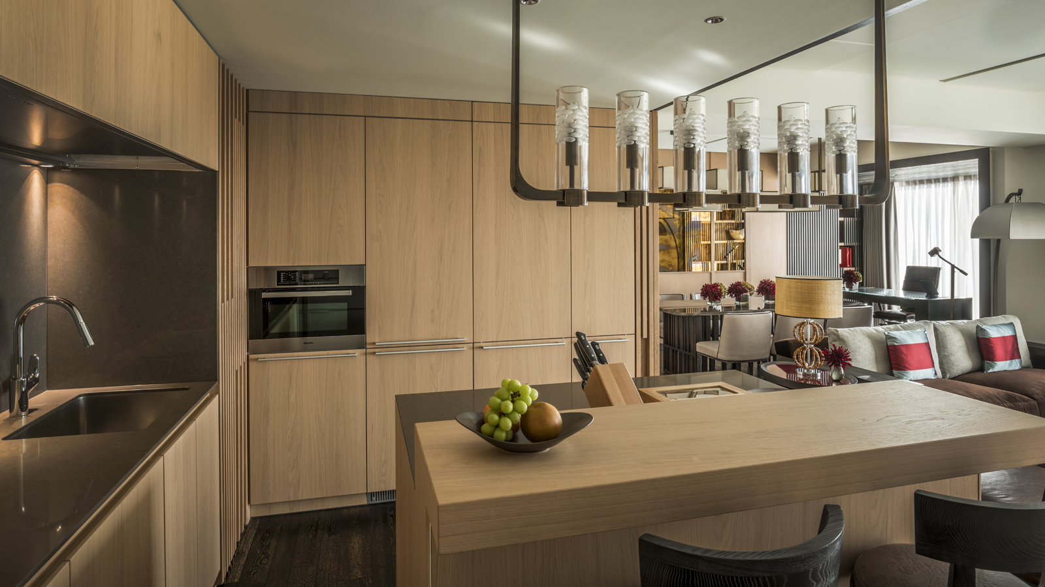 | 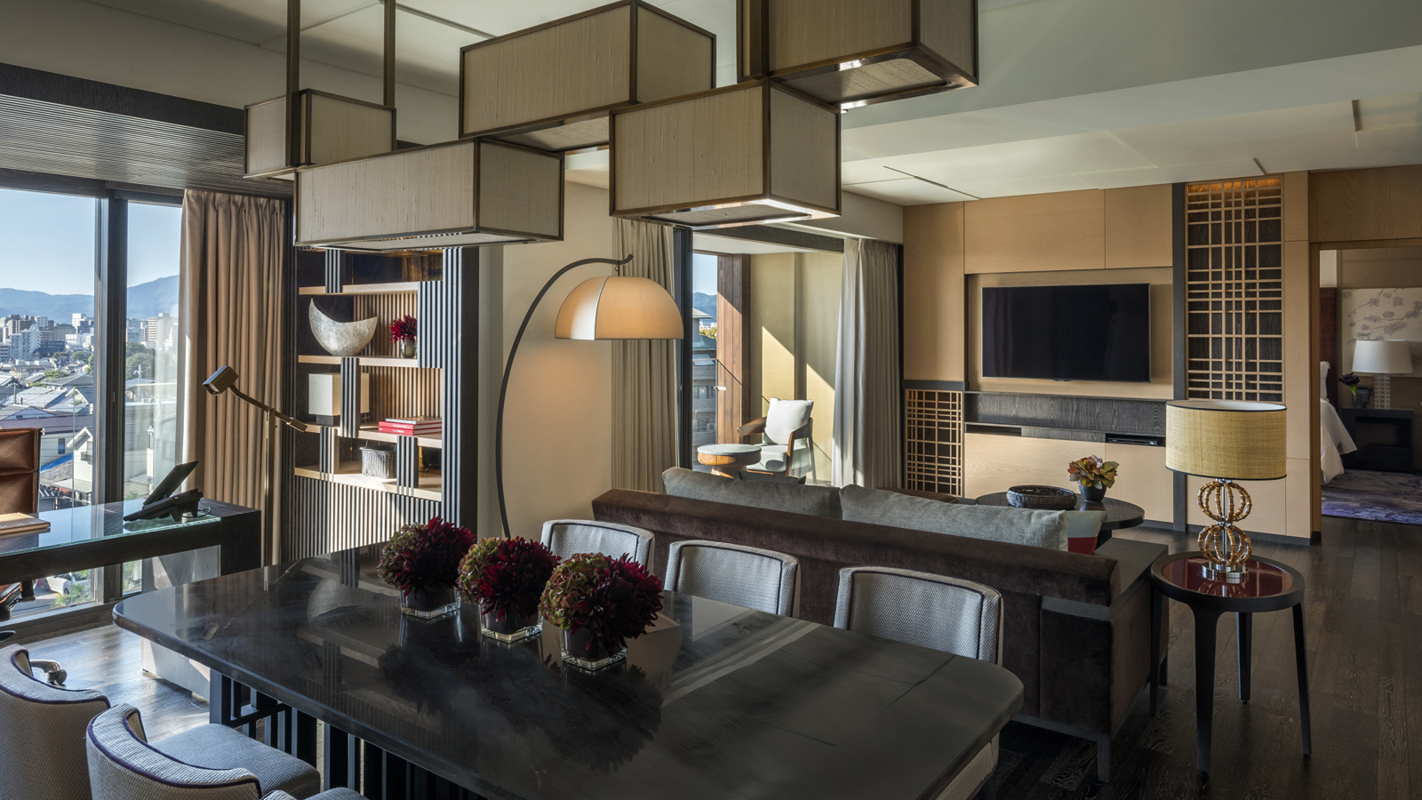 | 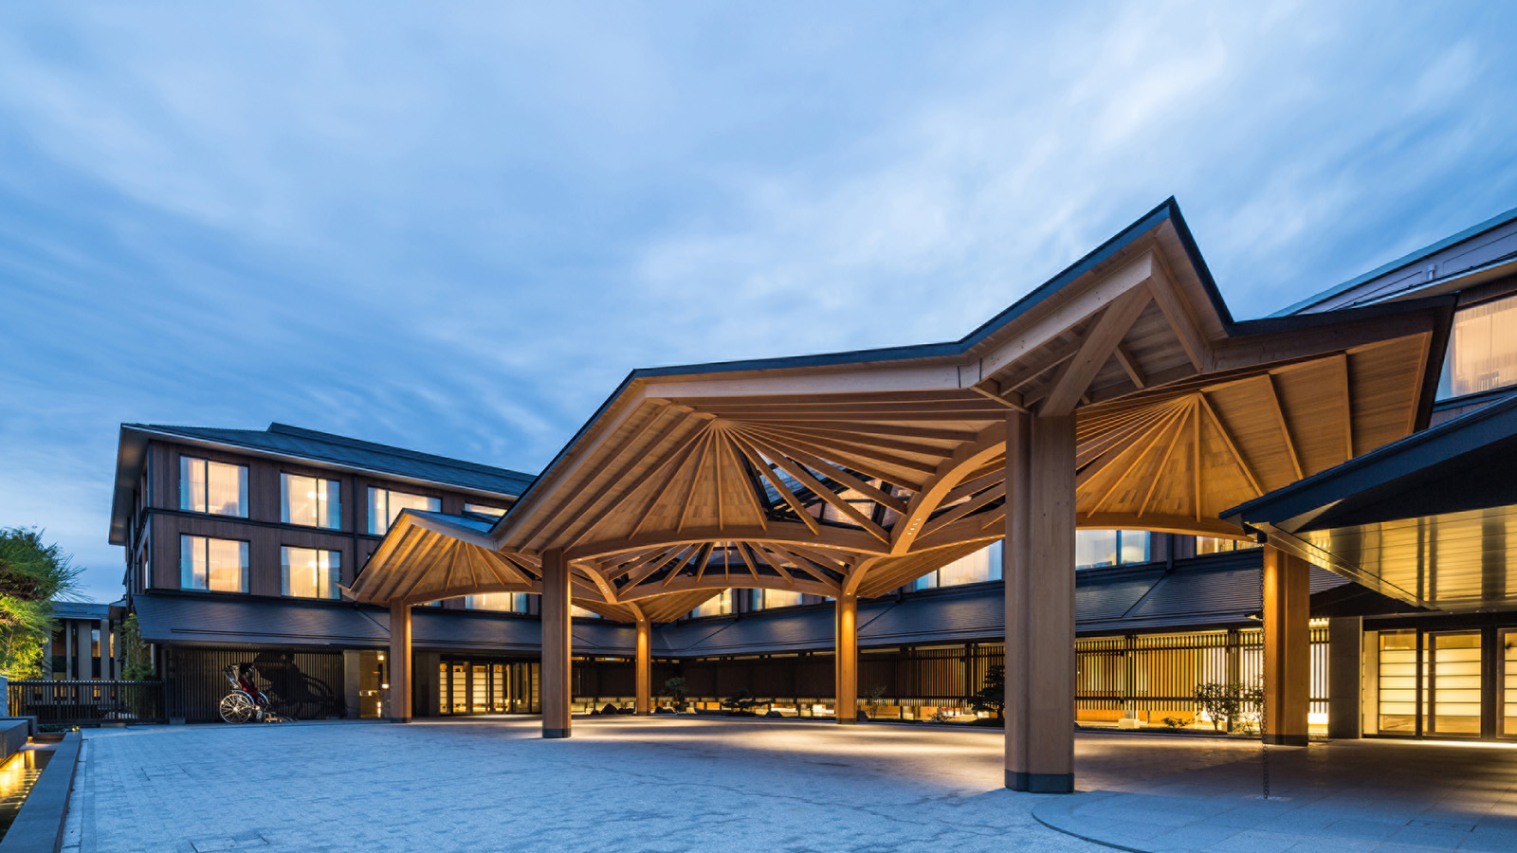
Enhanced Hotel Residences Services at Four Seasons Hotel Kyoto offer couples, families and groups seven elite privileges – a lucky number in Japan – for the ultimate urban retreat stay in Kyoto.
From a welcome glass of Champagne upon arrival to extended spa time, exclusive experiences and complimentary in-suite “My Bar,” it’s the pinnacle of hotel-meets-home living in Japan’s ancient Imperial capital.
Four Seasons Hotel Kyoto counts 70 suites among its 180 luxury accommodations, all set within a 12th century pond garden in the city’s best-preserved temple district, Higashiyama.
Of these suites, the largest are the 57 Hotel Residences: contemporary one and two bedroom home-away-from-homes, designed to maximise kutsurogi, the Japanese art of relaxation.
With full open kitchens, light-flooded living areas and the city’s largest in-suite entertaining space (some units also have walkout balconies facing the pond garden), each contemporary Hotel Residence combines the freedom and flexibility of a private home with the convenience of the city’s finest luxury Hotel facilities and enhanced service benefits to match.
The seven Residence Suite privileges begin on arrival with a welcome glass of Champagne, followed by complimentary pressing service on the day of arrival. In addition, optional one-off experiences are available, such as atmospheric garden-island dining and a Geisha-hosted Tea House experience.
Additional privileges include: complimentary, daily-replenished in-suite My Bar (excluding alcohol); complimentary premium Wi-Fi connection at 100 mbps supporting up to 6 devices per unit; the added bonus of 20 complimentary minutes added to all treatments at the award-winning Spa; and complimentary use of Press Reader via App or in-room tablet to access magazines and newspapers.
Commenting the Hotel Residence Services, General Manager Takuya Kishi says, “Families, honeymooners and groups are seeking ever-more private experiences, not only in terms of where they stay but what they do when they are here. By complementing the city’s top suites with a host of elite benefits, we’re delighted to be able to offer the ultimate city-centre stay, from size, luxury and exclusivity to thoughtful touches that showcase Kyoto’s unique hospitality.”
In addition to the seven new services and in-suite home-from-home comforts, all Hotel Residence guests can avail of Four Seasons exemplary facilities: Michelin-starred sushi and 24-hour in-room dining; Kyoto’s finest spa, indoor pool and fitness centre; atmospheric Shakusui-tei Tea House; and the city’s atmospheric winding streets and ancient temples – just a short stroll away.
To book a Hotel Residence stay at Four Seasons Hotel Kyoto visit the Hotel’s website, contact reservations.kyo@fourseasons.com or call +81 75 541 8288. To view the latest residential suite benefits, visit here.

RELATED

December 4, 2020, Kyoto, Japan
LINE公式アカウント開設記念「クリスマス＆ニューイヤープレゼントキャンペーン」
https://publish.url/jp/kyoto/hotel-news/2020/line-campaign.html

December 1, 2020, Kyoto, Japan
Four Seasons Hotel Kyoto Welcomes New General Manager Takuya Kishi
https://publish.url/kyoto/hotel-news/2020/new-general-manager-takuya-kishi.html

PRESS CONTACTS

Naoko Tokunaga
Director of Public Relations and Communications
445-3, Myohoin Maekawa-cho, Higashiyama-ku
Kyoto
Japan
naoko.tokunaga@fourseasons.com

+81 (0)75 541 8288

