Now Accepting Reservations: Four Seasons Hotel Bengaluru at Embassy ONE Unveils Special Opening Offers for Individual Travellers and Groups

All-new hotel in India’s high tech capital is confirming arrivals as of May 1, 2019
January 24, 2019, Bengaluru, India

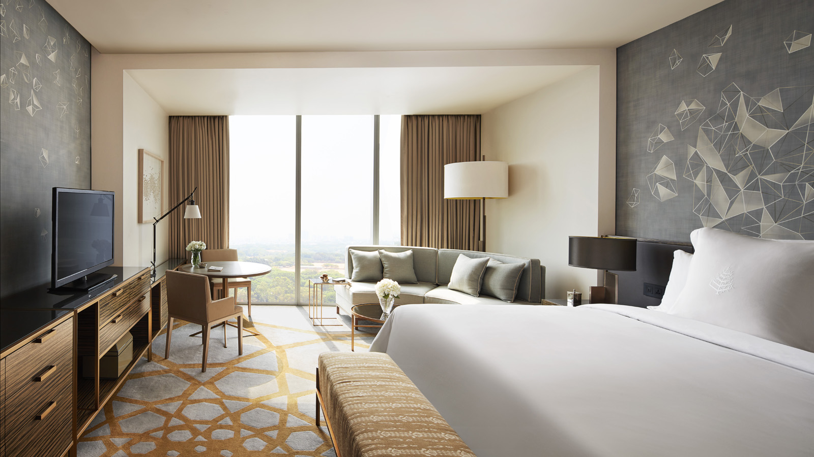
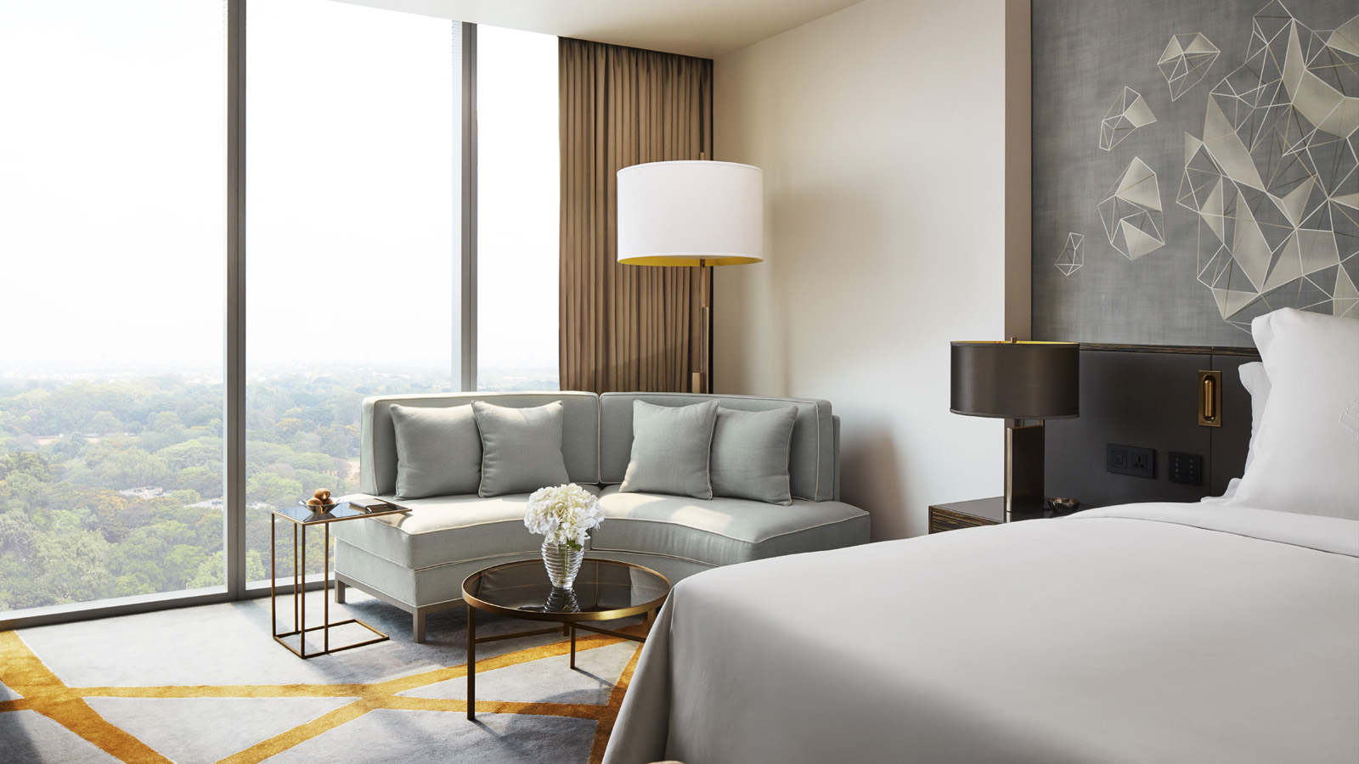 | 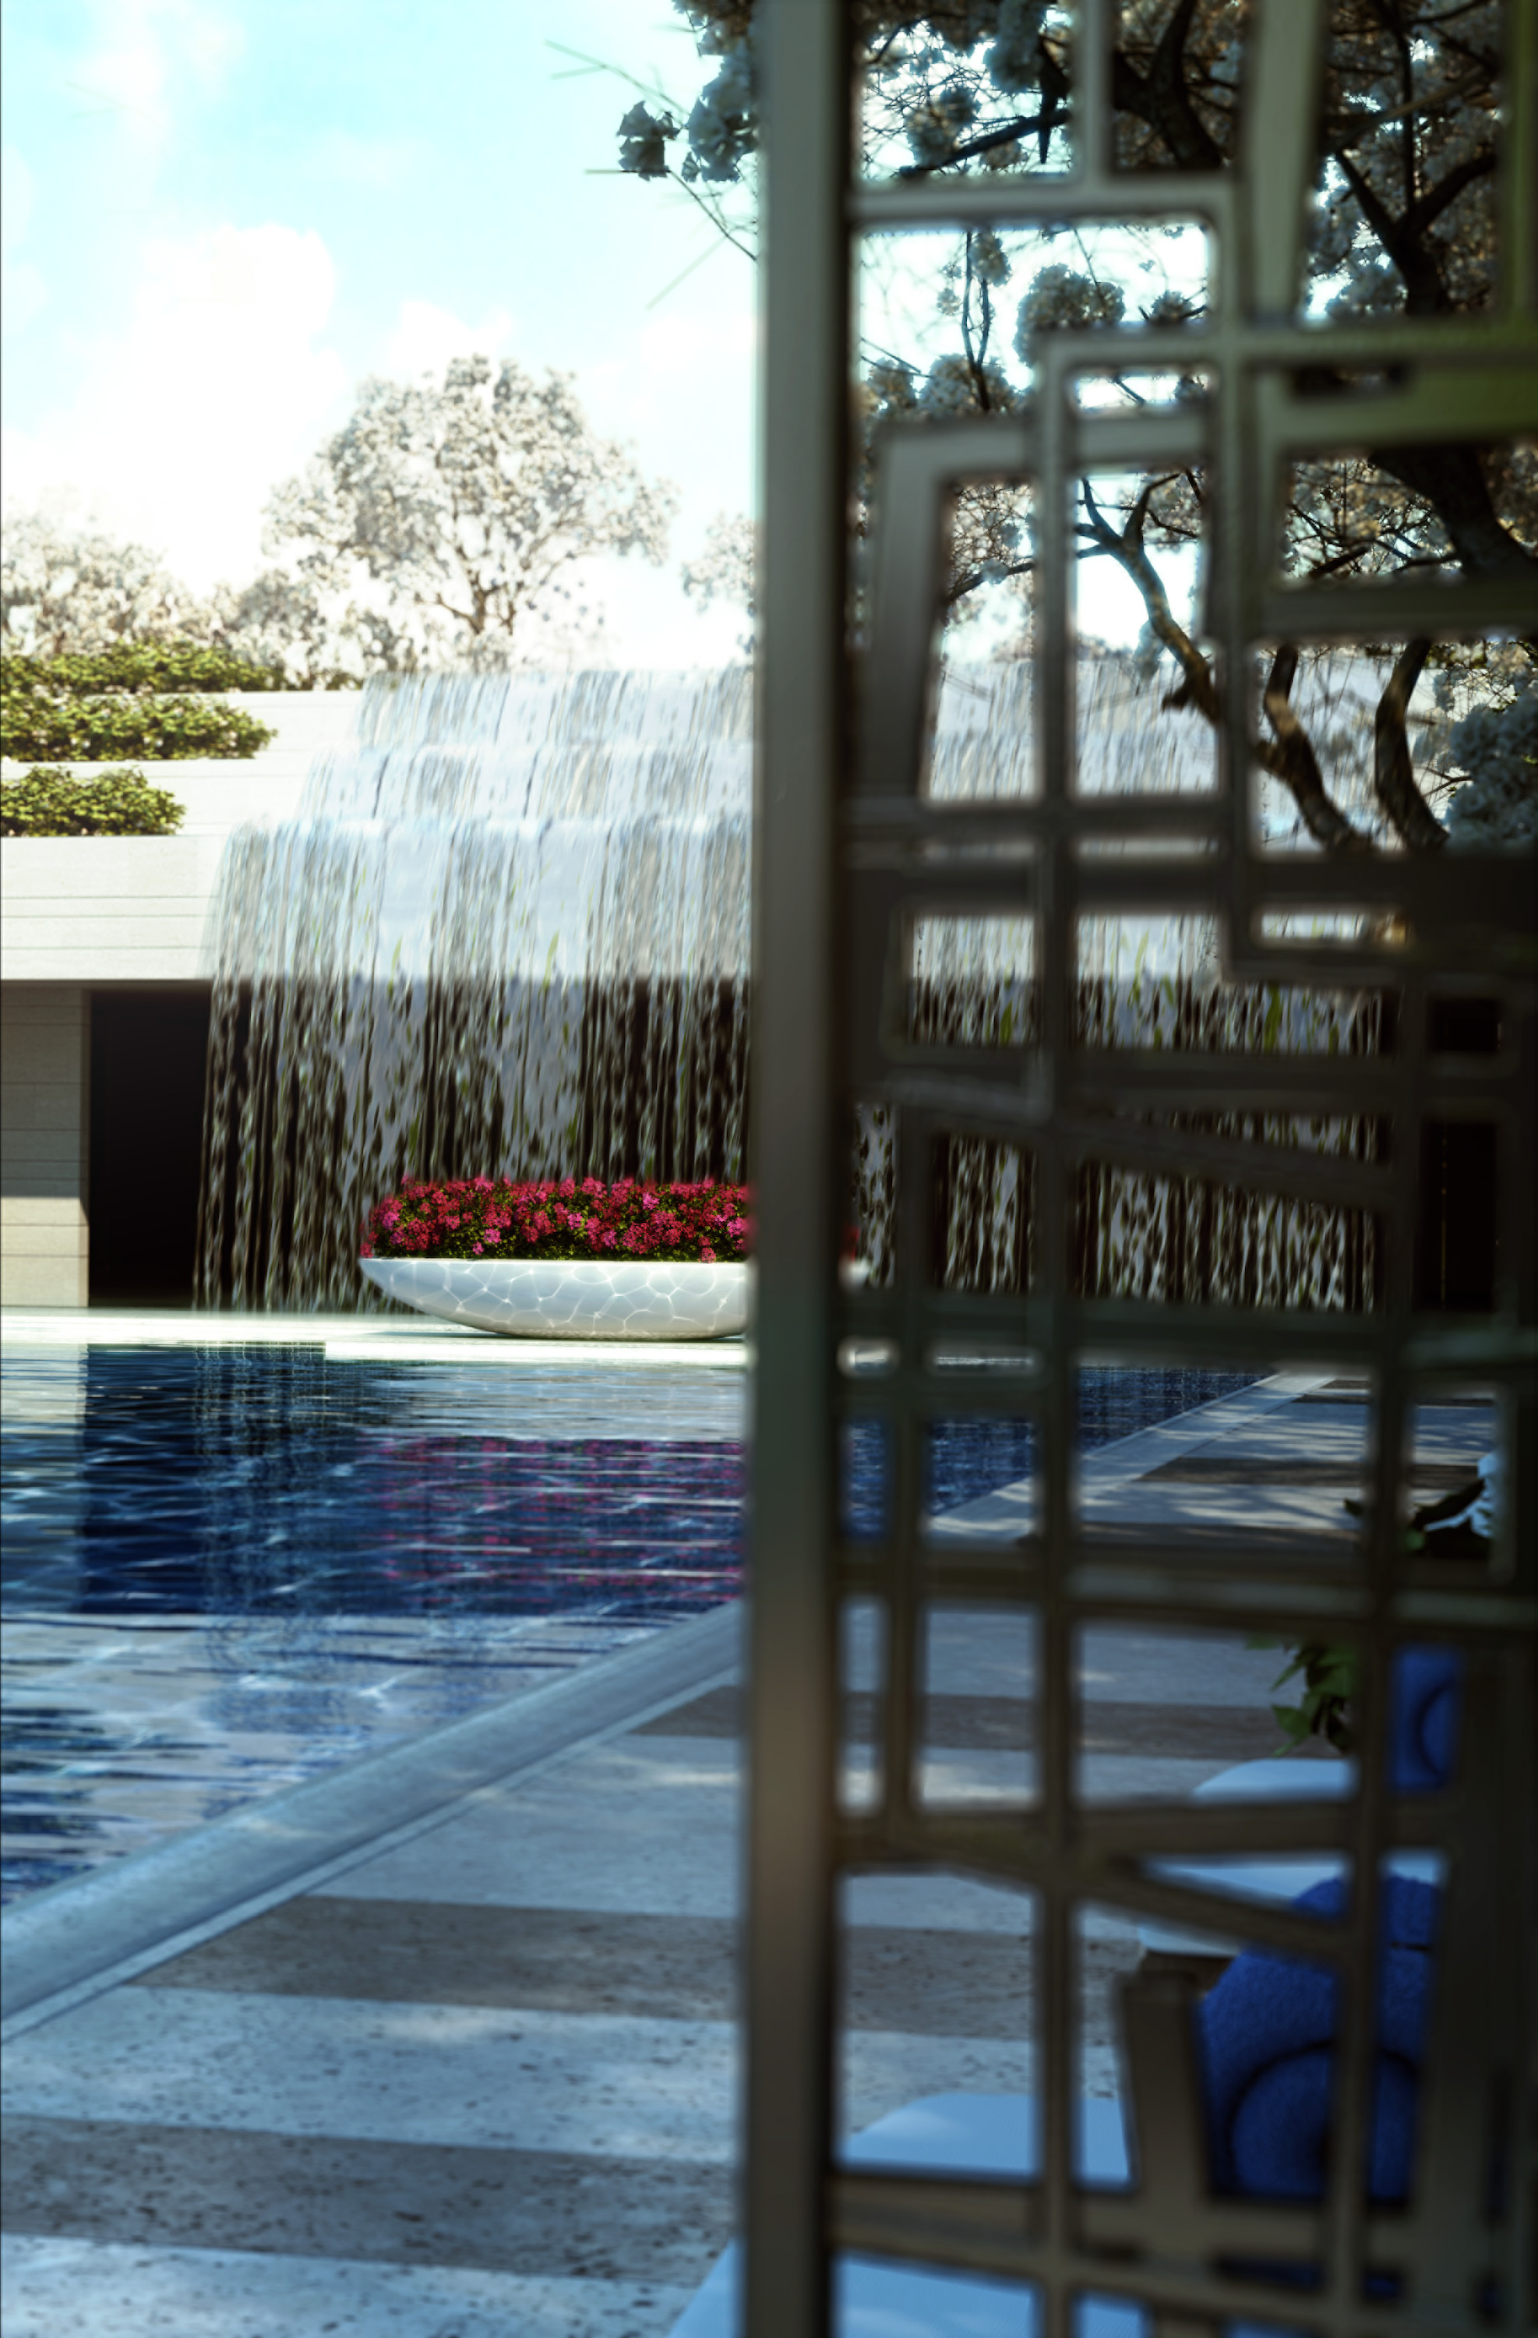 | 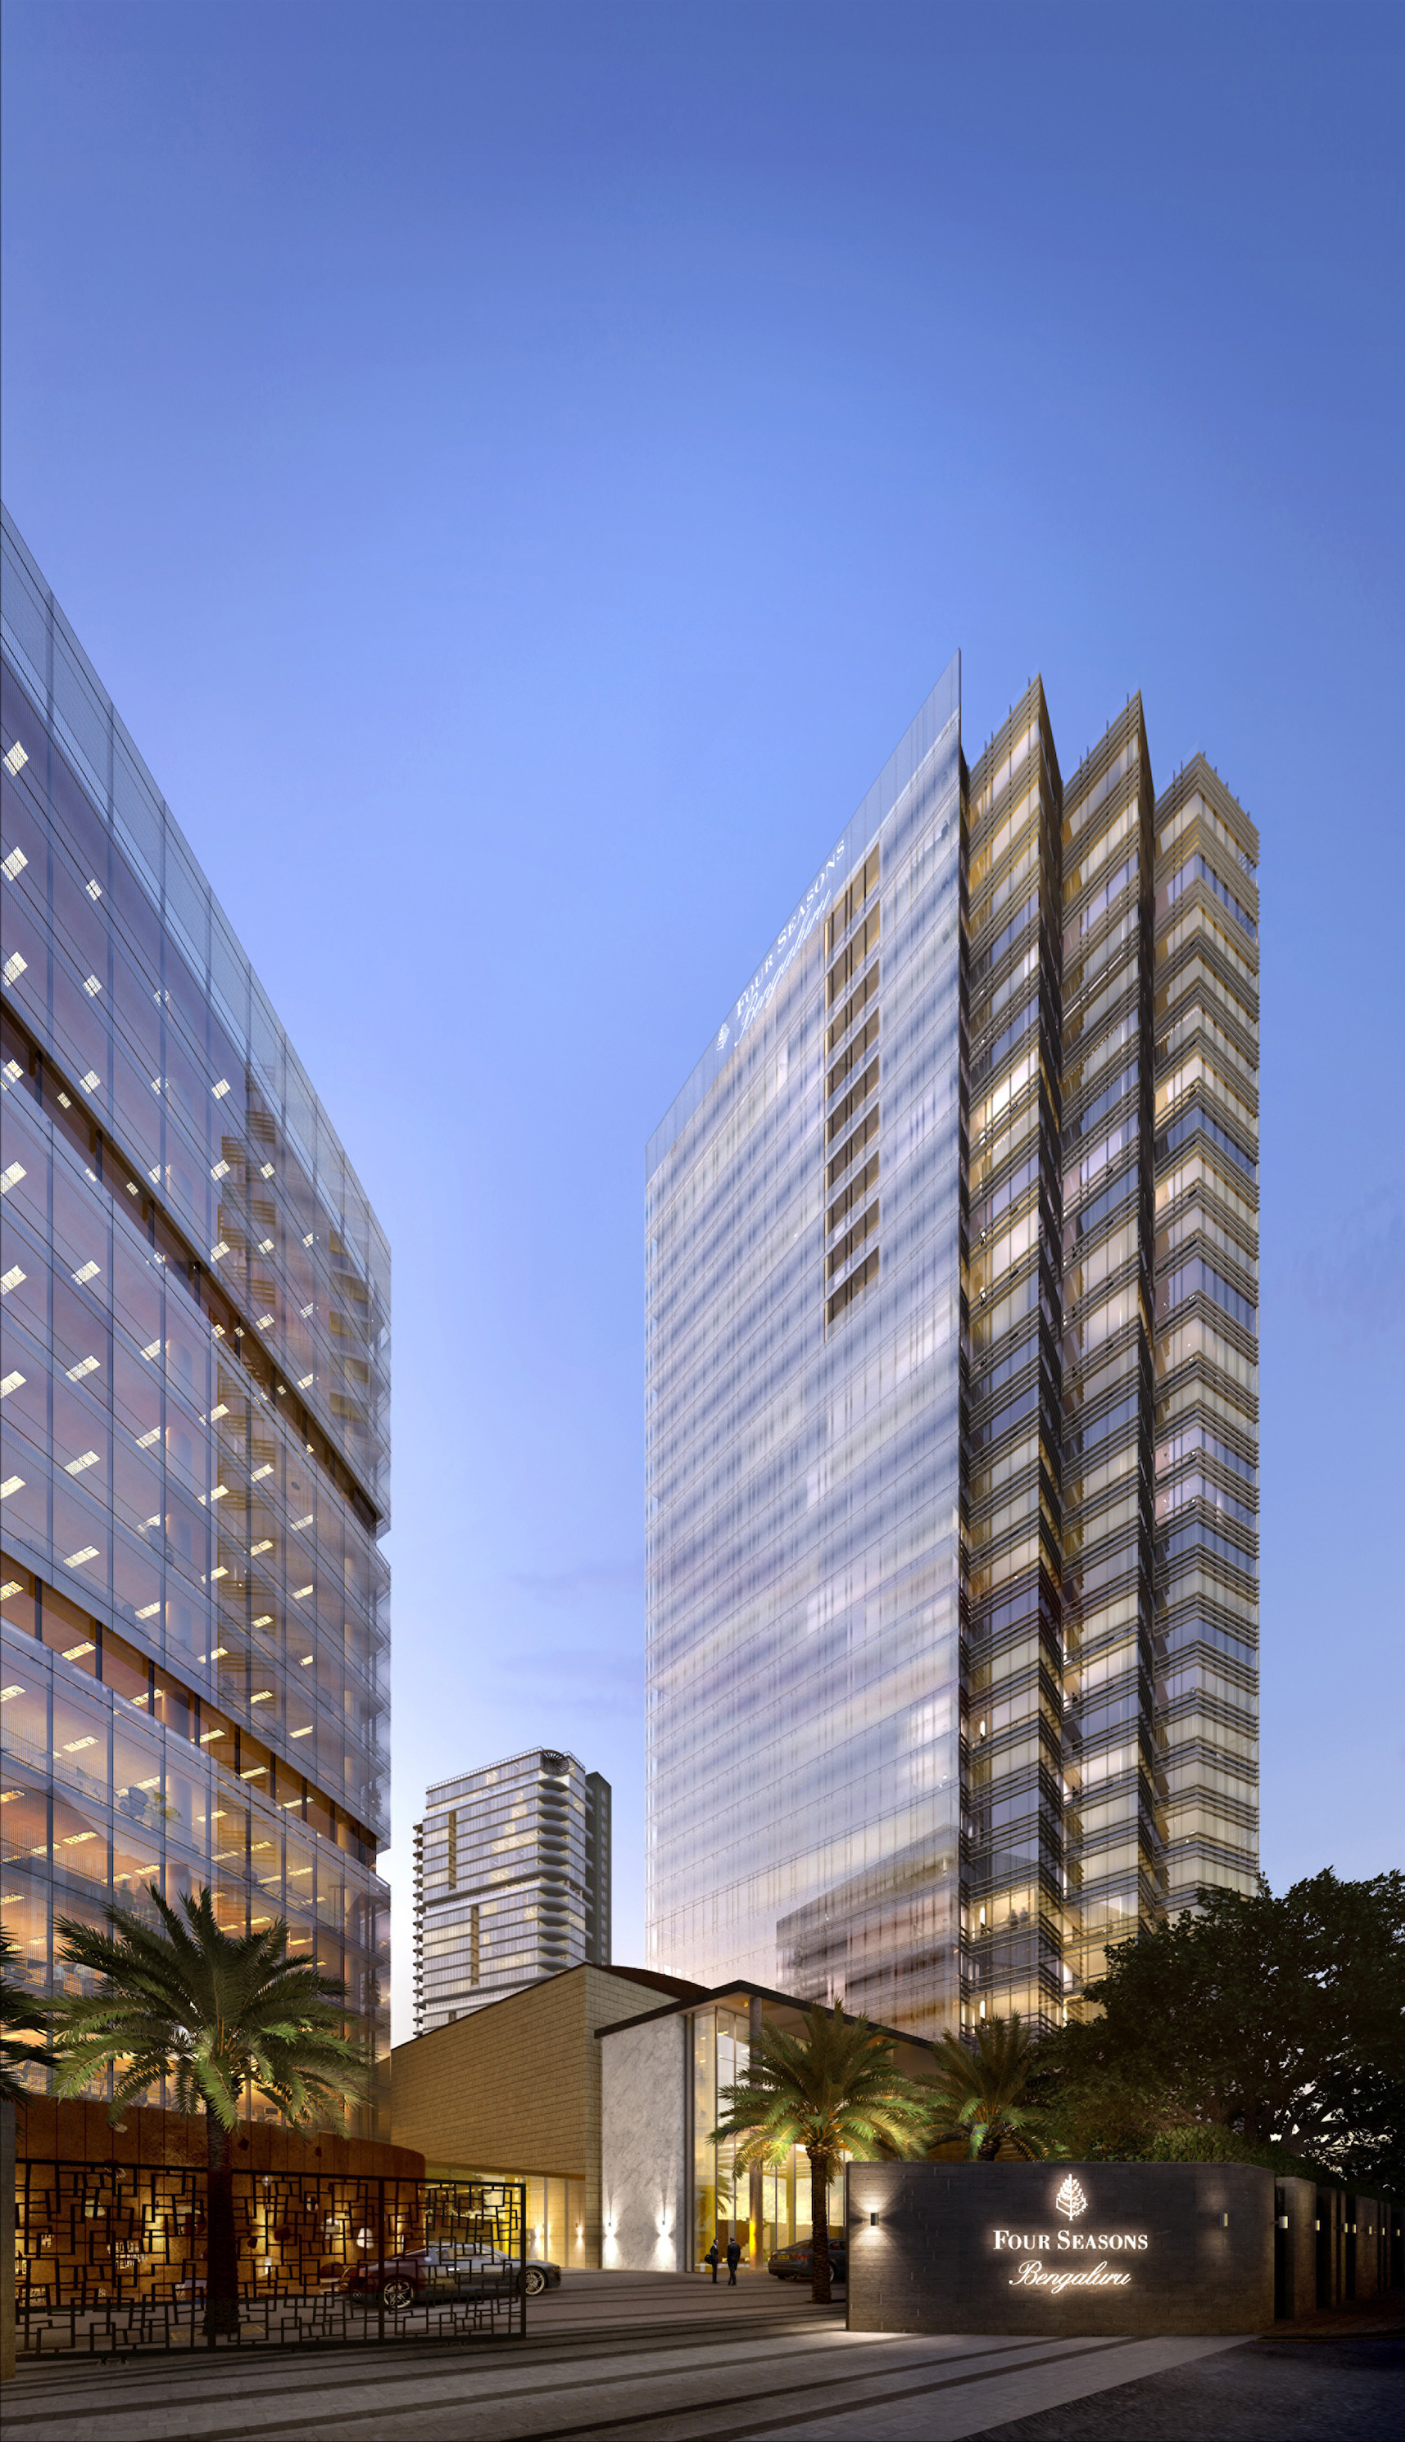
With its opening now just months away, Four Seasons Hotel Bengaluru at Embassy ONE is now confirming reservations beginning May 1, 2019, with introductory offers tailor-made for those who want to be among the first to experience the second Four Seasons hotel in India.
The epitome of modern luxury in this dynamic city, Four Seasons is part of the prestigious new Embassy ONE development, encompassing the 230-room Four Seasons Hotel Bengaluru, 105 Four Seasons Private Residences, and commercial space. The estate is conveniently located at about a 30-minute drive from the airport and well connected to the central business district. Within the Hotel, local guests and international travellers will find a warm and inviting all day dining restaurant, CUR8, featuring a showpiece grill and a custom-built, supersize pizza oven with interactive live counters; The Lounge & Terrace, which could be the perfect place for a relaxed afternoon tea; and a curated selection of whiskies from around the world at The Collection. The outdoor pool in the lushly landscaped private gardens will lend a resort-like feel to the place leading guests to Infuse Spa, an uplifting hideaway for modern and holistic wellness solutions.
“An extraordinary journey is about to begin as Four Seasons Hotel Bengaluru opens its doors. Experience an amazing culinary journey with us or visit the tranquil setting at the outdoor pool area - a spectacular and rejuvenating oasis for relaxation. Our teams are all geared up and excitedly look forward to welcoming guests as the curtains rise. The magic is about to unfold,” says General Manager Fredrik Blomqvist.
Four Seasons Hotel Bengaluru is located in the city’s northern corridor, close to Kempegowda International Airport, key business districts and landmarks including Bangalore Palace and Cubbon Park. It will be the second Four Seasons in India, joining sister property Four Seasons Hotel Mumbai, less than two hours away by air.
Be among the first to experience Four Seasons Hotel Bengaluru at Embassy ONE: In celebration of its opening later this year, Four Seasons Hotel Bengaluru is offering a special value package for a limited time only. The Early Bird Special enables guests to experience the best of Bengaluru with 15 percent off the Room Rate. Reservation for this must be made at least 14 days in advance. This offer is valid until December 20, 2019. This offer may be booked online.
Memorable Events at Four Seasons
As the city’s closest luxury hotel to the airport, guests can look forward to optimal productivity with myriad considerations designed specifically for the business traveller, including a 24-7 multilingual concierge team and 1,821 square metres (19,592 square feet) of flexible indoor-outdoor event spaces.
As a special introductory offer, groups that choose Four Seasons Hotel Bengaluru for their next meeting or event will receive up to 25 percent savings when booking 10 rooms or more with the Great Group Values package.
To start planning a corporate or social event at the new Four Seasons Hotel Bengaluru, or for more information about facilities and to arrange a site visit, contact +91 80 4522 2222.
Wedding couples and their families may get in touch with Mahema Bhutia, Director of Marketing at mahema.bhutia@fourseasons.com for wedding related queries.
About Embassy ONE
The Embassy ONE development consists of three new buildings, with Four Seasons Hotel and Private Residences located in the North and South Towers, and the third building housing office and retail space. The hotel, designed by HKS Architects and Studio u+a, with interiors by Yabu Pushelburg, is located in the South Tower of the development, with the Private Residences occupying the upper floors of the South Tower as well as all 30 floors of the North Tower.
Landscape architects P Landscape (PLA) are creating a tranquil outdoor oasis, featuring a pool and waterfall, butterfly garden and ribbon lawn, conveniently located between the North and South Towers, yet quietly secluded from the surrounding city.

RELATED

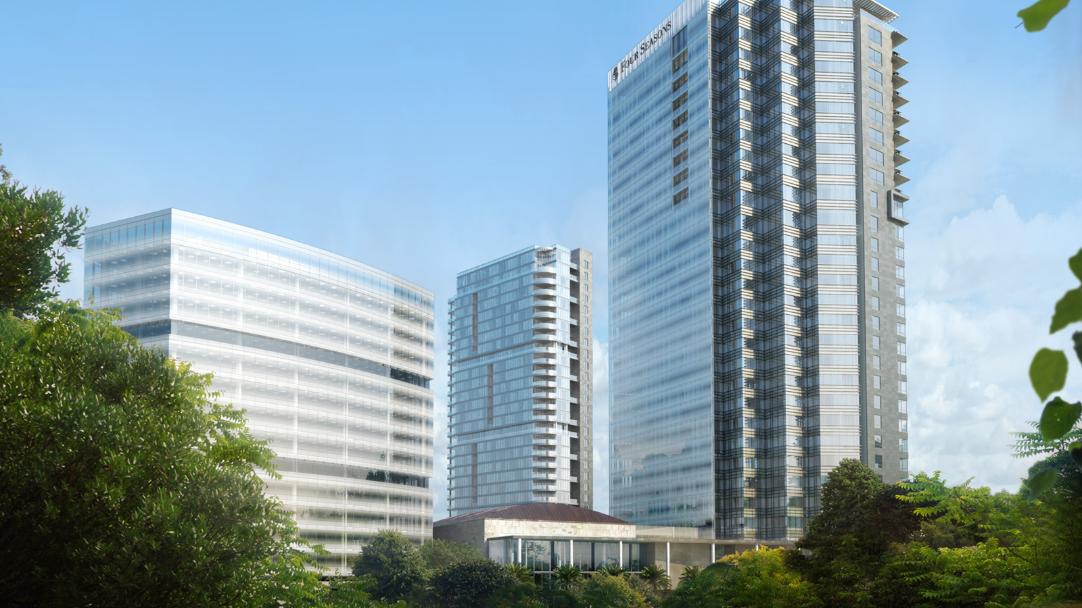 | January 19, 2018, Toronto, Canada  フォーシーズンズ ホテルズ アンド リゾーツとエンバシーグループが インドのバンガロールに新たなラグジュアリーホテルと プライベートレジデンスの開業計画を発表  https://publish.url/news-releases/2018/new-four-seasons-in-bengaluru-6.html
January 19, 2018, Toronto, Canada
Four Seasons Hotels and Resorts and Embassy Group to Introduce New Luxury Hotel and Private Residences in Bengaluru, India
https://publish.url/news-releases/2018/new-four-seasons-in-bengaluru.html

PRESS CONTACTS

Gargi Guha
Director of Public Relations
8, Bellary Road, Ganganagar
Bengaluru
India
gargi.guha@fourseasons.com

+91 80 4522 2222

