Four Seasons Hotel Hampshire and Skincare Brand AMRA Introduce Bespoke Massage Journeys at the Spa with Gold, Platinum and Diamond Body Oils

August 30, 2022, Hampshire, England

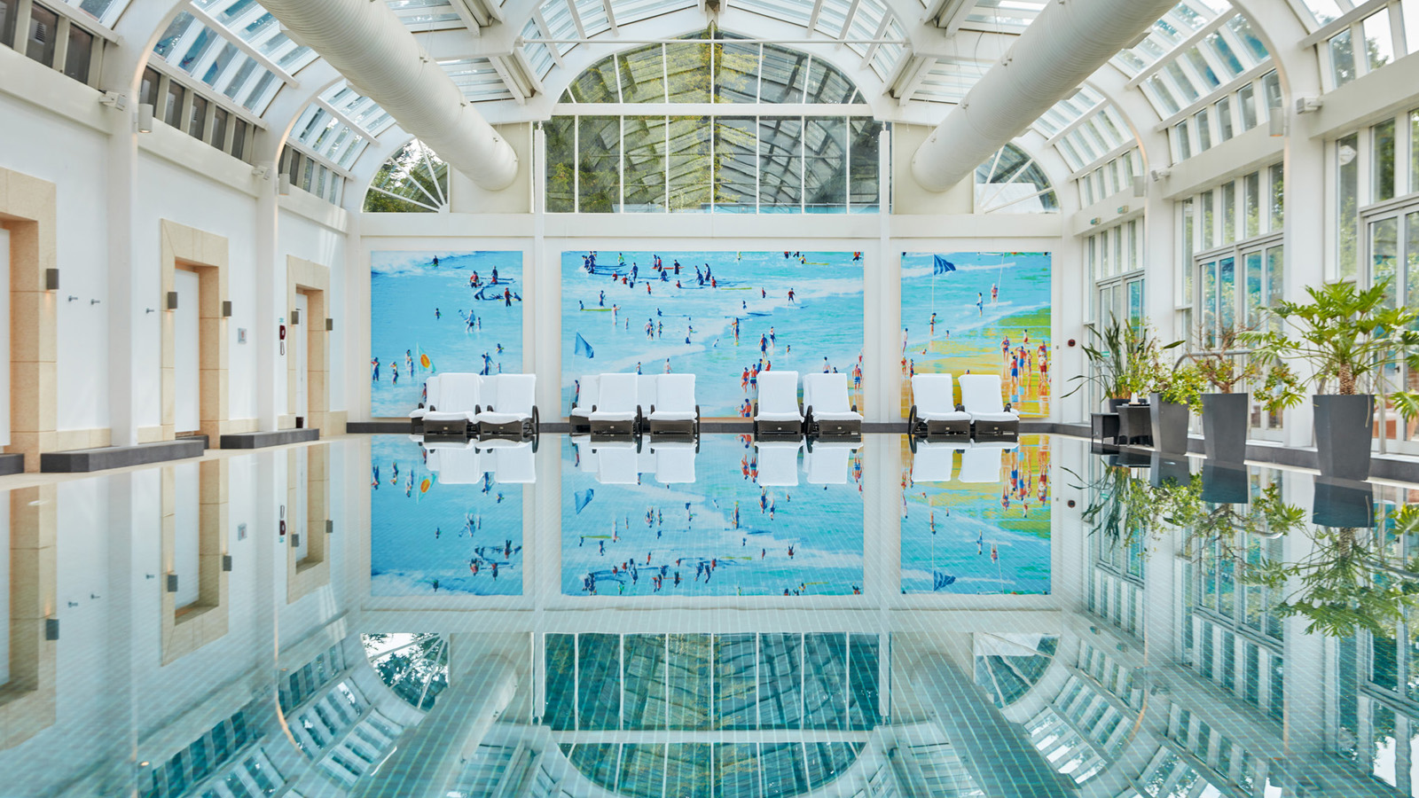
Four Seasons Hotel Hampshire has partnered with luxury skincare brand AMRA to unveil new bespoke massage journeys at the Spa.
The new offering includes five indulgent massages that are not only designed for the skin but for the balance of the body, created to work with guests' specific needs and target areas of concern. Each massage journey is tailored using choreographed techniques and incorporates AMRA’s new luxurious body oils, each formulated with a purpose to deliver results.
Using only the most precious ingredients such as pearl, caviar, gold and diamond encapsulated with the latest scientific natural bio-actives and with a focus on only ethically and sustainably sourced ingredients, founder Sue Jones developed AMRA’s range of skincare and body oils.
To begin the massage journey guests can choose from five bespoke treatments and work with the Hotel's expert therapists to prescribe one of AMRA’s body oils, selecting from products including the Gold Rejuvenating Oil, the Platinum Firming Oli, The Diamond Illuminating Oil, and the Pearl Purifying Oil to deliver the best results.
Deep Rejuvenation Massage
Curated for guests who require muscular tension release, the Deep Rejuvenation massage is expertly tailored to each individual. Designed to work anatomically to relieve stress and deep tension within the muscles, it ensures a feeling of complete rejuvenation.
Lymphatic Drainage Massage
Designed to increase movement of fluid around the body, the Lymphatic Drainage treatment helps to drain and reduce inflammation and tension. Therapists tailor specific choreographed techniques to create a bespoke treatment for each guest.
Body Sculpt and Contour
Created to help redefine the body’s silhouette and curate smooth contours and definition, choreographed techniques are used to tone and firm while working anatomically to break down and improve the appearance of cellulite.
Olfaction Massage
Engage the senses and awaken the mind, as guests are instantly transported on a journey of olfaction. This bespoke massage has been designed to engage the olfactory system with the most decadent of aromas using AMRA’s body oil and can be tailored depending on preferred focus areas.
Signature Massage
The Signature Massage offers the ultimate relaxation, transporting guests on a journey of tranquillity. Take a deep breath and clear the mind and enjoy a targeted massage with soothing and nourishing essential oils to ensure the very best results for each individual’s needs.
Amid the beautiful natural setting of the English countryside, guests can continue their wellness journey with restorative yoga sessions, adrenaline pumping exercise classes or simply a dip in the Hotel’s star conservatory style pool, all in the Hotel's relaxing 18th century converted barn.
Treatments can be booked for a choice of 60 or 90 minutes and prices start at GDP 175.
AMRA’s full range of eight body oils are now also available to purchase at the Spa.
For reservations call the Spa on 01252 853 000.

RELATED

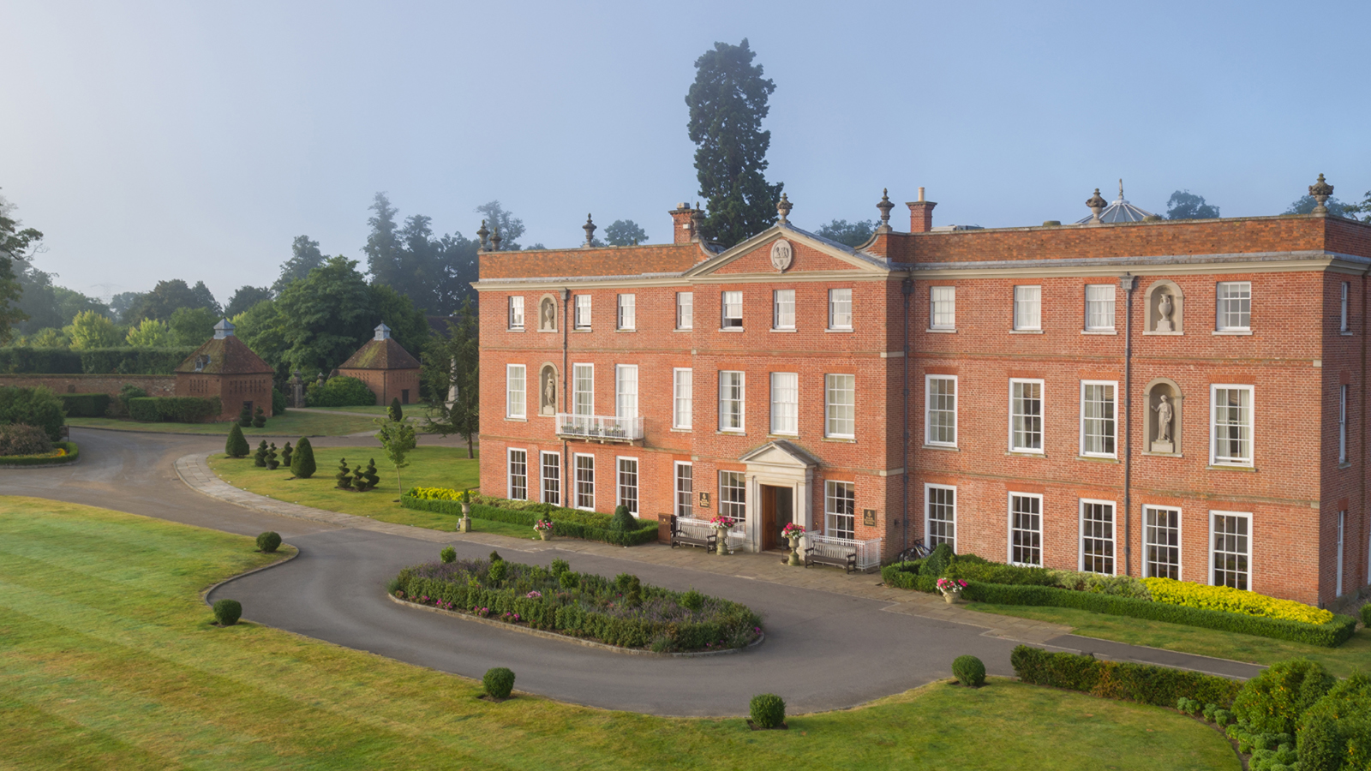 | July 11, 2022, Hampshire, England  It’s Showtime at Four Seasons Hotel Hampshire  https://publish.url/hampshire/hotel-news/2022/open-air-theatre-evenings.html
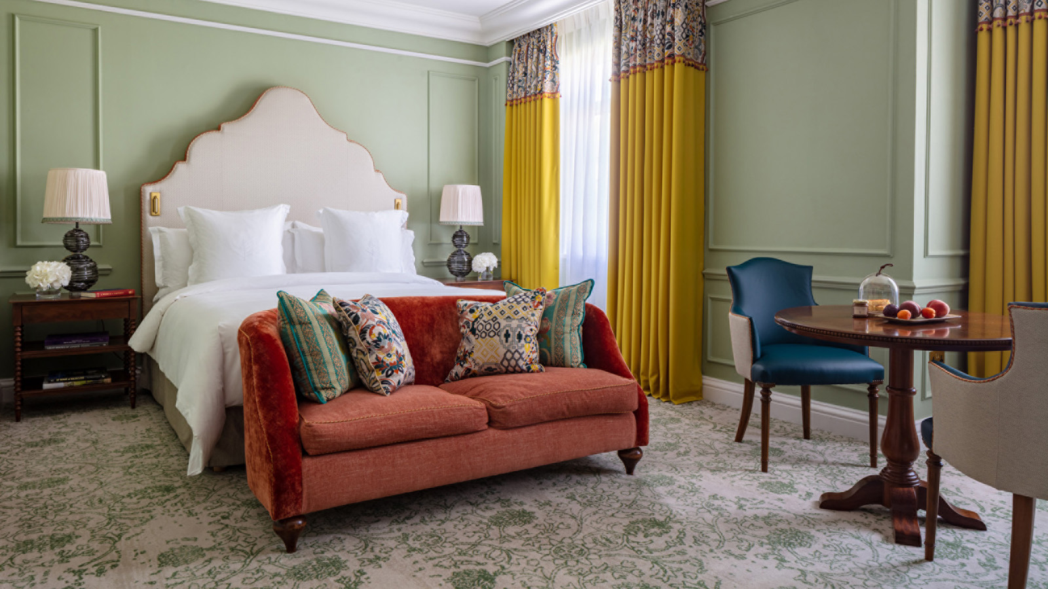 | July 5, 2022, Hampshire, England  Stay, Play and Spa This Summer at Four Seasons Hotel Hampshire  https://publish.url/hampshire/hotel-news/2022/stay-play-spa-summer-package.html

PRESS CONTACTS

Poppy Law
Public Relations Manager
Dogmersfield Park, Chalky Lane
Hook
United Kingdom
poppy.law@fourseasons.com

+44 (0)1252 853 000

Freya Costello
Senior Director of PR & Communications
Hamilton Place, Park Lane
London
England
freya.costello@fourseasons.com

+44 7788232969

