Hand-Crafted Indian Mithais, Chocolates and Macarons in Gift-Ready Boxes from Four Seasons Hotel Bengaluru
July 30, 2020, Bengaluru, India

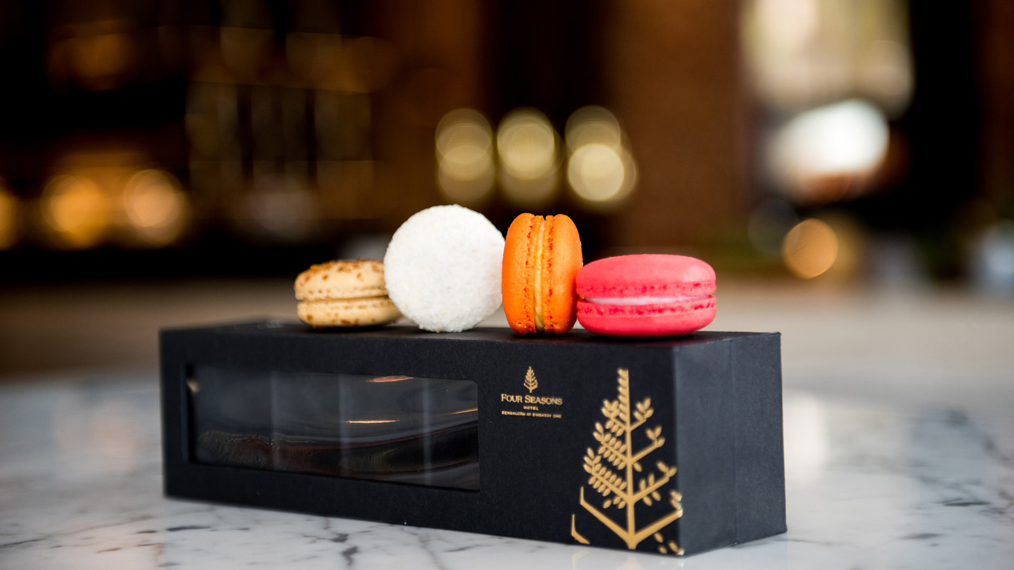
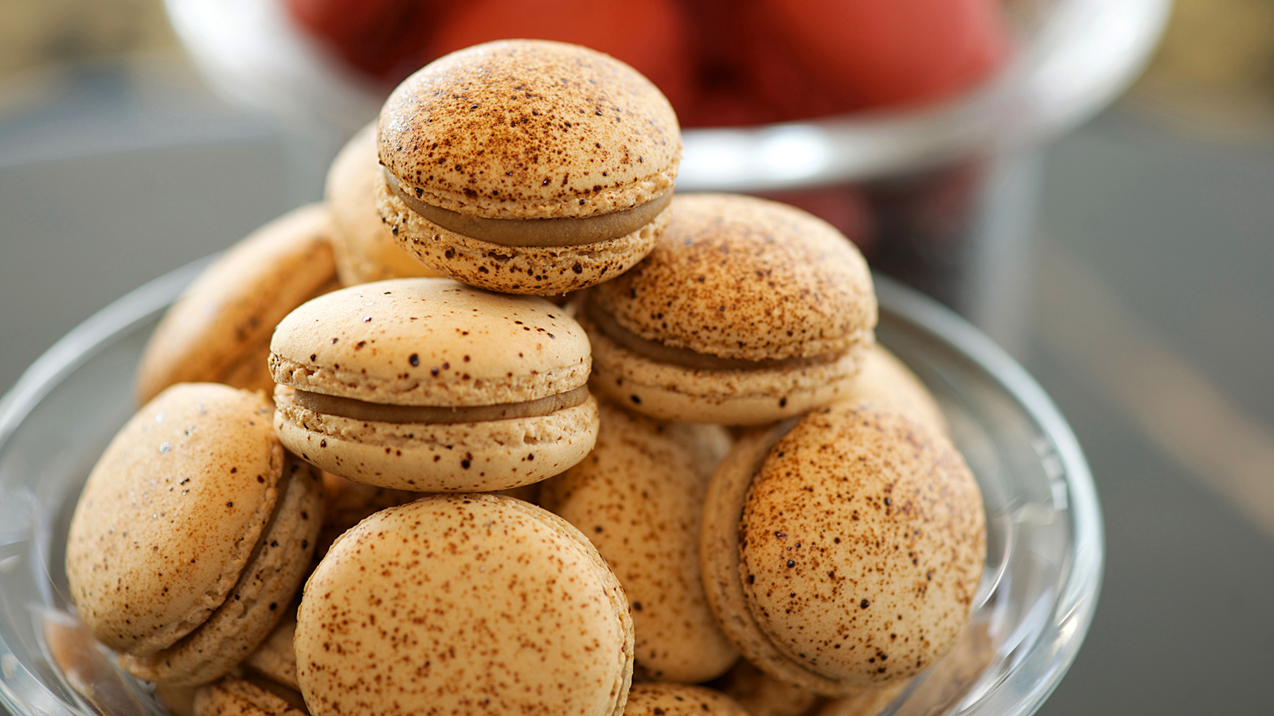 | 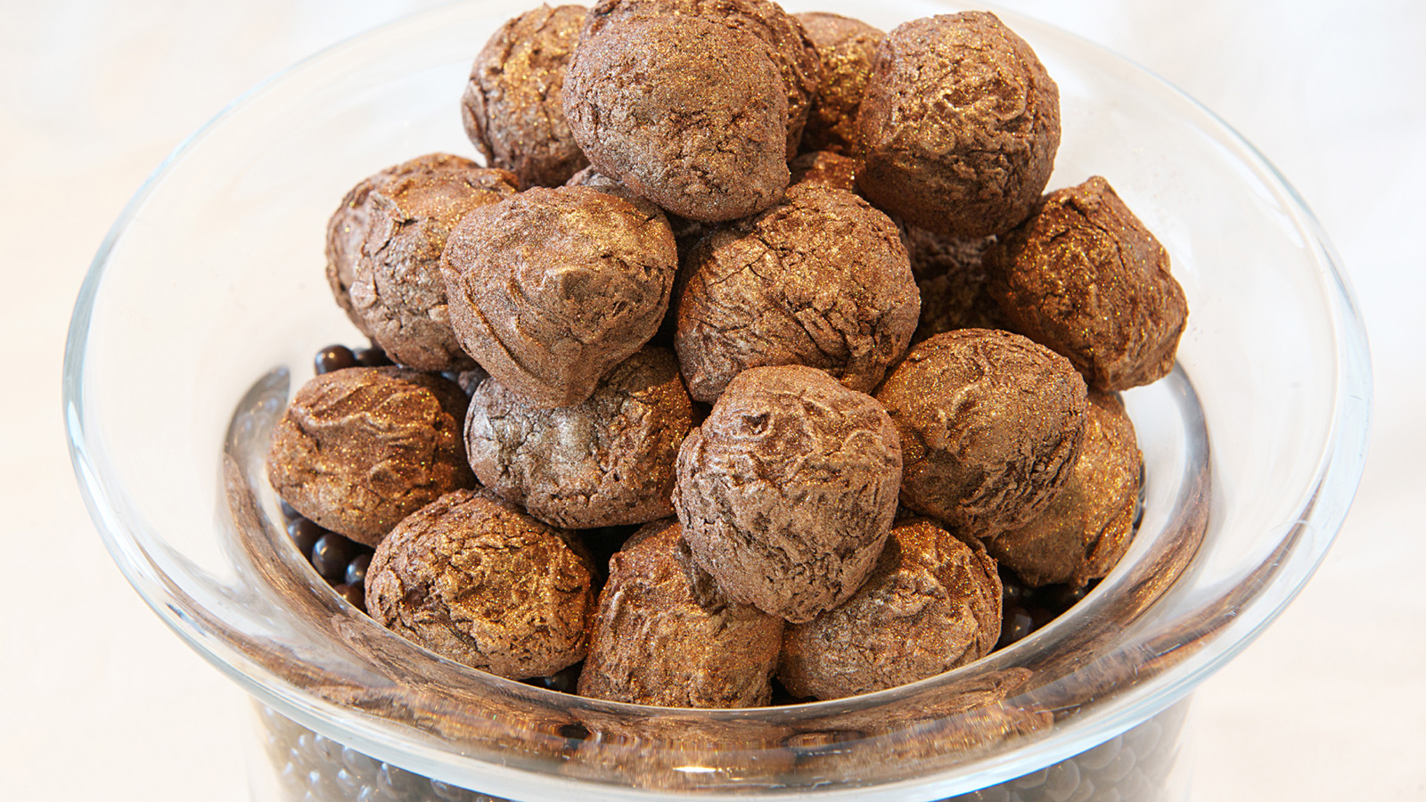 | 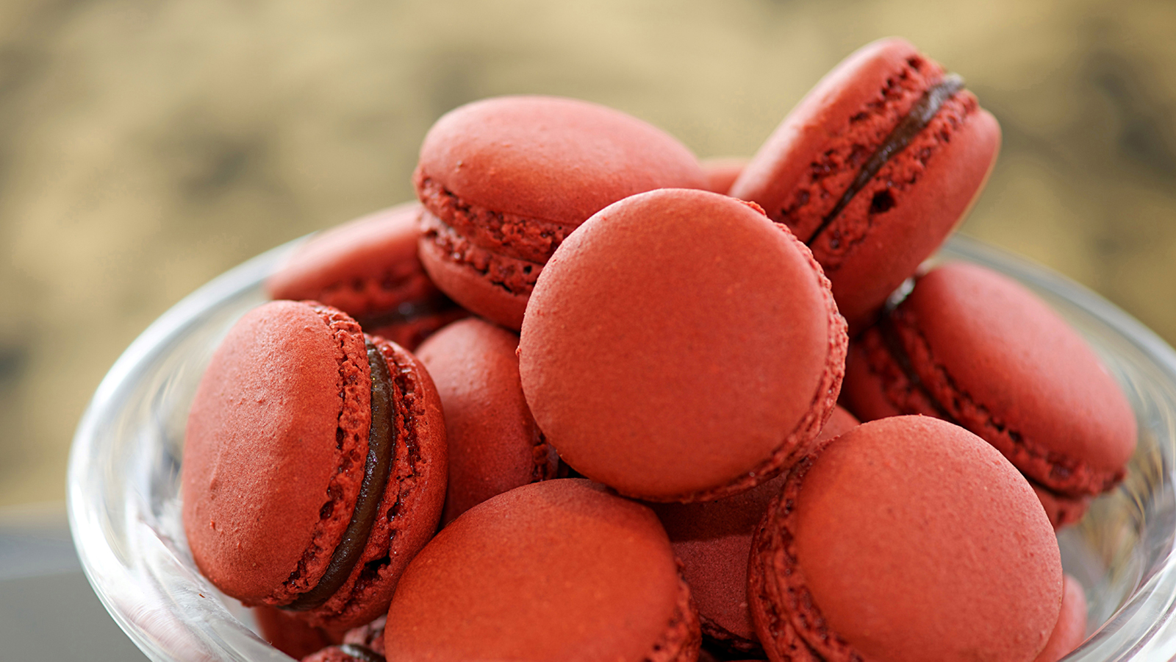
The tradition of Raksha Bandhan is not just bound together with a sweet chord, but also indulgences.
A blend of traditional Indian and international flavours makes handcrafted gifting options from Four Seasons Hotel Bengaluru a great way to celebrate this festival.
While spiced mango, cinnamon and berry, rose and Coorgi coffee add a certain flair to light and airy macarons, there is also a certain pride of position for well-loved Indian confections such as lavang latika, badam pista roll, Kashmiri apple doodh peda and a decadent gulkand mawa katori. Chocolate lovers have ample choices in coconut and berry truffles, mango praline and choco-delights in seductive cardamom, gulkand and coffee flavours.
The endearing ritual of Raksha Bandhan, or Rakhi, entails tying the ceremonious rakhi or a decorative string on the brother's wrist by a loving sister. Giving return gifts in exchange is also an important tradition and Hindu families celebrate this festival on the full moon day in August, with gifting of sweet treats.
Artisanal Raksha Bandhan gift boxes are on sale from July 30 through August 4, 2020 and available in various sizes.
- Gift box of six macarons: INR 600 + taxes
- Gift box of six chocolate and sweets: INR 600 + taxes
- Gift box of twelve chocolate and sweets: 950 + taxes
For orders call +91 76191 46004 or email sandesh.dhume@fourseasons.com.

RELATED

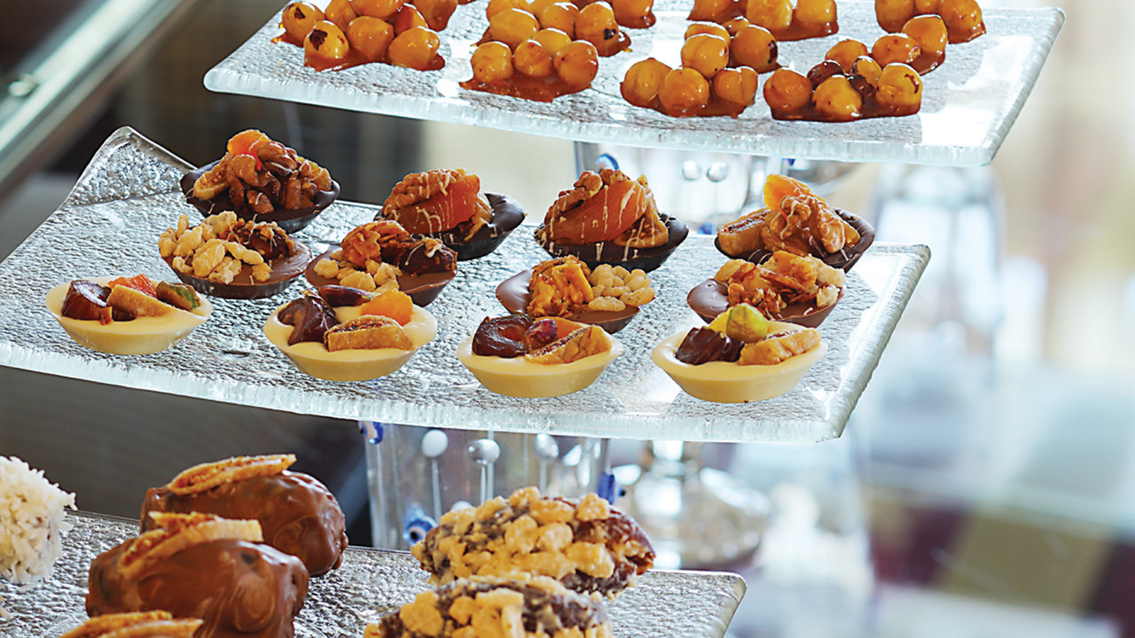 | July 24, 2020, Bengaluru, India  Eid al-Adha Celebrations at Four Seasons Hotel Bengaluru  https://publish.url/bengaluru/hotel-news/2020/eid-al-adha-takeaway-menu.html
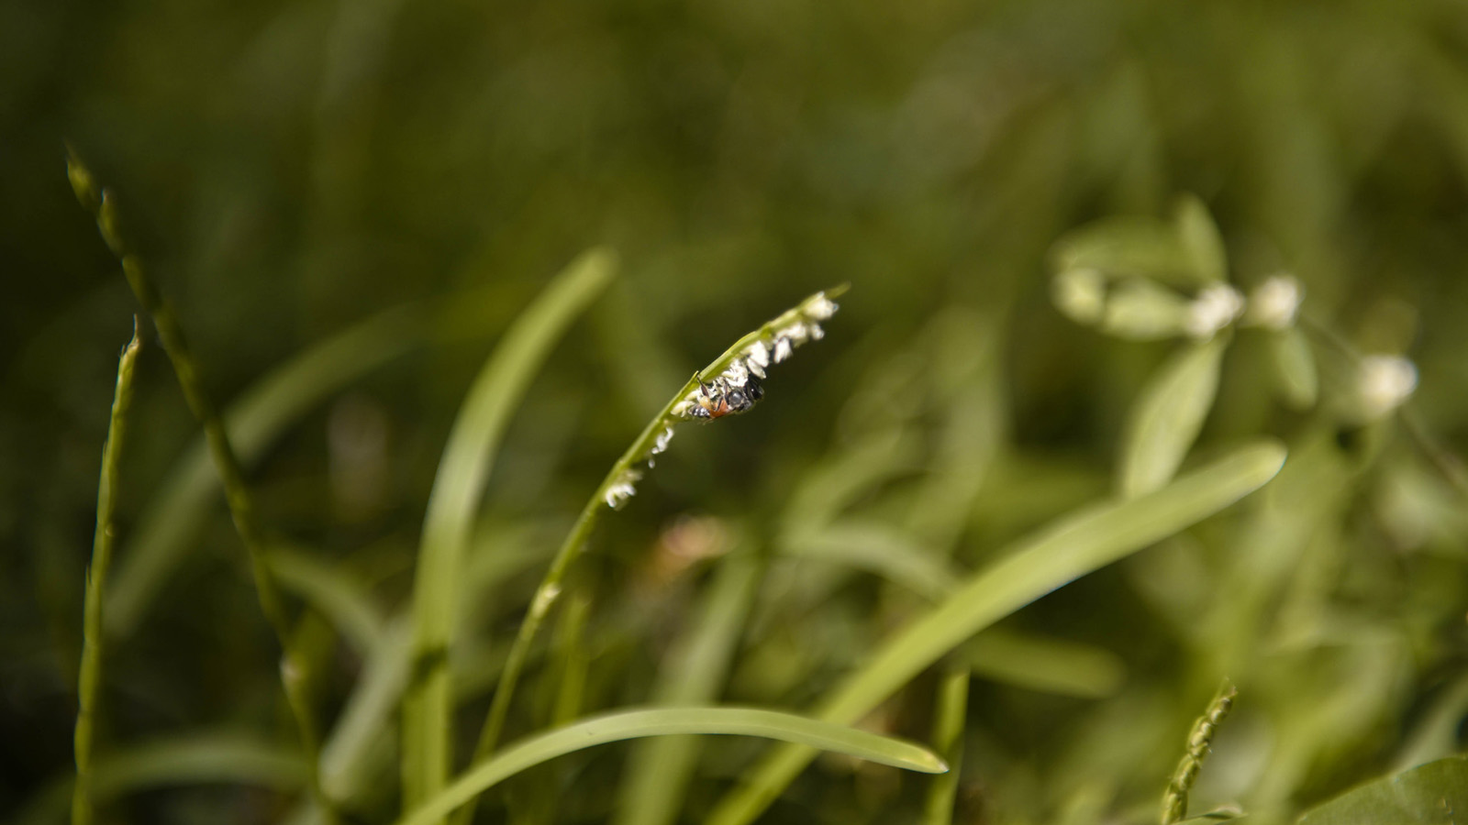 | July 7, 2020, Bengaluru, India  Monsoon Medley: Four Seasons Hotel Bengaluru Launches a Month-Long Menu Featuring Monsoon Favourites  https://publish.url/bengaluru/hotel-news/2020/monsoon-season-menu.html

PRESS CONTACTS

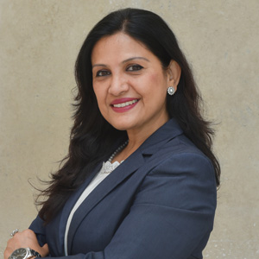 | Gargi Guha  Director of Public Relations  8, Bellary Road, Ganganagar  Bengaluru  India  gargi.guha@fourseasons.com  +91 80 4522 2222

