Four Seasons Hotel Hangzhou at West Lake Named Five Star Hotel by Forbes Travel Guide

Hotel earns prestigious award as its spa and signature restaurant are also recognised, continuing iits legacy into the fourth year
February 21, 2019, Hangzhou at West Lake, China

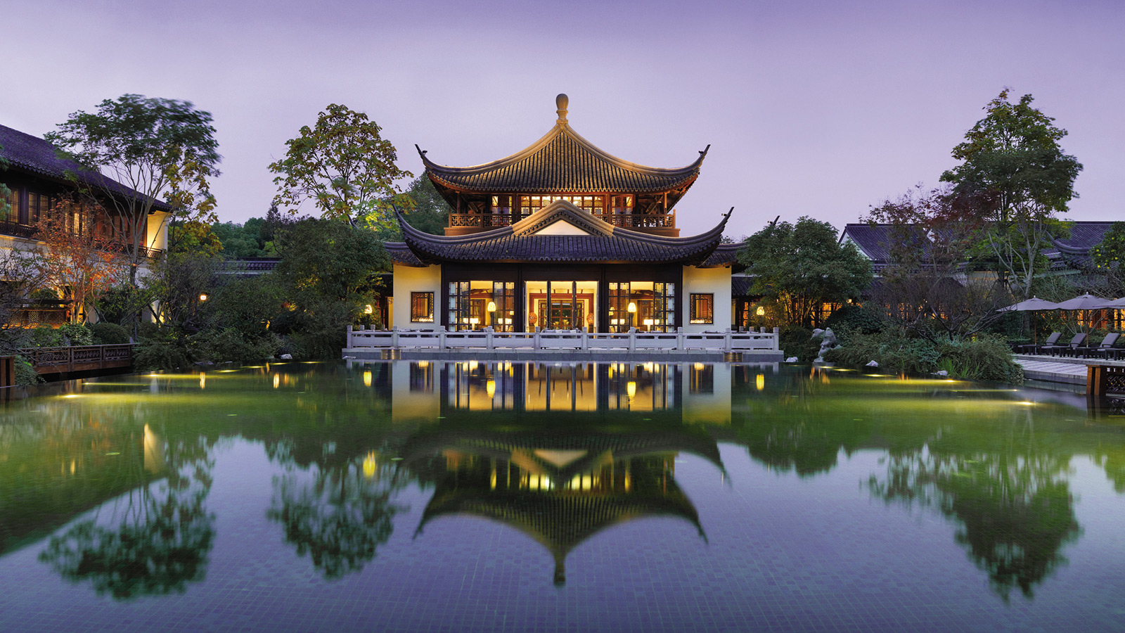
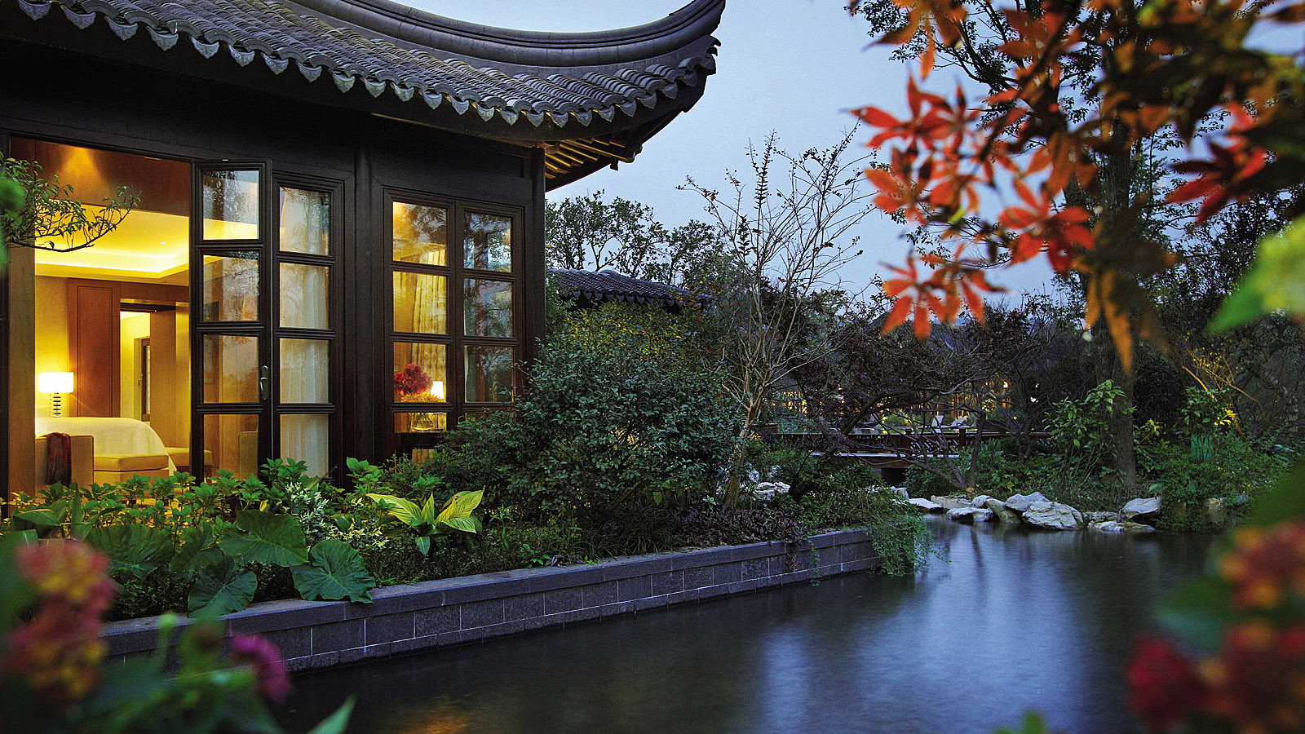 | 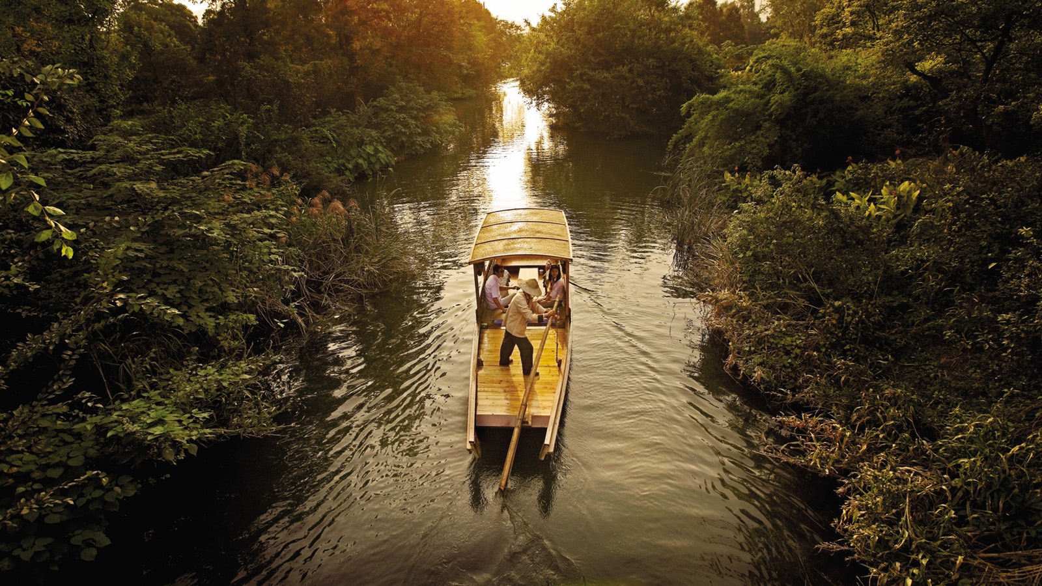 | 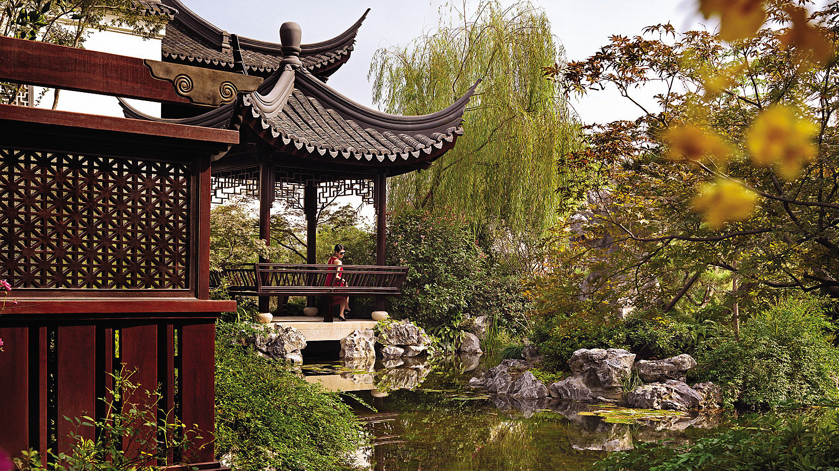
Forbes Travel Guide has recognised Four Seasons Hotel Hangzhou at West Lake as a Five-Star Hotel, defined as “outstanding, often iconic properties with virtually flawless service and amazing facilities.” Moreover, Jin Sha restaurant became the only award-winning restaurant in Hangzhou with the honour of a Four-Star Restaurant and The SPA was also named Four-Star Spa.
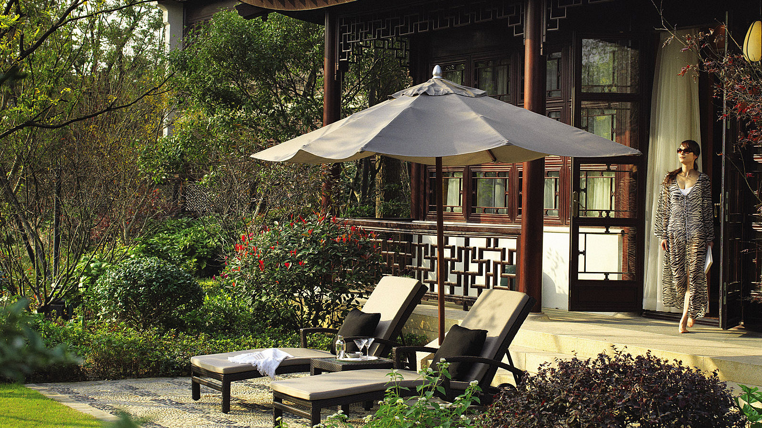 |  | 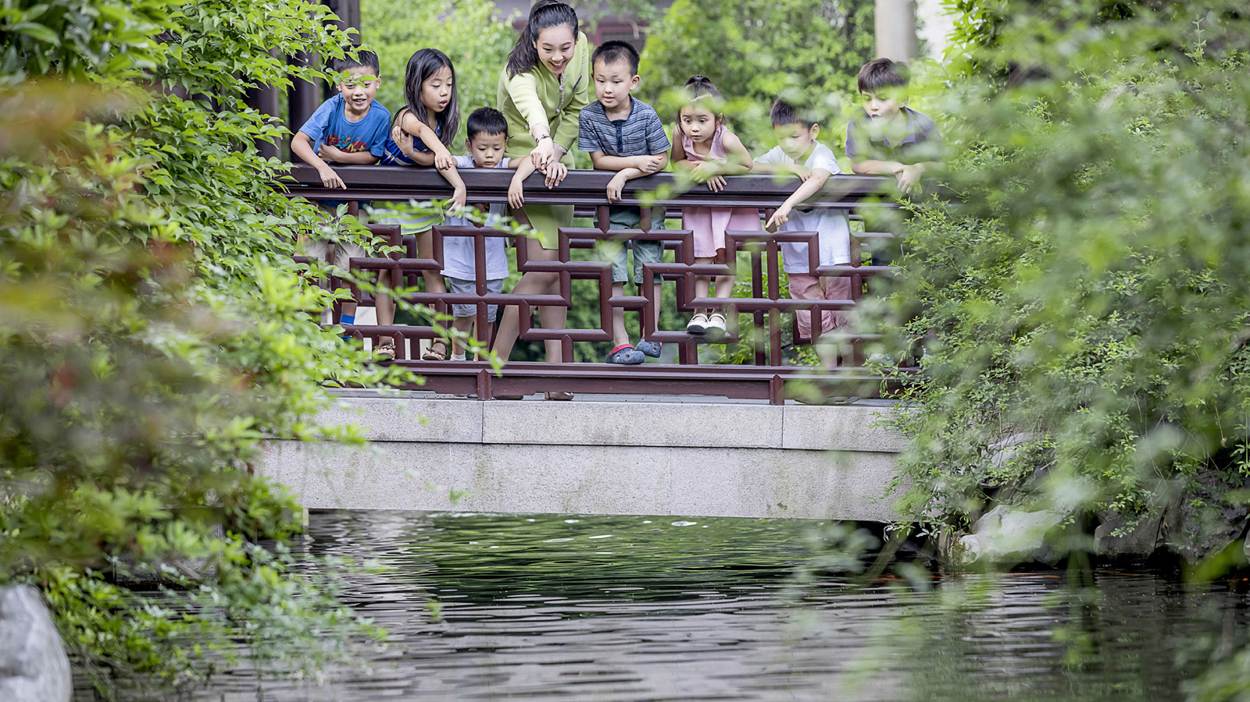
In addition, once again Four Seasons Hotels and Resorts has received the most Five-Star ratings awarded to a hotel brand in a single year in the list’s 61-year history.
“We are extremely honoured to be the only hotel in Hangzhou to have been awarded Five-Star again in this year and we are extremely proud. The award is a tremendous recognition for our staff’s unwavering commitment in delivering outstanding service to every guest. Our service is authentic and personalised, and comes from the heart,” says Michael Branham, General Manager of Four Seasons Hotel Hangzhou at West Lake. “The Forbes Travel Guide Five-Star designation is the gold standard in the hospitality industry. To be given this acknowledgement from Forbes encourages us to continue fulfilling our promises, and to keep raising the bar for outstanding services and products at Four Seasons Hotel Hangzhou at West Lake.”
Four Seasons Hotel Hangzhou at West Lake enjoys an unrivalled location nestled in the northwest corner of the UNESCO World Heritage Site of West Lake. The Song Dynasty-inspired urban resort with pagoda-style pavilions and terraces is set in stunning landscaped Chinese water gardens featuring a bamboo forest, secluded pathways and meandering lagoons. Whether it’s a weekend escape, executive retreat or a destination wedding, Four Seasons invites guests to explore what is one of China’s best kept secrets. With its own private dock guests can even arrive by boat to experience the natural beauty of the lake. The Hotel has 78 guest rooms and suites and 3 residential-style villas. Several of the rooms come with a private terrace and beautiful garden views.
“We are delighted to celebrate the 2019 Star Rating winners, an outstanding collection of hotels, restaurants and spas that demonstrates a strong culture of service,” said Filip Boyen, Chief Executive Officer of Forbes Travel Guide.

RELATED

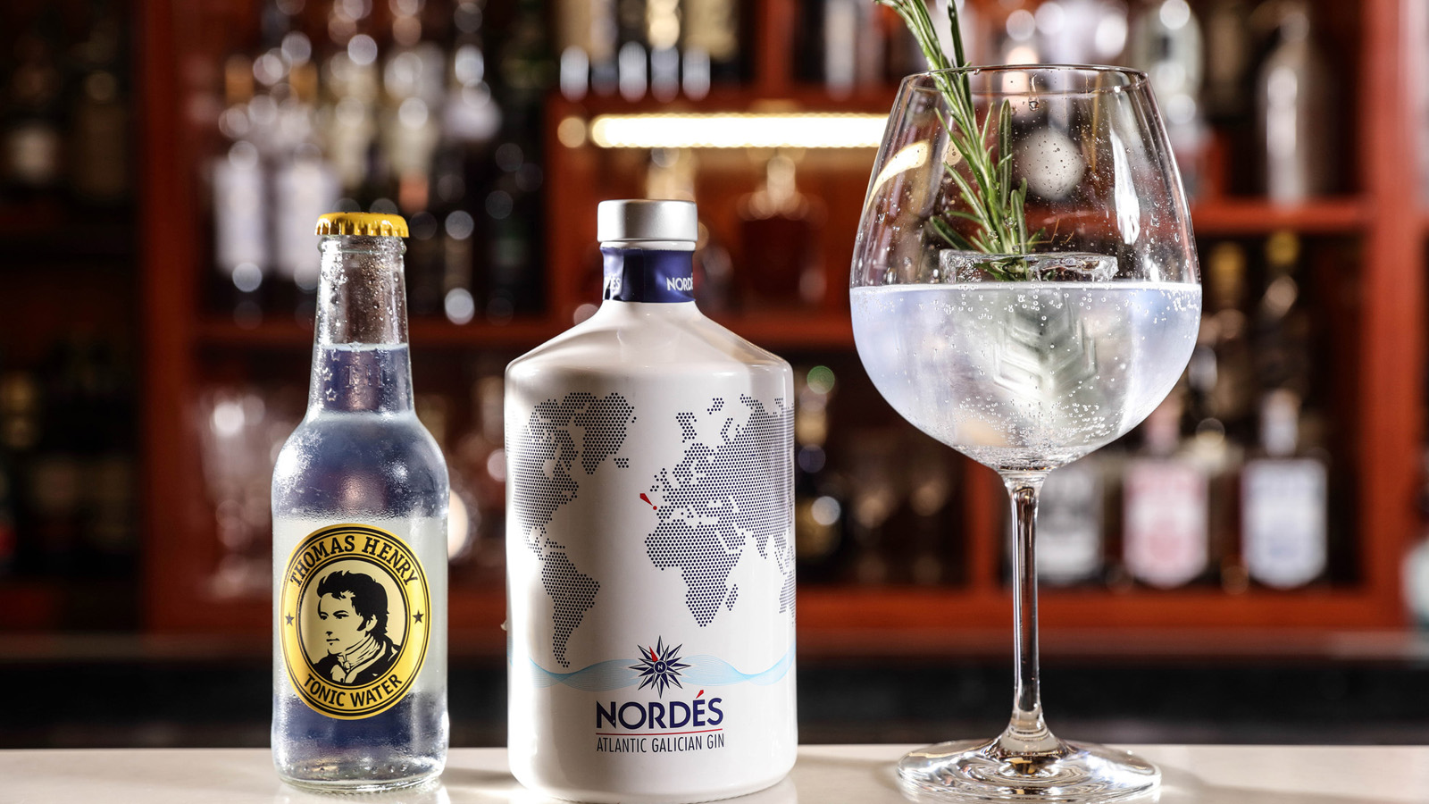 | February 14, 2019, Beijing, China  用心調配，只為一杯金湯力  https://publish.url/zh/beijing/hotel-news/2019/gin-collection-at-opus-bar-2.html
February 14, 2019, Beijing, China
Gin & Tonic – We Take It Seriously at Four Seasons Hotel Beijing
https://publish.url/beijing/hotel-news/2019/gin-collection-at-opus-bar.html

PRESS CONTACTS

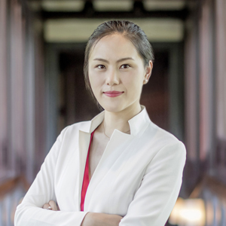 | Cecilia Xu  Assistant Director of Public Relations  5 Lingyin Road  Hangzhou  China  cecilia.xu@fourseasons.com  +86 571 8829 8888
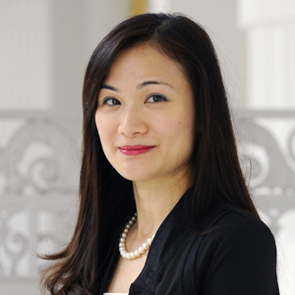 | Vivian Koh  Director, Public Relations and Content, Asia-Pacific  Tourism Court, 1 Orchard Spring Lane #04-01  Singapore  Singapore  vivian.koh@fourseasons.com  +65 6739 5806

