Hop into the Year of the Rabbit with Delectable Celebrations at Four Seasons Hotel Kuala Lumpur

January 11, 2023, Kuala Lumpur, Malaysia

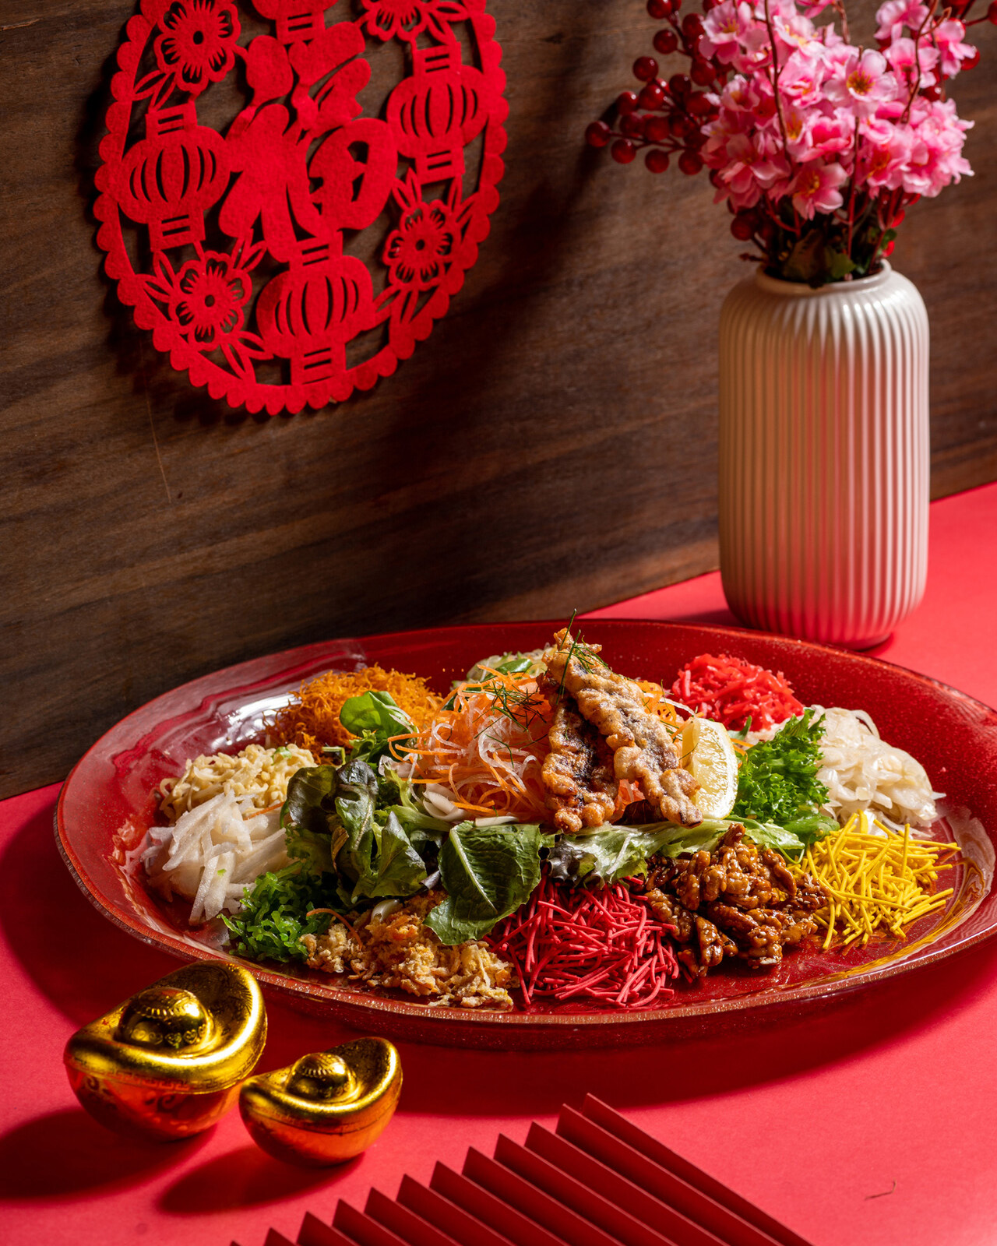
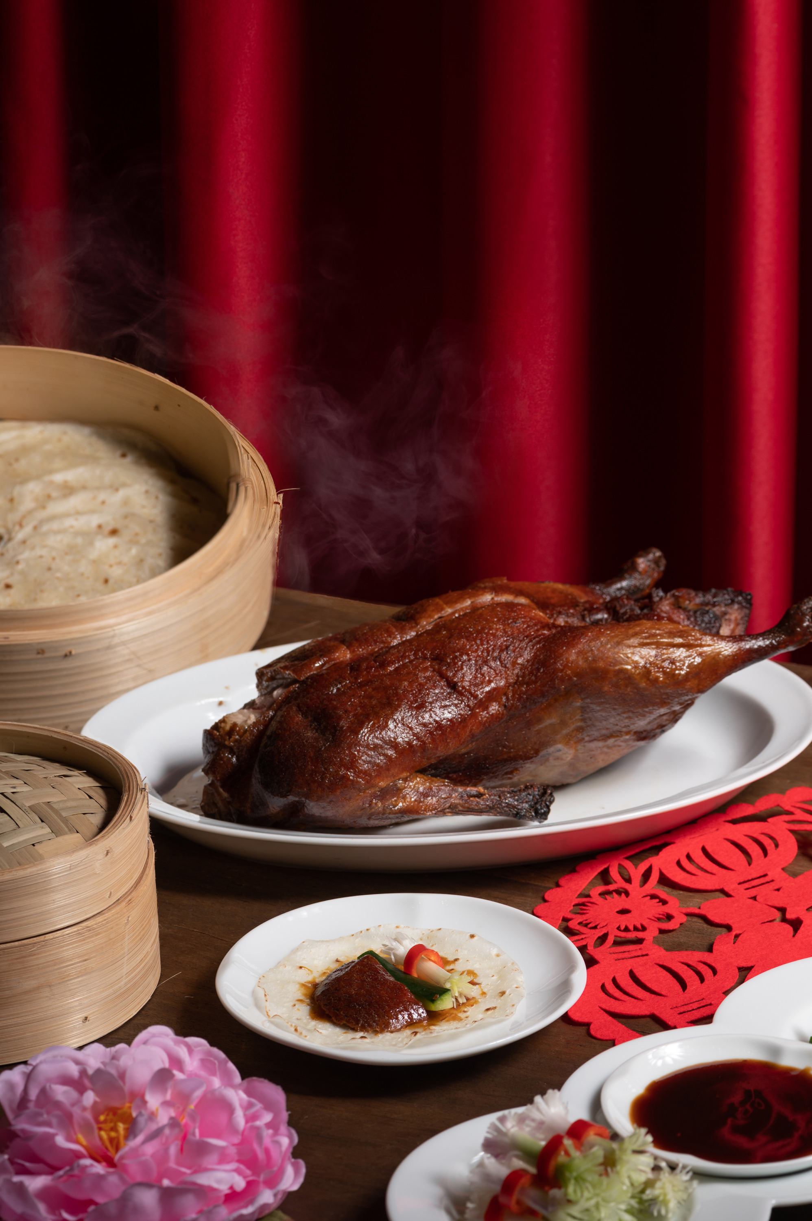 | 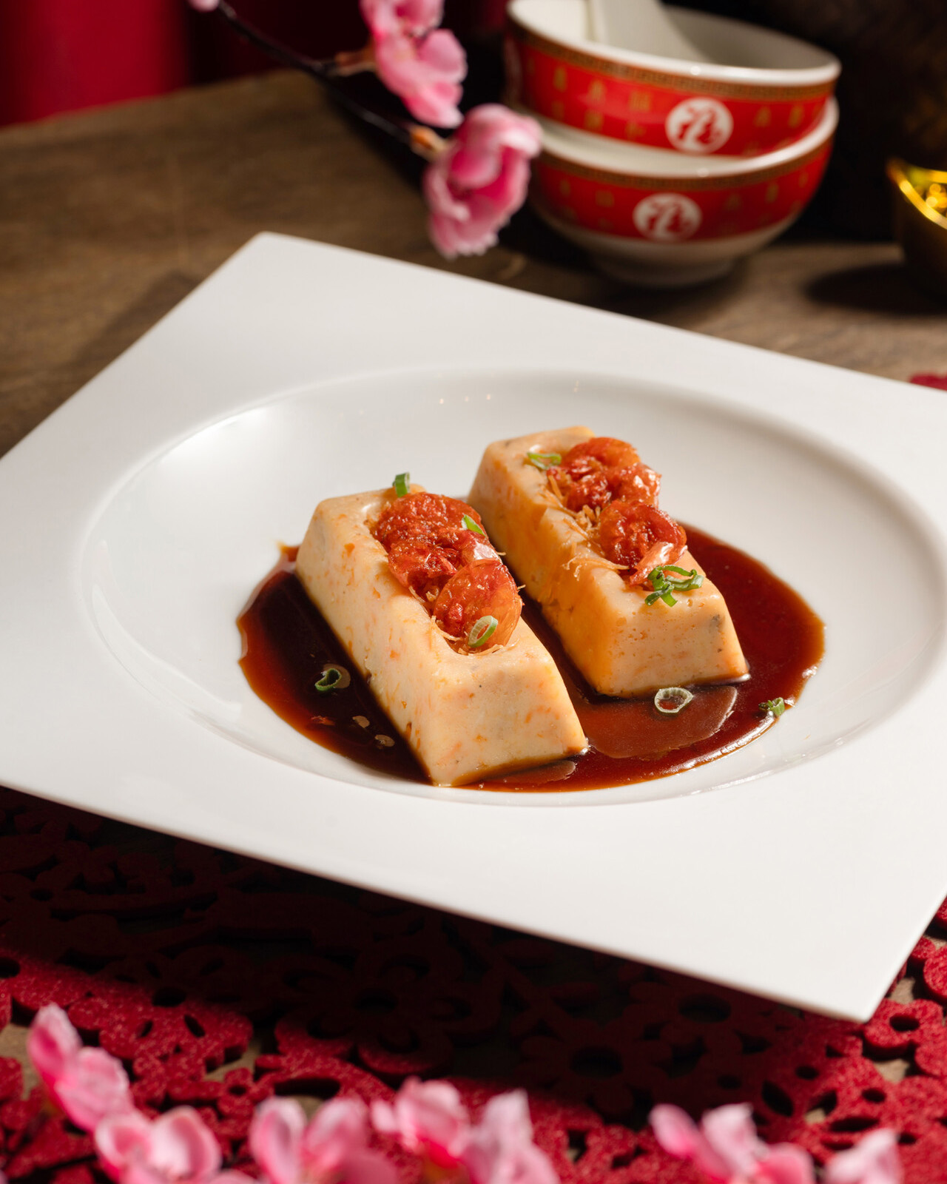
Gong Xi Fa Cai! Usher in the Lunar New Year at Four Seasons Hotel Kuala Lumpur with delectable festivities. The Year of the Rabbit brings the promise of peace, prosperity and reconnection. Gather with family and friends to renew and strengthen precious bonds over traditionally inspired feasts. What better way to celebrate the beginning of a brand new year?
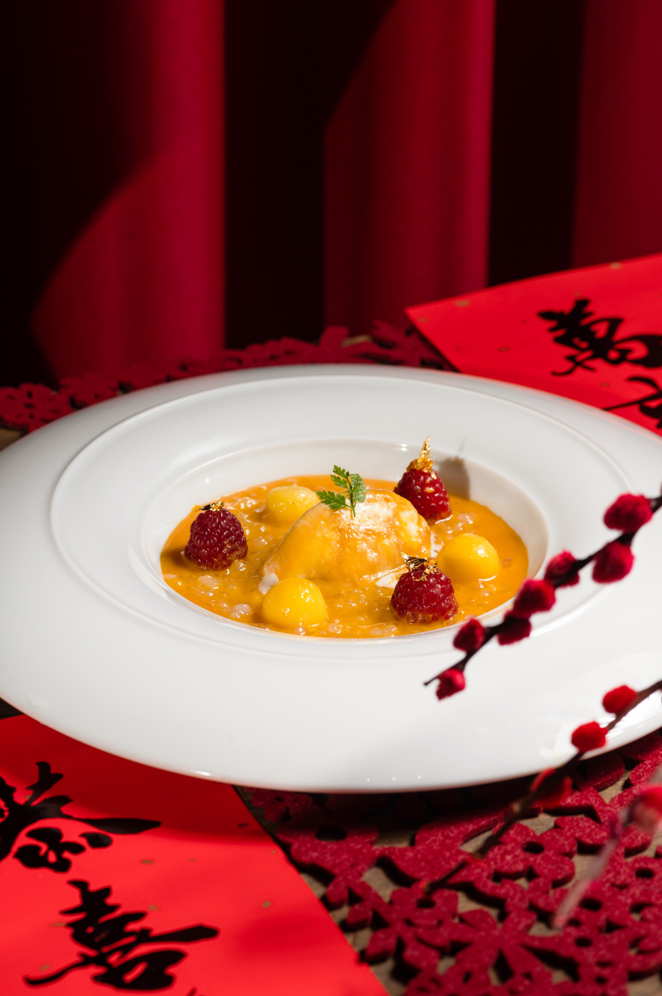 | 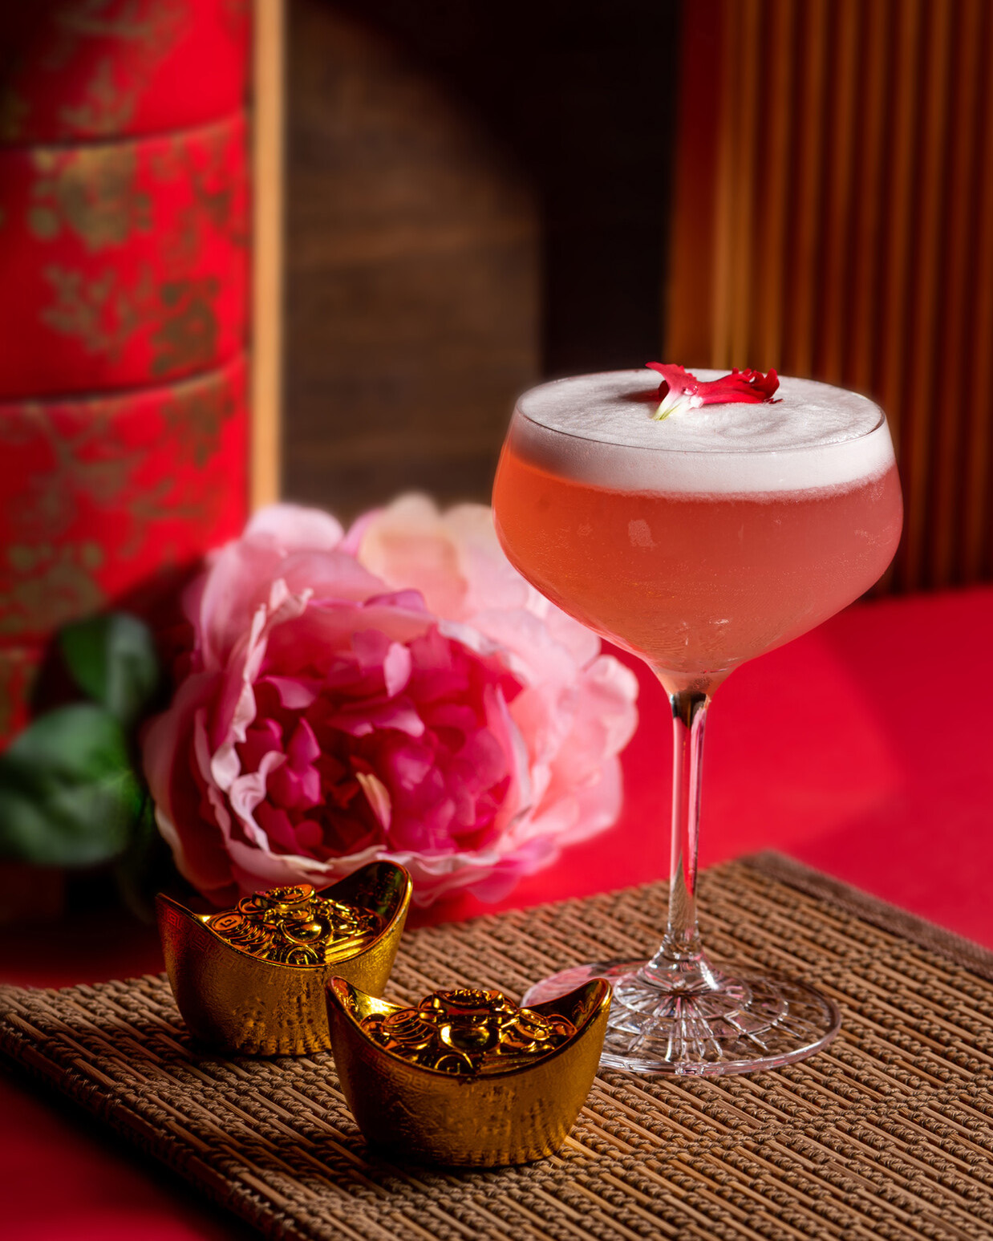 | 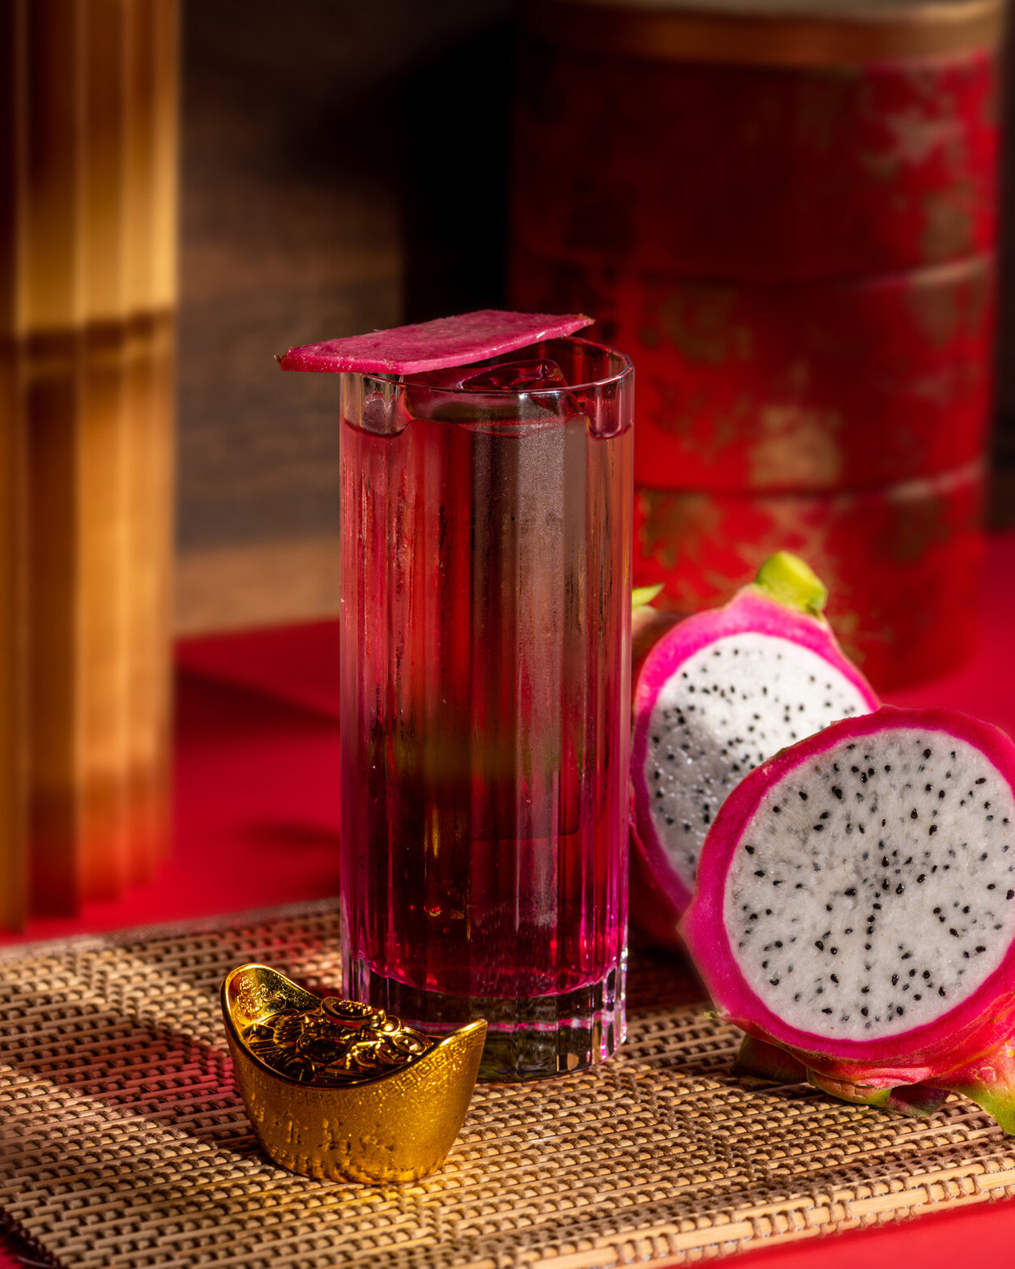
“The Lunar New Year holds a very special place in Malaysia, especially for communities with Chinese ancestry,” explains General Manager Blaise Montandon. “Our team has curated joyful culinary experiences for this auspicious period, bringing together beloved flavours and customs with classic Four Seasons flair.”
Vibrant decorations set the stage for celebration across the Hotel’s dining outlets, with mandarin oranges, fortune cookies and ang paos in attendance. On January 21 and 22, 2023, the God of Prosperity is slated to make a special appearance with goodie bags and photo opportunities. Guests can also enjoy a special lion dance performance on January 30, 2023, a lively ritual to welcome good fortune and happiness.
Lucky Rabbit Buffet at Curate
Gong Hei! Gong Hei! Greet the Year of the Rabbit with a smorgasbord of delicacies from around the world, with top honours accorded to traditional Chinese specialties. Inspired by ancient recipes from China and vibrant morning markets across Asia, the team at Curate presents a tantalising spread, from wok-tossed dishes and delicately steamed seafood to a sumptuous array of desserts. Ignite the palate with Sichuan specialties such as La Zi Chicken, Hunan Steamed Fish with Pickled Chilli, River Tiger Prawns with Salted Egg, and Barbecue Roasted Beef Shank.
Composed by Chef Cheong, the Lunar New Year selection captures the warm, festive spirit of family reunions. Discover seven auspicious foods, including dumplings and wontons for wealth, noodles for longevity, rice cakes for professional success, and spring rolls for a fresh star.! Also on the menu: curated Yee Sang with tuna and salmon, Ding Ding candy, and authentic Chinese sweets.
- Buffet Dinner: 6:00 to 10:00 pm (available January 21-23, 2023)
- Buffet Lunch: 12:30 to 3:30 pm (available January 22-23, 2023)
- MYR 218-238 per adult, MYR 109-119 per child
- Add-on beverage packages: Wine and beer MYR 188 per person; prosecco, wine and beer MYR 328 per person
- Specially priced Champagne bottles available a la carte
Lunar New Year Menu at Yun House
Pay homage to the Lunar New Year with an iconic meal at Yun House, the city’s go-to for elevated Cantonese cuisine. Executive Chef Jimmy Wong pulls out all the stops for this festive feast, presenting spectacular specialties that dazzle the eye and elate the palate.
Featuring prized auspicious ingredients – think Musang king durian, T’Lur caviar, lobster, black truffle – this a la carte menu is woven around the phoenix, a symbol of peace and prosperity in Chinese culture. Sample creations such as the Steamed Rice Roll with European Lobster, Luo Han Style Assorted Vegetables with Sliced Truffle, and Mango Cream with Milk Powder Crumble, Alphonso Granita and Caramelized Bamboo Sugar.
Yee Sang, the centrepiece of the Lunar New Year, is uniquely crafted and presented in eye-catching style – “tailormade for Insta-stories!” as Chef Jimmy puts it. On Lunar New Year Eve (January 21, 2023), choose from three superb set menus: Majestic, Auspicious or Fortuity.
- A la carte menu: available until February 5, 2023
- Set menu: Majestic MYR 568 per person, Auspicious MYR 688 per person, Fortuity MYR 888 per person
- On Lunar New Year Eve (January 21, 2023), only set menus will be served.
Lunar New Year Afternoon Tea at The Lounge
Raise an elegant cup to the Year of the Rabbit with an enchanting selection of sweets and savouries, served in the special ambience of The Lounge. This special Afternoon Tea sparkles with the flavours of Lunar New Year.
Taste sweet delights such as the Ginger Baba with Mango, Nian Gao with Chocolate Ganache, and Lychee Cheesecake with Osmanthus Jelly. On the savoury side, discover intricate creations such as the Crispy Taro Paste with Foie Gras Pate, Five-Spiced Caramelized Onions and Hoisin Cream. The menu also includes teatime classics with a festive twist: think Warm Scones with Pu Erh Marmalade and Salted Chestnut Butter.
The celebrations unfold through the afternoon, with complimentary pass-around treats such as fortune cookies and ginger sorbet on dry ice. Guests can also sip Ong Lai (meaning “pineapple” in Hokkien), a zesty beverage that combines mint and sour lime with pineapple, a traditional signifier of fortune and prosperity.
- Available until February 5, 2023
- 3:00 to 5:30 pm
- MYR 208 per person
All prices listed above are subject to service charge and government taxes.
To reserve a Lunar New Year celebration at Four Seasons Hotel Kuala Lumpur, chat via Four Seasons App.

RELATED

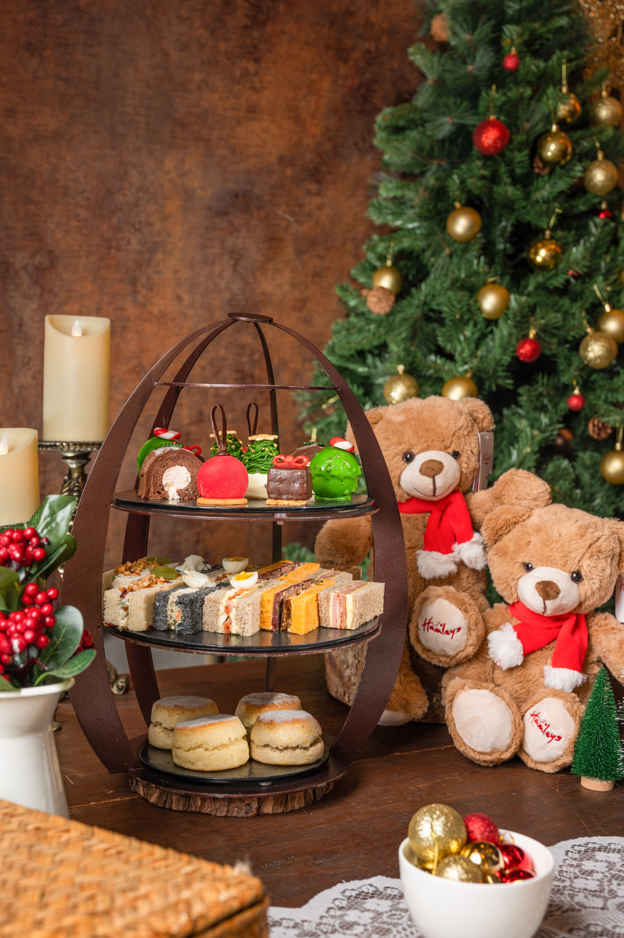 | November 7, 2022, Kuala Lumpur, Malaysia  Mistletoe & Magic: Celebrate the Holidays in Traditional Style with Four Seasons Hotel Kuala Lumpur  https://publish.url/kualalumpur/hotel-news/2022/festive-season.html
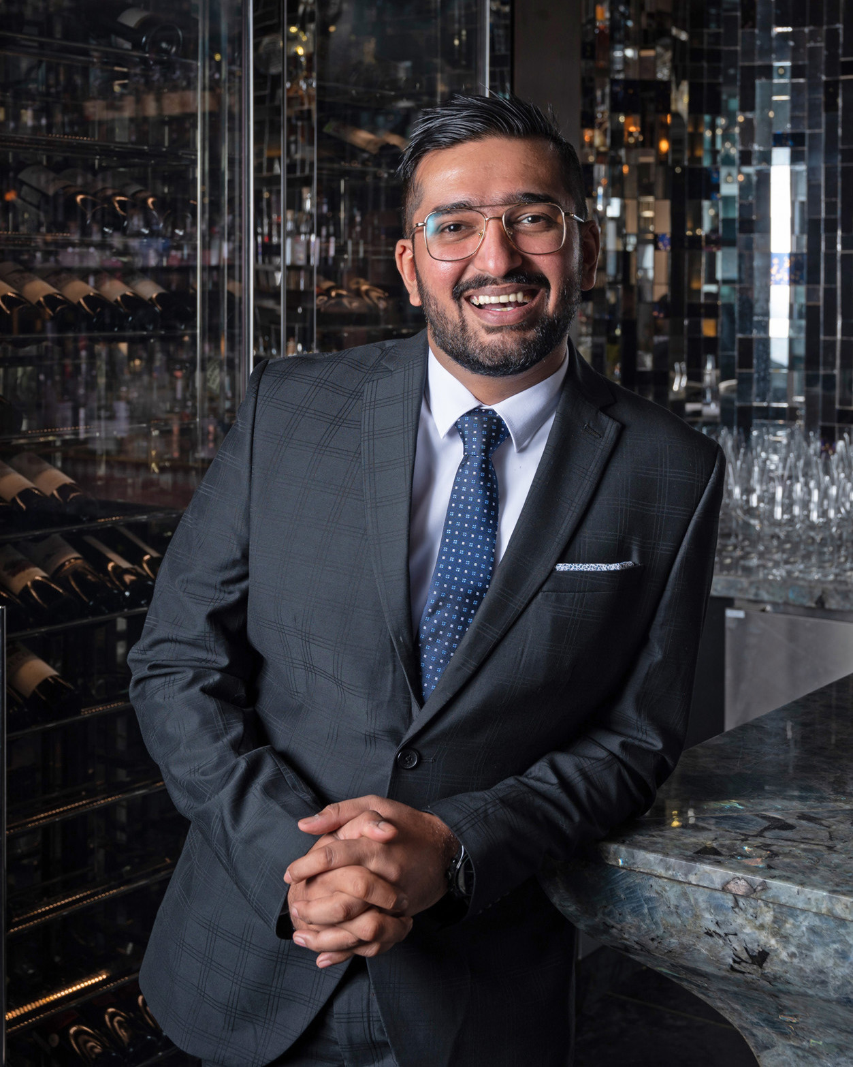 | October 27, 2022, Kuala Lumpur, Malaysia  Acclaimed Mixologist Rohan Matmary Appointed Head Bartender of Bar Trigona at Four Seasons Hotel Kuala Lumpur  https://publish.url/kualalumpur/hotel-news/2022/new-head-bartender-rohan-matmary.html

PRESS CONTACTS

Kanchana Ganglani
Director of Public Relations
145 Jalan Ampang
Kuala Lumpur
Malaysia
kanchana.ganglani@fourseasons.com

+6(03) 2382 8740

