Four Seasons Resort Lanai Receives Golf Digest Editors’ Choice Award

Spectacular Nicklaus Signature Design remains ultimate island golf
April 3, 2018, Hawaii, Lanai, U.S.A.

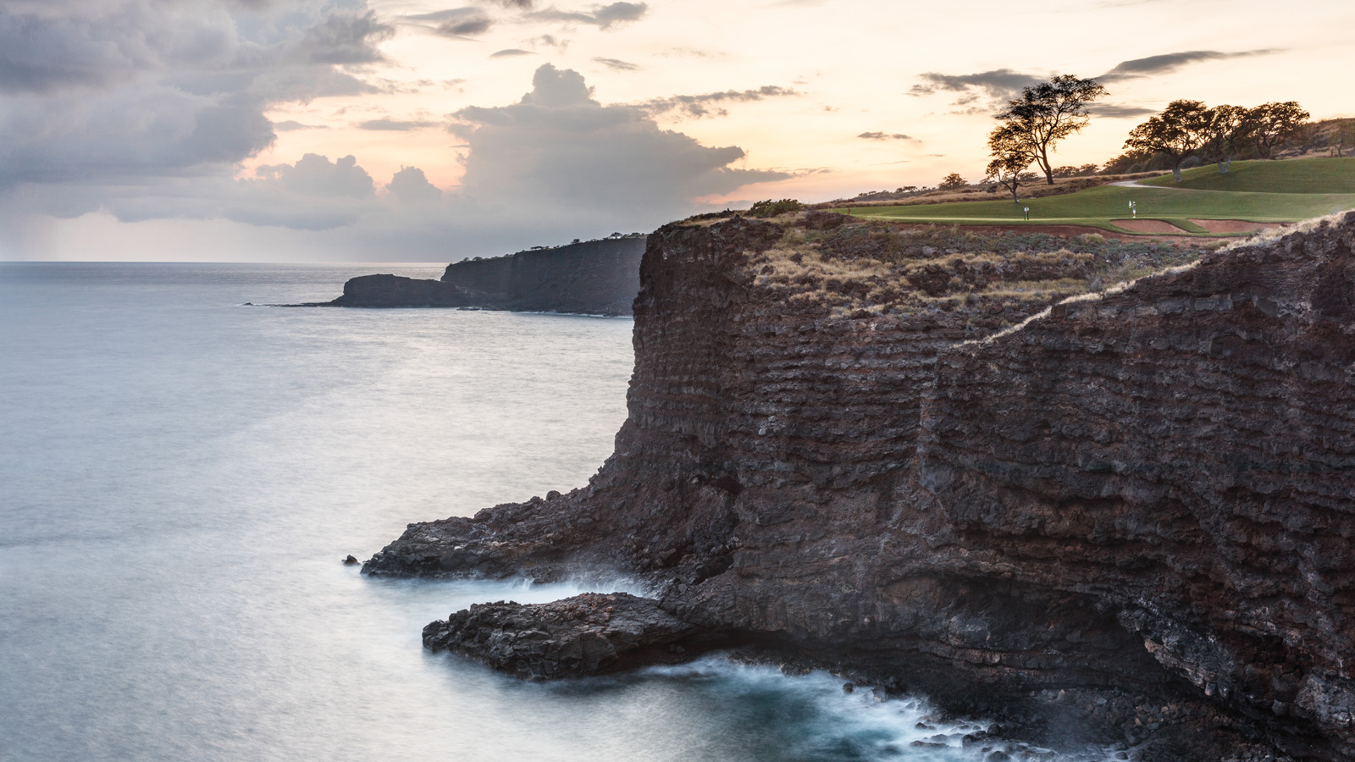
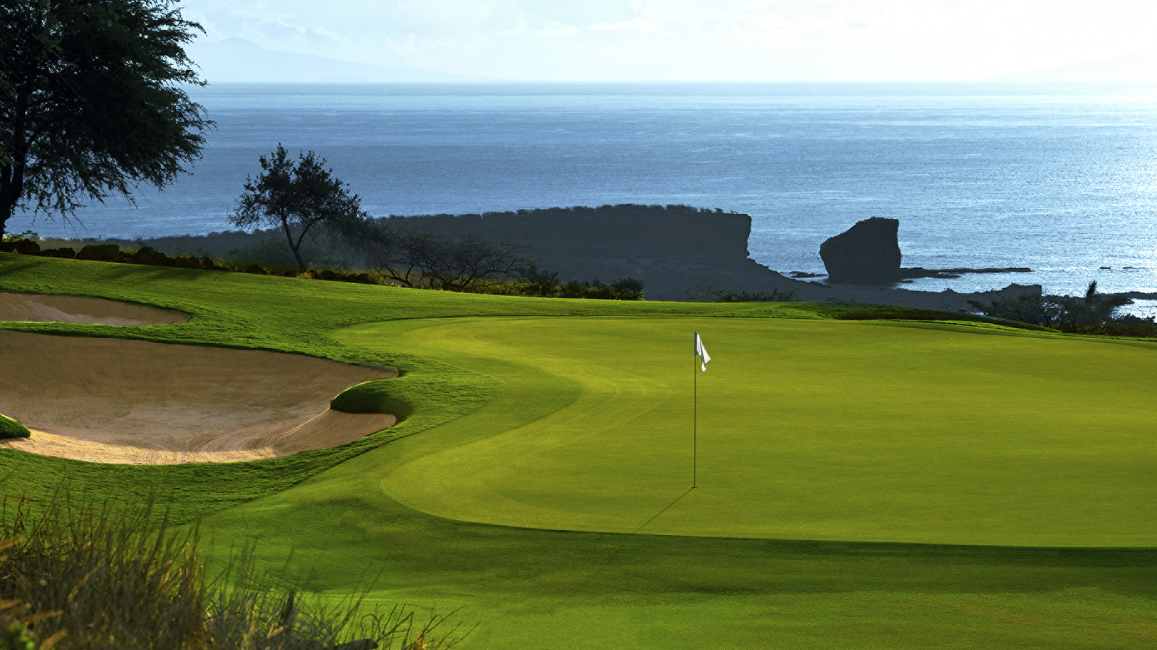 | 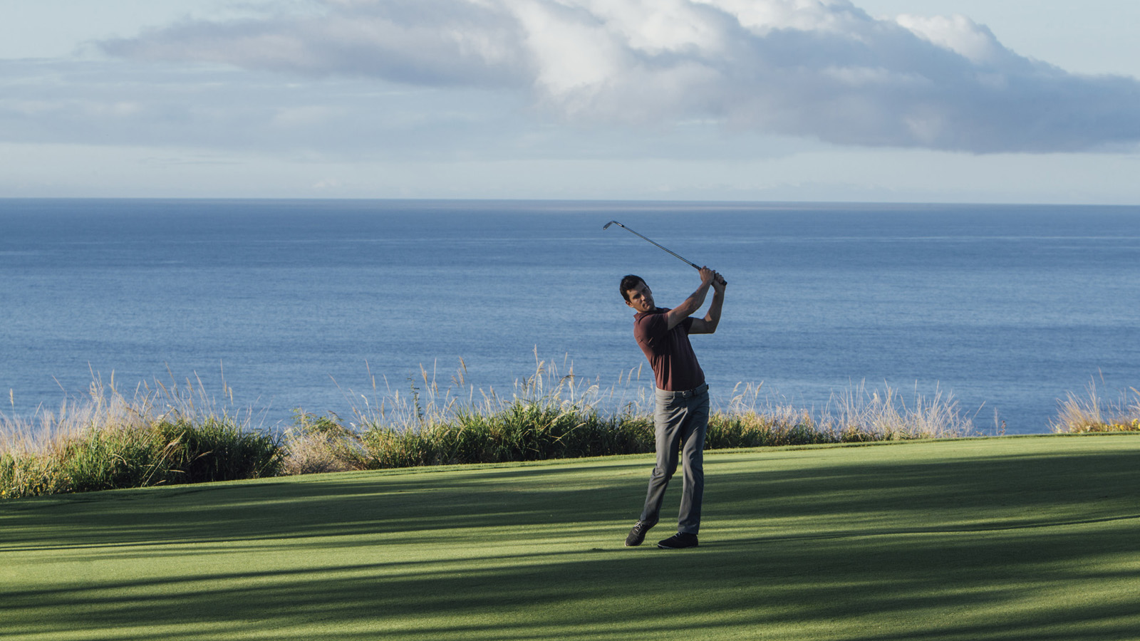
Four Seasons
Resort Lanai, home to one of the world’s most striking venues for the game, has received an Editors’ Choice Award for “Best in Travel 2018” in the May issue of Golf Digest.
The selection, through which the magazine leadership identifies its list of “The Best Things in Golf,” adds to the legacy of the Jack Nicklaus-designed Manele Golf Course and the premier luxury travel lifestyle at
Four Seasons
Resorts Lanai.
“Playing Manele Golf Course is something magical golfers remember forever,” says Scott Ashworth, Manele’s PGA Director of Golf. “The tropical coastline and special serenity of the island makes Manele an extraordinary experience unlike anything else in the world. It exemplifies the world-class lifestyle of
Four Seasons
Resort Lanai.”
The awards list recognises resorts throughout the United States, Mexico, Central America, the Caribbean, Bermuda and Canada.
“Whether it’s a buddies’ trip or a getaway with our significant other, what we seek from a golf resort is an experience greater than our usual weekend round,” Golf Digest said of its selection criteria. “We want to be pampered on and off the fairways,” noting that “the joy of a great golf resort” is that “it’s overstocked with activities and diversions, and we get to pick our pleasures.”
“In identifying The Best Things in Golf, we place an emphasis on lifestyle properties, products and services,” said Max Adler, Golf Digest’s editorial director.
A true island golf paradise, Manele Course is the ultimate in must-play golf experiences. Highly acclaimed, yet still very much untouched and uncrowded, Manele is laid out on lava outcroppings and features three holes along rugged oceanside cliffs.
The course offers heavenly views of the Pacific on all 18 holes. Its signature hole is No. 12, a par 3 where the tee sits 150 feet (46 metres) above the crashing surf. Five sets of tees ensure a fair, fun challenge for every golfer, but do-or-die shots over natural gorges and ravines must be precise.
“We appreciate the editors of Golf Digest magazine recognising the excellence of
Four Seasons
Resort Lanai among most outstanding golf destinations in the country,” says Alastair McAlpine, General Manager of
Four Seasons
Resorts Lanai. “We welcome the opportunity to share our stunning resort and ocean-view course with avid golf travellers from around the world. We know when they visit us they will enjoy a trip of a lifetime.”

RELATED

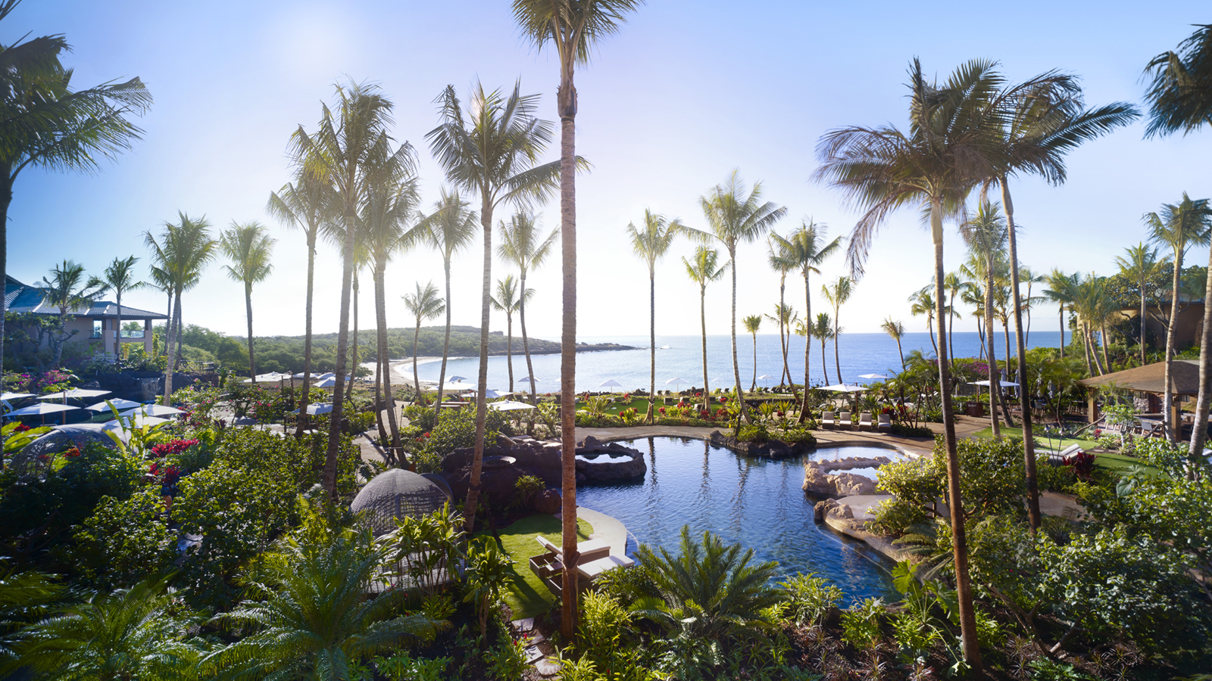 | March 27, 2018, Hawaii, Lanai, U.S.A.  Extend an Island Adventure with Four Seasons Resort Lanai  https://publish.url/lanai/hotel-news/2018/stay-longer-5th-or-6th-night-free.html
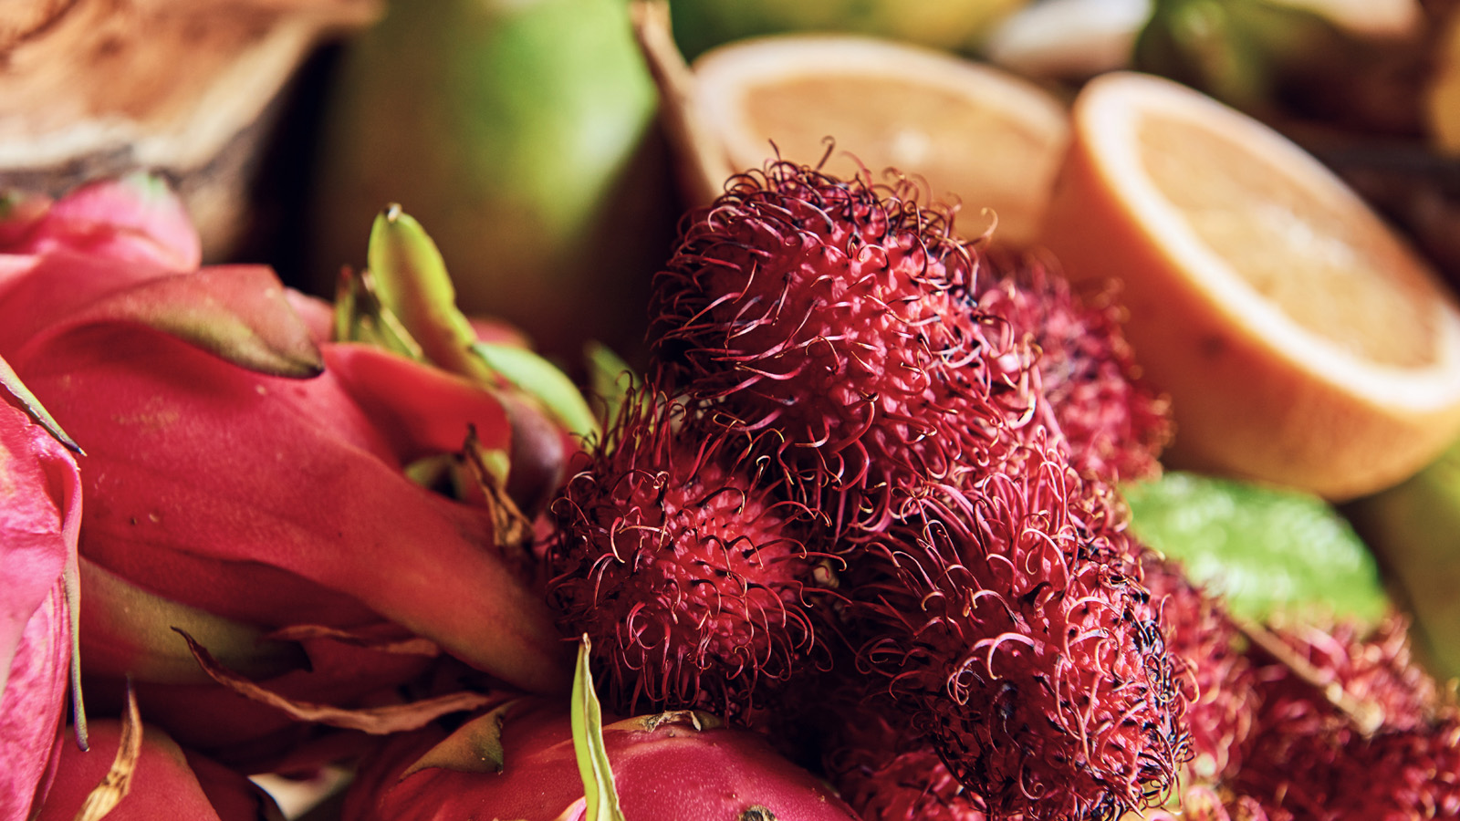 | March 20, 2018, Hawaii, Oahu, U.S.A.  Chef Simeon Hall Jr. Delivers Artisanal Dining with Island Flair at La Hiki Kitchen at Four Seasons Resort Oahu at Ko Olina  https://publish.url/oahu/hotel-news/2018/la-hiki-kitchen-chef-simeon-hall-jr.html

PRESS CONTACTS

Lori Holland
Director of Public Relations
6100 Center Drive, Suite 1250
Los Angeles
U.S.A.
lori.holland@fourseasons.com

+1 (201) 294-7810

Olivia Kragen
Digital Marketing Manager
6100 Center Drive, Suite 1250
Los Angeles
U.S.A.
olivia.kragen@fourseasons.com

+1 (310) 695-3385

Laura Fairweather
Director of Public Relations, Americas
1165 Leslie Street
Toronto
Canada
PRSM@fourseasons.com
@FourSeasonsPR
1 (416) 441-4233

