Four Seasons Residence Club Aviara Celebrates Global Wellness Day

A look at the events and activities that will be offered to boost body, soul and spirit
June 5, 2017, San Diego, Aviara

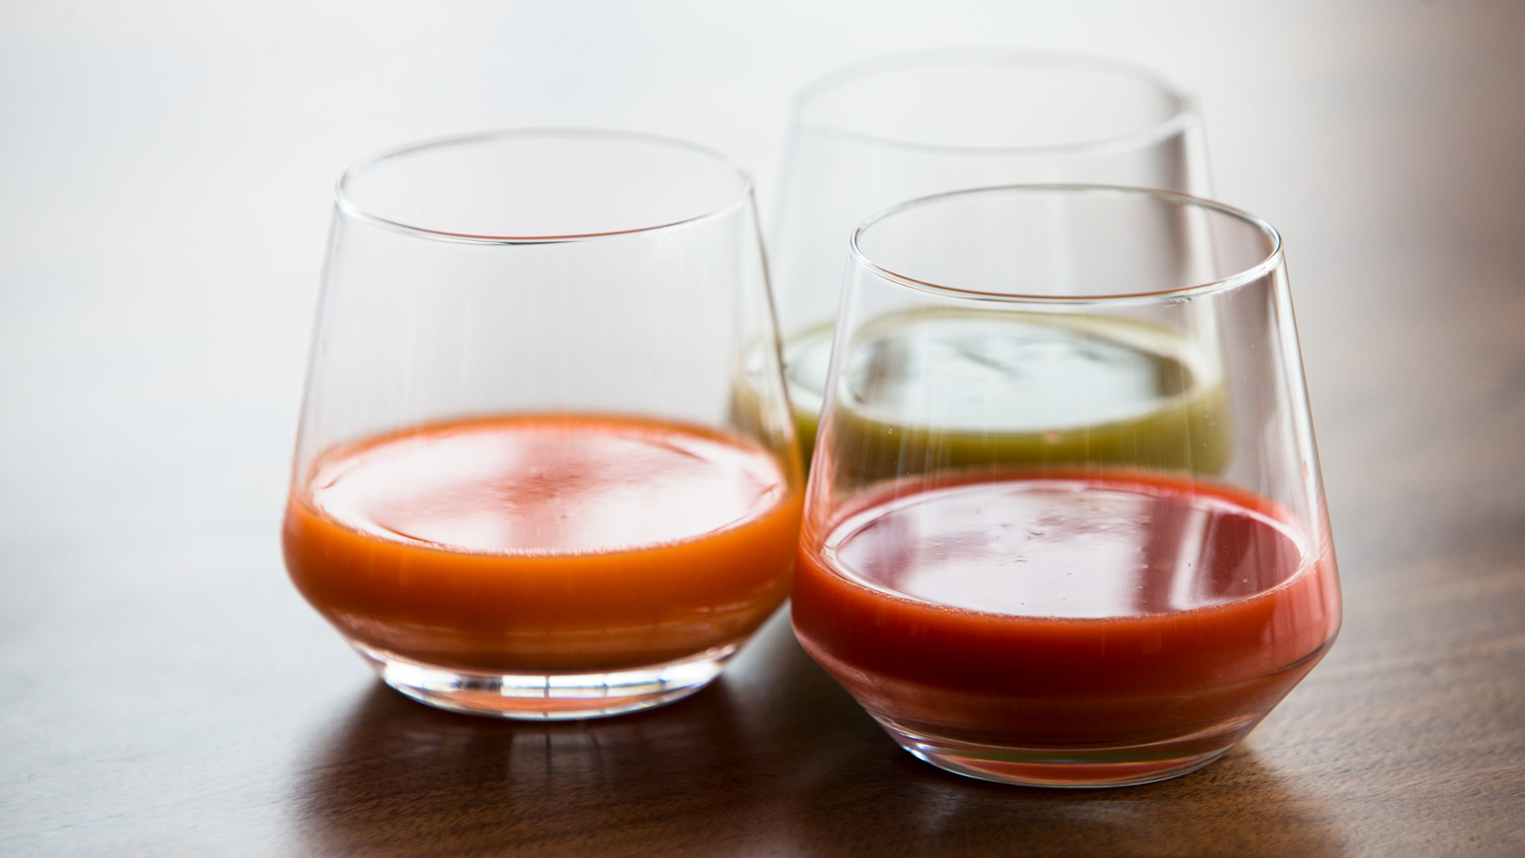
On June 10, 2017,
Four Seasons
Residence Club Aviara will be joining forces with other
Four Seasons
properties around the world to celebrate Global Wellness Day. Created to promote the importance of health, well-being and harmony between body and spirit, Global Wellness Day embodies the kind of spirit and lifestyle that is so prevalent in San Diego.
On this special Saturday, guests checking in to
Four Seasons
Residence Club Aviara will receive a special wellness amenity, and all guests on property will discover fun activities and offerings that will inspire lifestyle changes and a new outlook on their well-being.
Meditation with Bobbi Hamilton: Certified Yoga Teacher Bobbi Hamilton left her career as a medical researcher behind to promote holistic wellness and fitness among adults and children alike. Having turned to yoga to heal the spine and sports injuries she suffered as a Division 1 college athlete, Bobbi become a certified yoga teacher and lifelong devotee to meditation, yoga, and movement therapy.
Join Bobbi in the Yoga Pavilion for very special 60-minute session that will set one's intentions for Global Wellness Day.
- 9:00 am, complimentary
Kids Yoga with Bobbi Hamilton: As the creator of Chi Fresh Yoga Mats, Bobbi is committed to making fitness fun for kids. She will introduce young guests to a special 60-minute class in the Yoga Pavilion in which they will have fun stretching, breathing and learning to adopt a sense of calm and mindfulness.
- 11:00 am, class is complimentary, mats will be provided for the class
Wellness Menu: The culinary team at Seasons restaurant has created a special menu to celebrate Global Wellness. An à la carte brunch menu will feature healthful from 11:00 am to 2:00pm.
Spa Treatment: Driftwood Spa will be featuring the Himalayan Salt Stone Massage with a complimentary elixir on Global Wellness Day. This highly relaxing and re-mineralising massage utilises warm hand-carved salt stones from the Himalayan Mountains to help balance the central nervous system and nourish depleted cells. Guests will drift off into a state of deep relaxation.
- 50 minutes - USD 165, 80 minutes - USD 220
To join us in any of these events, call 800 828 4466.

RELATED

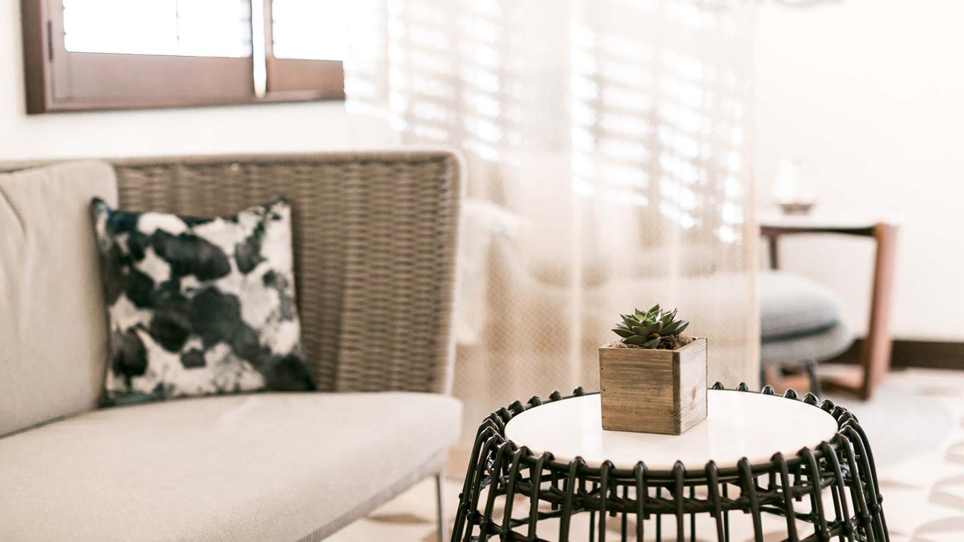 | January 24, 2017, San Diego, Aviara  Seasons Restaurant and Driftwood Spa Now Open at Four Seasons Residence Club Aviara  http://publish.url/northsandiego/hotel-news/2017/restaurant-and-spa-welcome-local-guests.html
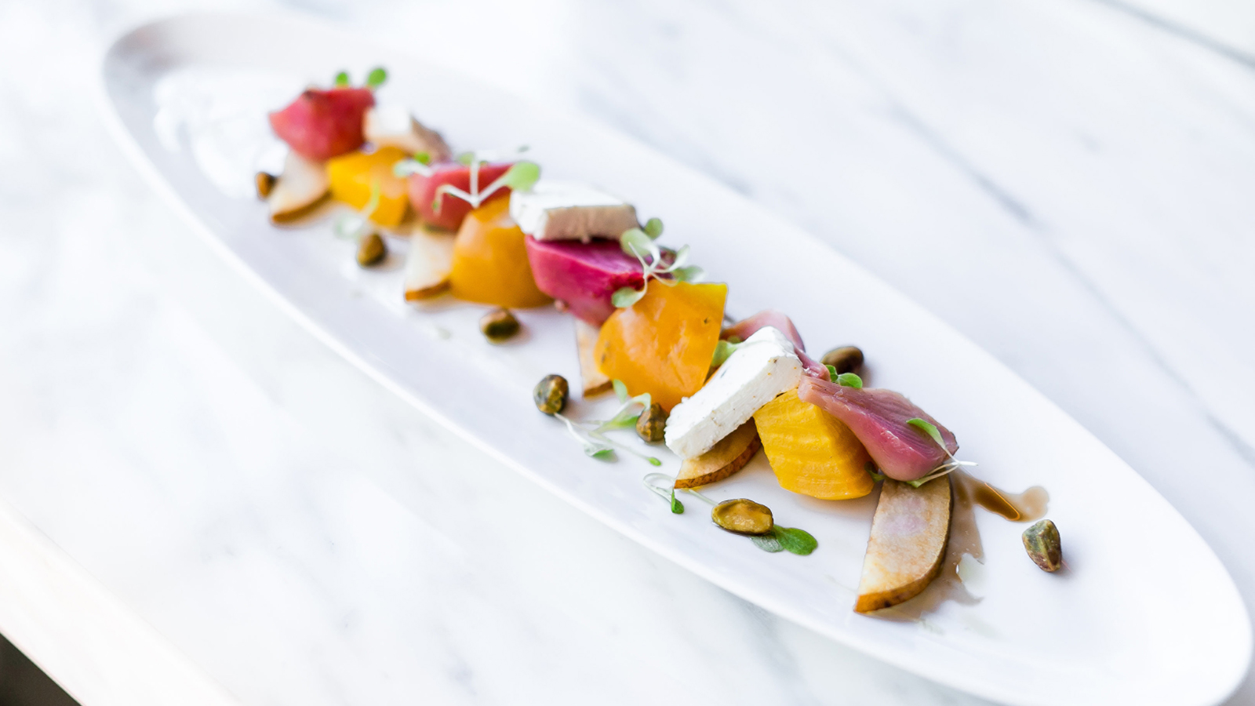 | October 26, 2016, San Diego, Aviara  New Seasonal Menu at Seasons Restaurant - Four Seasons Residence Club Aviara  http://publish.url/northsandiego/hotel-news/2016/fall-menus-at-seasons.html

PRESS CONTACTS

Jessica M. Roach
Director of Villa Sales and Marketing
7210 Blue Heron Place
Carlsbad
U.S.A.
jessica.roach@fourseasons.com

1 (760) 603-3739

