Songkran Delights at Far & East at Four Seasons Hotel Bengaluru

Special Thai delicacies to celebrate the New Year
April 7, 2021, Bengaluru, India

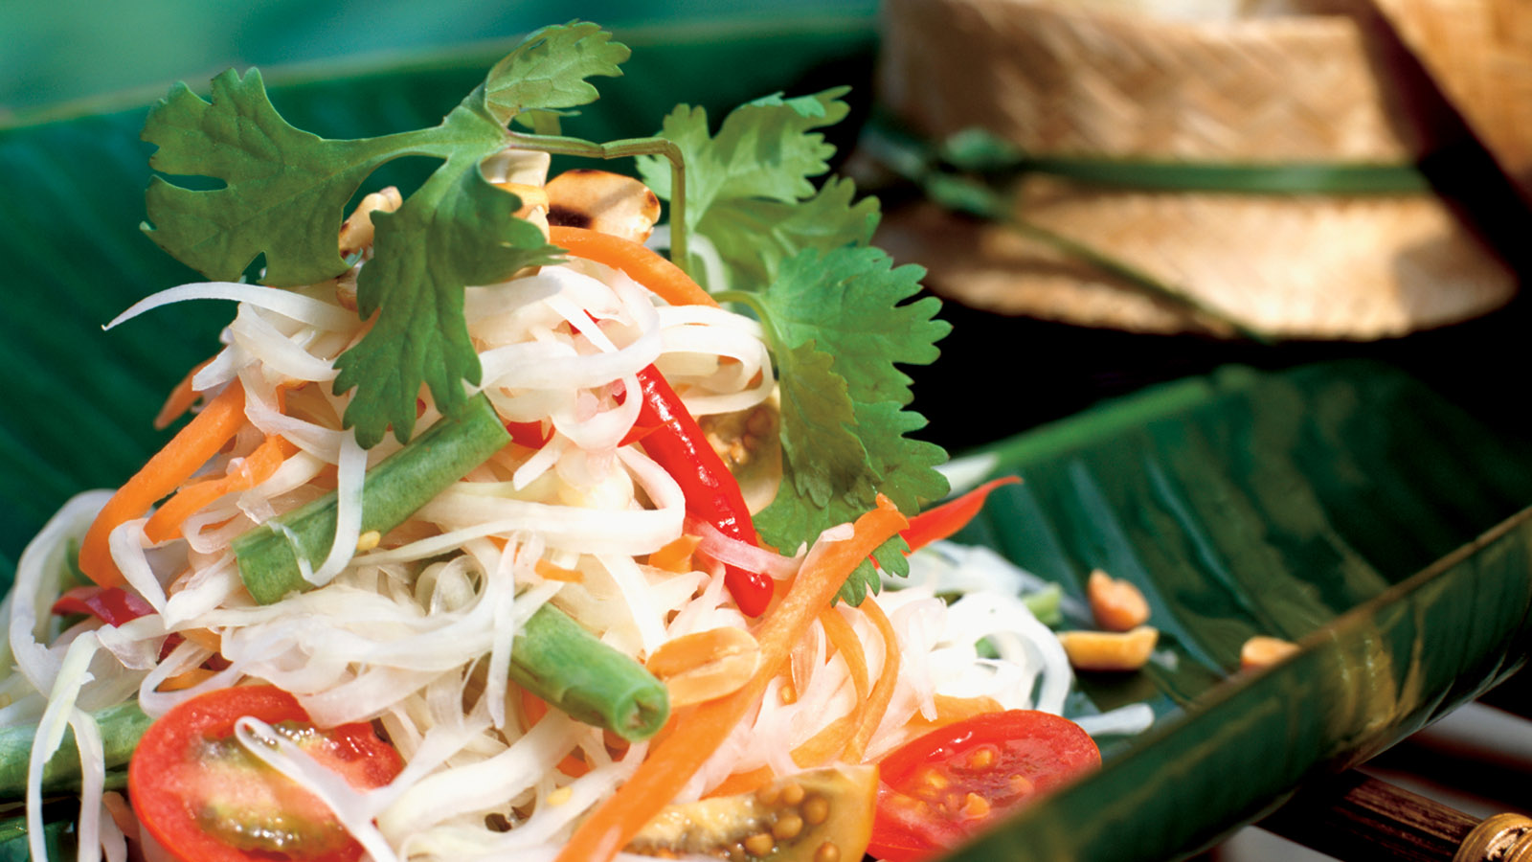
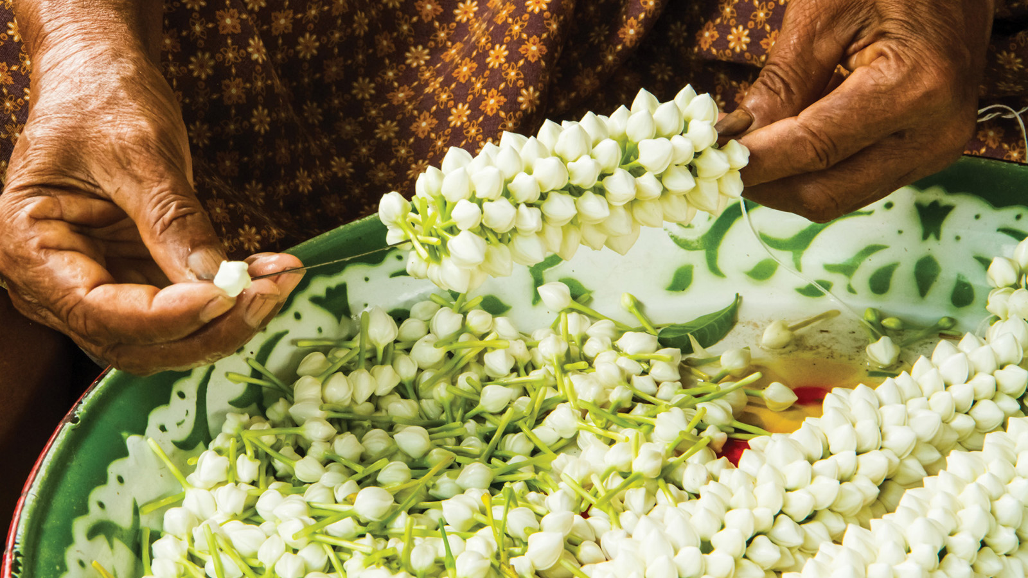 | 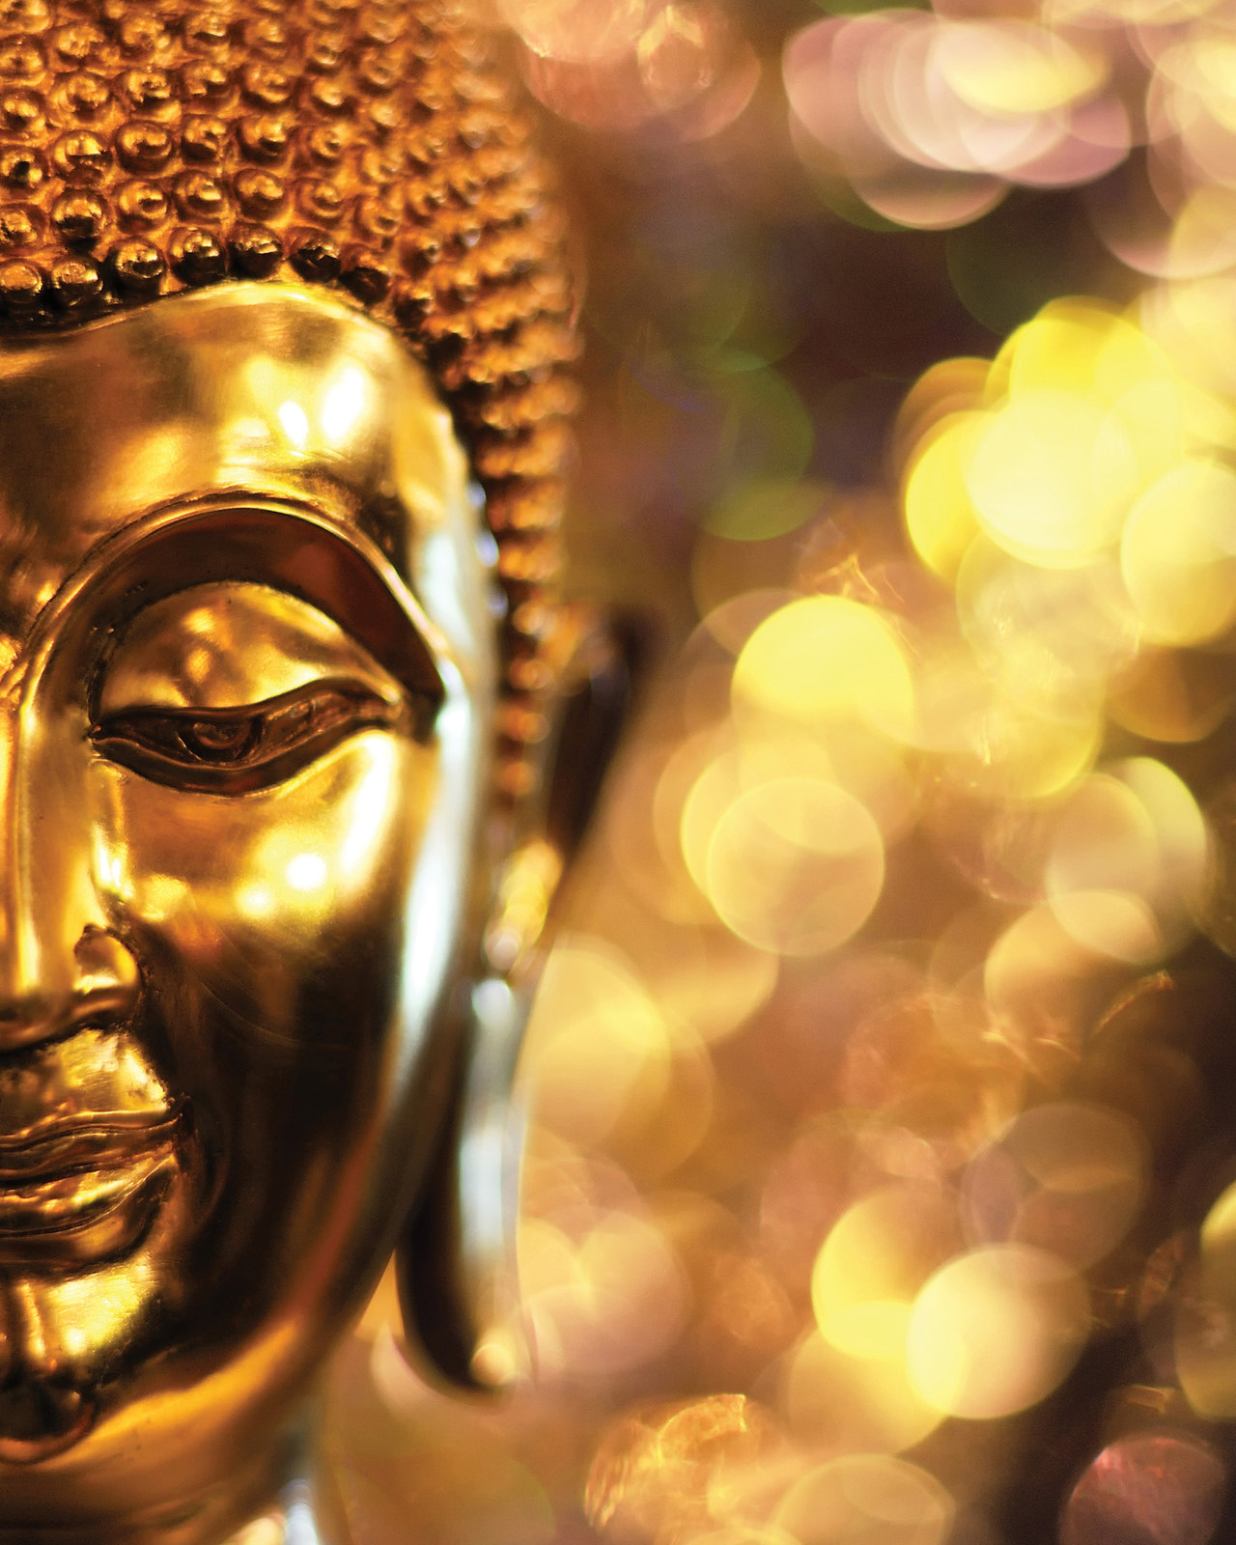 | 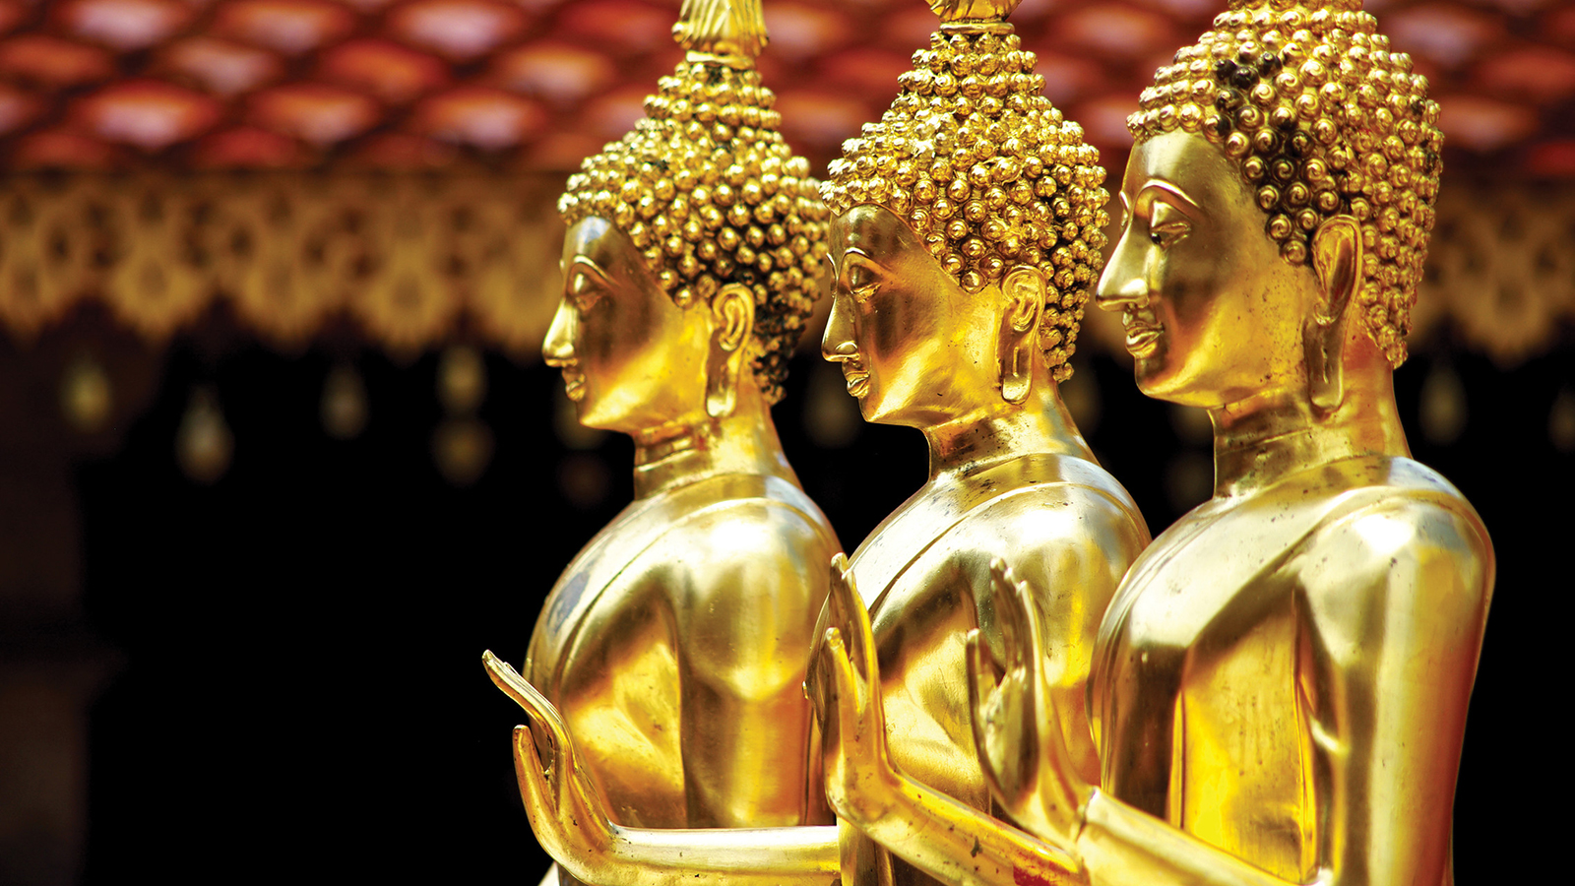
Just as the Hindu calendar starts around mid-April each year, Songkran is a celebration to mark the start of the Buddhist New Year, an adored holiday in Thailand. Also known as the “Water Splashing Festival,” Songkran sees multitudes of tourists too, who enjoy partaking in the festivities on streets.
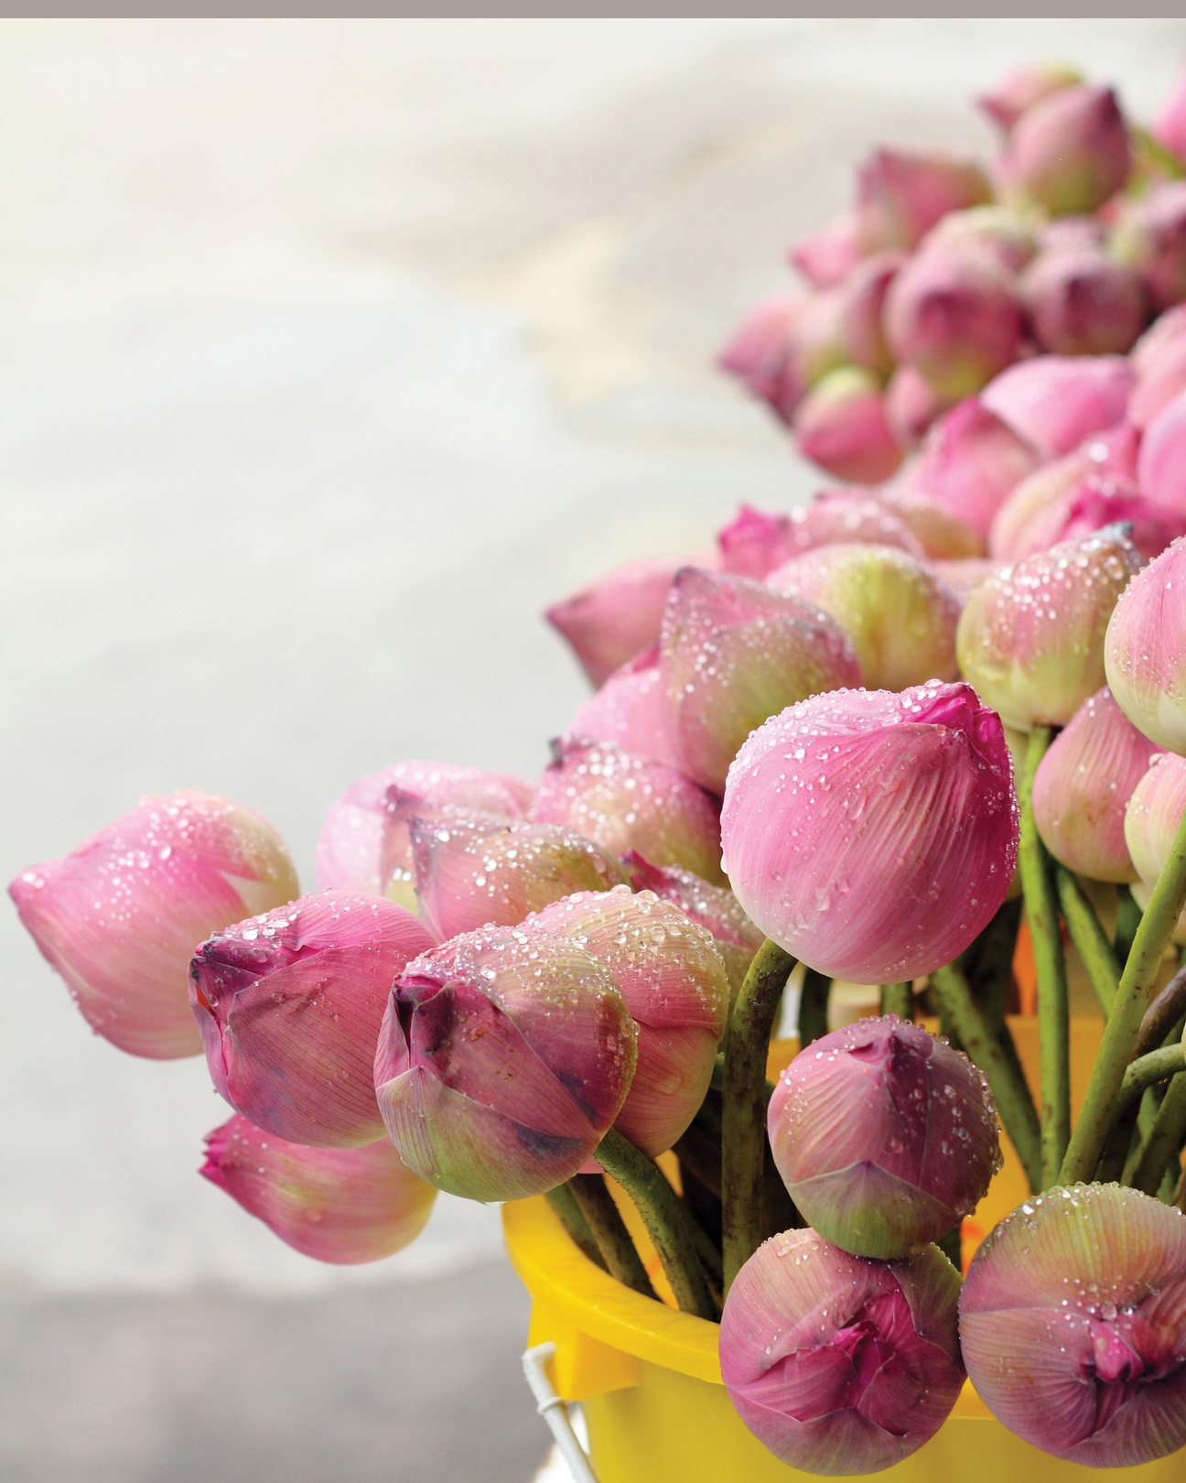 | 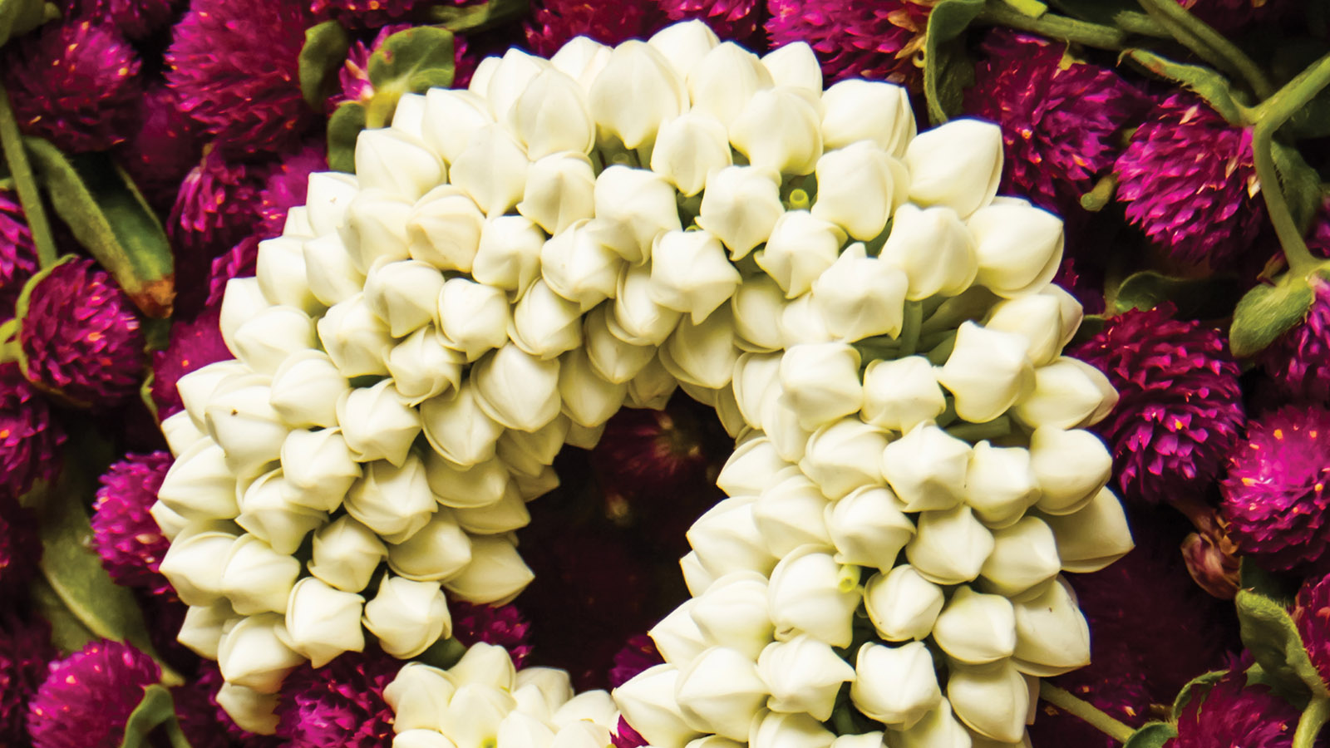 | 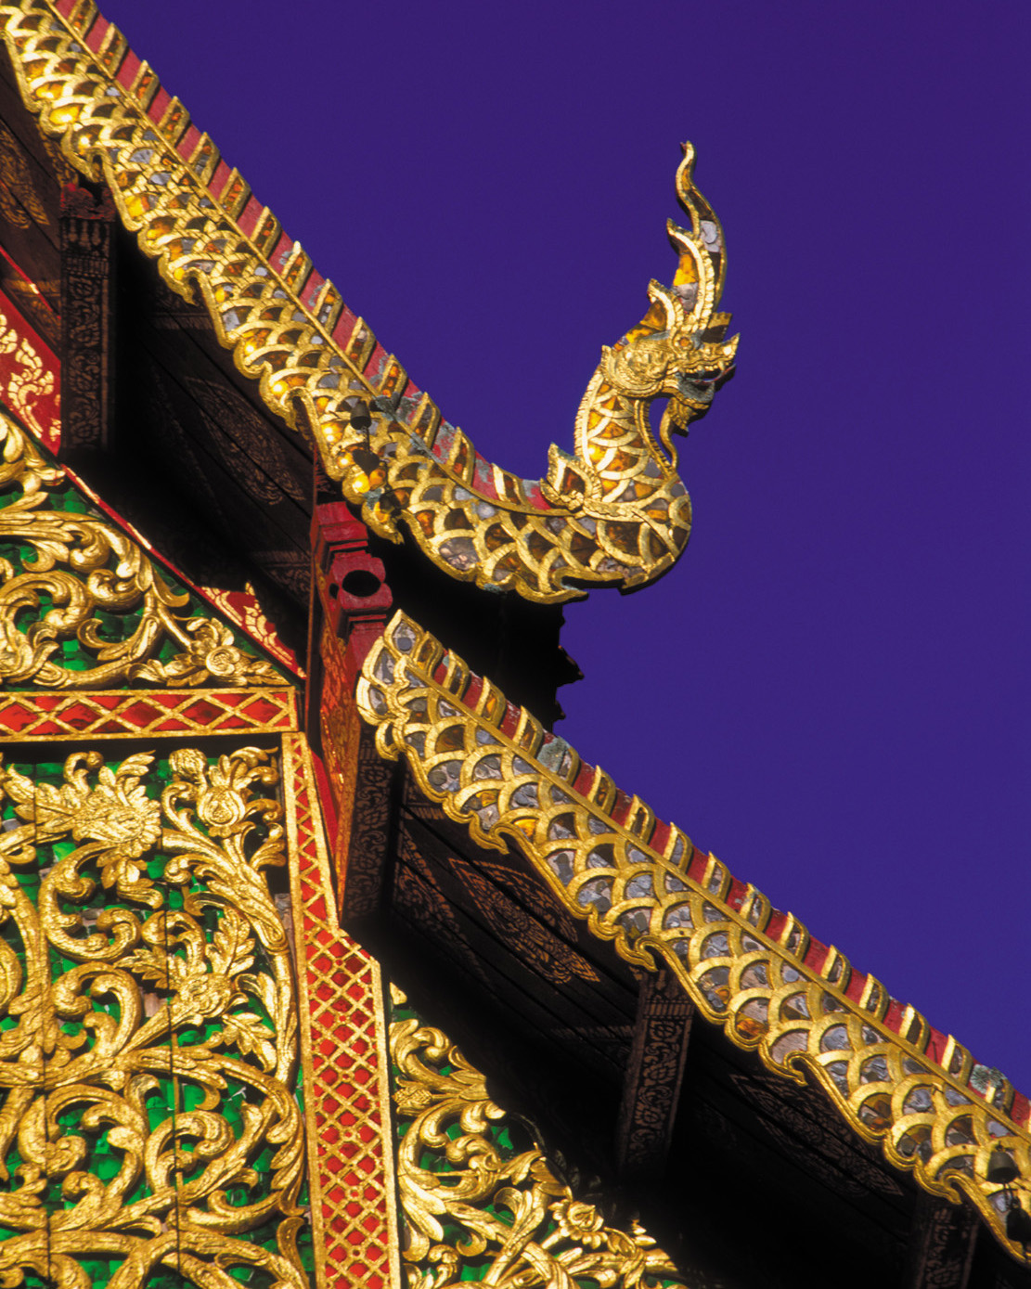
Known as Songkran, the first day of the festival, usually on April 13, is an exuberant celebration with processions of the Buddha, with thronging crowds joining in the merriment. Thai people also prepare themselves for the beginning of the New Year by cleaning their houses and Buddha idols are bathed and revered with offerings.
Though this year is not the same in terms of celebration and revelry, Far & East will showcase delectable Thai delicacies around the festival of Songkran.
Expect a crunchy som tam thod, which is a tempura fried green papaya and carrots with sweet and sour tamarind dressing; or yam wonsen, a flavoursome glass noodle salad to start the meal replete with the most mouth-watering Thai delicacies such as goong neung manao (steamed tiger prawns) or a massaman curry with fragrant spice undertones.
These delicious traditional eats will be available for Songkran for a limited period only.

RELATED

March 26, 2021, Bengaluru, India
Easter at Four Seasons Hotel Bengaluru
https://publish.url/bengaluru/hotel-news/2021/easter.html

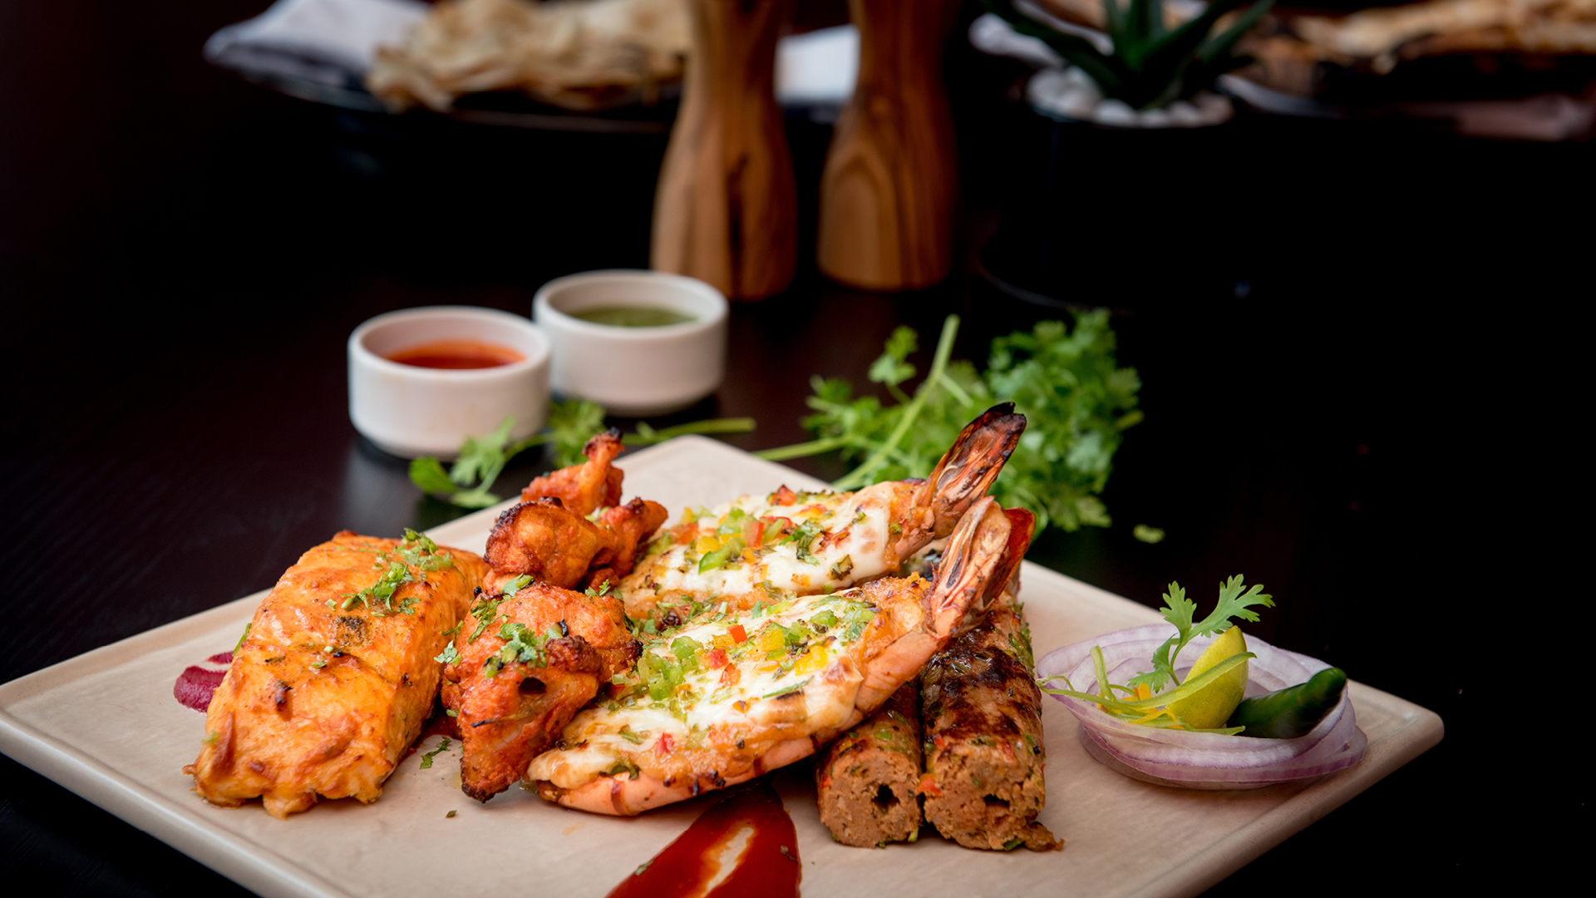 | March 12, 2021, Bengaluru, India  KBB Nights are Back at Four Seasons Hotel Bengaluru  https://publish.url/bengaluru/hotel-news/2021/kbb-nights-at-cur8.html

PRESS CONTACTS

Gargi Guha
Director of Public Relations
8, Bellary Road, Ganganagar
Bengaluru
India
gargi.guha@fourseasons.com

+91 80 4522 2222

