Peninsula Papagayo Hosts Second Annual Invitational Member-Guest Charity Golf Tournament at Four Seasons Resort Costa Rica with Global Ambassador and World Golf Hall of Famer Ernie Els

Guests to enjoy two unforgettable days of camaraderie and world class golf in one of Latin America’s most exclusive resort and club communities
January 21, 2020, Costa Rica

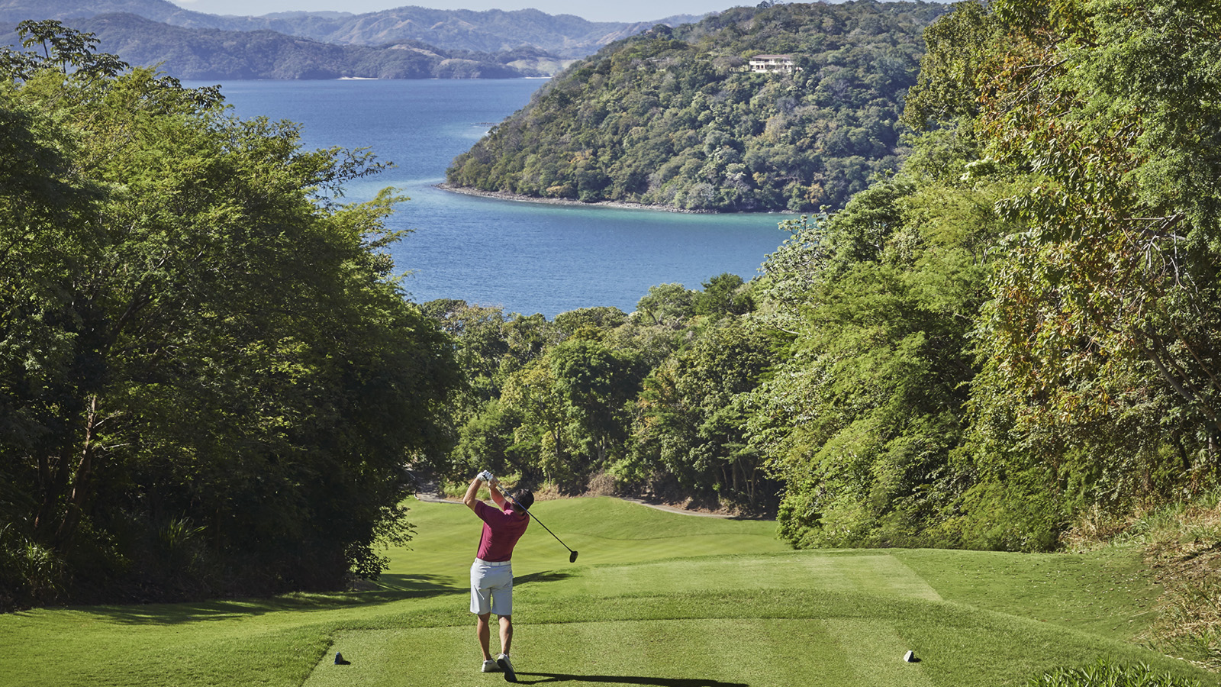
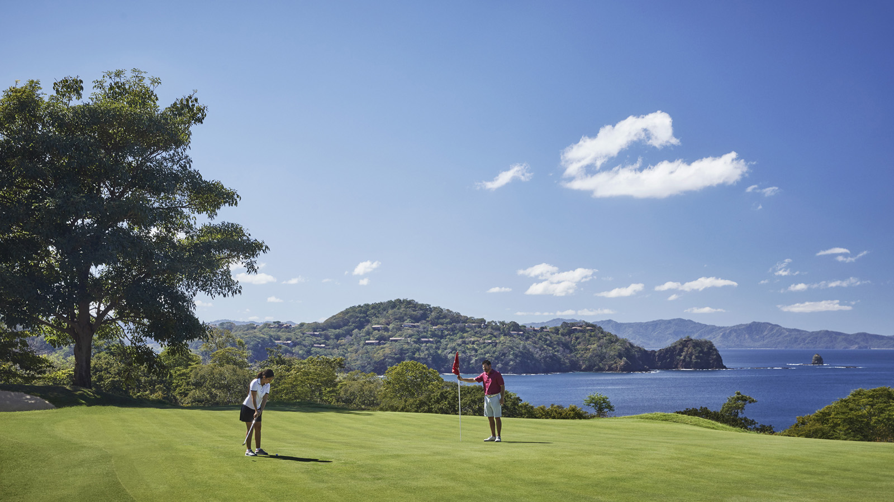 | 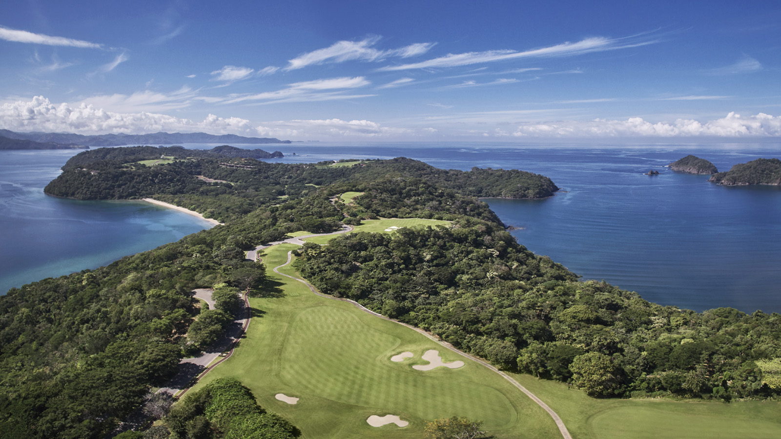
Latin America’s premier residential and resort destination, Peninsula Papagayo, announces its exclusive, second annual Invitational Member-Guest Charity Golf Tournament featuring the community’s global ambassador, four-time Major Champion and World Golf Hall of Famer Ernie Els. Taking place on January 23 and 24, 2020 at the signature Arnold Palmer-designed Ocean Course at Four Seasons Resort Costa Rica at Peninsula Papagayo, this marquee event will offer 18-holes of world class golf, exceptional dining experiences and signature activities with special guest Golf Channel anchor Todd Lewis as MC. Twenty-two teams of four will enjoy an elaborate awards gala dinner reception, a sunset cocktail event with an exciting “beat the pro” contest, an exclusive Ernie Els-hosted clinic with Q&A and more. Newly introduced this year, the one-hour, private golf clinic will allow guests rare direct access to Ernie Els for a once-in-a-lifetime chance to perfect their game with the world hall of famer. Open to owners and guests of Peninsula Papagayo, the second annual invitational member-guest tournament promises to be one of the year’s ultimate experiences.
Entry fees will be in the form of donations with 100 percent of funds raised going towards local Guanacaste non-profit Creciendo Juntos, in support of exciting new projects aimed at improving the quality of education and increasing student graduation rates at local Guardia High School.
“I am excited to be returning again to Peninsula Papagayo to support the wonderful initiative benefitting local schools in the area,” said Ernie Els. “This year’s new clinic will truly be a special event that I hope all guests will enjoy. I’m honoured to be a global brand ambassador for Peninsula Papagayo and look forward to continuing to celebrate such a beautiful and special place.”
Following donations from Peninsula Papagayo’s Invitational Member-Guest Charity Golf Tournament, Creciendo Juntos received USD 54,838.87, resulting in the implementation of a new water system to address health conditions and a new network infrastructure designed to facilitate improvements in school productivity. Enhancements were put into effect at the beginning of the 2019 school year.
“Due to donations from Peninsula Papagayo’s Invitational Member-Guest Charity Golf Tournament, the lives of hundreds of kids and their families living in the Guanacaste region are forever changed for the better,” said Elsa Bonilla of Creciendo Juntos. “We are thrilled to continue this important partnership with Peninsula Papagayo.”
Peninsula Papagayo’s Ocean Course offers the ultimate eco-golf experience with recurring vistas of white sand beaches, sparkling turquoise waters of the Pacific Ocean. The 18-hole, par-72 Arnold Palmer Signature course winds through lush forests, valleys and sea cliffs with glimpses of white-faced monkeys in the trees overhead. Against this serene backdrop, Peninsula Papagayo’s second annual Invitational Member-Guest Charity Golf Tournament will host more than 80 players made up of 20 paid teams of four including any combination of men, women and junior golfers.
Donations begin at USD 750 per person to benefit Creciendo Juntos. Entry fees include all green and cart fees, cocktail receptions on both Thursday and Friday evenings, breakfast on Friday, the prize presentation and gala dinner on Friday evening. The event is open to members of the Peninsula Papagayo Resort Community Master Association and invited guests including hotel guests staying at Four Seasons Resort Costa Rica.

RELATED

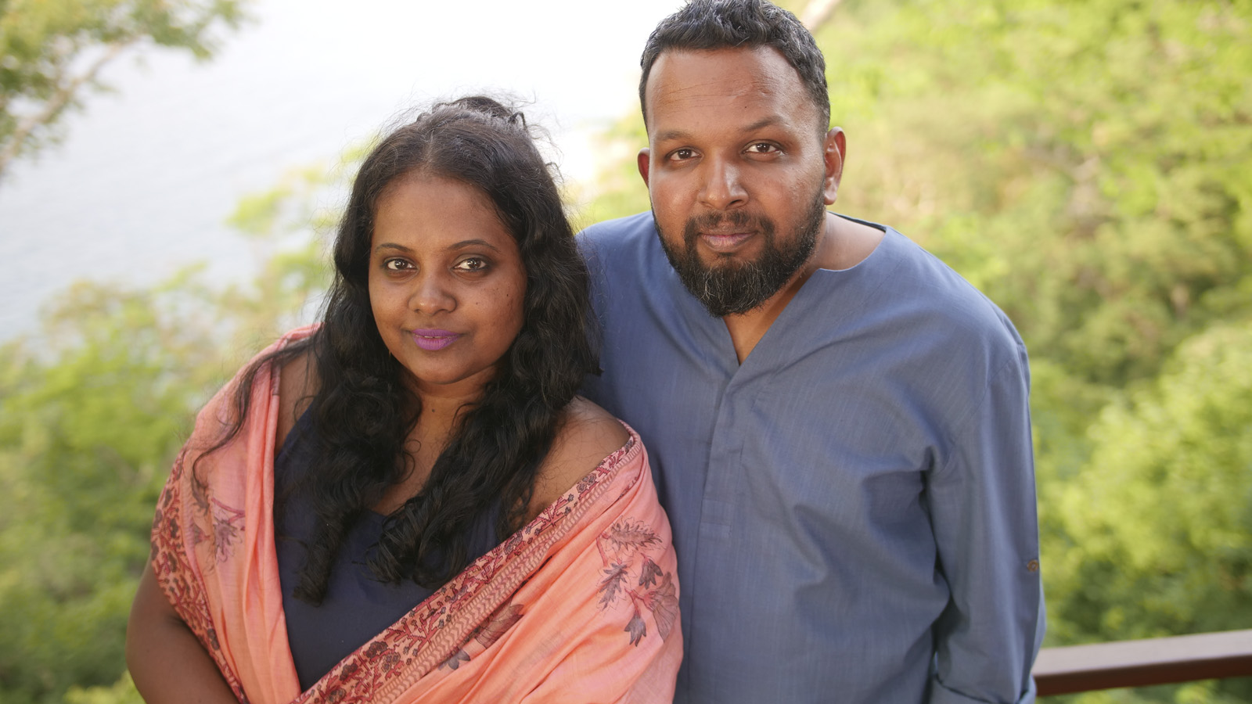 | November 12, 2019, Toronto, Canada  Four Seasons apresenta a Costa Rica em programa que revoluciona o relacionamento da marca com influenciadores  https://publish.url/news-releases/2019/envoy-by-four-seasons-hari-and-deepti-2.html
November 12, 2019, Toronto, Canada
新任“四季大使”——孟买艺术家Hari & Deepti用纸与光讲述故事
https://publish.url/news-releases/2019/envoy-by-four-seasons-hari-and-deepti-3.html

PRESS CONTACTS

Danielle Finnegan
Director of Public Relations
Peninsula Papagayo
Guanacaste
Costa Rica
danielle.finnegan@fourseasons.com

+1 (786) 655-9898

