Four Seasons Resort Punta Mita Celebrates Festive Season with Two Weeks of Culinary, Wellness, Art and Adventure Experiences for All Ages

Guests can enjoy unique seasonal programming including wellness activities, themed culinary menus, tequila blending, kids camping under the stars and more
November 27, 2019, Punta Mita, México

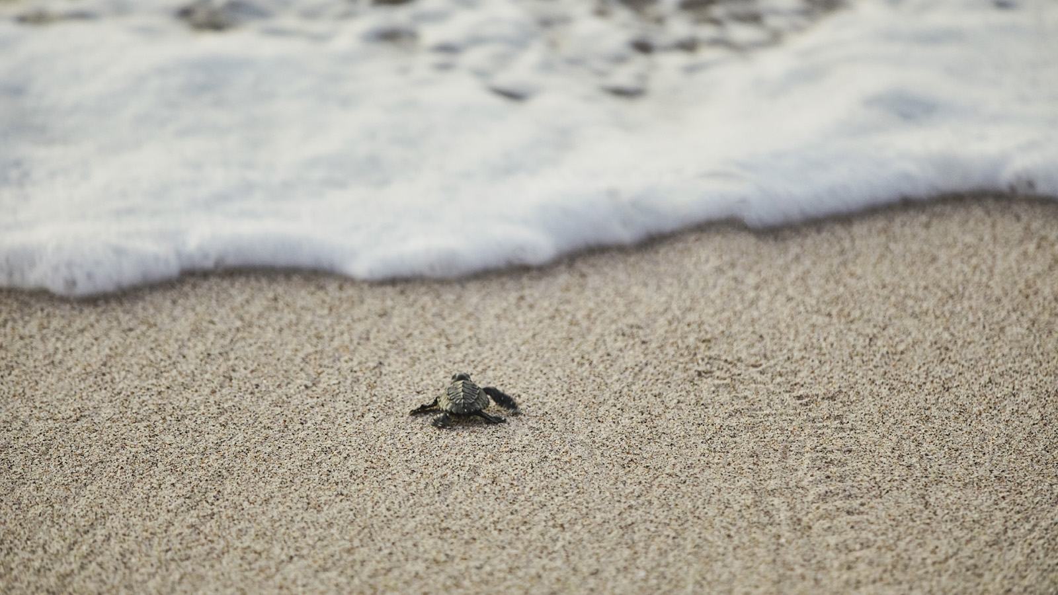 | 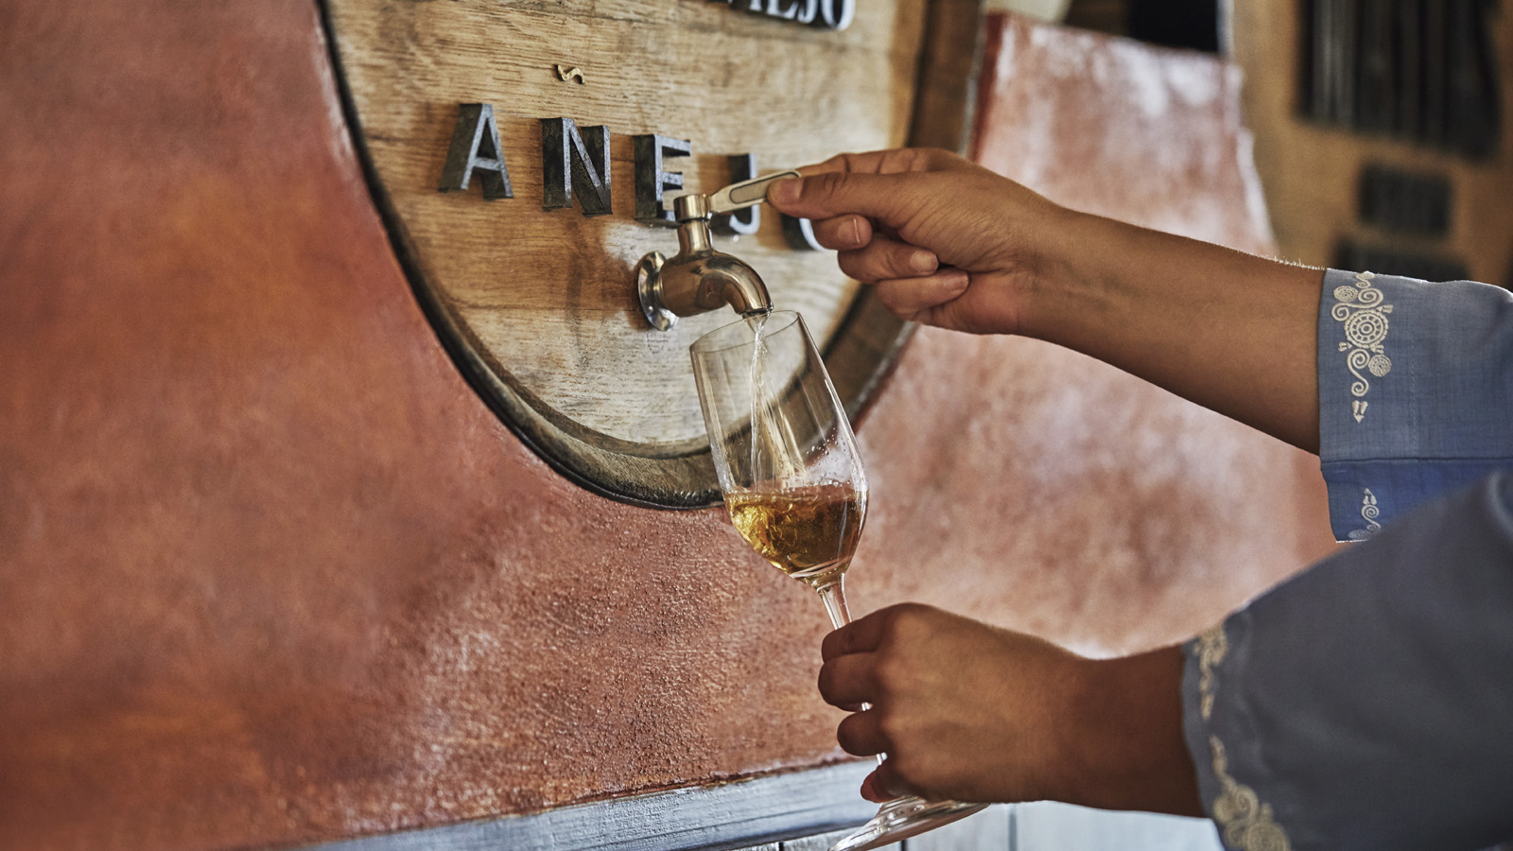 | 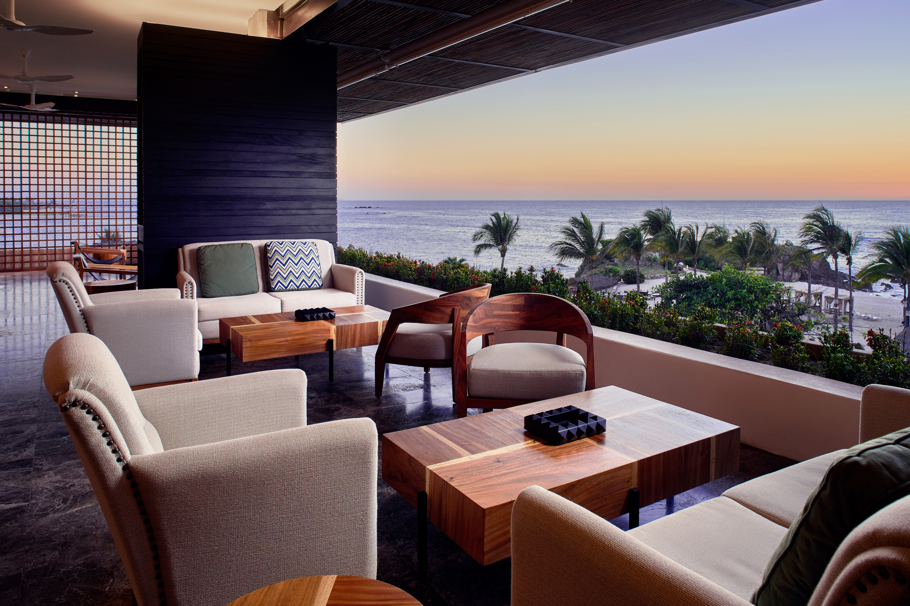
Four Seasons Resort Punta Mita, the five-star oceanfront resort tucked into the lush landscape of Banderas Bay in the Mexican Riviera Nayarit, will celebrate this year’s festive season with only-here holiday offerings for the whole family. Guests can enjoy a wide array of seasonal programming including health and wellness activities, cultural workshops, tequila blending, sea turtle release, and special holiday menus at all dining outlets.
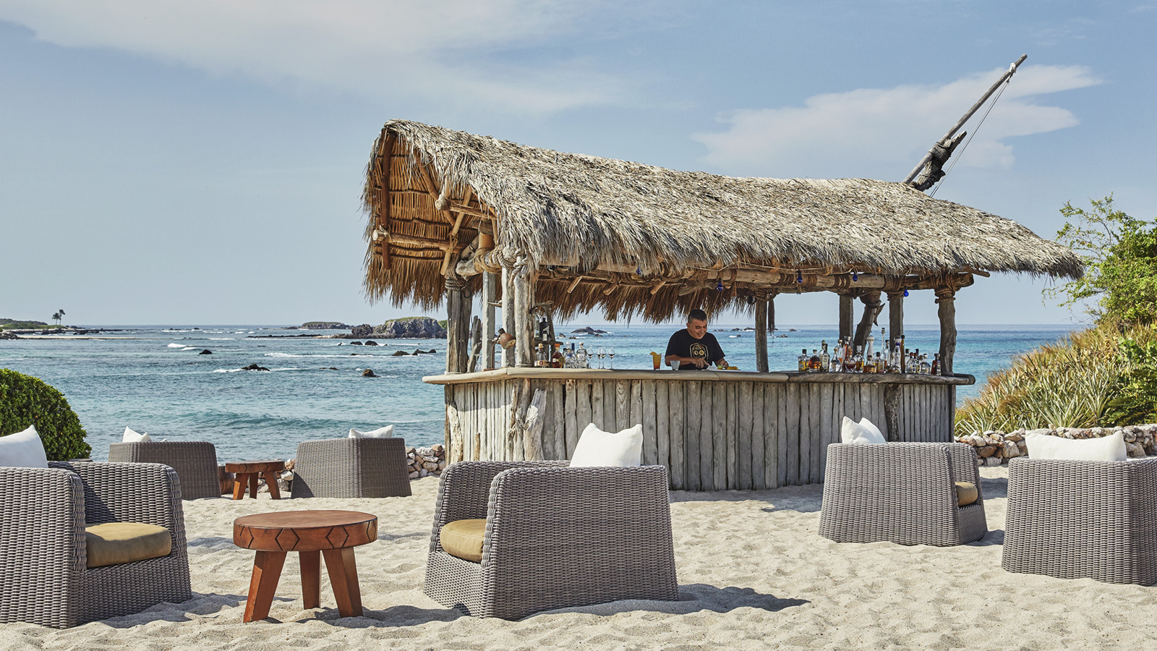 | 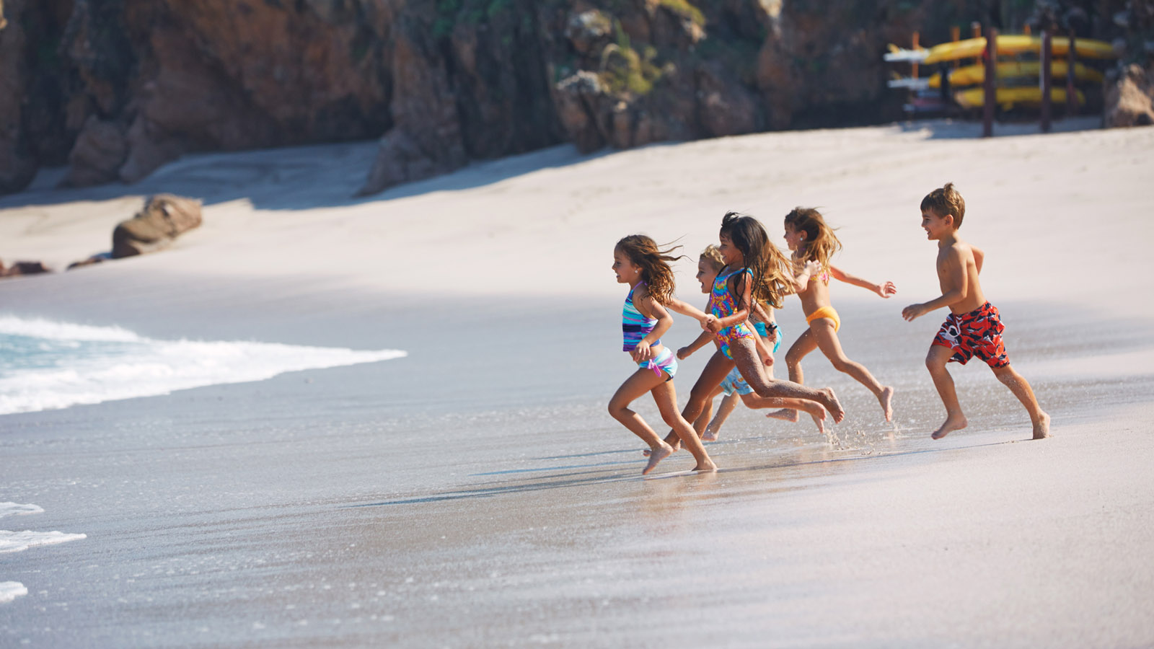 | 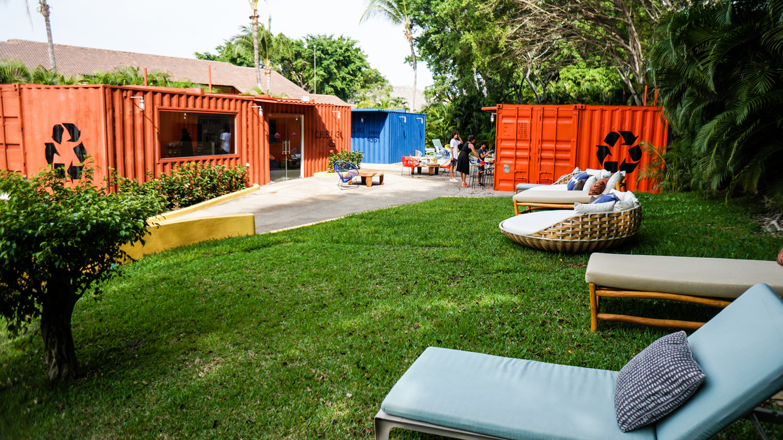
“We cannot wait to welcome new and returning guests to our beachfront paradise this holiday season,” says John O’Sullivan, General Manager, Four Seasons Resort Punta Mita. “We look forward to sharing our festive programming, curated experiences and beloved holiday traditions inspired by the magic of Punta Mita.”
Four Seasons Resort Punta Mita festive season highlights include:
Health and Wellness Activities
Guests can enrich their spirit with mind-body-soul experiences ranging from a chakra balancing ritual that uses Tibetan bowls, precious stones and carefully selected essential oils to a yin yang yoga class that combines a yoga lesson with Chi Kung, Tai-Chi and other martial arts while atop a platform on a rock overlooking the ocean.
Sea Turtle Release
Led by the Resort’s cultural concierge Enrique Alejos, this once-in-a-lifetime experience begins with a brief overview of turtle biology followed by an interactive experience on a nearby beach where guests are given baby sea turtles to place on the sand and watch as they make their way home.
Tequila Blending
Guests can feel like a real tequila master and learn how to blend flavours and aromas to create a customised concoction in a blending session led by the Resort’s certified tequila master. The final tequila blend is bottled, lacquered, signed and registered, creating a one-of-a-kind souvenir for guests to take home.
DJ Nights and Live Cuban Music
DJs will set the tone for guests to enjoy a dynamic beach atmosphere with the hottest tunes while lounging and sipping innovative craft cocktails at Dos Catrinas, the Resort’s newest signature dining destination. Additionally, guests can enjoy live Cuban music every night at Aramara Restaurant.
Themed Culinary Menus
Guests can indulge in an array of themed culinary menus and events such as a pozole night, enchilada night, ramen night, roving taco and cocktail carts, and a festive rum bar at Shack Bar.
Cultural Programming
Immersive guest experiences include dream catcher making; a sandal making experience; salsa classes; Spanish lessons and mezcal bingo.
Culinary, Arts and Adventure Experiences for Teens and Kids
Kids of all ages can delight in fun and festive activities including arts and crafts, cooking classes, pajama parties and a special New Year’s Eve show. Young adults will be able to take advantage of the Resort’s teen centre, The Container, which offers simulator games, air hockey, a movie theatre, and more.
Kids’ Camping Under the Stars
Kids can take part in a one-of-a-kind sleepover and camp underneath the stars on Las Cuevas Beach. Kids will spend the evening sleeping in tents suspended from palm trees for a truly unforgettable experience. The night’s festivities include dinner, games, and stargazing by night and breakfast the following morning.
Beach Bonfires and New Year’s Eve Celebration at Las Cuevas Beach
Guests can cosy up to a roaring fire overlooking the ocean with family and friends and spend an evening under Punta Mita's starry skies. On New Year’s Eve, guests can ring in the New Year and start of the decade with a special beachfront celebration featuring different culinary flavours from all around Mexico.
Festive season experiences at Four Seasons Resort Punta Mita will be available from December 20, 2019 through January 4, 2020. Guests can now stay in the Resort’s newly redesigned contemporary guest rooms inspired by the natural wonders of the vibrant destinations. For reservations, contact your travel advisor, call the Resort +52 (329) 291-6000 or book online.

RELATED

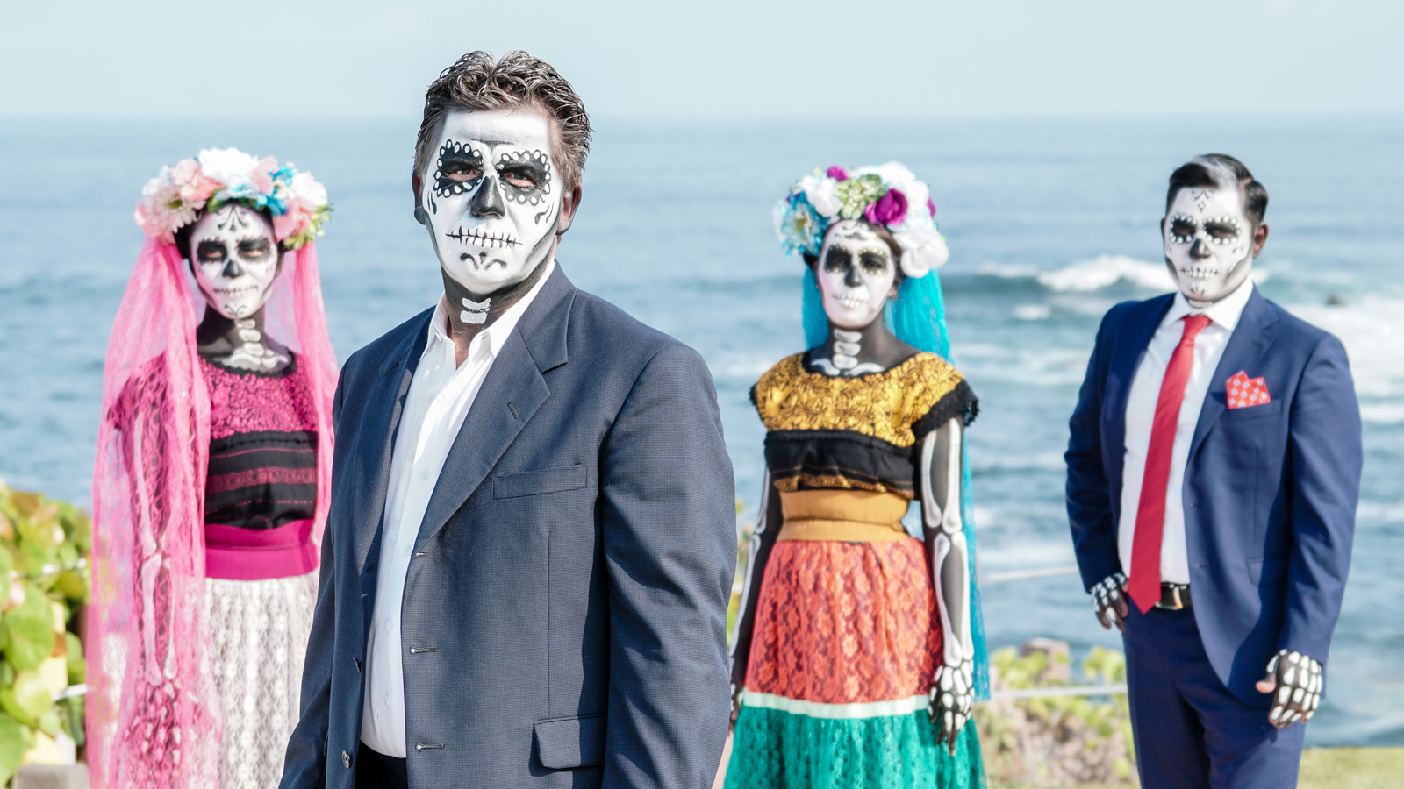 | October 3, 2019, Punta Mita, México  Four Seasons Resort Punta Mita Celebrates Día de Los Muertos with “Catrinas Fest” Culinary Weekend  https://publish.url/puntamita/hotel-news/2019/catrinas-fest-culinary-weekend.html
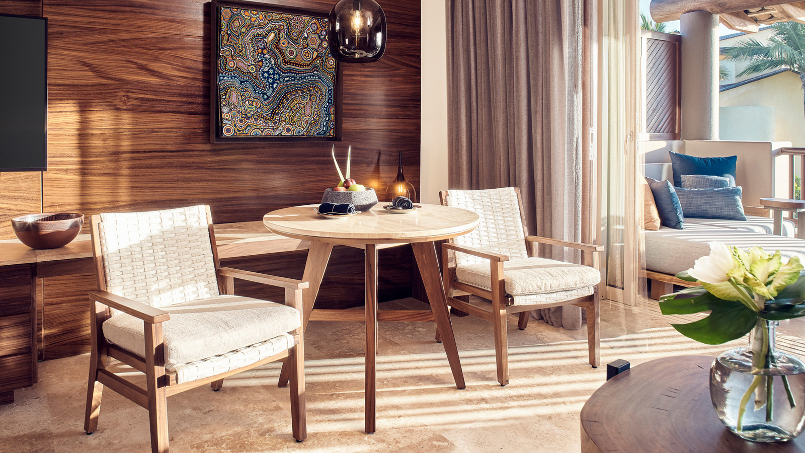 | September 16, 2019, Punta Mita, México  Four Seasons Resort Punta Mita Debuts Redesigned Contemporary Guest Rooms as Final Phase of Multi-Year, Multi-Millions Dollar Resort Transformation  https://publish.url/puntamita/hotel-news/2019/renovated-guest-rooms.html

PRESS CONTACTS

Miguel Peregrina
Director of Public Relations
Punta Mita, Bahia de Banderas
Nayarit
Mexico
miguel.peregrina@fourseasons.com

+52 329 29160000

Kimi Ozawa
Murphy O'Brien PR
11444 Olympic Boulevard, Suite 600
Los Angeles
U.S.A.
fspuntamita@murphyobrien.com

+1 (310) 586-7138

