Restart 2020 with a Staycation at Four Seasons Hotel Kuala Lumpur

Special moments at a luxurious urban sanctuary, close to home
May 19, 2020, Kuala Lumpur, Malaysia

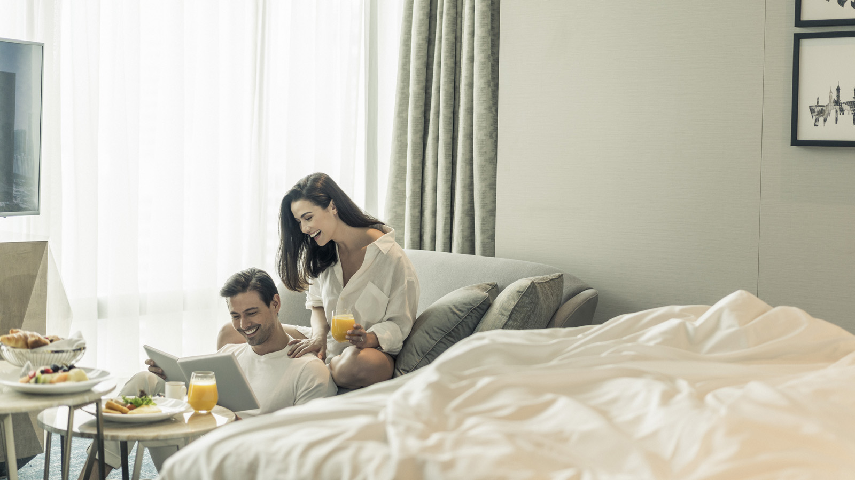
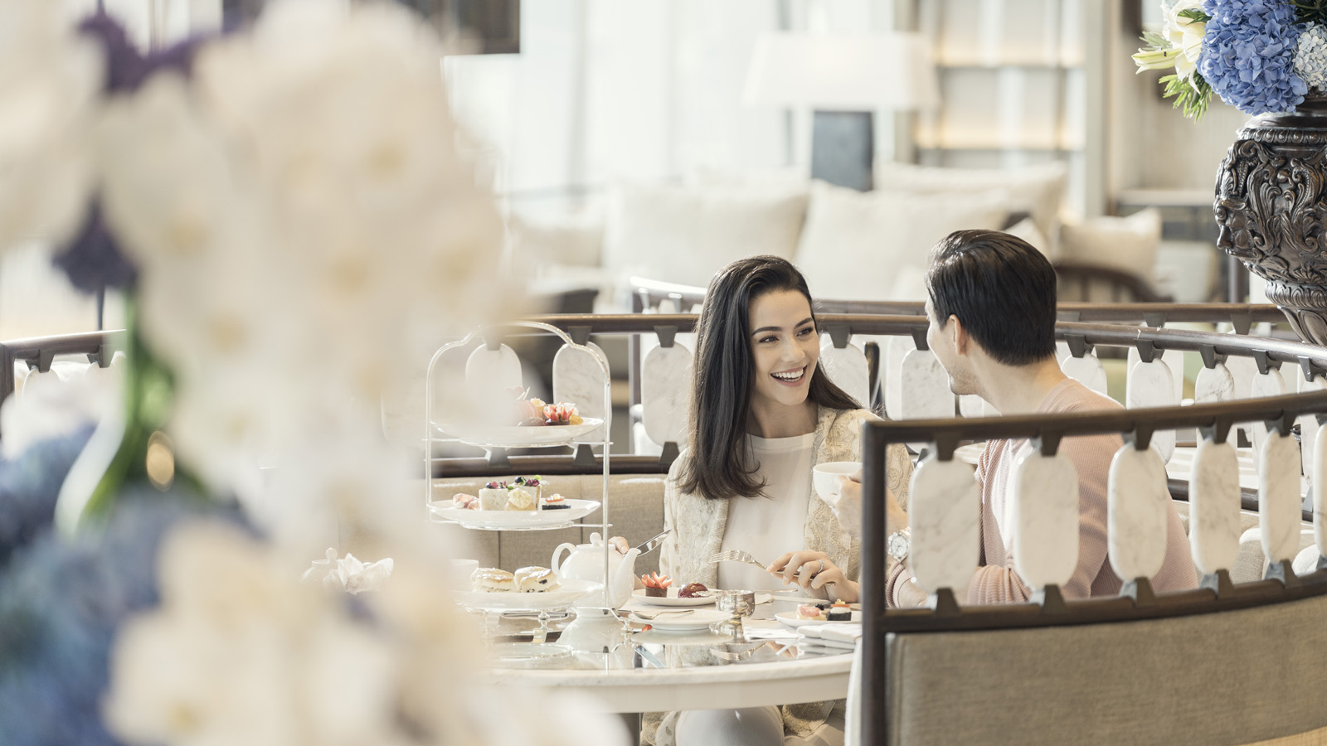 | 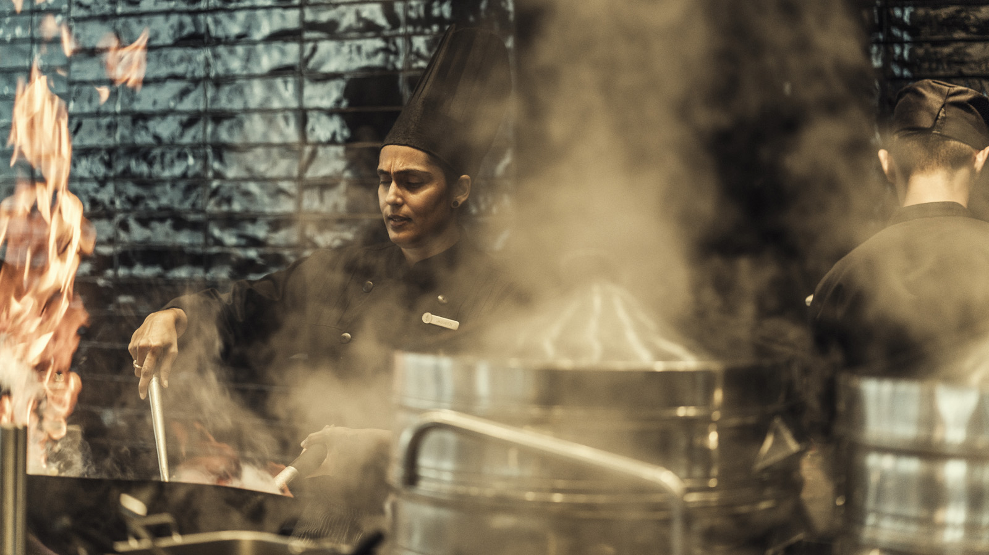 | 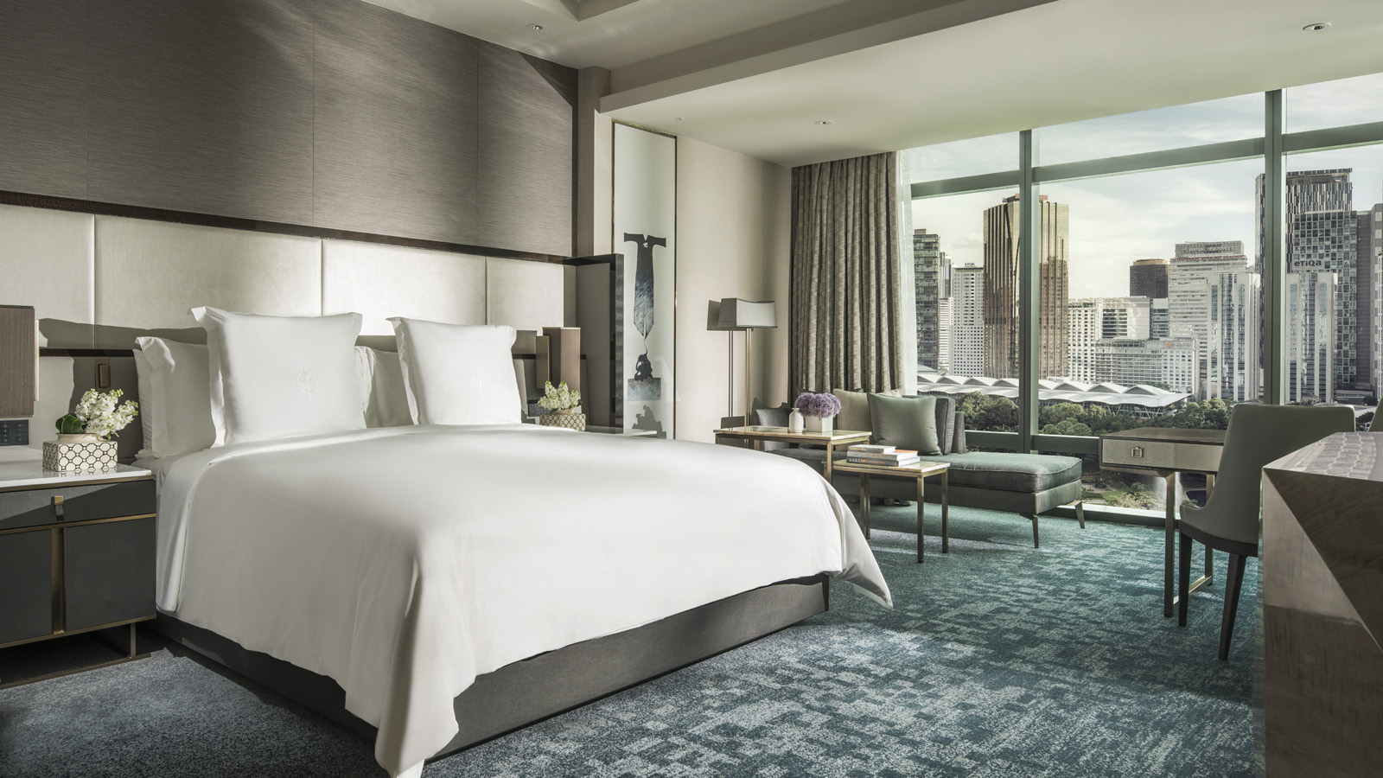
During these times, taking a pause from the daily routine of the past few months is a well-deserved luxury. With the launch of its new staycation package, Four Seasons Hotel Kuala Lumpur offers KL residents a welcome change of scene – without needing to venture far from home. While guests unwind, rejuvenate and cherish special moments with loved ones, Four Seasons takes care of everything else.
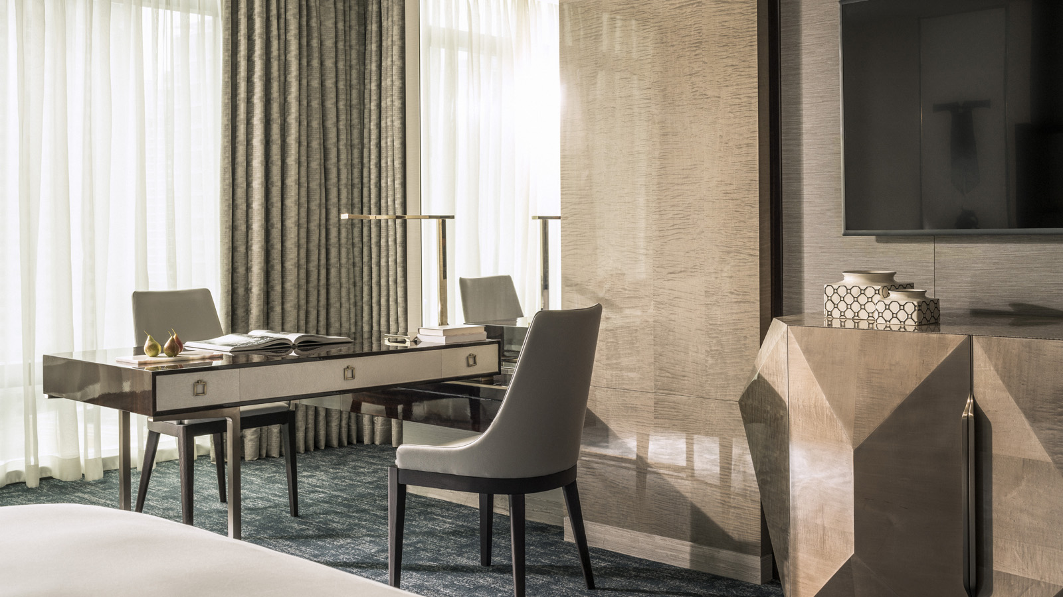 | 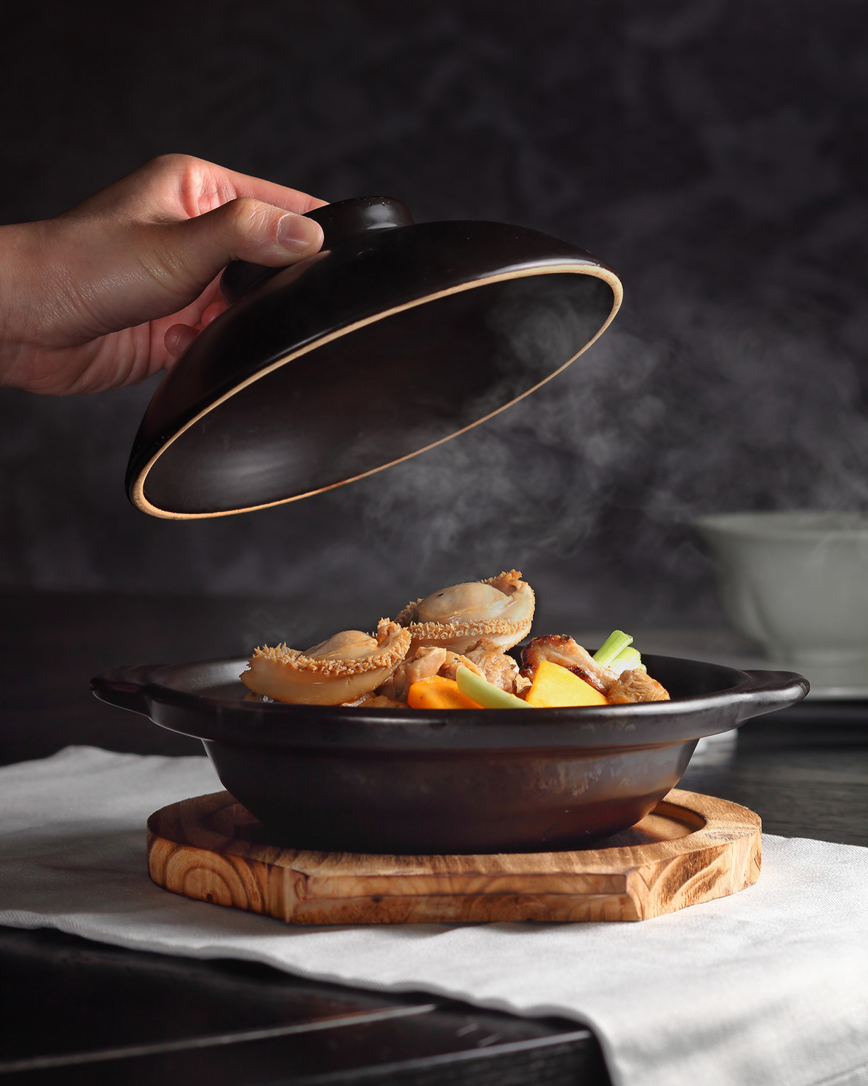
Restart 2020 package
Residents of Kuala Lumpur enjoy 20 percent savings on the room rate, daily breakfast for two, and 15 percent savings on dining.
With floor-to-ceiling views of the city, pool or park, the Hotel’s airy, beautifully-appointed rooms offer a refreshing getaway. Answer emails at the work desk, read on the window-side lounger or take a restful nap on the custom Four Seasons bed. The Pool Garden-View Room features views of the tropical pool terrace, while the Premier Park-View Room overlooks the lush greenery of KLCC Park – ideal for some socially-distanced nature therapy.
For a true "home away from home" experience, reserve one of the stylish, light-filled suites. With separate sleeping, living and dining areas, these generously-sized accommodations have the space and privacy that matter most for families.
Guests can book their staycation here, or email res.kualalumpur@fourseasons.com for more information.
The World on a Plate
Globetrotting may not be possible just yet, but diners at Four Seasons can now travel around the world through tastes and flavours. Curate presents an array of international specialties in a safe and hygienic environment, from authentic pastas and crafted burgers to gourmet dim sum and festive Malaysian delights.
As Executive Chef Junious Dickerson notes, “We’re taking our guests on an exciting culinary adventure, right here in the heart of Kuala Lumpur.”
Curate is open all day for a la carte dining.
Restore Wellbeing
Recent lifestyle restrictions have taken a toll on all facets of wellbeing, from physical fitness to skin vitality. Begin the journey back to optimum health with special offers from Four Seasons.
Guests can pre-buy savings vouchers for treatments at the Spa and personal training sessions at the gym, available for redemption as per health and safety guidance of the local authorities.
Spa Packages
Revitalise skin and ease muscle tension with bespoke Spa treatments. With experienced and caring Four Seasons therapists, guests are in excellent hands.
- Package 1: Any three 90-minute facial treatments, with one complimentary 90-minute massage (MYR 1519 nett)
- Package 2: Any five 90-minute body massages, with two complimentary 90-minute massages sessions (MYR 2199 nett)
- Package 3: Five Sport Remedial/Deep Tissue massages and five personal training sessions, with two complimentary personal training sessions (MYR 2579 nett)
Fitness Packages
Achieve personal fitness goals through one-on-one sessions with certified trainers. Workouts can also be arranged at an approved outdoor venue without any additional charges.
- Package 1: Four one-hour personal training sessions (MYR 450 nett)
- Package 2: Six one-hour personal training sessions (MYR 600 nett)
- Package 3: Thirteen one-hour personal training sessions (MYR 1050 nett)
All packages come with a 20 percent savings on food and beverages (excluding alcohol) and all-day access to the pool and other facilities, including the steam, sauna and shower rooms. Valid for six months (fitness packages) and one year (spa packages) from purchase.
Email spa.kualalumpur@fourseasons.com for more information.
Lead With Care
Four Seasons is proud to introduce Lead With Care, an enhanced global health and safety program that is being implemented at Four Seasons properties worldwide. To learn more about Lead With Care, click here.
As Four Seasons Hotel Kuala Lumpur welcomes guests back, the entire team is committed to ensuring the highest standards of health and hygiene, without compromising the quality of the guest experience.

RELATED

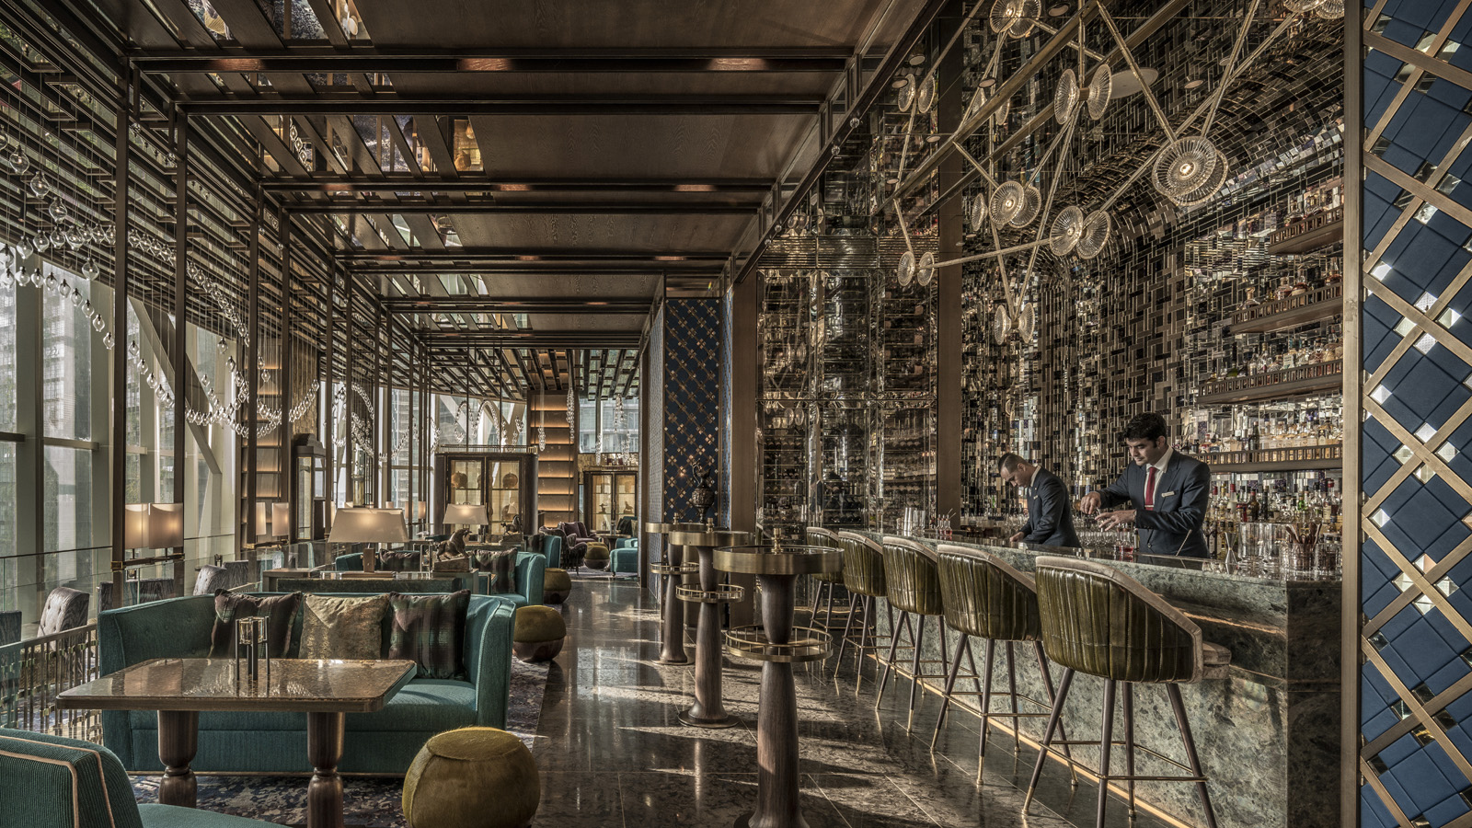 | May 14, 2020, Kuala Lumpur, Malaysia  Drumroll, Please! Bar Trigona at Four Seasons Hotel Kuala Lumpur Tops the Malaysian Entry in Asia’s 50 Best Bars 2020  https://publish.url/kualalumpur/hotel-news/2020/asias-50-best-bars.html
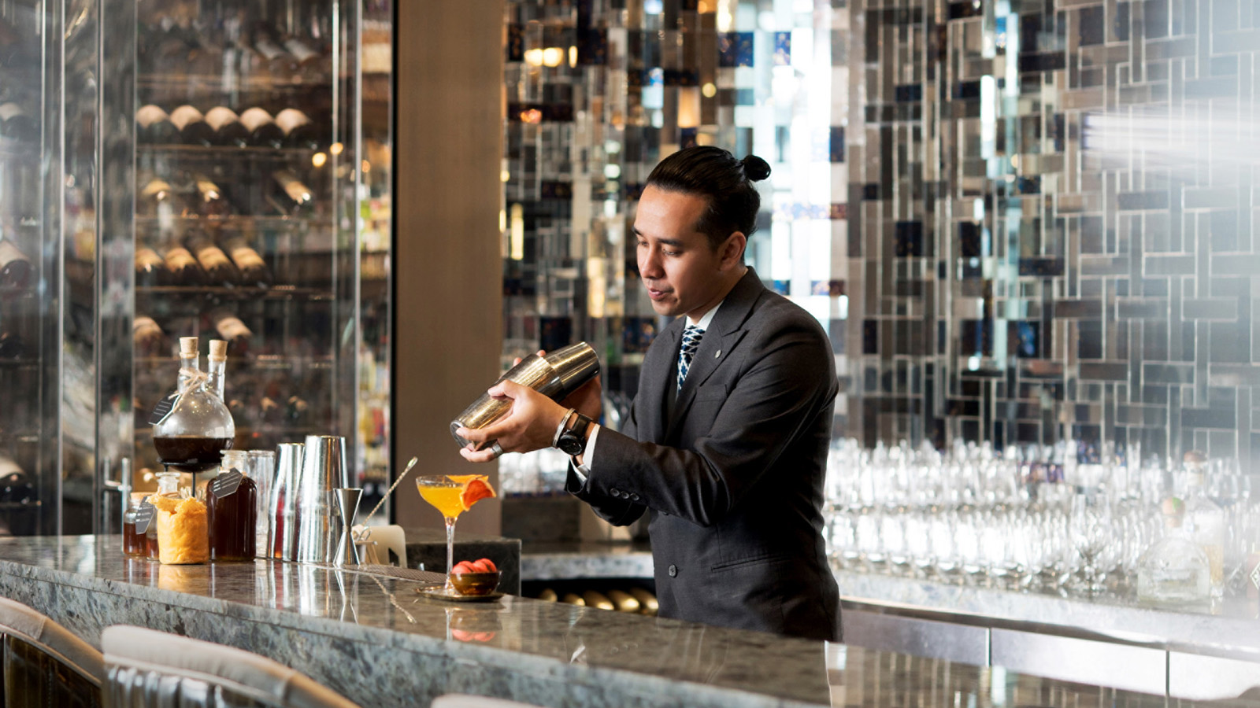 | May 12, 2020, Kuala Lumpur, Malaysia  Inspirations to Take Home, by Four Seasons Hotel Kuala Lumpur  https://publish.url/kualalumpur/hotel-news/2020/at-home-experiences.html

PRESS CONTACTS

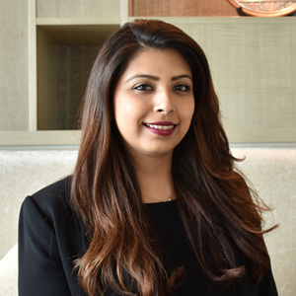 | Kanchana Ganglani  Director of Public Relations  145 Jalan Ampang  Kuala Lumpur  Malaysia  kanchana.ganglani@fourseasons.com  +6(03) 2382 8740

