DJ Re:Flex Brings Latin Vibes with “Viva Cuba!” New Year’s Eve Countdown Party at Four Seasons Hotel Hong Kong

November 14, 2017, Hong Kong, China

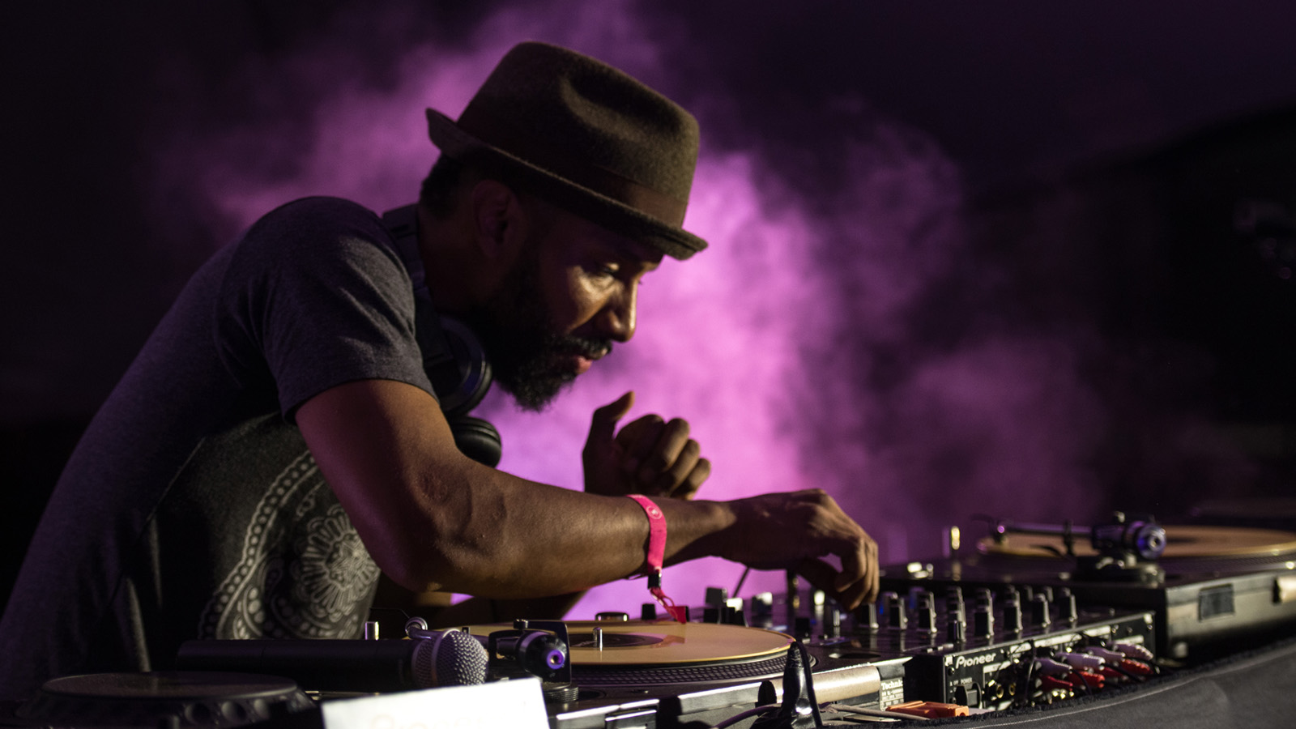 | 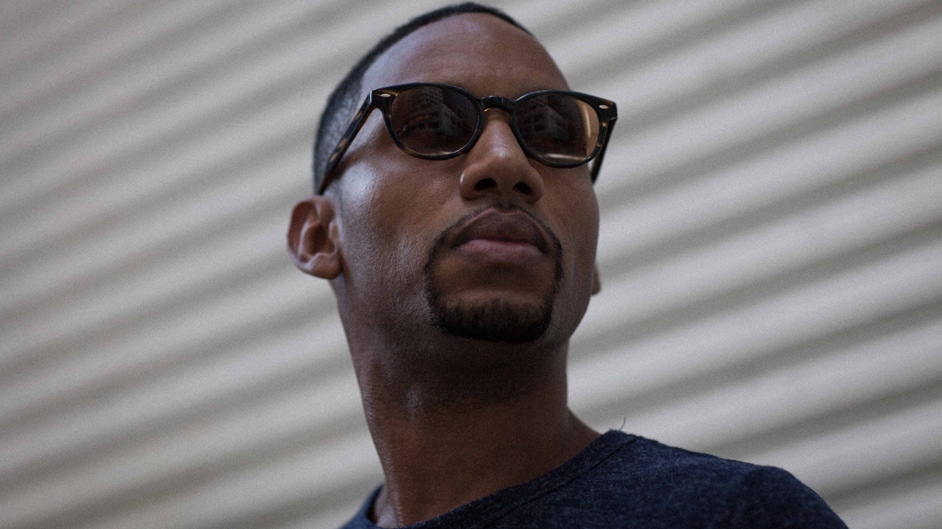
This New Year's Eve, Blue Bar at
Four Seasons
Hotel Hong Kong will be getting steamy with its Viva Cuba! New Year's Eve Countdown Party. Guests will get the Havana vibe going with complimentary Panama hats for the men, fans for the ladies, and one Cuban cigar per person to be enjoyed on the outdoor balcony, transformed for the night into a cigar lounge. Meanwhile, DJ Re:Flex will be spinning Latin beats and the latest party tunes late into the night, Executive Chef Andrea Accordi will give guests a real taste of Cuba with a delicious snack menu and the Blue Bar mixologists will be shaking up new takes on classic cocktails worthy of Hemingway himself.
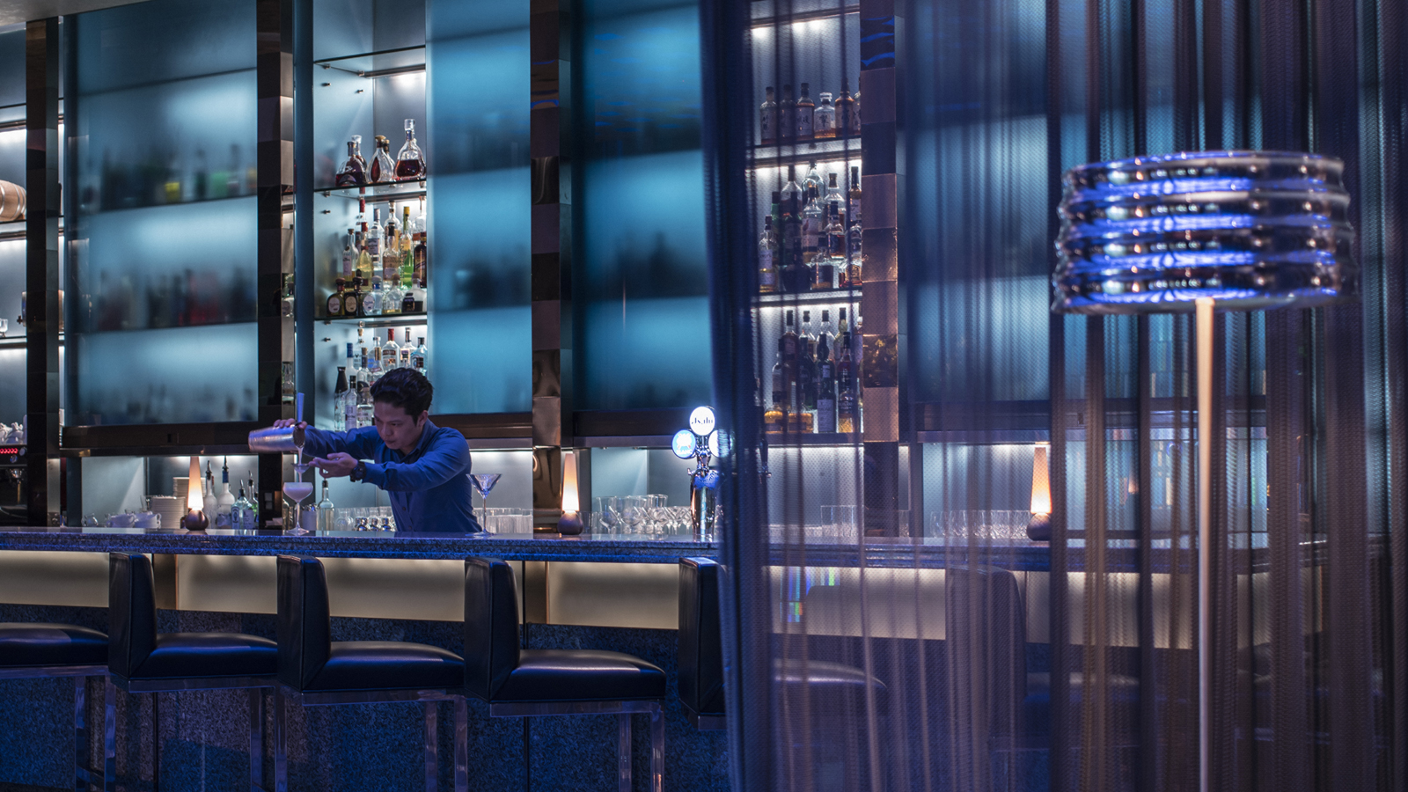
DJ Re:Flex
Hailing from Washington, DC via New York City, Re:Flex started break-dancing at 17 and was quickly introduced to DJing. Since his first exposure to hip hop culture he has continued to experiment with all kinds of sounds, molding his cross-genre style into a provocative musical experience.
Since relocating to Hong Kong in 2007, Re:Flex has rocked parties all over Asia, and in 2009 completed a pan-Asia tour with Hennessy Artistry. Playing alongside acts such as Ben Pearce, Skratch Bastid, Chali 2na, the Ting Tings, Nickodemus, the Cuban Brothers, Zinc and the legendary Doc Scott, Re:Flex has learned to adjust his style to the ever-changing crowd, while still remaining true to his roots, never shying away from his funky, soulful, bass banging past. Listeners have dubbed his sets as unpredictable, esoteric and fresh.
Hot Bites and Cool Drinks
A little Spanish, a little African, very much of the Caribbean, Cuban food is an ever evolving cuisine. In that spirit, Chef Accordi has taken a nod from Cuba and to craft a late night snack menu of lux Latin bites. Dishes include wagyu beef empanadas, red snapper ceviche with kaluga caviar, and chicken and black truffle croquetas. Every guest will receive a complimentary Cuban toast with chipotle, avocado, seared salmon ceviche and Baikal caviar.
Behind the bar, the star mixologists of Four Seasons have put their own spin on classic Caribbean cocktails such as with the Varadero, a lychee and grapefruit Mojito; and the Pape Doble, given an Asian twist with clarified yuzu juice mixed with white rum, maraschino liqueur and lime.
Cuban Style
To complement the Panama hats and fans, guests are encouraged to sport their best Latin flair. The best dressed couple of the evening will go home with a voucher for dinner for two at 2 Michelin star Caprice.
The Santa Clara package is HKD 990 per person at the door and includes entrance fee, DJ performance, welcome drink and snack, one cigar and souvenirs. The Santiago de Cuba package is HKD 1950 per person in advance and includes entrance fee, DJ performance, complimentary snack, one cigar, souvenirs, selected Champagne, red wine, white wine and cocktails inclusive. Doors open at 10:00 pm on December 31, 2017. To book contact the Festive desk at +852 3196 8708 or by email at shop.hkg@fourseasons.com.

RELATED

November 14, 2017, Pudong, Shanghai, China
Get the Luxury Treatment in Style at FLARE Spa at Four Seasons Hotel Pudong, Shanghai
https://publish.url/pudong/hotel-news/2017/guerlain-spa-treatments.html

November 14, 2017, Pudong, Shanghai, China
时光逆转 绽放美丽
https://publish.url/zh/pudong/hotel-news/2017/guerlain-spa-treatments-2.html

PRESS CONTACTS

Mimi Cheung
Digital Media and Content Manager
8 Finance Street, Central
Hong Kong
China
mimi.cheung@fourseasons.com

852 3196 8317

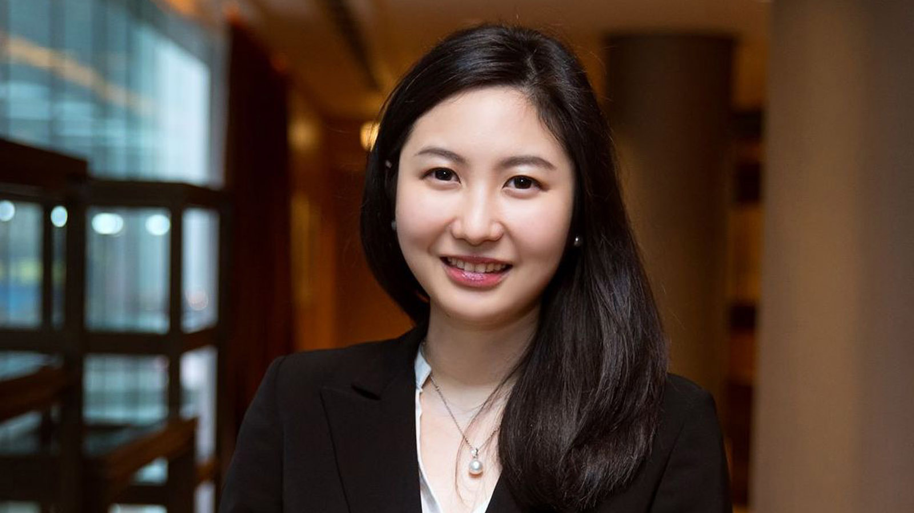 | Priscilla Chan  Public Relations Manager  8 Finance Street, Central,  Hong Kong  China  priscilla.chan@fourseasons.com  (852) 3196 8307
Amy Powell
Director of Public Relations and Communications
8 Finance Street, Central
Hong Kong
China
amy.powell@fourseasons.com

+852 3196 8306

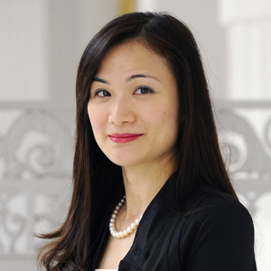 | Vivian Koh  Director, Public Relations and Content, Asia-Pacific  Tourism Court, 1 Orchard Spring Lane #04-01  Singapore  Singapore  vivian.koh@fourseasons.com  +65 6739 5806

