Four Seasons to Expand Mexican Portfolio with New Project in Cabo Del Sol

Resort and Private Residences breaks ground in the heart of the famed Los Cabos Corridor
November 14, 2019, Toronto, Canada

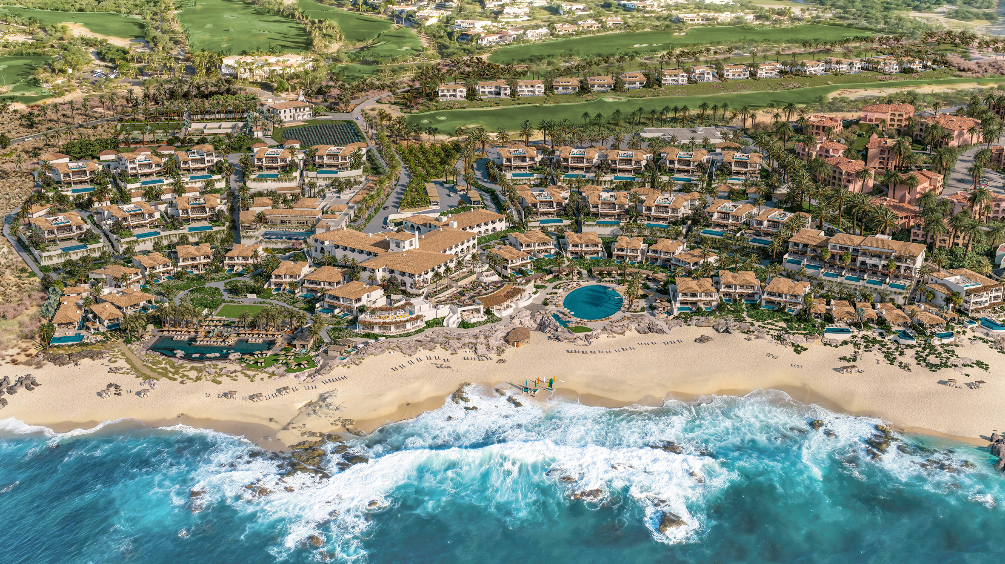
Four Seasons Hotels and Resorts, the world’s leading luxury hospitality company, and Oakmont Corporation, a Los Angeles-based family office, today announced plans for Four Seasons Resort and Residences Cabo San Lucas at Cabo Del Sol.
Situated on the southern tip of Mexico’s Baja California Peninsula, nestled in the centre of the famed Los Cabos Corridor between Cabo San Lucas and San José del Cabo, the new-build 96-key Resort with 61 residences, villas and estates will sit on more than 50 oceanfront acres (20 hectares) within Cabo Del Sol’s new private beachfront community, The Cove Club.
“We couldn’t be more pleased to announce our partnership with Four Seasons Hotels and Resorts,” said Robert Day, CEO of Oakmont Corporation. “Four Seasons is an acknowledged leader in the luxury lifestyle segment. Their commitment to providing the ultimate guest and resident experience is perfectly aligned with our own, and will serve to establish a new standard of excellence in Cabo's Golden Corridor.”
“With our second property on the Baja Peninsula, we are excited to offer another unique opportunity to live and stay with Four Seasons in the Cabo region,” says John Davison, President and CEO, Four Seasons Hotels and Resorts. “Together with our partners at Oakmont, guests and residents will enjoy the adventure and activity that Cabo San Lucas is known for, with the luxury experiences and service that are the hallmarks of our brand.”
About Four Seasons Resort and Residences Cabo San Lucas at Cabo Del Sol
Welcoming couples, families and adventure seekers amid the sweeping ocean and mountain backdrop, the expansive grounds will offer a constellation of dining options, a well-stocked Kids for All Seasons program and private Beach Club. A signature Four Seasons spa and a cutting-edge fitness centre will also be available for those yearning to reconnect body and mind.
In addition to on-property facilities, owners of Four Seasons Private Residences will have an opportunity to purchase membership in the Cove Club, the newest private golf and beach club in the region at Cabo Del Sol.
Along with Four Seasons Resort and Residences, the Cove Club at Cabo Del Sol includes a luxurious, members-only beach club with toes-in-the-sand dining, rare swimmable beaches, beachside fitness, a resort-style pool and private cabanas; a private golf club on the region’s top golf course; and La Montaña, a thrilling mountain adventure park. Other planned amenities include an organic farm and garden offering true sea- and farm-to-table dining experiences; a family park; as well as a signature member services and outdoor adventure program.
The Resort and Residences are perfectly located in the heart of the famed Golden Corridor surrounded by endless opportunities for dining, shopping and entertainment. Cabo San Lucas, known for its vibrant nightlife, world-class marina and El Arco, a natural stone arch that is the icon of the region, sits at the western end of the Corridor, while San José del Cabo, the cultural and artistic heart of Los Cabos, marks the eastern end. Both are only minutes from Cabo Del Sol.
Furthermore, the best snorkelling sites of the alluring Sea of Cortez are also within quick reach. Swim the pristine aquamarine waters, once termed “the aquarium of the world” by oceanographer Jacques Cousteau, or whale watch for migrating humpbacks and gray whales, in season. All around are endless opportunities for desert and mountain adventures, from hiking, biking and horseback riding to exploring secluded caves and hidden waterfalls.
To learn more about Four Seasons Resort and Residences Cabo San Lucas at Cabo Del Sol, visit cabodelsol.com/private-residences.

RELATED

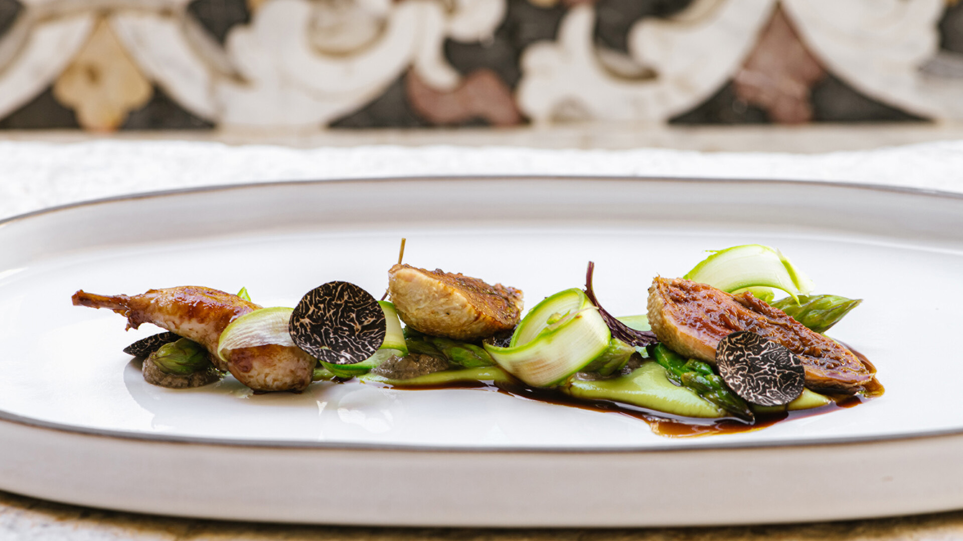 | June 7, 2023, Toronto, Canada  Four Seasons Celebrates Global Michelin Star Leadership with 32 Stars Across Its Dynamic Restaurant Portfolio  https://publish.url/news-releases/2023/michelin-starred-restaurants.html
June 7, 2023, Toronto, Canada
Four Seasons feiert die globale Michelin-Stern-Führung mit 32 Sternen in seinem dynamischen Restaurant-Portfolio
https://publish.url/news-releases/2023/michelin-starred-restaurants-2.html

PRESS CONTACTS

Sarah Tuite
Vice President, Corporate Public Relations
1165 Leslie Street
Toronto
Canada
prsm@fourseasons.com

