A Tribute to Coconut Paradise

July 26, 2017, Koh Samui, Thailand

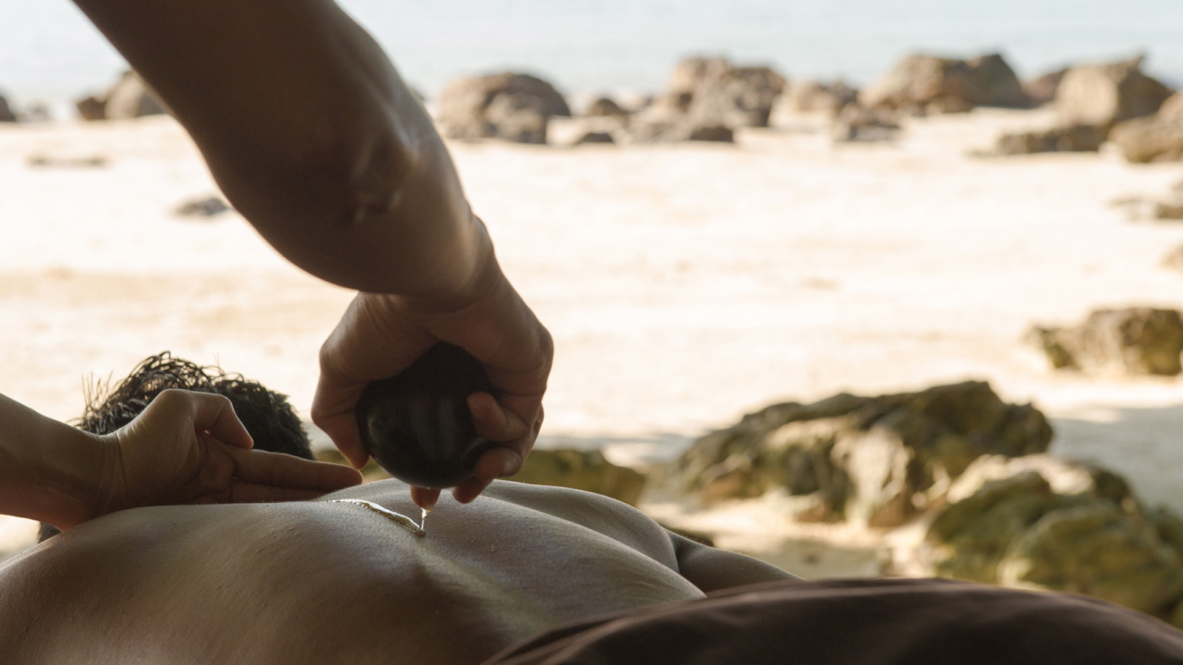
Only introduced to mainstream tourism towards the end of the 20th century, Koh Samui was little more than a few fishing hamlets and coconut plantations stitched together by the small indigenous communities that had lived here for centuries. Revealing its secrets slowly but steadily, it has now transformed into a tropical temptation, with hidden treasures for those seeking new discoveries.
Virgin coconut oil isn’t often sold as mainstream wellness product, and even here on Koh Samui, remains a cottage-industry by-product with a steadily growing market. Local families, working under those very coconut trees, remove the fresh pulp and with some simple, cold-press techniques, produce this mildly fragrant, but richly nourishing oil.
While the world of wellness is only now taking notice of the wondrous healing benefits of virgin coconut oil, at
Four Seasons
Resort Koh Samui, a pioneering spa treatment using this local product brings healing to you in a picturesque tropical landscape.
The Kala Coconut Massage, incorporates locally inspired, deep-tissue techniques using kala – smoothly finished, half coconut shells – and virgin coconut oil made exclusively on the island for the Resort.
With this signature experience at Secret Garden Spa or Secret Beach Spa, you will certainly experience first-hand the healing effects and benefits of coconut oil, the traditional way.

RELATED

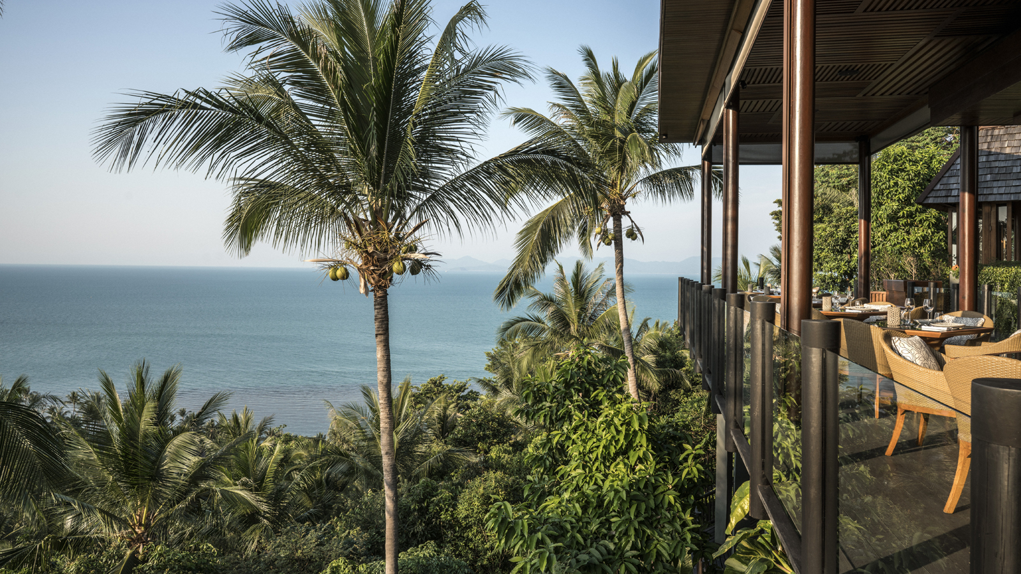 | February 28, 2017, Koh Samui, Thailand  Four Seasons Resort Koh Samui in Collaboration with Bo.lan Presents "A Taste of the Orient"  http://publish.url/kohsamui/hotel-news/2017/bolan-event.html
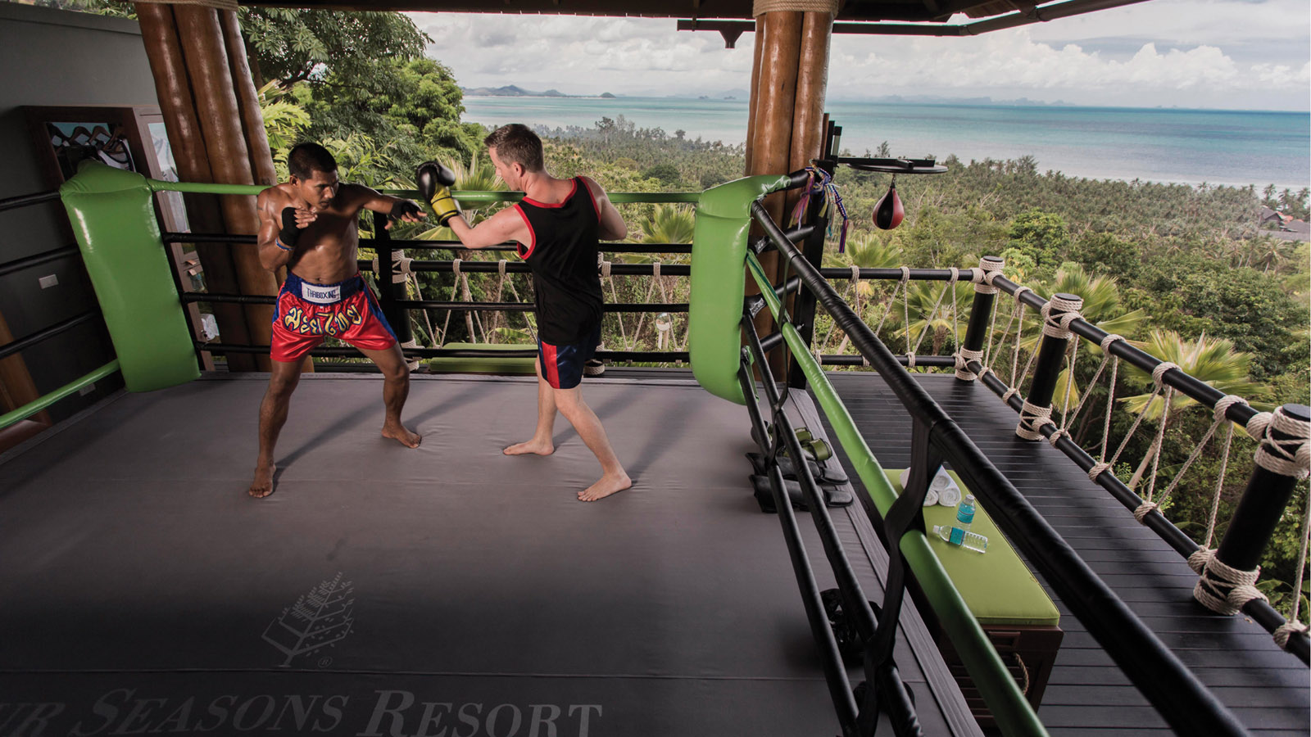 | December 30, 2016, Koh Samui, Thailand  Muay Thai Discovery Package at Four Seasons Resort Koh Samui  http://publish.url/kohsamui/hotel-news/2016/muay-thai-plus-spa-package.html

PRESS CONTACTS

Karuna Amarnath
Director of Public Relations and Communications
3/F, 159 Rajadamri Road
Bangkok
Thailand
karuna.amarnath@fourseasons.com

+66 2207 8916

Pitchanan Tongsuk
Public Relations Executive
219 Moo 5, Angthong,
Koh Samui, Surat Thani
Thailand
pitchanan.tongsuk@fourseasons.com

+66 077 243 000

